COMPETENCE BASED CURRICULUM

KENYA PRIMARY SCHOOL EDUCATION ASSESSMENT
GRADE 4

MATHEMATICS ACTIVITIES

Learner’s name:...............................................................................................

School’s Name: .................................................................................................

Assessment No...................................... Date: ...............................................

INSTRUCTIONS TO LEARNER

- Answer ALL the questions in the spaces provided.

Time: 1 hour 30 minutes

FOR OFFICIAL USE ONLY
SCORE GRID

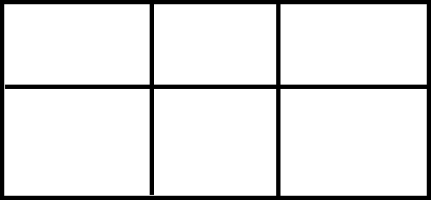
Number of Maximum Candidates’

Questions Score Score
50

ASSESSMENT RUBRICS
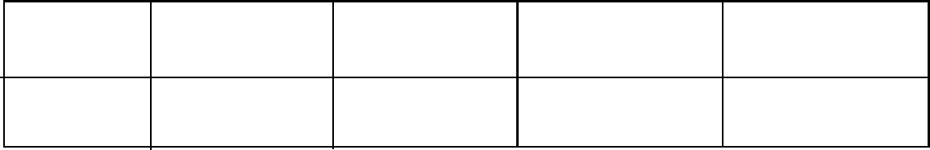

Performance Exceeds Meets Approaching Below

Expectations(4) expectations(3) Expectations(2) Expectations(1)

ANSWER ALL QUESTIONS IN THE SPACES PROVIDED BELOW
- Kamau is carrying three large fish. the mass of each fish is 5 kg , what is the total mass of fish -------------------------------------------------------------------------------- (2mks)
- Which unit do we use to measure capacity --------------------------------- (1mk)
- Two packets of milk is one litre. How many packets of milk are needed to make 1 litre ----------------(1mk)
What is the place of digit 6 in the following numbers (4mks)
- 96 --------------------------------------
- 465 --------------------------------------
- 9406 -------------------------------------
- 60000 -------------------------------------
What is the total value of the in brackets values (4mks)
- 5021 (2) ----------------------------------
- 7689 (6) ---------------------------------
- 43016 (0) -------------------------
- 6569 (9) -------------------------
Write the following numbers in words (3mks)
- 599------------------------------------------------------------------------------
- 420------------------------------------------------------------------------------
- 755-----------------------------------------------------------------------------
- Three symbols 3, 8, 9 were used to form some digits. write down the largest numbers formed in words ------------------------------------------------------------------(1mk)
- There are eight hundred and eighty eight. write in symbols -------(1mk)
Arrange the following numbers from the largest to the smallest (2mks)
- 30,56 , 76 , 9 ,88 ,72 --------------------------------------------------------
- 624, 223,789,11,98 --------------------------------------------------------
Round of the following to the nearest 10 (4mks)
- 49 --------------------
- 87 --------------------
- 85 ---------------------
- 90 ---------------------
Round of the following to the nearest 100 (3mks)
- 654 -----------------
- 866 -----------------
- 708 ------------------
- Which multiple of three comes just after 12 ----------------(1mk)
Write the following in roman numbers (3mks)
- 3 -----------------
- 7------------------
- 10 ----------------
Write the next 2 number in the pattern (2mks)
- 12 , 14 , 16 -------, ---------
- 11, 13 15 17 ------ , ---------
- There were 2600 pupils in Kitengela School in the year 2010, 1240 pupils transferred to Muthurwa School in the year 2011. How many pupils remained ---------------------------------------------------------------------------------------------A(2mks)
Work out (3mks)
- ---- * 9 = 81
- ----- * ----- = 60
- 6 * 11 = ------
- Circle the even numbers In the table below (4mks)
49 | 4 | 99 | 12 | 14 | 23
17 | 26 | 19 | 24 | 65 | 22
8 | 73 | 28 | 47 | 36 | 60
84 | 81 | 78 | 26 | 18 | 13
Work out
- 1/3 of 12 = ---------------- (1mk)
- Divide and shade an eighth of this shape (2mks)

- What is the sum of 78 and 87---------------------------------------(2mks)
- Ab teacher had 48 pencils , he divided them among the 8 pupils , how Many did each pupil got ----------------------------------------------------------------- (2mks)
- Share 40 books among 4 boys . Each gets -----------------------------------(2mks)
- How many 5 litres are in 35 litre container ----------------------------(2mks)
- Work out
¼ + ¼ = ------------------------(2mks)

Marking scheme
- 15kg
- litres/deciliters
- 2packets
- ones
- tense
- ones
- tens of thousands
- 20
- 600
- 0
- 9
- five hundred and ninety
- four hundred and twenty
- seven hundred and fifty five
- 983
- 888
- 88,76,72,56,30,9
- 789,624,223.98,11
- 50
- 90
- 90
- 90
- 700
- 900
- 700
- 15
- iii
- vii
- x
- 18,20
- 19.21
- 1360
- 9
- 6*10
- 66
- 4,12.14,26,24,22,8,28,60,84,78,26,18
- 4

- 165
- 6
- 10
- 7litres
- 1/2

