COMPETENCE BASED CURRICULUM

KENYA PRIMARY SCHOOL EDUCATION ASSESSMENT
GRADE 4

ENGLISH ACTIVITIES

SECTION A

Learner’s name:...............................................................................................

School’s Name: .................................................................................................

Assessment No...................................... Date: ...............................................

INSTRUCTIONS TO LEARNER

- Answer ALL the questions in the spaces provided.

Time: 20 minutes per learner
SCORE GRID

ASSESSMENT RUBRICS
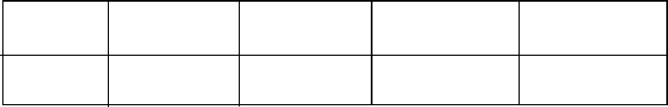

Performance Exceeds Meets Approaching Below

Expectations(4) expectations(3) Expectations(2) Expectations(1)

SECTION 1: LISTENING AND SPEAKING
Your teacher will read for you the following story and you will answer the questions that follow.
One day Amina was walking towards home from the market. Along the way Amina met a stranger who offered her various gifts in exchange for sex. Amina refused to accept the gifts but the man the man insisted on sleeping with Amina. The man forced Amina to sleep with him. Amina cried aloud but no one came for help. Amina reported the matter to the nearest police station and the man was arrested.
- What did the stranger want from Amina?
- What happened when Amina refused to take the gifts?
- Where should we report to when raped like Amina apart from a police station?
- How can you avoid strangers when you meet them?
SECTION II: READING ALOUD
Read the following passage fluently
Covid-19 is a disease that has killed so many people. Young and old alike. It kills if you don’t take care of yourself by washing your hands, keeping social distance and wearing a face mask. If you happen to be infected you should quarantine yourself for fourteen days. In school our teachers have put measures to ensure that we do not infect others. They have provided us with free facemasks and also by ensuring we keep social distance at all times.

