COMPETENCE BASED CURRICULUM

KENYA PRIMARY SCHOOL EDUCATION ASSESSMENT
GRADE 4

CRE ACTIVITIES

Learner’s name:...............................................................................................

School’s Name: .................................................................................................

Assessment No...................................... Date: ...............................................

INSTRUCTIONS TO LEARNER

- Answer ALL the questions in the spaces provided.

Time: 1 hour 30 minutes
SCORE GRID

ASSESSMENT RUBRICS
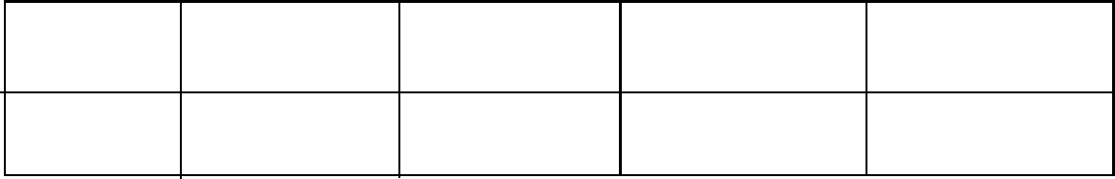

Performance Exceeds Meets Approaching Below

Expectations(4) expectations(3) Expectations(2) Expectations(1)

Strand/Sub strand | Questions | Total marks | Score | Performance Level
Creation | 1,2,3,4,7,8,9 | 21
The Holy Bible | 10 | 4
The Life of Jesus Christ | 6 | 3
Christian Values | 5 | 6
TOTAL |  | 34

Answer all questions
- God Created us in his own and (2 marks)
- State 4 things we do to cope with our emotions (4 marks)

- Veronica a grade 4 pupil decided to fight her friend florence in school because Florence stole and ate her packed lunch. What kind of choice did florence make? ( 2marks)
b. state three things that happen when fight in school? (3 marks)

c. What was the outcome of the Choice that our First Parents Adam and Eve made in the garden of Eden (2 marks)

- Name two members of the Nuclear Family (2 marks)

- What type of Values did the children show in the following situations?
- Mutisia while passing through the streets of the town saw, a beggar who has stayed for two days without eating. Mutisia decided to buy for the beggar some food to eat.
(2 marks)

- Venesa sat in her chair in a bus, an old man gets in and Venesa decides to leave for him his chair to sit on. 2 marks)
- Musa was attacked by a stranger on his way to school and decided to report the matter to the police station for action. (2 marks)
- Mention any three miracles performed by Jesus Christ ( 3 marks)

- Fill the missing letters
- God has no sin. He is h___ ____y. ( 1 mark)
- God is our Loving F____th____ r ( 1 mark)
- We should say NO to before marriage. (1 mark)
- Draw the family tree of your family and label accordingly. Circle your name on it. ( 3 marks) ……………………..use the back space for drawing…………….
- Recall on any two uses of the bible (4 marks)

Marking scheme
- God Created us in his own image and likeness (2 marks)
- State 4 things we do to cope with our emotions (4 marks)
Singing
Playing
Swimming
Permance of drammers
- Veronica a grade 4 pupil decided to fight her friend florence in school because Florence stole and ate her packed lunch. What kind of choice did florence make? Stealing ( 2marks)
b. state three things that happen when fight in school? (3 marks)
injuries
suspension
punishment by the teacher
c. What was the outcome of the Choice that our First Parents Adam and Eve made in the garden of Eden (2 marks)
they ate the forbidden fruit
- Name two members of the Nuclear Family (2 marks)
Mother
Father
Children
- What type of Values did the children show in the following situations?
- Mutisia while passing through the streets of the town saw, a beggar who has stayed for two days without eating. Mutisia decided to buy for the beggar some food to eat.
kindness (2 marks)

- Venesa sat in her chair in a bus, an old man gets in and Venesa decides to leave for him his chair to sit on.respect 2 marks)
- Musa was attacked by a stranger on his way to school and decided to report the matter to the police station for action.obedience to the law (2 marks)
- Mention any three miracles performed by Jesus Christ ( 3 marks)
Turning water into wine,
Raising the dead
Walking on water
Healing the sick
- Fill the missing letters
- God has no sin. He is holy. ( 1 mark)
- God is our Loving Fathe r ( 1 mark)
- We should say NO to sex before marriage. (1 mark)
- Draw the family tree of your family and label accordingly. Circle your name on it. ( 3 marks)
(award marks accordingly)
- Recall on any two uses of the bible (4 marks)
For swearing in to government offices
Used in churches by preachers
Used in schools to teach learners
Used to compose gospel songs

