COMPETENCE BASED CURRICULUM

KENYA PRIMARY SCHOOL EDUCATION ASSESSMENT
GRADE 4

CREATIVE ARTS ACTIVITIES

Learner’s name:...............................................................................................

School’s Name: .................................................................................................

Assessment No...................................... Date: ...............................................

INSTRUCTIONS TO LEARNER

- Answer ALL the questions in the spaces provided.

Time: 1 hour 30 minutes

FOR OFFICIAL USE ONLY
SCORE GRID


Number of Maximum Candidates’

Questions Score Score
60

ASSESSMENT RUBRICS
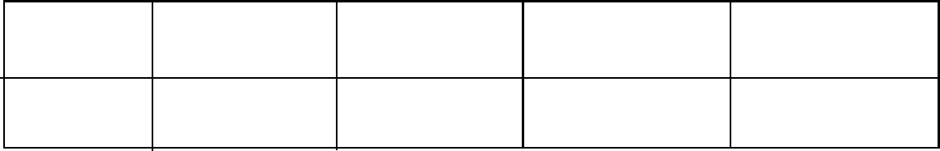

Performance Exceeds Meets Approaching Below

Expectations(4) expectations(3) Expectations(2) Expectations(1)

- Draw any two shapes of your choice. Using a pencil shade the shapes using smudge technique to show dark and light areas. (5 marks)

- You are provided with the following materials
- Still life objects (Teacher to provide any)
- Paper for drawing
- Rubber
- Ruler
- Pencil
- Razor or sharpener
Using still life technique draw a still life composition of a fruit basket. Ensure the arrangement is properly adhered to. (10 marks) ……….. use the back of paper for drawing….
Assessment area | Marks | Score
Arrangement of Objects | 10 marks
Shading light and dark areas | 2 marks
Right application of tonal gradation | 2 marks
Are their overlaps | - mark

- State 3 types of songs (3 marks)

- Tuishangilie Kenya
Tuishangilie Kenya
Taifa letu tukufu
Kenya tunayoipenda,
Daima
Kenya nchi tunayoipenda,
Daima
Kenya nchi tunayoipenda,
Daima
- Name the type of song above ( 1 mark)

- State the reason for your answer in (a) 2 marks

- What values does the song above promote? (3 marks)

- Name two instruments that can be used to accompany the song while singing (2 marks)

- List any 3 instruments used in a folk song (3 marks)

- Tick (√)appropriately whether right or wrong.
Scenario | Wrong | Correct
Singing while not pronouncing words |  |  | 1 mark
Singing while paying attention to elements of music |  |  | 1 mark
Clapping hands helps us to sing with the correct rhythm |  |  | 1 mark

- You’re a required to sing stanza 1 of the Kenya National Anthem as your Teacher listens and assess as per the sheet below. Ensure you are able to sing stanza one of the National anthem in both English and Kiswahili.
Indicator | Marks | Score
Pay attention to pitch accuracy | 4 marks
Sings in the correct rhythm and accentuation | 1 mark
Sings with appropriate phrasings and articulation expressing the desired emotions, feelings and ideas | 2 marks
Improvises other dynamics not indicated | 1 mark
20-25 scores -level 4
15-19 scores – level 3
9-14 scores – level 2
  - scores level 1

- What is the name given to the place where athletes run? ( 2 mark)
....................................................................................................................................................................................................................................................................................................................................................................................................................................
- State 3 safety measures that you consider when running 100m and 200m ( 3 marks)

- List 3 importance’s of Team work during sports activity in school (3 marks)

- Name 3 items you can use to improvise balls (3 marks)

- What type of catching is shown in the picture below? (1 mark)
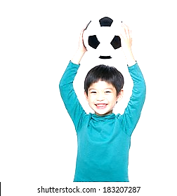
- Identify the types of passes shown in the pictures below.
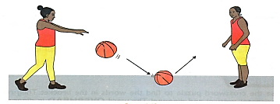 (1 marks)
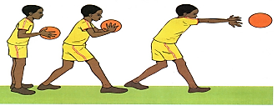 (2 marks)

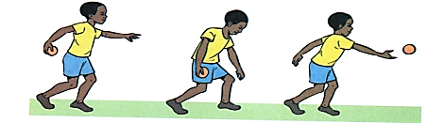 ( 2 marks)
- Give 1 reason why we should have commitment in sports. (1 mark)
a…………………………………………………………………………………………………………………………………………..

- Name the Name the type of game shown below.

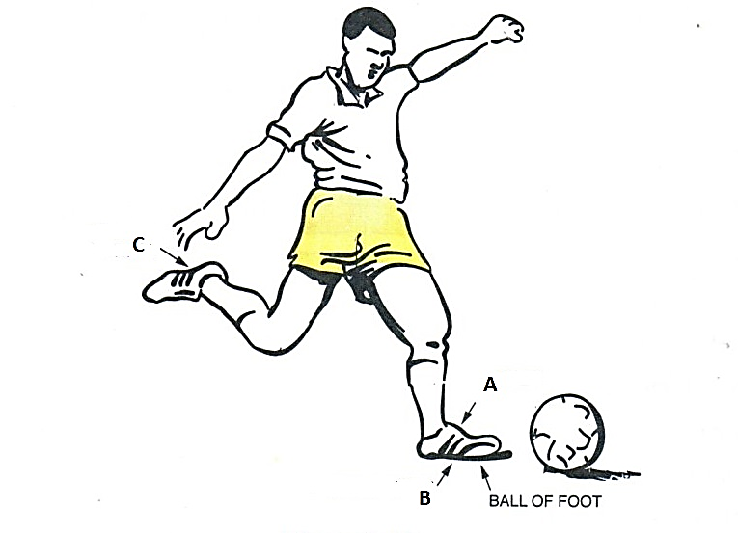

Marking scheme
- Draw Any two shapes of your choice. Using a pencil shade the shapes using smudge technique to show dark and light areas. (5 marks)
- (award accordingly )
- State 3 types of songs (3 marks)
- Sacred songs
- Patriotic songs
- Lullabies
- Tuishangilie Kenya
Tuishangilie Kenya
Taifa letu tukufu
Kenya tunayoipenda,
Daima
Kenya nchi tunayoipenda,
Daima
Kenya nchi tunayoipenda,
Daima
- Name the type of song above ( 1 mark)
patriotic
- State the reason for your answer in (a) 2 marks
It talks about development and appreciation of the country (
- What values does the song above promote? (3 marks)
Unity
Peace
Love
- Name two instruments that can be used to accompany the song while singing (2 marks)
Guitar
Flute
Shaker
- List any 3 instruments used in a folk song (3 marks)
Drum
Banjo
(mark any relevant)
- Tick (√) appropriately whether right or wrong.
Scenario | Wrong | Correct
Singing while not pronouncing words | √ |  | 1 mark
Singing while paying attention to elements of music |  | √ | 1 mark
Clapping hands helps us to sing with the correct rhythm |  | √ | 1 mark

- You’re a required to sing stanza 1 of the Kenya National Anthem as your Teacher listens and assess as per the sheet below. Ensure you are able to sing stanza one of the National anthem in both English and Kiswahili.(award marks accordingly )
Indicator | Marks | Score
Pay attention to pitch accuracy | 4 marks
Sings in the correct rhythm and accentuation | 1 mark
Sings with appropriate phrasings and articulation expressing the desired emotions, feelings and ideas | 2 marks
Improvises other dynamics not indicated | 1 mark
20-25 scores -level 4
15-19 scores – level 3
9-14 scores – level 2
0-8 scores level 1

(TOTAL MARKS 25)
- What is the name given to the place where athletes run? ( 2 mark)
Athletic field
- State 3 safety measures that you consider when running 100m and 200m ( 3 marks)
Stop running if you get hurt or feel pain
Maintain your lane while running
Do not hold each other while running

- List 3 importance’s of Team work during sports activity in school (3 marks)
Motivate the players
Resque the injured athlete by doing first Aid practice
Mark any relevant point

- Name 3 items you can use to improvise balls (3 marks)
Old newspaper
Rope
Polythene
- What type of catching is shown in the picture below? (1 mark)
head trap

- Identify the types of passes shown in the pictures below.
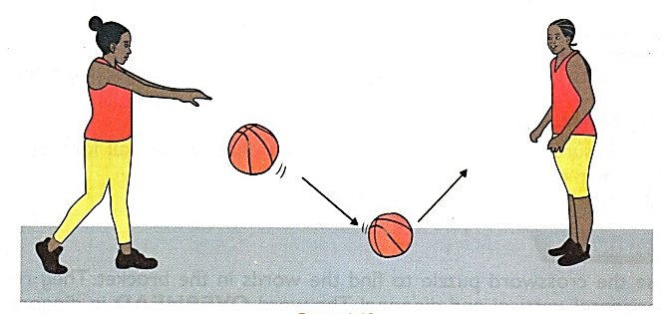 bounce pass (1 marks)
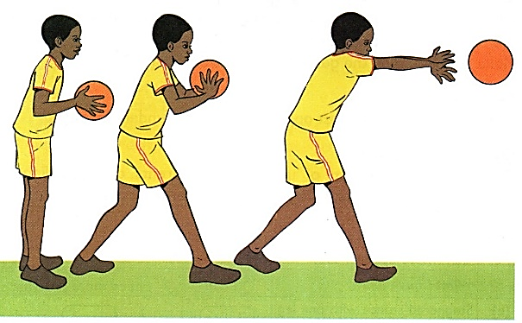 air pass (2 marks)

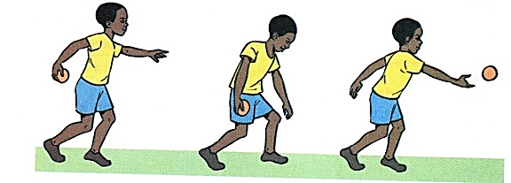 ( 2 marks)
- Give 1 reason why we should have commitment in sports. (1 mark)
Exercise and entertainment
- Name the type of game shown below.

football

