COMPETENCE BASED CURRICULUM

KENYA PRIMARY SCHOOL EDUCATION ASSESSMENT
GRADE 4

ENGLISH ACTIVITIES
ENGLISH SECTION C

Learner’s name:...............................................................................................

School’s Name: .................................................................................................

Assessment No...................................... Date: ...............................................

INSTRUCTIONS TO LEARNER

- Answer ALL the questions in the spaces provided.

Time: 1 hour 30 minutes
SCORE GRID

ASSESSMENT RUBRICS
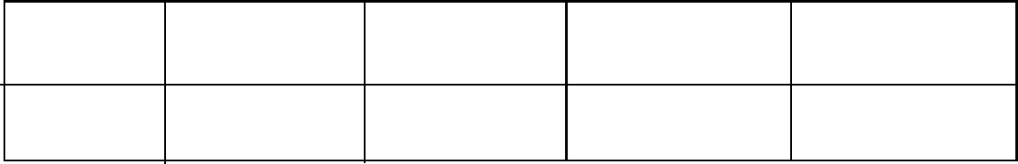

Performance Exceeds Meets Approaching Below

Expectations(4) expectations(3) Expectations(2) Expectations(1)

WRITING 20 MARKS
COMPOSITION
Write an interesting composition about:
OUR HEADTEACHER
……………………………………………………………………………………………………………………………………………………………………………………………………………………………………………………………………………………………………………………………………………………………………………………………………………………………………………………………………………………………………………………………………………………………………………………………………………………………………………………………………………………………………………………………………………………………………………………………………………………………………………………………………………………………………………………………………………………………………………………………………………………………………………………………………………………………………………………………………………………………………………………………………………………………………………………………………………………………………………………………………………………………………………………………………………………………………………………………………………………………………………………………………………………………………………………………………………………………………………………………………………………………………………………………………………………………………………………………………………………………………………………………………………………………………………………………………………………………………………………………………………………………………………………………………………………………………………………………………………………………………………………………………………………………………………………………………………………………………………………………………………………………………………………………………………………………………………………………………………………………………………………………………………………………………………………………………………………………………………………………………………………………………………………………………………………………………………………………………………………………………………………………………………………………………………………………………………………………………………………………………………………………………………………………………………………………………………………………………………………………………………………………………………………………………………………………………………………………………………………………………………………………………………………………………………………………………………………………………………………………………………………………………………………………………………………………………………………………………………………………………………………………………………………………………………………………………………………………………………………………………………………………………………………………………………………………………………………………………………………………………………………………………………………………………………………………………………………………………………………………………………………………………………………………………………………………………………………………………………………………………………………………………………………………………………………………………………………………………………………………………………………………………………………………………………………………………………………………………………………………………………………………………………………………………………………………

