COMPETENCE BASED CURRICULUM

KENYA PRIMARY SCHOOL EDUCATION ASSESSMENT
GRADE 4

AGRICULTURE AND NUTRITION ACTIVITIES

Learner’s name:...............................................................................................

School’s Name: .................................................................................................

Assessment No...................................... Date: ...............................................

INSTRUCTIONS TO LEARNER

- Answer ALL the questions in the spaces provided.

Time: 1 hour 30 minutes
SCORE GRID


Number of Maximum Candidates’

Questions Score Score
70

ASSESSMENT RUBRICS


Performance Exceeds Meets Approaching Below

Expectations(4) expectations(3) Expectations(2) Expectations(1)

QUESTIONS
- Name the three types of soil (3 marks)

- State two characteristics of clay soil (2 marks)

- Name the type of soil suitable for farming (1 mark)

- Outline 3 uses of soil (3 marks)

- Give an example of a plant that can be grown in the following types of soil
- Clay soil (1 mark)
- Sandy Soil ( 1 mark)
- Loam Soil (1 mark)
- Describe any two methods used in watering seedlings (2 marks)

- Explain the meaning of the term weed. (2 marks)

- Why is mulching Important? (1 mark)

- Below is demonstration of the ability of soil to hold water.
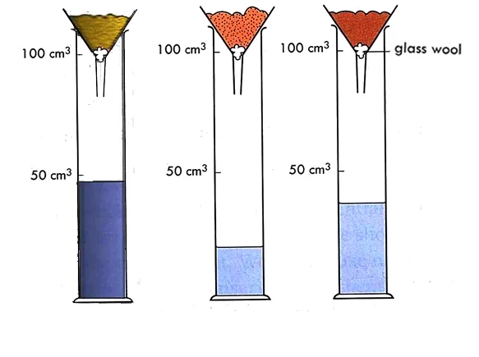
C
B
A
Name soil:
- a (1 mark)
- b (1 mark)
- c (1mark)
- a. You are provide with the following materials
- old sack
- sewing thread
- dry grass
- buttons
- hanging pole
Use the above materials and construct a scarecrow or model the scarecrow. (10 marks)

- Show three uses of water in farming (3 marks)

- Mention 3 tools that are used to prepare a seedbed (3 marks)

- Differentiate between a seed and seedling (2 marks)

- Explain the reason why we dry seeds before putting them in seedbed. (2 mark)

- Name two games played in the locality. (2 marks)

- Name any 3 locally available materials that can be used to improvise play items (3 marks)

- List 3 qualities to consider when choosing play items for a child (3 marks)

- Identify 3 common illness in your locality (3 marks)

- Name 3 causes of illness of in the society (3 marks)

- What is tippy tap used for? (1 mark)

- Using the space provided, draw and colour a tippy tap. (4 marks)

- Name two illnesses in the locality that can prevented by washing hands (2 marks)

- State whether the following situations are healthy or unhealthy practices.
- Eating fruits before washing them ( 1 mark)
- Washing vegetables before cooking (1 mark)
- Drinking contaminated water ( 1 mark)
- Eating soil or soft stones ( 1 mark)
- Opening windows while sweeping the house ( 1 mark)
- Mention 2 ways you can use to care for play items (2 marks)

- Discuss 2 safety measures to be observed while handling play items (2 marks)

Marking schemes
- a. Name the three types of soil (3 marks)
Sandy soil
Loam soil
Clay soil
- State two characteristics of clay soil (2 marks)
Low capilairy
High drainage
- Name the type of soil suitable for farming (1 mark)
clay soil
- Outline 3 uses of soil (3 marks)
moulding
building
farming
- Give an example of a plant that can be grown in the following types of soil
- Clay soil (1 mark)
- Sandy Soil ( 1 mark)
- Loam Soil (1 mark)
Mark any plant named
- Describe any two methods used in watering seedlings (2 marks)
Dripping
Irrigation
- Explain the meaning of the term weed. (2 marks)
any crop that grows where it is not needed
- Why is mulching Important? (1 mark)
conserves soil moisture

- Below is demonstration of the ability of soil to hold water.

Name soil:
- a clay (1 mark)
- b loam (1 mark)
- c sand (1mark)
- a. You are provide with the following materials
- old sack
- sewing thread
- dry grass
- buttons
- hanging pole
Use the above materials and construct a scarecrow or model the scarecrow. (10 marks)
Mark accordingly
- Show three uses of water in farming (3 marks)
irrigating crops
cleaning fruits
drinking
- Mention 3 tools that are used to prepare a seedbed (3 marks)
hoe
panga
deep stick
- a. Differentiate between a seed and seedling (2 marks)
seed – is a small embroyonic plant that has not been planted
seedling - a very young plant that grows from a seed
- Explain the reason why we dry seeds before putting them in seedbed. (2 mark)
to prevent it from germinationg when time planting time not ready
to keep it safe from pest
- Name two games played in the locality. (2 marks)
Football
Hide and seek
(award marks for any other correct answer)
- Name any 3 locally available materials that can be used to improvise play items (3 marks)
Strings
Old newspapers
Old socks
(award marks for any other correct answer)

- List 3 qualities to consider when choosing play items for a child (3 marks)
appropriate age
child interest
creativity
Identify 3 common illness in your locality (3 marks)

- Stomachache
- Headache
- Coughing
- Name 3 causes of illness of in the society (3 marks)
Drinking untreated water
Wrong use of toilet
Eating without washing hands
(mark any three relevant point)
- What is tippy tap used for? (1 mark)
Washing hands
- Using the space provided, draw and colour a tippy tap. (4 marks)
(award marks accordingly)
- Name two illnesses in the locality that can prevented by washing hands (2 marks)
Stomache
cholera
- State whether the following situations are healthy or unhealthy practices.
- Eating fruits before washing them unhealthy ( 1 mark)
- Washing vegetables before cooking healthy (1 mark)
- Drinking contaminated water unhealthy ( 1 mark)
- Eating soil or soft stones unhealthy ( 1 mark)
- Opening windows while sweeping the house healthy ( 1 mark)
- Mention 2 ways you can use to care for play items (2 marks)
Keeping at a safe place after use
Repair when worn out ( award correct points)
- Discuss 2 safety measures to be observed while handling play items (2 marks)
Balls should be kept after the game
Wash games skits after match

