COMPETENCE BASED CURRICULUM

EARLY YEARS EDUCATION ASSESSMENT
GRADE 3

MATHEMATICS ACTIVITIES

Learner’s name:...............................................................................................

School’s Name: .................................................................................................

Assessment No...................................... Date: ...............................................

INSTRUCTIONS TO LEARNER

- This paper consists of 30 questions.

- Answer ALL the questions in the spaces provided.

Time: 1 hour 30 minutes

FOR OFFICIAL USE ONLY
SCORE GRID
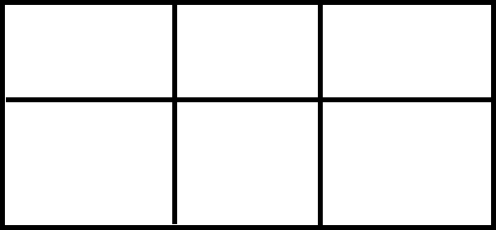

Number of Maximum Candidates’

Questions Score Score

30 30

ASSESSMENT RUBRICS
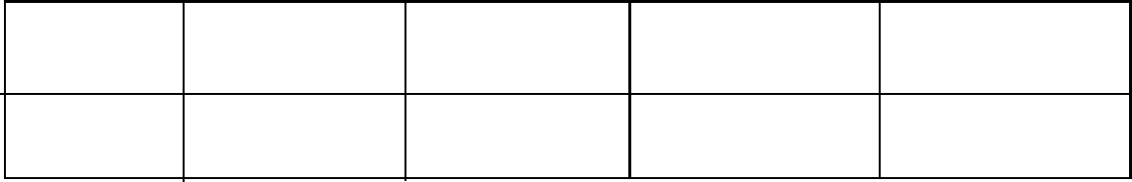

Performance Exceeds Meets Approaching Below

Expectations(4) expectations(3) Expectations(2) Expectations(1)

READ CAREFULLY AND ANSWER ALL THE QUESTIONS (30 MARKS)

- Write in symbols:
Five hundred and seventy six = ____________________________

- Add: 23 pens + 43 pens = ___________________________

- A learner arranged the following items.

Which item is the fifth position? __________________

- Work out: 45 goats - 34 goats = ___________________

- Fill in the missing numbers:

310, 320, _____, 340, _______

- Complete: 128 = _________ hundreds __________ tens ________ ones

- Share 27 mangoes equally among 9 leaners. How many mangoes will each get?

____________

- Which of the following shaded parts is smaller?

____________________________

- Add: 2 hours 15 minutes + 2 hours 5 minutes = _____________________

- A school was awarded 376 spoons and 27 plates. How many utensils did the school have altogether? ______________________

- A shopkeeper had 28 trays of eggs. He sold 13 trays. How many trays remained?

___________________________

- Teresa has sh 300. How many sh 20 coins will she get as change? ____________

- Circle half of the following items.

___________________
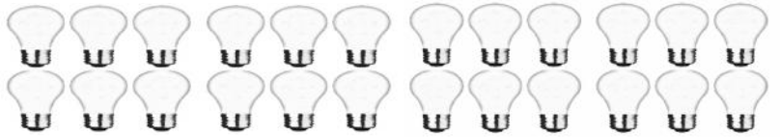
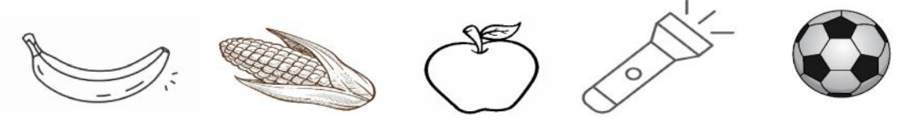
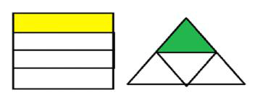

- Subtract: 86 metres - 58 metres = __________________

- Multiply:

3 x 3 = ______________________

- A basin holds 3 litres of water. A jerrican holds 12 litres of water. How many basins of water can fill the jerrican? _______________________

- Complete the following. 5 + 5 + 5 + 5 = ______ x ________

- Mbuvi shared 64 cakes among his 8 children. How many cakes did each child get?

_____________________

- The distance from Maria’s home to church is 340 metres. Maria went to church and back home. What distance did she cover?___________________________

- Work out: 112kg + 234 kg = _________

- Ali used 230 litres of water from the tank below. How many litres remained?
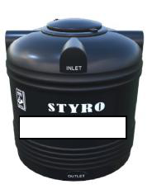

500 Litres | ________________________

- Show 30 minutes past 11 on the clockface below.

- Subtract: sh 450 - sh 150 = ________________________________

- Name the shapes used to make the picture below.
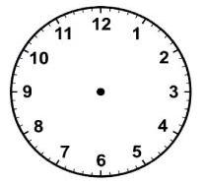
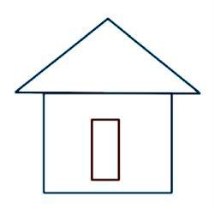

25. Use the number line below to add; 14 +5 + 4 = _________________
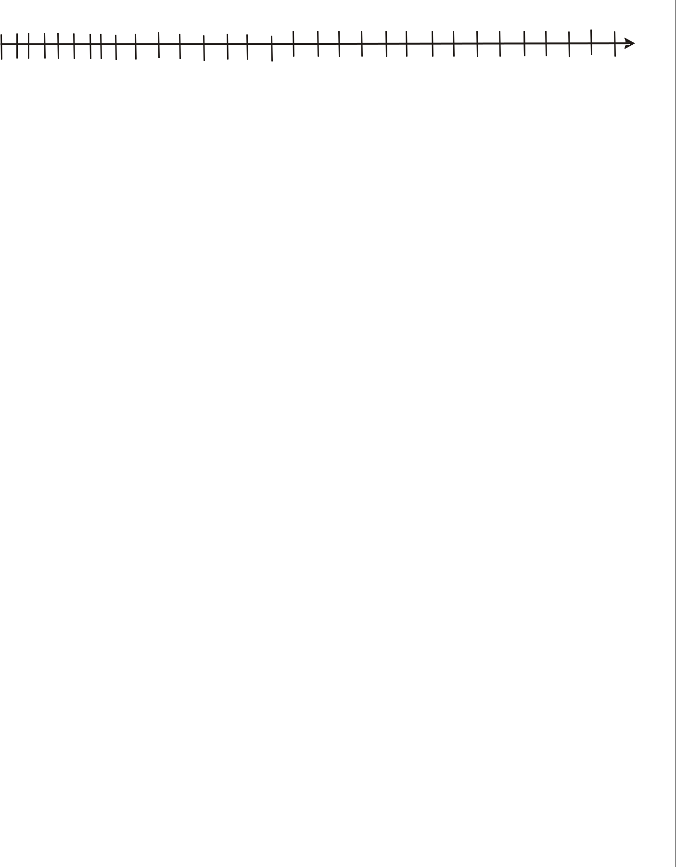

123456789101112131415161718192021222324252627282930

- Draw the next shape in the pattern below.

- Draw squares to show 12.

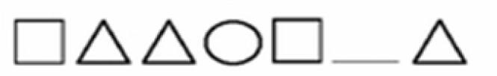

- The month of October has ______________________ days.

- Fatima is 37 years old this year. What was her age last year?

_________________________________________

- How many lines were used to make the following item?





