**FORM 4**

**COMPUTER STUDIES PAPER 1**

**MARKING SCHEME**

**SECTION A**

1. Other than cost and compatibility, state two factors to consider when selecting an input device for an organization
2. User needs
3. Type of data to be entered

Or any other correct response

Factor @ 1 Mark

Total =2 * 1 Mark

=2 Marks

1. State the importance of the cache memory to the computer

It improves the speed and general performance of the computer

Importance @ 1 Mark

1. Distinguish between the address bus and the control bus in the CPU

The address bus is an electronic pathway that transmits the memory location address where the next instruction to be executed is located while the control bus is an electronic pathway that transmits the timing and control signal to all components

Difference @ 2 Marks

1. State any two disadvantages of printing documents using thermal printers
2. Its printing paper and ink are expensive
3. Its print out is affected by direct sunlight
4. Its print out fades over time

Or any other correct response

Factor @ 1 Mark

Total =2 * 1 Mark

=2 Marks

1. State one advantage of storing data on an optical disk over the magnetic disk
2. Cannot be easily modified
3. Cannot be attacked by a virus
4. Data can be stored for a long time

Advantage @ 1 Mark

1. a. Define the term network topology

Topology is the physical and logical arrangement of a network. It is the coordination by which devices in the network are arrange in their logical and physical relations to one another

Definition @ 1 mark

b. Distinguish between a logical and physical topology

The physical topology of a network refers to the physical arrangement of cables, computers, and other peripheral devices on a network. While Logical topology is the method used to pass information between computers on a network.

Difference @ 2 Marks

1. a. Distinguish between a web portal and a blog

**Web portals** are web pages which offer specialized services such as searching, e-mail, sports updates, financial, news and links to the selected websites. While **A blog** is a website that contains personal information which can be easily updated. blogs can be used as; resumes, diary, as a tool of business, advocacy and campaign purposes

Difference @ 2 Marks

b. List four components of an e-mail header (2 Marks)

1. FROM - sender details
2. TO - receiver details
3. DATE – The day the e-mail was sent
4. SUBJECT – the message title
5. CC.- the other recipients who will receive the same message

Or any other correct response

Component @ ½ Mark

Total = 4 * ½ Mark

=2 Marks

1. The tables below were extracted from jobu’s enterprise database. Use them to answer the questions that follows

|  |  |  |  |  |
| --- | --- | --- | --- | --- |
| CUSTOMER TABLE | | | | |
| CUSTOMER ID | ID NUMBER | NAME | ADDRESS | TOWN |
|  |  |  |  |  |

|  |  |  |  |  |  |
| --- | --- | --- | --- | --- | --- |
| ORDER TABLE | | | | | |
| ORDER ID | CUSTOMER ID | ORDER DATE | PARTICULARS | QUANTITY | UNIT COST |
|  |  |  |  |  |  |

1. Identify the most appropriate primary keys in both tables

CUSTOMER TABLE – CUSTOMER ID

ORDER TABLE – ORDER ID

Primary key @ 1 Mark

1. Identify a candidate key in any of the tables

CUSTOMER ID – ID NUMBER

Candidate key @ 1 Mark

1. Describe the relationship formed between the two tables

A one to many relationship whereby one record in the customer table relates to many records in the order table.

Description @ 2 Marks

1. Write a function that would be used in a query to display the delivery date; given that all deliveries are made three days after the order date. Name the query field “Delivery Date”

Delivery Date: dateadd(“d”,3,[ORDER DATE])

Function @ 2 Marks

1. Explain the circumstances that may lead to use of the cropping tool in a word processing document.
2. When some parts of an image  are unwanted
3. To resize the image to fit in a specified area
4. When there is need to change orientation
5. To change the aspect ratio

Or any other correct response

Circumstance @ 1 Mark

Total = 2 * 1 Mark

=2 Marks

1. State two advantages of using templates when creating documents in word processing
2. It saves time since all steps of creating a document is guided
3. Formatting is already done, thus can be used even with those having little knowledge of word processing to produce professionally looking documents

Or any other correct response

Advantage @ 1 Mark

Total = 2 * 1 Mark

=2 Marks

1. The emergence of Gen-Z popular ‘maandamano’ has led to many organizations in major cities in Kenya to embrace teleworking approach

a) State the meaning of the term teleworking

Note that teleworking is also known as telecommuting or remote work refers to a work arrangement in which employees perform their job tasks from home or a location outside the traditional office environment using a computer connected to the workplace network

Meaning @ 1 Mark

b) State two benefits that the organization gained by using this approach

1. Reduces travel expenses
2. Reduces stress due to commuting inconveniences e.g. traffic jams
3. Reduces risk of contracting communicable diseases, e.g. COVID-19

Or any other correct response

Benefit @ 1 Mark

Total = 2 * 1 Mark

=2 Marks

1. (a) (i) State the meaning of each of the following terms used in spreadsheets (2 Marks)

Value

**An intersection of rows and columns**

Chart

Is a visual representation of data in a worksheet

Meaning @ 1 Mark

Total = 2 * 1 Mark

=2 Mark

(ii) A certain formula was typed in a cell within a worksheet. Upon execution the cell displayed the error #NULL. State the meaning of the error

The **#NULL! error** in Excel occurs when you use an incorrect range operator or an intersection operator (space character) between range references that don’t intersect.

Error @ 1 Mark

1. State the hardware technological differences between the second generation and the third generation computers. (3 Marks)

|  |  |
| --- | --- |
| **Second Generation Computers**   1. Low memory 2. Used transistors to process 3. Less powerful processing speed | **Third generation computers**   1. Larger memory 2. Used integrated circuits to process 3. More powerful processing speed |

1. State three ways of transforming a picture embedded in a Desktop Publishing programme in order to fit in a designated space on a document.
   * Rotation
   * Flipping
   * Cropping
   * Stretching

Or any other correct response

Transformation @ 1 Mark

Total = 3 * 1 Mark

=3 Marks

b) State two application areas of a desktop publishing software.

* Posters
* -Book publishing
* -Card design
* (any other correct answer)

Or any other correct response

Application area @ 1 Mark

Total = 2 * 1 Mark

=2 Marks

1. List two duties performed by each of the following personnel (3 Marks)
   * 1. System analyst

- Reviewing the current manual/ current system and making recommendations on how to replace it with a more efficient one.

-Working with programmers to construct and test the system

-Co- ordinate training of users of new system.

ii) Network administrator

-Set-up a computer network.

-Maintain and enforce security measures on the network.

-Monitor the use of network resources

-Maintain and troubleshoot network related problems

iii) Computer trainer

-Develop training reference material

-Train people on how to use a computer and various application programs.

-Prepare learners for ICT exams.

-Advising learners on various career opportunities in ICT field

Or any other correct response

Duty @ ½ Mark

Total = 6 * ½ Mark

=3 Marks

**SECTION B**

**Answer question 16 and any other three questions**

1. a. State two functions of a language translator in program development (2 Marks)

-Converting high level programming language code into machine code

-Allowing programmers to code in specific programming languages

-Ensuring code correctness and if it’s executable

-Error detection

b. Pseudo-code (10 Marks)

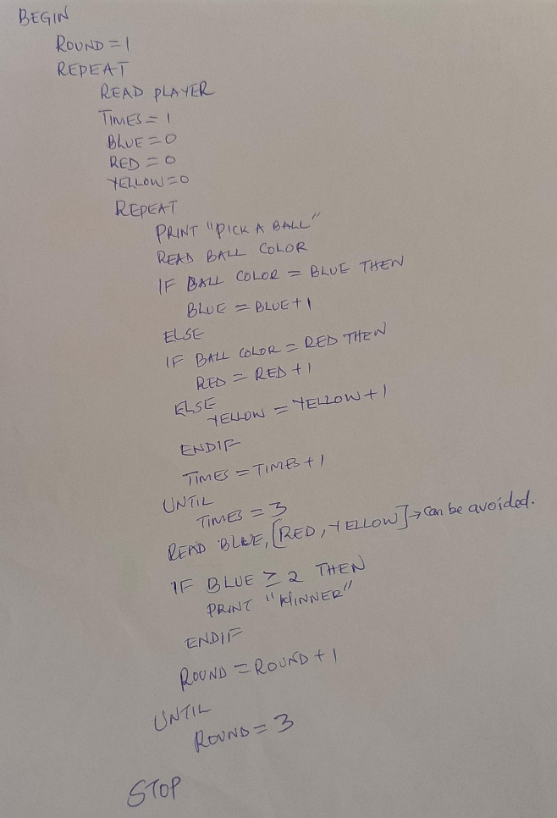

c. Methods used for testing and debugging a program (3 marks)

-Using error detection software’s

-Functional testing – Using a sub program to test the main program

-Use of test data e.g. Normal, abnormal and extreme data

1. An information system is a critical tool of success in any organization. For this reason, many organization set aside a lot of resources in supporting their information system.
   1. Define the term information system

* An information system is a system that accepts data resources as input and processes them into information products as output.
* Information systems can also be defined as any organized combination of people, hardware, software, communications networks, and data resources that stores, retrieves, transforms, and disseminates information in an organization.
* Information systems can also be defined as an arrangement of people, data, processes, communication and information technology that interact to support and improve day-to-day operations as well as support the problem-solving and decision making needs of an organization.

Definition @ 2 marks

* 1. Different methodologies are used to develop systems depending on the nature of the system and the organization.

1. Define the term methodology as used in systems development

A system development methodology refers to the framework that is used to structure, plan, and control the process of developing an information system.

Definition @ 2 Marks

1. State any two advantages of a prototype during system development
2. The software designer and implementer can obtain feedback from the users early in the project.
3. The client and the contractor can compare if the software made matches the software specification, according to which the software program is built.
4. It also allows the software engineer some insight into the accuracy of initial project estimates and whether the deadlines and milestones proposed can be successfully met.
5. Prototyping can also avoid the great expense and difficulty of changing a finished software product.

Or any other correct response

Component @ 1 Mark

Total = 2 * 1 Mark

=2 Marks

1. List any four tools that can be used to design a system
   * + Algorithms

* Pseudocode
* Flowcharts
* Decision tree
* Decision table
* Data flow diagrams
* Context diagrams
* Entity relationship diagrams

Or any other correct response

Tool @ ½ Mark

Total = 4 * ½ Mark

=2 Marks

1. Identify the system flow chart symbol shown in the diagram below and state its function

Symbol

Manual Input

Symbol @ 1 Mark

Function

These are steps where the operator/ user is prompted for information that must be manually input into a system.

Function @ 1 Mark

* 1. List the order in which the operating system organizes information from top to bottom
* Root directory/ drive label/ Root folder
* Directory/ folder
* Sub-directory/ sub-folder
* File

Or any other correct response

Component @ ½ Mark

Total = 4 * ½ Mark

=2 Marks

* 1. State the purpose of a disk diagnostic utility provided by the operating system

This is a special software used to diagnose and repair errors on the storage media and files

Purpose @ 1 Mark

* 1. As John was booting his computer, the process was terminated before completion with an error message “Missing Operating System”, identify the reason for the error and its solution.

Reason

Some system files required by the computer for booting may be corrupted or missing

Reason @ 1 Mark

Solution

* Re-installing the operating system
* Using a repair/ recovery tool to reconstruct or REPLACE the corrupted/ missing files

Solution @ 1 Mark

1. (a)Mention three factors to consider when choosing a file organization method

* **Fast Data Retrieval**: Choose an organization that allows quick access to your data. Efficient retrieval is crucial for productivity and performance
* **Efficient Use of Storage Space**: Optimize storage by selecting a method that minimizes wasted space. Efficient storage management helps conserve resources.
* **Protection from Failures or Data Loss**: Ensure your chosen method provides safeguards against data loss or corruption. Backup strategies and redundancy are essential

Or any other correct response

Component @ 1 Mark

Total = 3 * 1 Mark

=3 Marks

b) Define the term Data integrity

Validity, correctness or completeness of data entered in a computer

Definition @ 1 Mark

(c) State three ways of minimizing threats to data integrity.

* Back up data
* Control access by enforcing security measures
* Using user interface to minimize invalid entry
* Use error detector and corrector software
* Data capture devices from the source
* Best practices when designing algorithms

Or any other correct response

Component @ 1 Mark

Total = 3 * 1 Mark

=3 Marks

d) Briefly describe the following data processing modes

i) Online processing.

Data is processed automatically on a remote computer called server

ii) Real-time processing.

Computer processed incoming data as soon as it occurs and gives immediate feedback in order to provide accurate up to date information based on input

iii) Multi-programming

Several tasks are processed apparently at the same time by single processing unit.

Or any other correct response

Processing mode @ 1 Mark

Total = 3 * 1 Mark

=3 Marks

e) Why computers are said to be Automatic at the same time they have No Intelligent Quotient (IQ). Explain to her the observation concepts.

* Computers follow instructions precisely and perform repetitive tasks efficiently. They execute code, process data, and carry out operations automatically. This ability to follow instructions without deviation is what we mean by “automatic.”
* -Intelligence involves understanding, reasoning, learning, and adapting to new situations. Human intelligence is multifaceted, combining logical reasoning, emotional awareness, creativity, and problem-solving abilities. Computers lack subjective experiences, emotions, and consciousness. They don’t “think” or “understand” in the way humans do. The absence of an IQ in computers stems from their inability to experience hunger, taste an apple, or feel emotions

Concept @ 1 Mark

Total = 2 * 1 Mark

=2 Marks

f) Give three reasons to justify why many computer users today prefer saving their documents in the google drive

* **Easy Access Anywhere**: Google Drive allows you to access your files from any device with an internet connection. Whether you’re at home, work, or on the go, your documents are readily available.
* **Collaboration and Sharing**: Google Drive simplifies collaboration. You can easily share files with others, collaborate in real-time, and grant specific permissions.
* **Vast storage space available for storage**

Or any other correct response

Component @ 1 Mark

Total = 3 * 1 Mark

=3 Marks

1. a) State three standard coding schemes used in computing

-Binary Coded Decimal (BCD)

-American Standard Code of Information Interchange (ASCII)

-Extended Binary Coded Decimal Interchange Code (EBCDIC)

-Unicode

Or any other correct response

Component @ 1 Mark

Total = 3 * 1 Mark

=3 Marks

b) Convert the following numbers

i) 111.0102 to decimal (3 Marks)

Solution

|  |  |  |  |  |  |  |  |
| --- | --- | --- | --- | --- | --- | --- | --- |
| Place value | 22 | 21 | 20 | . | 2-1 | 2-2 | 2-3 |
| Binary digit | 1 | 1 | 1 | . | 0 | 1 | 1 |
| Value | 4 | 2 | 1 | . | 0 | 0.25 | 0.125 |

Add values (Left to Right) = **7.12510**

ii) 13.87510 to binary (3 Marks)

|  |  |  |
| --- | --- | --- |
| 2 | 13 |  |
| 2 | 6 | 1 |
| 2 | 3 | 0 |
| 2 | 1 | 1 |
| 2 | 0 | 1 |

|  |  |  |
| --- | --- | --- |
| 0.875x2 | 1.75 |  |
| 0.75x2 | 1.50 |  |
| 0.50x2 | 1.00 |  |

**1101.1112**

c) i) Give three reasons why primary storage devices are not used for secondary storage

* Expensive
* Holds less volume of data
* Volatile hence cannot store data once power is off
* Short access time: it is dependent on access time
* ROM cannot store data

Or any other correct response

Component @ 1 Mark

Total = 3 * 1 Mark

=3 Marks

ii) A computer teacher put a rule that flash disks should not be used in the computer laboratory (1 Mark)

* + - * 1. Give a reason for the rule

Introduction of viruses and other bugs from the flash disks

Reason @ 1 Mark

(b)State two other alternatives that can be used to achieve the same objective

-By disabling the flash disk drive

-Having up to date antivirus software that will defect and eradicate any virus in the flash disks.

Or any other correct response

Component @ 1 Mark

Total = 2 * 1 Mark

=2 Marks

1. The development of internet has succeeded in reducing the world into a global village
2. State any two benefits of networking
3. Communication
4. Sharing of the network resources
5. In research
6. Provision of a wide range of information

Or any other correct response

benefit @ 1 Mark

Total = 2 * 1 Mark

=2 Marks

1. 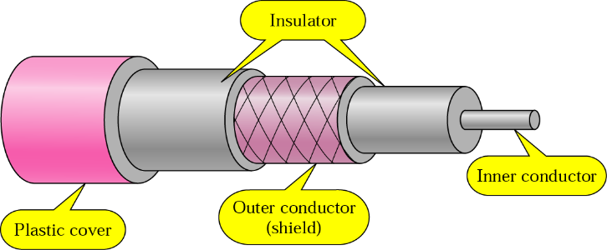Identify the cable in the diagram below

Coaxial cable

Cable @ 1 Mark

c. State any two reasons for making it a better choice for a backbone in a bus topology network

1. They are very stable even under high loads.
2. They have a large bandwidth (up to I Gbps) compared to twisted pair.
3. They can carry voice, data and video signal simultaneously.
4. They are more resistant to radio and electromagnetic interference than twisted pair cables.
5. The layers of insulation help minimize interference and distortion.
6. Relatively high data transmission speed which ranges from 200 million to more than 500 million bits per second.
7. It is used for long distance (300-600 meters).

Or any other correct response

Reason @ 1 Mark

Total = 2 * 1 Mark

=2 Marks

c. State three components of satellite communication (3 Marks)

1. Transmitter
2. Satellite
3. Receiver

Or any other correct response

Component @ 1 Mark

Total = 3 * 1 Mark

= 3 Marks

d. Distinguish between a switch and a router (2 Marks)

* Switches are a special type of hub that uses packet switching instead of message broadcasting. This allows switches to repeat incoming data frames only to the computer or computers to which a frame is addressed.
* Brouters are a combination of router and bridge. This is a special type of equipment used for networks that can be either bridged or routed, based on the protocols being forwarded.

i. Explain the following principles in relation to data integrity principle Data integrity

This is the correctness and completeness of data

ii. Availability

This is to ensure that data is always available to the authorized users whenever it is required

Or any other correct response

Principle @ 1 Mark

Total = 2 * 1 Mark

=2 Marks

1. John was promoted at work but James was not happy about it, he therefore decided to steal and destroy critical information from John’s computer.
2. Identify the threat committed by James

Sabotage

Threat @ 1 Mark

1. State two ways John could have avoided the threat mentioned in (i) above

* Use of password to access the system
* Locking the room whenever he moves out
* Use of a keyboard logger to record all activities done

Or any other correct response

Solution @ 1 Mark

Total = 2 * 1 Mark

=2 Marks