NAME…………………………………ADM NO……………………CLASS………………
SIGNATURE…………………………..DATE……………..
TERM 3 2025
OPENER EXAMINATION
TIME: 1 ¼ HOURS
CHEMISTRY FORM TWO
INSTRUCTIONS: ANSWER ALL QUESTIONS
1. a) What is a flame? (1mk)
……………………………………………………………………………………………………………………………………………………………………………………………………………………………………………………………………………………………………………………………………
b) In terms of colour, size and zones, differentiate between luminous and non-luminous flames. (3mks)
flames | colour | zones | size
Luminous
Non-luminous
c) Name two apparatus for approximate measure of volume and two apparatus for accurate measure of volume. (2mks)
Approximate……………………………………………………………………………………………………………………………..
Accurate……………………………………………………………………………………………………………………………………
2. A mixture contains iodine, sand and sodium chloride. Name three processes in order that can be used to separate the mixture. (3mks)
………………………………………………………………………………………………………………………………………………………………………………………………………………………………………………………………………………………………………………………………………………………………………………………………………………………………………………………………………………………………………
3. Fractional distillation of liquid air is usually used to separate various gaseous mixtures in air. Explain how to;
a) Remove carbon (iv) oxide ……………………………………………………… (1 mk)
b) Remove water ………………………………………………………………………. (1mk)
c) Obtain nitrogen ……………………………………………………………………….. (1mk)
4. The diagram below is a set up for laboratory preparation of oxygen gas.
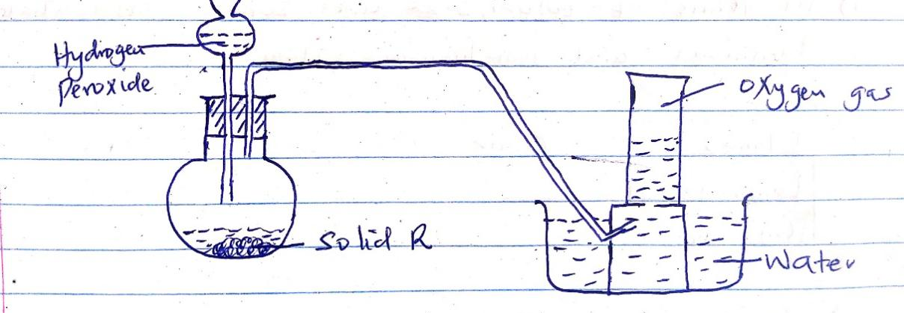
a) Name solid R………………………………………………………………………… (1mk)
b) Write an equation for the reaction that takes place. (2mks)
………………………………………………………………………………………………………………………………………………………………….
c) Name one commercial use of oxygen. (1mk)
……………………………………………………………………………………………………………………………………………………………………………………………………………………………………………………………………………………………………………………………………

5. An element Y has an electron arrangement of 2.8.5.
a) State the period and group to which the element belongs. (2mks)
Period……………………………………….
Group……………………………………….
b) Write the formula of the most stable ion formed when the element Y ionizes. (1 mk)
………………………………………………………………………………………………………………………………………………………………….
c) Explain the difference between the atomic radius of element Y and its ionic radius. (2 mks)
……………………………………………………………………………………………………………………………………………………………………………………………………………………………………………………………………………………………………………………………………………………………………………………………………………………………………………………………………………………………………….
6. a) write down the electronic configuration of the atoms with the following atomic numbers. (2mks)
i) 7……………………………………………………………………….
ii) 9……………………………………………………………………….
iii) 14…………………………………………………………………….
iv)18…………………………………………………………………....
b) An atom of an element has the electronic configuration of 2.8.2
i) Write its atomic number ……………………………………………………………… (1mk)
ii) Is the element metal or a non-metal? Explain. (1mk)
……………………………………………………………………………………………………………………………………………………………………………………………………………………………………………………………………………………………………………………………………
iii) If the atom has 14 neutrons in its nucleus determine its mass number. (1 mks)
……………………………………………………………………………………………………………………………………………………………………………………………………………………………………………………………………………………………………………………………………
7. Magnesium carbonate reacts with hydrochloric acid to form a colorless solution T, gas W that forms a white precipitate with lime water and a colorless liquid S.
i) Name; T…………………………………….. (1mk)
W……………………………………… (1mk)
S………………………………………. (1mk)
ii) Write a chemical equation for the reaction. ( 2 mks)
………………………………………………………………………………………………………………………………………………………………….
iii) Explain why a reaction between lead carbonate and sulphuric acid start and stops after a while. (1mk)
……………………………………………………………………………………………………………………………………………………………………………………………………………………………………………………………………………………………………………………………
8. Write the chemical formula for the following compounds. (5 mks)
i) Potassium chloride ……………………………………………………………………………………
ii) Magnesium chloride ……………………………………………………………………………..
iii) Sodium sulphate …………………………………………………………………………………..
iv) Copper (ii) nitrate ……………………………………………………………………..
v) Aluminum oxide ……………………………………………………………………………………
9. The grid below shows part of the periodic table. Letters do not represent the actual symbols of the elements. Use it to answer the questions that follow.

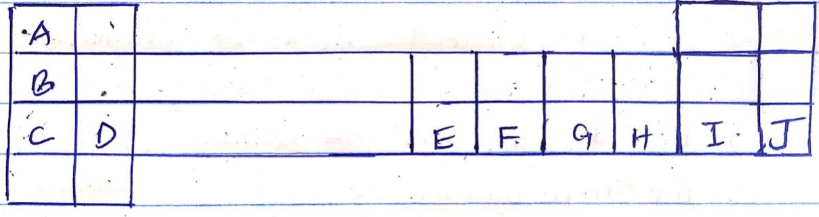

a) Give the names of the families to which;
i) A belongs …………………………………………………………………………… (1mks)
ii) I belongs ………………………………………………………………………….. (1 mks)
b) Write the electron arrangement of E ……………………………………………………………………………..(1mk)
c) Select an element that forms an ion with a charge of 2+ …………………………….. (1mk)
d) Using dots (.) or crosses (x) to represent electrons draw the atomic structure of the atom of F (2mks)

e) Select an element that will react rapidly with cold water (1mk)
…………………………………………………………………………………………………………………………………………………………………
10. use dots(.) and crosses (x) to draw a structure of ammonia molecule, NH₃ (2mks)

11 i) define the following terms:
a) Normal salt (1mk)
……………………………………………………………………………………………………………………………………………………………………………………………………………………………………………………………………………………………………………………………………

b) Acid salt (1mk)
……………………………………………………………………………………………………………………………………………………………………………………………………………………………………………………………………………………………………………………………………
c) A saturated solution (1mk)
ii) Name a process that occurs when anhydrous calcium chloride is left in an open beaker overnight a solution is formed. (1mk)
……………………………………………………………………………………………………………………………………………………………….

