NAME: ___________________________________________ADM NO: __________CLASS: ________
DATE: ______________________________ SIGN: _______________________
FORM TWO BIOLOGY
TERM 3 2025
OPENER EXAMINATION
TIME: 1 ¼ HOURS

INSTRUCTIONS: Answer all the questions in the spaces provided TIME: 1 HR 15 MIN
- A doctor performing an operation cut two blood vessels by mistake. He notices that from one of the blood vessels blood spurts out while from the other blood flows out smoothly.
(a) Identify the type of each blood vessel in which; (2 marks)
(i) Blood spurts out
…………………………………………………………………………………………………………………………………………………………………………………………………………………………………………
(ii) Blood flows smoothly
…………………………………………………………………………………………………………………………………………………………………………………………………………………………………………
(b) Give a reason for your answer in (a) above. (2 marks)
………………………………………………………………………………………………………………………………………………………………………………………………………………………………………………………………………………………………………………………………………………………………
- An individual is of blood group B Positive
- Name the antigens in the individual’s blood. (2 marks)
………………………………………………………………………………………………………………………………………………………………………………………………………………………………………………………………………………………………………………………………………………………………
- Give a reason why the individual cannot receive blood from a blood group A donor. (2 marks)
………………………………………………………………………………………………………………………………………………………………………………………………………………………………………………………………………………………………………………………………………………………………
- Name the blood vessel that; (3 marks)
- Supplies oxygenated blood to the liver
…………………………………………………………………………………………………………………………………………………………………………………………………………………………………………
- Transports blood from the heart to the lungs
…………………………………………………………………………………………………………………………………………………………………………………………………………………………………………
- Supplies blood to the heart muscles
…………………………………………………………………………………………………………………………………………………………………………………………………………………………………………
- (i) Name the compound formed when carbon (ii) oxide combines with haemoglobin. (1 mark)
…………………………………………………………………………………………………………………………………………………………………………………………………………………………………………
(ii) Why would the compound named in (a) above lead to death. (2 marks)
………………………………………………………………………………………………………………………………………………………………………………………………………………………………………………………………………………………………………………………………………………………………
- Name the disorder of the mammalian circulatory system that specifically affect; (2 marks)
- Arteries
……………………………………………………………………………………………………………………
- Veins
……………………………………………………………………………………………………………………
- State three sites of gaseous exchange in mesophytes. (3 marks)
………………………………………………………………………………………………………………………………………………………………………………………………………………………………………………………………………………………………………………………………………………………………
- Apart from the lungs, name two gaseous exchange surfaces in a frog (2 marks)
………………………………………………………………………………………………………………………………………………………………………………………………………………………………………………………………………………………………………………………………………………………………
- Explain why respiratory surfaces need to be thin and moist. (2 marks)
………………………………………………………………………………………………………………………………………………………………………………………………………………………………………………………………………………………………………………………………………………………………
- State three functional differences between arteries and veins. (3 marks)
……………………………………………………………………………………………………………………………………………………………………………………………………………………………………………………………………………………………………………………………………………………………………………………………………………………………………………………………………………………
- (i) State the respiratory surface in amoeba. (1 mark)
……………………………………………………………………………………………………………………
(ii) Explain why diffusion alone is adequate for gaseous exchange in amoeba (2 marks)
………………………………………………………………………………………………………………………………………………………………………………………………………………………………………………………………………………………………………………………………………………………………
- Give a reason for the following features present in human trachea
(i) Ring of cartilage. (1 mark)
……………………………………………………………………………………………………………………
(ii) Presence of cilia. (1 mark)
……………………………………………………………………………………………………………………
- Name two structures for gaseous exchange in aquatic plants. (2 marks)
…………………………………………………………………………………………………………………………………………………………………………………………………………………………………………
- The diagram below shows part of the mammalian breathing system. Study it and answer the questions that follow.
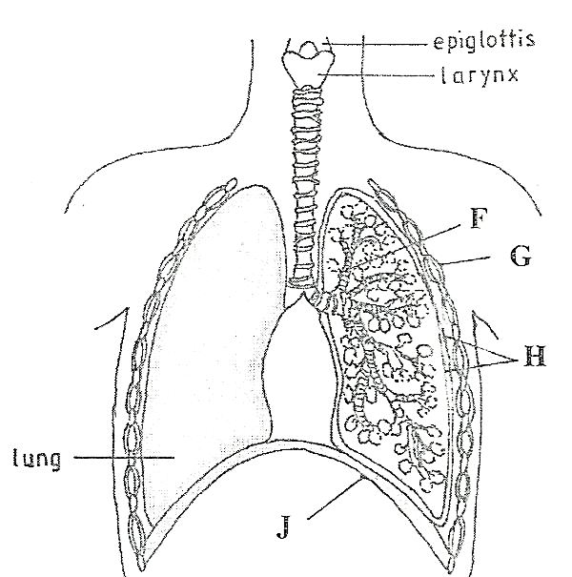

(a) Name the parts labeled F and G. (2 marks)
F - ………………………………………………………………………………………………….
G- ………………………………………………………………………………………………….
(b) State one function of each of the parts labeled H and J (2 marks)
H - ………………………………………………………………………………………………..
J- ………………………………………………………………………………………………….
- Study the flow chart below which represents a physiological process in mammals
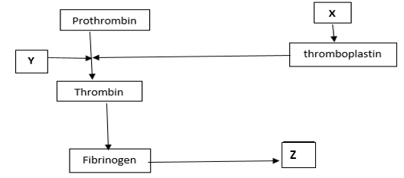
(i) Name the blood component represented by X. (1 mark)
…………………………………………………………………………………………………………………
(ii) What is the significance of product represented by Z. (2 marks)
…………………………………………………………………………………………………………………………………………………………………………………………………………………………………………
(iii) Under what condition is thrombokinase released by the platelets? (1 mark)
………………………………………………………………………………………………………………..
15. Explain how the following theory explain the opening of the stomata
(a) The photosynthetic theory (4 marks)

(b) The pH theory. (4 marks)

