BIOLOGY
FORM: 2
TERM 3 2025
OPENER EXAMINATION
TIME: 1 ¼ HOURS

INSTRUCTIONS: Answer all the Questions TIME: 1 HR 15 MIN
- A doctor performing an operation cut two blood vessels by mistake. He notices that from one of the blood vessels blood spurts out while from the other blood flows out smoothly.
(a)Identify the type of each blood vessel in which;(2marks)
(i)Blood spurts out-Artery
(ii)Blood flows smoothly-Vein
(b)Give a reason for your answer in (a) above(2marks)
Blood spurts out of the artery because of high pressure and pumping of the heart.
Blood flows smoothly in a vein because blood is under low pressure because of the resistance at the capillaries.
- An individual is of blood group B Positive
(i)Name the antigens in the individual’s blood(2marks)
Antigen B
Antigen D/Rhesus antigen/Rhesus factor
(ii)Give a reason why the individual cannot receive blood from a blood group A donor(2marks)
This individual has antibody a in the blood plasma which corresponds with Antigen A in the donor’s blood, hence there will be antigen-antibody reaction/agglutination.
- Name the blood vessel that;(3marks)
(i)Supplies oxygenated blood to the liver
Hepatic artery
(ii)Transports blood from the heart to the lungs
Pulmonary artery
(iii)Supplies blood to the heart muscles
Coronary artery
- (i) Name the compound formed when carbon (ii) oxide combines with haemoglobin(1mark)
Carboxyhaemoglobin
(ii)Why would the compound named in (a) above lead to death(2marks)
It is stable /does not easily dissociate and hemce lowers efficiency of haemoglobin to carry oxygen.
- Name the disorder of the mammalian circulatory system that specifically affect;(2marks)
(i)Arteries
Arterioscelerosis
(ii)Veins
Varicose veins
- State three sites of gaseous exchange in mesophytes(3marks)
Stomata
Lenticels
Cuticle
- Apart from the lungs, name two gaseous exchange surfaces in a frog(2marks)
Buccal cavity
Skin
- Explain why respiratory surfaces need to be thin and moist(2marks)
Thin-to reduce the diffusion distance.
Moist-to dissolve respiratory gases.
- State three functional differences between arteries and veins(3marks)
Arteries | Veins
Carry blood away from the heart | Carry blood towards the heart
Blood flows rapidly under high pressure | Blood flows slowly under low pressure
Carry oxygenated blood except pulmonary artery | Carry deoxygenated blood except the pulmonary vein
Blood flows in pulses | Blood flows smoothly with no pulses

- (i)State the respiratory surface in amoeba(1mark)
Cell membrane
(ii)Explain why diffusion alone is adequate for gaseous exchange in amoeba (2marks)
Most protozoans are single celled hence have a large surface area to volume ratio;
They live in water/moist environment and their body is in contact with the surrounding water;
Oxygen in the water diffuses into the body of the protozoans while carbon (iv) oxide diffuses out into the surrounding water;
- Give a reason for the following features present in human trachea
(i) Ring of cartilage(1mk)
to keep it open / provide mechanical strength
(ii)Presence of cilia(1mk)
to propel dust / bacteria / mucus out of trachea
- Name two structures for gaseous exchange in aquatic plants. (2mks)
Aerenchyma
Pneumatophores
- The diagram below shows part of the mammalian breathing system. Study it and answer the questions that follow.
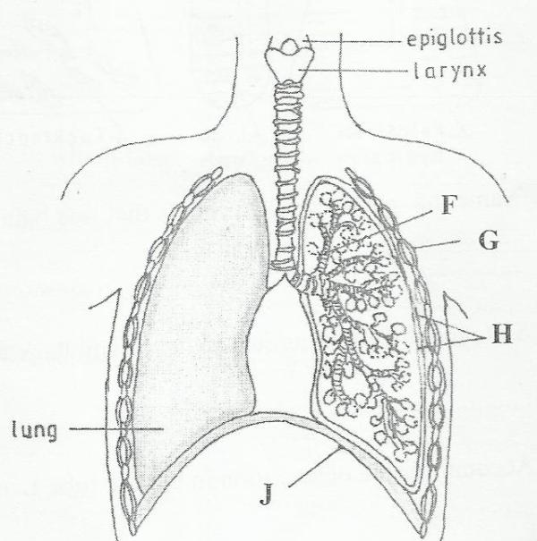

(a) Name the parts labeled F and G. (2 marks)
F -bronchiole
G- Internal intercostal muscles
(b) State one function of each of the parts labeled H and J (2 marks)
H - (Pleural membranes) secrets/encloses pleural fluid to lubricate/protect lungs
J- (Diaphragm) separates chest cavity from abdominal cavity/work to effect volume/pressure changes in chest cavity necessary for inhalation and exhalation
- Study the flow chart below which represents a physiological process in mammals

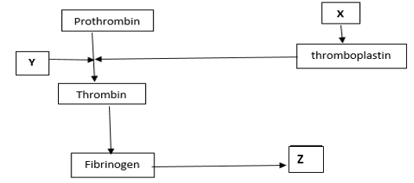
(i)Name the blood component represented by X. (1mk)
Platelets
(ii) What is the significance of product represented by Z. (2mks)
Forms a clot that prevents excessive bleeding/prevents entry of pathogens (iii) under what condition is thrombokinase released by the platelets? (1mk)
When platelets are exposed to air;/ When platelets clump together and adhere to the wall of damaged blood vessel.
15. Explain how the following theory explain the opening of the stomata
(a)The photosynthetic theory (4marks)
During the day photosynthesis takes place in the guard cells producing sugar/glucose. Glucose is osmoticaly active and its accumulation in the guard cells increases the osmotic pressure of the guard cells. The guard cells draw water from the adjacent epidermal cells, become turgid and bulge outward opening the stomata.
(b)The pH theory.(4marks)
During the day photosynthesis takes place in the guard cells using up carbon (iv) oxide.The pH of the guard cells rises favoring conversion of starch to glucose. Glucose is osmotically active and increases the osmotic pressure of the guard cells. The guard cells draw water from the adjacent epidermal cells, become turgid and bulge outward opening the stomata.

