NAME……………………….……………………………………………CLASS……….ADM:..................
DATE…………………………….………………………………. SIGNATURE…………………..............
FORM TWO AGRICULTURE
TERM 3 2025
OPENER EXAMINATION
TIME: 1 ¼ HOURS
ANSWER ALL THE QUESTIONS IN THE SPACES PROVIDED

- Define the following terms.
Seed dressing. (1 mark)
…………………………………………………………………………………………………………………………………………………………………………………………………………………………………………………………………………………………………………………………
Chitting (1 mark)
…………………………………………………………………………………………………………………………………………………………………………………………………………………………………………………………………………………………………………………………
- The diagram below represents a field management practice carried out on crops.
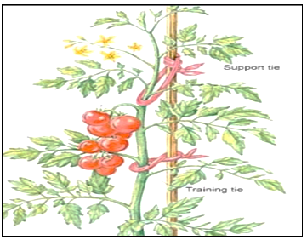
  - Identify the above practice (1 mark)
…………………………………………………………………………………………………………………………………………………………………………………………………………………………………………………………………………………………………………………………
  - Name one crop the practice is commonly practiced on (1 mark)
…………………………………………………………………………………………………………………………………………………………………………………………………………………………………………………………………………………………………………………………
  - Give two reasons for carrying out the above practice (2 marks)
…………………………………………………………………………………………………………………………………………………………………………………………………………………………………………………………………………………………………………………………
- List four human factors that influence agriculture (2 marks)
…………………………………………………………………………………………………………………………………………………………………………………………………………………………………………………………………………………………………………………………………………………………………………………………………………………………………………………………………………………………………………………………………………………………………………………………………………………………………………………………………………………………………………………………………………………………………………………………………………………
- Give four reasons for treating water for use on the farm (2 marks)
…………………………………………………………………………………………………………………………………………………………………………………………………………………………………………………………………………………………………………………………………………………………………………………………………………………………………………………………………………………………………………………………………………………………………………………………………………………………………………………………………………………………………………………………………………………………………………………………………………………
- State four precautions that should be observed when using workshop tools (2 marks)
…………………………………………………………………………………………………………………………………………………………………………………………………………………………………………………………………………………………………………………………………………………………………………………………………………………………………………………………………………………………………………………………………………………………………………………………………………………………………………………………………………………………………………………………………………………………………………………………………………………
- Give four reasons why burning is discouraged as a method of land clearing (2 marks)
…………………………………………………………………………………………………………………………………………………………………………………………………………………………………………………………………………………………………………………………………………………………………………………………………………………………………………………………………………………………………………………………………………………………………………………………………………………………………………………………………………………………………………………………………………………………………………………………………………………
- Name four practices that enhance minimum tillage (2 marks)
…………………………………………………………………………………………………………………………………………………………………………………………………………………………………………………………………………………………………………………………………………………………………………………………………………………………………………………………………………………………………………………………………………………………………………………………………………………………………………………………………………………………………………………………………………………………………………………………………………………
- Give two sources of underground water (1 marks)
………………………………………………………………………………………………………………………………………………………………………………………………………………………………………………………………………………………………………………………………………………………………………………………………………………………………………………………………………………………
- State four characteristics of a fertile soil (2 marks)
…………………………………………………………………………………………………………………………………………………………………………………………………………………………………………………………………………………………………………………………………………………………………………………………………………………………………………………………………………………………………………………………………………………………………………………………………………………………………………………………………………………………………………………………………………………………………………………………………………………
- Name four breeds of dairy goats (2 marks)
…………………………………………………………………………………………………………………………………………………………………………………………………………………………………………………………………………………………………………………………………………………………………………………………………………………………………………………………………………………………………………………………………………………………………………………………………………………………………………………………………………………………………………………………………………………………………………………………………………………
- Name two types of Inventory records (1 mark)
………………………………………………………………………………………………………………………………………………………………………………………………………………………………………………………………………………………………………………………………………………………………………………………………………………………………………………………………………………………
- List four symptoms of Nitrogen deficiency in plants (2 marks)
…………………………………………………………………………………………………………………………………………………………………………………………………………………………………………………………………………………………………………………………………………………………………………………………………………………………………………………………………………………………………………………………………………………………………………………………………………………………………………………………………………………………………………………………………………………………………………………………………………………
- Name two vegetative materials used to propagate pineapples (1 mark)
………………………………………………………………………………………………………………………………………………………………………………………………………………………………………………………………………………………………………………………………………………………………………………………………………………………………………………………………………………………
- Outline four factors considered when selecting a nursery site (2 marks)
…………………………………………………………………………………………………………………………………………………………………………………………………………………………………………………………………………………………………………………………………………………………………………………………………………………………………………………………………………………………………………………………………………………………………………………………………………………………………………………………………………………………………………………………………………………………………………………………………………………
- State four characteristics of a good grain store (2 marks)
…………………………………………………………………………………………………………………………………………………………………………………………………………………………………………………………………………………………………………………………………………………………………………………………………………………………………………………………………………………………………………………………………………………………………………………………………………………………………………………………………………………………………………………………………………………………………………………………………………………
- Study the diagram below and answer the following questions.
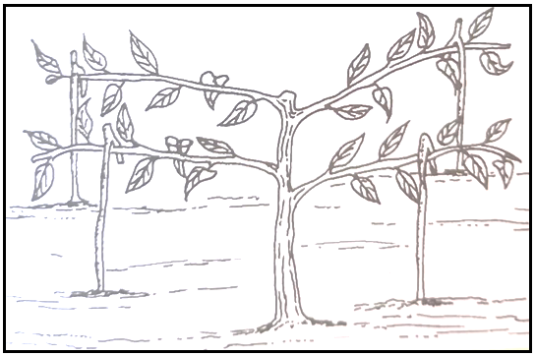

a. Identify the practice above. (1 mark)
…………………………………………………………………………………………………………………………………………………………..
State two reasons for carrying out the practice above. (2 marks)
…………………………………………………………………………………………………………………………………………………………………………………………………………………………………………………………………………………………………………………………………………………………………………………………………………………………………………………………………………………………………………………………………………………………………………………………………………………………………………………………………………………………………………………………………………………………………………………………………………………
- The diagram below shows an experiment set up using soil types G, H and J.
Observations were made after 24hrs. Study the diagram and answer questions that follow.
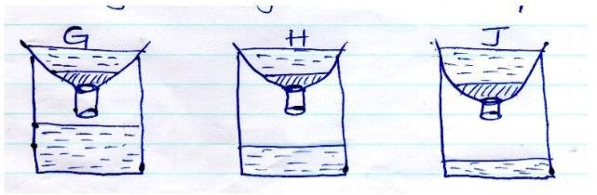
- What is the experiment above designed to study? (1 mark)
…………………………………………………………………………………………………………………………………………………………..
- Name the three soil types G, H and J. (3 marks)
…………………………………………………………………………………………………………………………………………………………………………………………………………………………………………………………………………………………………………………………………………………………………………………………………………………………………………………………………………………………………………………………………………………………………………………………………………………………………………………………………………………………………………………………………………………………………………………………………………………
- Explain how the farmer can improve soil type G. (1 mark)
……………………………………………………………………………………………………………………………………………………………
- a) State the factors that determine the stage and time of harvesting crops. (5 marks)
……………………………………………………………………………………………………………………………………………………………………………………………………………………………………………………………………………………………………………………………………………………………………………………………………………………………………………………………………………………………………………………………………………………………………………………………………………………………………………………………………………………………………………………………………………………………………………………………………………………………………………………………………………………………………………………………………………………………………………..…………………………………………………………………………………………………………………………………………………………………………………………………………………………………………………………………………………………………………………………
- state four methods of harvesting crops (4 marks)
…………………………………………………………………………………………………………………………………………………………………………………………………………………………………………………………………………………………………………………………………………………………………………………………………………………………………………………………………………………………………………………………………………………………………………………………………………………………………………………………………………………………………………………………………………………………………………………………………………………
- Outline four importance of pruning in coffee production. (4 marks)
…………………………………………………………………………………………………………………………………………………………………………………………………………………………………………………………………………………………………………………………………………………………………………………………………………………………………………………………………………………………………………………………………………………………………………………………………………………………………………………………………………………………………………………………………………………………………………………………………………………

