Candidate’s Name |  | Assessment Number
School Name |  | School Code
Candidate’s Signature |  | Date

MONITORING JUNIOR SCHOOL LEARNER PROGRESS
GRADE 9: PRETECHNICAL STUDIES.
PAPER 1. (Theory)
CODE: 009 YEAR: 2025
TIME: 1 hour 40 minutes
INSTRUCTIONS TO CANDIDATES
- Write your name and assessment number in the spaces provided above.
- Write the name and code of your school in the spaces provided above.
- Sign and write the date of the assessment in the spaces provided above.
- This paper consists of two sections: A and B.
- Section A comprises Multiple Choice Questions.
- Section B comprises Short Structured questions.
- Answer ALL the questions in section A on the separate ANSWER SHEET provided.
- Answer ALL the questions in section B in the spaces provided in this question paper.
- Do not remove any page from this question paper.
- Answer all questions in English.
For official use only

SECTION A: MULTIPLE CHOICE QUESTIONS (30 Marks)
Question Number | 1 | 2 |  | 3 | 4 |  | 5 | 6 | 7 |  | 8 | 9 | 10 | 11 | 12 | 13 | 14 | 15
Maximum Score | 1 | 1 |  | 1 | 1 |  | 1 | 1 | 1 |  | 1 | 1 | 1 | 1 | 1 | 1 | 1 | 1
Candidate’s Score
Question Number | 16 |  | 17 |  |  | 18 |  | 19 |  | 20 |  | 21 | 22 | 23 | 24 | 25 | 26 | 27 | 28 | 29 | 30 | Total score
Maximum Score | 1 |  | 1 |  |  | 1 |  | 1 |  | 1 |  | 1 | 1 | 1 | 1 | 1 | 1 | 1 | 1 | 1 | 1 | 30
Candidate’s Score

SECTION B: STRUCTURED QUESTIONS. (50 Marks)
Section | Question | Candidate's Score | Max Score
A | 1-30 |  | 30
B | Task 1 |  | 25
 | Task 2 |  | 12
 | Task 3 |  | 13
TOTAL |  |  | 80

This paper consists of 6 printed pages. Candidates should check the question paper to ascertain that all the pages are printed as indicated and that no questions are missing.
© 2025 The Kenya Junior School Examination and Assessment Series. Turn over

SECTION A: (30 Marks)
Choose the most appropriate answer in each question.

- Mary wants to start a bakery business. Which economic resource is her oven an example of?
A. Labour
B. Land
C. Capital
D. Enterprise
- A computer virus that tricks users into opening dangerous files is known as:
A. Phishing
B. Worm
C. Trojan
D. Firewall
- Which of the following is not a metallic material?
A. Steel
B. Aluminium
C. Brass
D. Rubber
- Which type of projection is used to draw a 3D object slanted at 45 degrees?
A. Isometric
B. Oblique
C. Orthographic
D. Perspective
- Which raised platform is used for performing repair and inspection work on tall machines?
A. Catwalk
B. Scaffolding
C. Ladder
D. Ramp
- The line used to show dimensions on a drawing is:
A. Centre line
B. Dimension line
C. Hidden line
D. Cutting plane line
- Which component stores programs and data for long-term use?
A. RAM
B. CPU
C. Hard Disk
D. ROM
- A main reason for seasoning wood is to:
A. Improve smell
B. Reduce cost
C. Remove moisture
D. Make it darker
- Which of these is not a principle of freehand sketching?
A. Accuracy
B. Proportion
C. Roughness
D. Neatness
- A businessman who sees a market gap and quickly starts a business is showing:
A. Dishonesty
B. Opportunity grabbing
C. Innovation
D. Risk avoidance
- Which software would best help a student create a poster?
A. Excel
B. Scratch
C. Word
D. Publisher
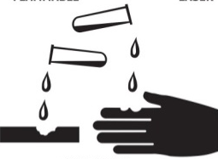
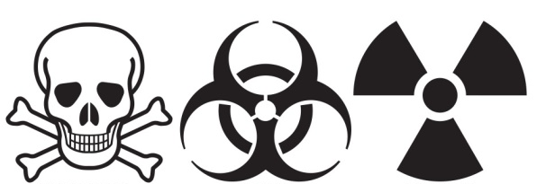
- Which of the following symbols is found on poisonous substances?

A B C D
- Which factor is most important when selecting a communication channel?
A. The sender’s age
B. Type of message
C. Colour of message
D. Number of letters
- Which waste type is most common in offices with many printers?
A. Glass
B. E-waste
C. Metal
D. Organic
- Amina started a salon business. In the month of June, her records showed the following:
Item | Amount (Ksh)
Revenue from services | 85,000
Wages paid | 25,000
Rent | 15,000
Electricity bill | 5,000
Hair products used | 10,000
What was Amina’s profit or loss for the month of June?
A. Ksh 30,000 B. Ksh 45,000
C. Ksh 20,000 D. Ksh 50,000
- What is the reward for capital in business?
A. Rent
B. Salary
C. Interest
D. Profit
- A tool used for driving nails into wood is a:
A. Clamp
B. Hammer
C. Plane
D. Chisel
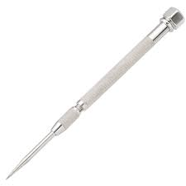
- A tool used to hold wood in place when working is:

A

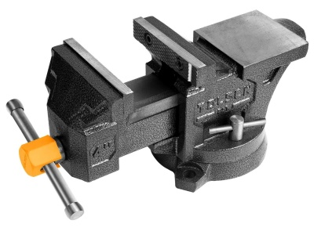

B

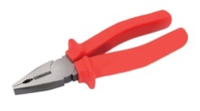
C
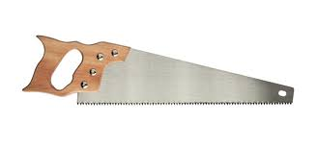

D

- The classification of computers by size includes all except:
A. Mainframe
B. Supercomputer
C. Gaming PC
D. Microcomputer
- Bronze is a mixture of:
A. Copper and Tin
B. Iron and Nickel
C. Steel and Zinc
D. Lead and Aluminium
- What is the main use of a plain scale?
A. Weighing materials
B. Cleaning tools
C. Measuring distances
D. Sharpening blades
- One characteristic of softwoods is that they:
A. Are from broad-leaf trees
B. Grow slowly
C. Are mostly found in Kenya
D. Have needle-like leaves
- One importance of ICT tools in communication is:
A. Slows delivery
B. Makes records manual
C. Enhances message speed
D. Increases travel needs
- Which of the following tools is used in freehand sketching?
A. Tape
B. Pencil
C. Divider
D. Hammer
- One ethical practice in production is:
A. Using child labour
B. Overpricing items
C. Selling defective goods
D. Honest advertising
- One use of money is to:
A. Reduce shopping
B. Exchange goods and services
C. Store taxes
D. Replace banks
- A simple budget helps a person to:
A. Avoid saving
B. Spend recklessly
C. Manage income and expenses
D. Increase loss
- What is one importance of entrepreneurship?
A. Increases laziness
B. Creates employment
C. Reduces business ideas
D. Increases debt
- An example of a government tax in Kenya is:
A. VAT
B. Loan
C. Bonus
D. Donation
- One use of oblique projection is in:
A. Writing novels
B. Making 3D drawings
C. Producing cement
D. Banking reports

SECTION B: STRUCTURED QUESTIONS (50 Marks)
Answer all questions in the spaces provided.
- Your class has been asked to build a display platform using wood.
a) Name two types of wood used in Kenya. (2 marks)

i. ……………………………………………

ii ……………………………………………
b) State two uses of hard wood. (2 marks)

i. ………………………………………………………………………………………………………………………

ii …………………………………………………………………………………………...…………………………
c) Explain why seasoning of wood is important. (1 mark)

……………………………………………………………………………………………………………………….

……………………………………………………………………………….……………………………………….
- You are tasked with creating a technical drawing of a table.
a) Name these types of lines used in technical drawing. (3 marks)
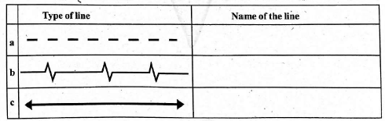
b) Define the following:
i. Linear dimensioning
………………………………………………………………………………………………………………………
……………………………………………………………………………………………………………………..
ii. Angular dimensioning (2 marks)
…………………………………………………………………………………………………………………….
…………………………………………………………………………………………………………………….
- John wants to buy a computer.
a) Name two input devices and one output device. (3 marks)
Input device | Output device
b) List two characteristics of computers. (2 marks)
i. ………………………………………………………………………………………………………………………

ii …………………………………………………………………………………………...…………………………
- Your class is exploring different types of communication.
a) List two forms of communication. (2 marks)
i. ……………………………………………………………………………………………………………………
ii ………………………………………………………………………………………...…………………………
b) Identify two ICT tools used in communication. (2 marks)
i. ………………………………………………………………………………………………………………………

ii …………………………………………………………………………………………...…………………………
- A family is preparing a monthly financial plan.
a) Prepare a simple budget showing income, expenses and savings. (3 marks)

b) State two reasons for creating a personal budget. (2 marks)
i. ………………………………………………………………………………………………………………………

ii …………………………………………………………………………………………...…………………………
- The school workshop was recently reorganized.
a) Mention two physical threats in a workshop. (2 marks)
i. ………………………………………………………………………………………………………………………
ii …………………………………………………………………………………………...…………………………
b) Identify two ways of preventing fire accidents. (2 marks)
i. ………………………………………………………………………………………………………………………

ii …………………………………………………………………………………………...…………………………
- Your class is discussing entrepreneurship.
a) Give two qualities of a good entrepreneur. (2 marks)
i. ………………………………………………………………………………………………………………………

ii …………………………………………………………………………………………...…………………………
b) List two sources of business ideas. (2 marks)
i. ………………………………………………………………………………………………………………………

ii …………………………………………………………………………………………...…………………………
- During a clean-up exercise, students found many e-wastes.
a) Define e-waste. (1 mark)
……………………………………………………………………………………………………………………….
.......................................................................................................................................................................................
b) List three types of hazardous wastes. (3 marks)
i. ………………………………………………………………………………………………………………………

ii …………………………………………………………………………………………...…………………………

iii. ……………………………………………………………………………………………………………………
- During ICT lessons, students used Scratch software.
a) What is visual programming? (2 marks)
i. ………………………………………………………………………………………………………………………

ii …………………………………………………………………………………………...…………………………
b) Give two benefits of using Scratch in learning. (2 marks)
i. ………………………………………………………………………………………………………………………

ii …………………………………………………………………………………………...…………………………
- A local SACCO offers several services.
a) Name two services provided by financial institutions. (2 marks)
i. ………………………………………………………………………………………………………………………

ii …………………………………………………………………………………………...…………………………
b) State two roles of government in protecting consumers. (2 marks)
i. ………………………………………………………………………………………………………………………

ii …………………………………………………………………………………………...…………………………

THIS IS THE LAST PRINTED PAGE.

