Candidate’s Name |  | Assessment Number
School Name |  | School Code
Candidate’s Signature |  | Date

MONITORING JUNIOR SCHOOL LEARNER PROGRESS
GRADE 9: INTEGRATED SCIENCE
PAPER 1 (Theory)
CODE: 009 YEAR: 2025
TIME: 2 HOURS
INSTRUCTIONS TO CANDIDATES
- Write your name and assessment number in the spaces provided above.
- Sign and write the date of the assessment in the spaces provided above.
- This paper consists of two sections: A and B.
- Section A comprises Multiple Choice Questions numbered 1 to 30.
- Section B comprises short, structured questions number 31 to 40.
- Answer ALL the questions in section A on the separate ANSWER SHEET provided.
- Answer ALL the questions in section B in the spaces provided in this QUESTION PAPER.
- Do NOT remove any page from this question paper.
- Answer ALL the questions in English.

For Official Use Only

SECTION A: (30 MARKS)
Question Number | 1 | 2 | 3 | 4 | 5 | 6 | 7 | 8 | 9 | 10 | 11 | 12 | 13 | 14 | 15 | 16 | 17 | 18 | 19 | 20
Maximum Score | 1 | 1 | 1 | 1 | 1 | 1 | 1 | 1 | 1 | 1 | 1 | 1 | 1 | 1 | 1 | 1 | 1 | 1 | 1 | 1
Candidate’s Score

Question Number | 21 | 22 | 23 | 24 | 25 | 26 | 27 | 28 | 29 | 30
Maximum Score | 1 | 1 | 1 | 1 | 1 | 1 | 1 | 1 | 1 | 1
Candidate’s Score

SECTION B: (40 MARKS)
Task | 31 | 32 | 33 | 34 | 35 | 36 | 37 | 38 | 39 | 40 | Total B | Section A | TOTAL (A + B)
Score per Question | 3 | 3 | 4 | 4 | 4 | 5 | 5 | 4 | 4 | 4
Maximum Score | 3 | 3 | 4 | 4 | 4 | 5 | 5 | 4 | 4 | 4 | 40 | 30 | 70
Candidate’s Score
This paper consists of 16 printed pages. Candidates should check the question paper to ascertain that all the pages are printed as indicated and that no questions are missing.
© 2025 The Kenya Junior School Examination and Assessment Series. Turn over

SECTION A: (30 marks)
Answer ALL the questions in this section.

- In a community clean-water project, students used biology, chemistry, and physics. What is the benefit?
A. Memorization
B. Practical problem-solving
C. Focusing on exams
D. Limiting subjects
- During a science lesson, learners discussed chemical symbols of the following elements:

    - Hydrogen
    - Nitrogen
    - Aluminium
    - Silver
Which one of the following sets shows the correct chemical symbol for each of the elements?

 | Hydrogen | Nitrogen | Aluminium | Silver
A. | H | N | al | Si
B. | Hg | Na | AL | Si
C. | H₂ | N₂ | Al | Ag
D. | H | N | Al | Ag

- A chemical bottle shows a flame icon. What hazard?
A. Toxic
B. Flammable
C. Corrosive
D. Harmful
- During a class discussion on functions of the parts of the male reproductive system, learners identified functions of various parts of the system. The function of testes is to
  - produce hormones and sperms.
  - transport sperms only.
  - produce sperms only.
  - transport sperms and produce hormones.
- The diagram below was drawn by a learner to represent the female reproductive system with parts labelled K, L, M and N. Use the diagram to answer questions 14 and 15.
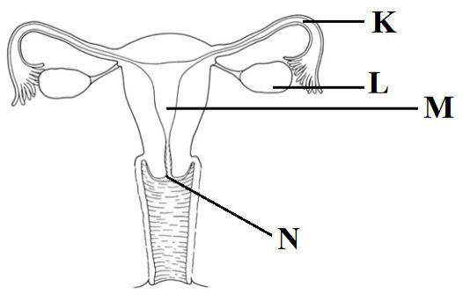

The part labelled N represents
  - cervix.
  - vagina.
  - uterus.
  - Oviduct
- Fertilization takes place at the part labelled
  - K.
  - L.
  - M.
  - N.
- During a class experiment on properties of magnets, a learner freely suspended a magnet as shown in the diagram below.
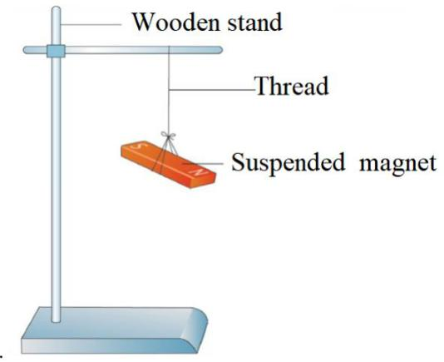

Which one of the following is the correct direction the bar magnet would be aligned to?
  - North East - South West.
  - East – West.
  - North – South.
  - North West - South East.
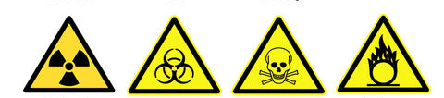
- During a laboratory lesson in school, learners were asked to identify Symbol indicating oxidizing substance. Which one is it?
A B C D
- Learners wanted to measure exactly 10 cm³ of acid, which apparatus will be used?
A. Beaker
B. Pipette
C. Measuring cylinder
D. Flask
- During a group discussion, learners listed the following as benefits of studying various subjects: to

  - understand nature;

  - strengthen one’s faith;

  - improve one’s behaviour;

  - solve problems in daily life.

Which two are the benefits of studying Integrated Science?
    - (i) and (ii)

    - (ii) and (iii)

    - (iii) and (iv)

    - (i) and (iv)
- The diagram below was drawn by a learner to show parts of the human urinary system with parts labelled P, Q, R and S. Use the diagram to answer questions 17 and 18.
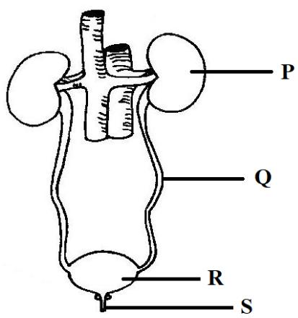

The part that stores urine temporarily is represented by letter

- P.

- Q.

- R.

- S.

- Substances in nature exist either as elements or compounds. During a lesson, learners classified substances into elements and compounds. Which one of the following pairs of substances consists only of compounds?

  - Copper and iron.

  - Iron and water.

  - Water and carbon dioxide.

  - Copper and carbon dioxide.

- In a class activity to classify mixtures, learners were given the following mixtures:

    - salt and sand;

    - sugar and water;

    - kerosene and water;

    - milk and water.

Which two of the mixtures are homogeneous?

  - (i) and (ii)

  - (ii) and (iv)

  - (i) and (iii)

  - (iii) and (iv)
- During a class discussion on metals and non-metals, learners were asked to classify the following elements:

    - Calcium;

    - Sulphur;

    - Phosphorus;

    - Sodium.
Which one of the following pairs of elements consists only of metals?
- (i) and (iv)

- (i) and (iii)

- (ii) and (iii)

- (ii) and (iv)

- The following are some changes that take place in day-to-day life:

  - water becoming ice;

  - fermenting of milk;

  - rusting of iron nails;

  - drying of wet clothes.

Which one of the following pairs consists only of physical changes?

  - (i) and (ii)

  - (ii) and (iii)

  - (iii) and (iv)

  - (i) and (iv)

- After a discussion on changes that take place in boys and girls during adolescence, a learner summarised the changes as shown in the table. Which one of the changes is correctly summarised?

 | Change in Boys | Change in Girls
A. | Hips become broad | Hips become broad
B. | Chest widens | Chest widens
C. | Breasts enlarge | Breasts enlarge
D. | Pubic hair grows | Pubic hair grows

- The human digestive system has various parts that perform different functions. In which one of the following parts of the system does the absorption of water take place?

- Stomach.

- Large intestine.

- Mouth.

- Small intestine.
The diagram below was drawn by a group of learners to represent the human skin with parts labelled T, U, V, W and X. Use the diagram to answer questions 18 and 19.
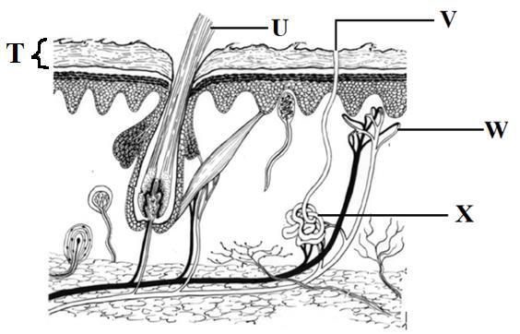

- The part of the skin that produces sweat is represented by letter

- U.

- V.

- W.

- X.
- Which one of the following is the function of the part represented by labelled T?

      - Protection against physical injury.

      - Insulation against heat loss.

      - Supply of blood.

      - Production of hair.

- Learners observed that water obtained from a nearby stream was not lathering easily with soap. They suggested the following as methods of making the water to lather easily:

    - boiling the water;

    - filtering the water;

    - adding washing soda.

Which of the methods suggested by the learners could be used to make the water lather easily?
- (i) and (ii).

- (ii) only.

- (i) and (iii).

- (iii) only.

- During a lesson, learners discussed applications of acids and bases. They listed the following applications: manufacture of

        - car batteries.

        - soft drinks.

        - Toothpaste.

        - baking powder.

Which one of the following pairs of the applications listed are for bases only?
  - (i) and (ii)

  - (ii) and (iii)

  - (iii) and (iv)

  - (i) and (iv)

- During a class discussion on appliances used in day-to-day life, learners listed the following appliances:

- Air conditioner

- Fireless cooker

- Thermos flask

- Washing machine
Which two of the listed appliances use electricity to perform their function?

  - (i) and (ii)

  - (ii) and (iii)

  - (i) and (iv)

  - (iii) and (iv)

- Curved mirrors are used in day today life for different purposes. Learners discussed and listed the following as applications of curved mirrors:

    - Security mirrors in supermarkets

    - Motor vehicle side mirrors

    - Car headlights

    - Solar cooker
Which two of the uses are correct only for convex mirrors?

- (iii) and (iv)

- (ii) and (iv)

- (i) and (iii)

- (i) and (ii)
- In an activity to identify magnetic and non-magnetic materials, learners put a certain object in a carton box and placed the box near a bar magnet as shown in the diagram below.

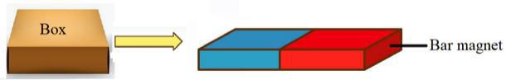

The box was observed to move in the direction shown by the arrow. The object inside the box was likely to have been

  - a silver coin.

  - an iron nail.

  - a gold ring.

  - a wooden rod.

- At adolescence, boys and girls may experience frequent changes in moods. The best advice for such adolescents would be to

  - be sleeping less.

  - avoid interactions.

  - do physical exercises regularly.

  - eat more energy giving foods.

- The function of the part represented by letter Q is to

  - filter salt and water.

  - filter waste products from blood.

  - provide temporary storage of urine.

  - provide passage of urine to the bladder.

- Human beings have different types of teeth. Each type has a unique structure suited for its functions. A learner observed a model of a human tooth that had sharp edges and was chisel shaped. The function of the tooth is likely to be

  - crushing.

  - cutting.

  - chewing.

  - tearing.

- A medical officer gave a talk on healthy lifestyles that promote kidney health. Which one of the following could not have been included in the talk as a healthy lifestyle that promotes kidney health?

  - Eating a balanced diet.

  - Drinking plenty of clean water.

  - Getting enough sleep.

  - Eating sugary foods.

- Learners classified sources of electricity into renewable and non-renewable sources. Which one of the following combinations of sources of electricity was correctly classified by the learners?

 | Renewable source | Non-renewable source
A. | Geothermal | Coal
B. | Wind | Hydroelectric
C. | Natural gas | Solar
D. | Tidal waves | Biomass

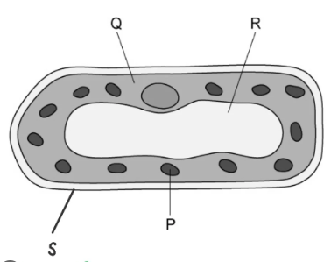
- Purity pointed a part in the cell known as the cytoplasm.the the image below, the cytoplasm has been labelled??

A.P
B. Q
C. R
D. S

SECTION B (40 marks)

Answer ALL the questions in this section.
Task 1: (10 Marks)
- A science teacher emphasizes the importance of safety in the laboratory.
a) State two general laboratory safety rules that students should always follow. (2 marks)
i. …………………………………………………………………………………………………………………...
ii. ………………………………………………………………………………….……………………………….
b) Describe the first aid procedure for a minor burn sustained in the laboratory. (2 marks)
i. ………………………………………………………………………………..…………………..……………..
ii. ………………………………………………………………………………………………….……………….
iii. ………………………………………………………………………….…………………….………………..
iv ………………………………………………………………………………………………………………….
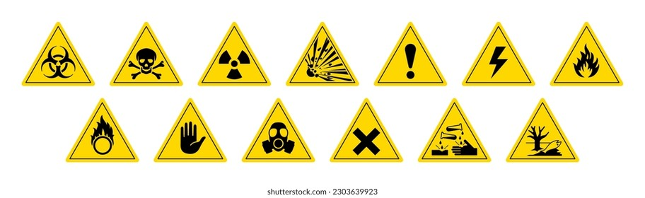
c) Identify the following laboratory hazard symbols. (1 mark)

A B

A. ……………………………………………
B. ……………………………………………

- You are given a cloudy mixture in a beaker. After some time, the solid particles settle at the bottom.
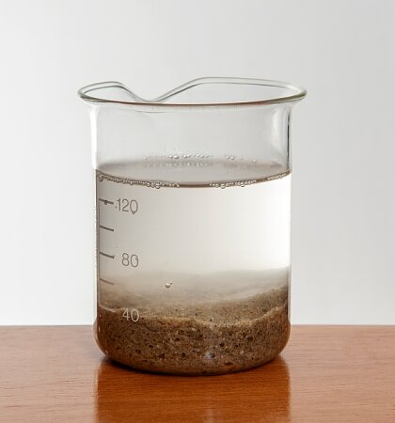
a) Identify this type of mixture and name the process by which the solid settles. (2 marks)
……………………………………………………………………………………………………….
b) Describe how you could separate the clear liquid from the settled solid in this mixture. (2 marks)
i. …………………………………………………………………………………………………………………...
ii. ………………………………………………………………………………….……………………………….
c) Give one example of such a mixture in everyday life. (1 mark)
i. …………………………………………………………………………………………………………………...
Task 2: (10 Marks)
- John is using a microscope to observe a prepared slide of plant cells.
a) Name two key differences between an animal cell and a plant cell that John might observe under the microscope. (2 marks)
Animal cell | Plant cell
b) Explain the role of the nucleus in a cell. (1 mark)
……………………………………………………………………………………………………………………….

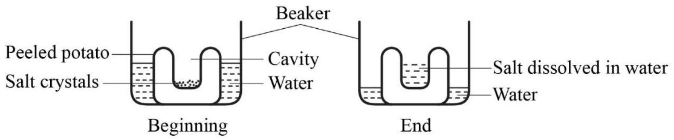
c) The diagrams below show a setup used by learners to demonstrate a certain process that takes place in living things.

Explain the observations made at the end of the demonstration. (2 marks)
…………………………………………………………………………………………………………………...
………………………………………………………………………………….……………………………….
- During a health talk, the challenges of adolescence are discussed. List two common physical changes that occur during adolescence in boys. (2 marks)
i. …………………………………………………………………………………………………………………...
ii. ………………………………………………………………………………….……………………………….
- During a nature walk to study adaptations of flowers to wind and insect pollination, learners observed a dull coloured flower with small petals.
(a) State the likely agent of pollination for the flower. (1 mark)

……………………………………………………………………………………………………………..

(b) State two other adaptations the learners may have observed on the flower. (2 marks)
i. …………………………………………………………………………………………………………………...
ii. ………………………………………………………………………………….……………………………….

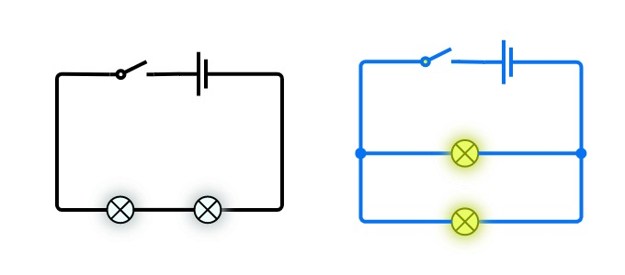
Task 3: (10 Marks)
- Two different simple circuits were set up as shown.

A B
a) What is the role of the battery in this circuit? (1 mark)
………………………………………………………………………………………………………………..
b) What is the type of bulb connection in set up B? (1 mark)
………………………………………………………………………………………………………………..
c) Name one common household appliance that uses an electric motor, which relies on the principles of magnetism. (1 mark)
………………………………………………………………………………………………………………
- You have two bars of metal. One is a permanent magnet, and the other is not magnetized.
a) Describe one way to determine which bar is the permanent magnet without using any other magnets. (2 marks)
…………………………………………………………………………………………………………………….
b) State two uses of permanent magnets. (2 marks)
i. …………………………………………………………………………………………………………………...
ii. ………………………………………………………………………………….……………………………….

c) Differentiate between a magnetic material and a non-magnetic material, giving one example of each. (2 marks)
…………………………………………………………………………………………………………………...
………………………………………………………………………………….……………………………….
…………………………………………………………………………………………………………………...
………………………………………………………………………………….……………………………….
Task 4: (10 Marks)
- In a chemistry class, students are learning about the structure of an atom and how elements are arranged.
a) Draw a diagram showing the electron arrangement for an atom with atomic number 12. (You do not need to draw the nucleus in detail, just represent the shells and electrons). (2 marks)

b) State whether this element is a metal or a non-metal, and give one reason for your answer based on its electron arrangement. (2 marks)

…………………….………………………………………………………………………………………………
……………………………………………………………….………………………….…………………………
c) Explain what an alloy is, and give one example of a common alloy. (2 marks)
…………………………………………………….………………..………………………………………………
………………………………………………………………………………………………………………………
- A household in an area with hard water is experiencing issues with soap lathering and scale buildup in their kettle.
a) Define "hard water". (1 mark)
……………………………………………………………………………………………………………………….
…………………………………………………………………………………………………………………………

b) Describe one method of removing temporary hardness from water. (2 marks)
…………………………………………………………………………………………………………………….
…………………………………………………………………………………………………………………….
c) State one disadvantage of using hard water for domestic purposes. (1 mark)
……………………………………………………………………………………………………………………
……………………………………………………………………………………………………………………

THIS IS THE LAST PRINTED PAGE.

