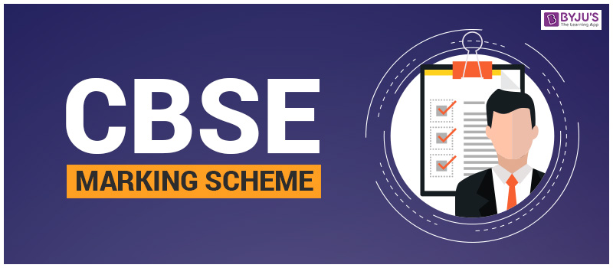
COMPETENCE BASED EDUCATION
GRADE 9
CODE: 009/2025
ENGLISH PP1



Question Number | Correct Answer
Section A: Reading Comprehension
1 | C
2 | C
3 | C
4 | B
5 | A
6 | C
7 | D
8 | B
9 | C
10 | D
11 | B
12 | C
13 | D
14 | C
15 | C
16 | C
17 | C
18 | B
19 | D
20 | A
Section B: Oral Skills
21 | C
22 | B
23 | D
24 | C
25 | C
Section C: Grammar
26 | A
27 | B
28 | A
29 | B
30 | A
31 | B
32 | B
33 | A
34 | A
35 | D
36 | C
37 | C
38 | D
39 | B
40 | C
41 | B
42 | A
43 | A
44 | C
45 | A
46 | B
47 | A
48 | C
49 | C
50 | C

THIS IS THE LAST PRINTED PAGE.

