Candidate’s Name |  | Assessment Number
School Name |  | School Code
Candidate’s Signature |  | Date
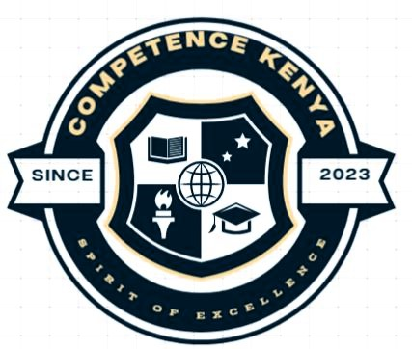
KENYA JUNIOR SCHOOL EDUCATION ASSESSMENT (KJSEA)
GR ADE 9: CREATIVE ARTS AND SPORTS
PAPER 1 (Project)
CODE: 009 YEAR: 2025
DURATION: 3 weeks

INSTRUCTIONS TO SCHOOLS
- This is a project paper to be done over a 3-weeks period.
- Teachers will assess each task based on the provided scoring rubrics.
- Each milestone should be marked and recorded for every learner as they progress.

This paper consists of 3 printed pages. Candidates should check the question paper to ascertain that all the pages are printed as indicated and that no questions are missing.
© 2025 The Kenya Junior School Examination and Assessment Series. Turn over

1. INTRODUCTION
This project is an integration of all components of the Creative Arts and Sports subject (Visual Arts, Performing Arts, and Physical Education). Learners will be assessed both individually and in groups, applying creativity, critical thinking, and collaboration skills.

2. PROJECT THEME: “Preserving Our Culture, Building Our Future”
As Kenya develops, we must keep our traditions alive while embracing modern creativity. Your class has been invited to host a "Cultural Heritage and Creativity Week". You are to showcase how youth can honour culture while building a better future through creative expression.

TASK 1: VISUAL ARTS – DESIGNING A CULTURAL LOGO AND MOTIF PATTERN
Individually:
a) Research patterns, symbols, and colours from any Kenyan community that reflect their cultural identity.
b) Design a logo that symbolizes your heritage and future dreams using pencil or digital tools.
c) Create a motif pattern based on the logo that can be used on clothes, school bags, or posters.
d) Add colour and label your work clearly.
e) Write a short paragraph explaining the meaning behind your logo and pattern.
Mount your work for display during Cultural Heritage Week.

TASK 2: PERFORMING ARTS – KENYAN DANCE FUSION
In groups of 6–10 learners:
a) Choose a traditional Kenyan folk dance (e.g., Isukuti, Taarab, Kikuyu dance) and combine it with a modern music or beat (fusion style).
b) Rehearse a 2–3 minute dance performance that incorporates both styles.
c) Include costumes, body movements, and at least one traditional instrument (or its improvised version).
d) Write a short description explaining:
- The origin of the traditional dance
- What modern elements were added
- What the fusion represents
e) Perform your fusion dance live during the school’s Cultural Heritage and Creativity Week.

TASK 3: PERFORMING ARTS – DRAMATIZED FOLKTALE
a) In groups of 4–6 learners, select a Kenyan folktale that teaches a cultural lesson (e.g., wisdom, unity, kindness).
b) Dramatise it using clear characters, props, costumes, and traditional sayings or songs.
c) Prepare a script with a beginning, conflict, and resolution.
d) Rehearse and perform the play before an audience of teachers, peers, or parents.
e) Each group must submit:
- A script
- A cast list
- Photos or short clips of rehearsal or performance

TASK 4: SPORTS – INDIGENOUS GAMES CHALLENGE
a) In pairs or teams, research and select a traditional game played by children in Kenya (e.g., Bladda, Shake, Kati, Bao).
b) Describe the rules and any items needed.
c) Use locally available materials to make equipment or playing areas for the game.
d) Play the game during school breaks or PE time and reflect on:
- Teamwork
- Physical benefits
- Fun/challenges
e) Prepare a short oral or written report explaining how the game promotes physical, social, and emotional well-being.

THIS IS THE LAST PRINTED PAGE

