Candidates Name |  | Assessment Number
School Name |  | School Code
Candidates Signature |  | Date
MONITORING JUNIOR SCHOOL LEARNER PROGRESS
GRADE 9: 906/1: AGRICULTURE AND NUTRITION
PAPER 1 (Theory)
CODE: 009 YEAR: 2025

TIME: 2 HOURS
INSTRUCTIONS TO CANDIDATES:
Instructions to Candidates:
- Write your name and assessment number in the spaces provided.
- Answer ALL questions in Section A and Section B.
- All answers must be written in the spaces provided in this question booklet.
- This paper consists of 12 printed pages. Candidates should check the question paper to ascertain that all pages are printed as indicated and that no questions are missing.
- Candidates should answer the questions in English.

For Official Use Only

SECTION A: MULTIPLE CHOICE QUESTIONS (30 Marks)
Question Number | 1 | 2 |  | 3 | 4 |  | 5 | 6 | 7 |  | 8 | 9 | 10 | 11 | 12 | 13 | 14 | 15
Maximum Score | 1 | 1 |  | 1 | 1 |  | 1 | 1 | 1 |  | 1 | 1 | 1 | 1 | 1 | 1 | 1 | 1
Candidates Score
Question Number | 16 |  | 17 |  |  | 18 |  | 19 |  | 20 |  | 21 | 22 | 23 | 24 | 25 | 26 | 27 | 28 | 29 | 30 | Total score
Maximum Score | 1 |  | 1 |  |  | 1 |  | 1 |  | 1 |  | 1 | 1 | 1 | 1 | 1 | 1 | 1 | 1 | 1 | 1 | 30
Candidates Score

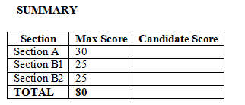
SECTION B: STRUCTURED QUESTIONS (50 Marks)
Section | Question Number | Total Marks
PART 1: AGRICULTURE |  | 25 Marks
 | 1 (a, b, c) | 10
 | 2 (a, b, c.i, c.ii) | 7
 | 3 (a, b.i, b.ii) | 8
PART 2: NUTRITION |  | 25 Marks
 | 4 (a, b.i, b.ii, c) | 10
 | 5 (a, b, c.i, c.ii) | 11
 | 6 (a, b, c.i, c.ii) | 5
GRAND TOTAL |  | 50 Marks

This paper consists of 11 printed pages. Candidates should check the question paper to ascertain that all the pages are printed as indicated and that no questions are missing.
© 2025 The Kenya Junior School Examination and Assessment Series. Turn over

SECTION A: (30 Marks)
Answer all questions in this section.

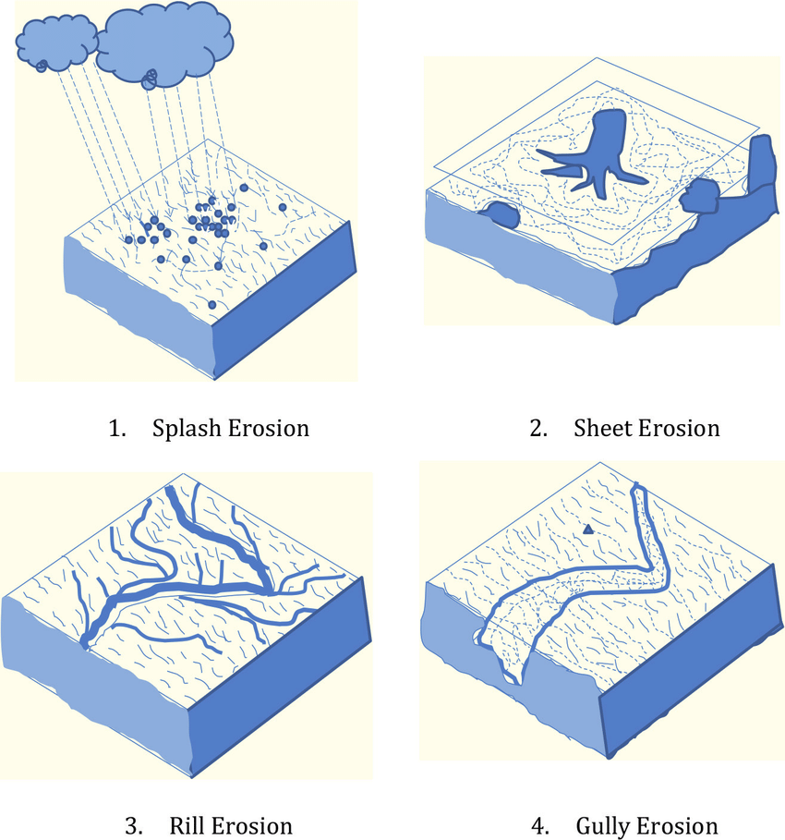
- A steep farm slope shows signs of deep, wide channels cut by concentrated water flow after heavy rains. These channels are difficult to cross with farm machinery. What type of soil erosion is evident in this situation?

A B

C D
- Mercy is planting carrot seeds in her kitchen garden. She knows that carrots require fine, loose soil for proper root development. What type of tilth is ideal for planting small seeds like carrots? A) Coarse tilth B) Cloddy tilth C) Fine tilth D) Lumpy tilth
- Mr. Kamau decided to plant Calliandra trees along the boundaries of his farm. He was informed that these trees would help in soil conservation. Besides providing fodder for his livestock, how do these trees primarily help in soil conservation? A) They increase soil salinity. B) Their roots bind the soil particles. C) They deplete groundwater. D) They attract pests to the soil.

- A poultry farmer is designing a new chicken house. He wants to ensure that the house is easy to clean and provides adequate space for his flock.
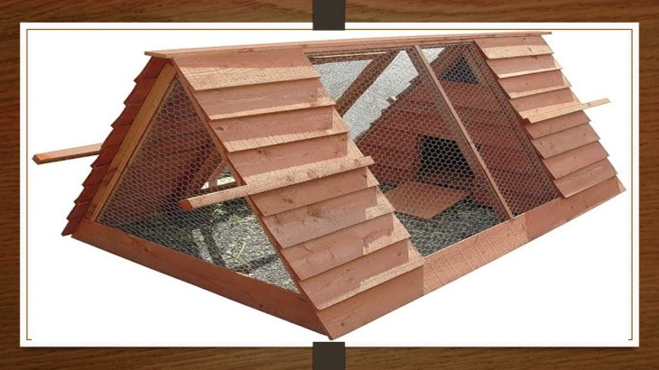
Which part of a poultry fold is primarily designed to provide proper drainage and ease of cleaning? A) Roosting perches B) Nest boxes C) Litter/floor material D) Feeders
- Sarah has a surplus of ripe bananas from her farm. She wants to add value to them to increase their shelf-life and market appeal.
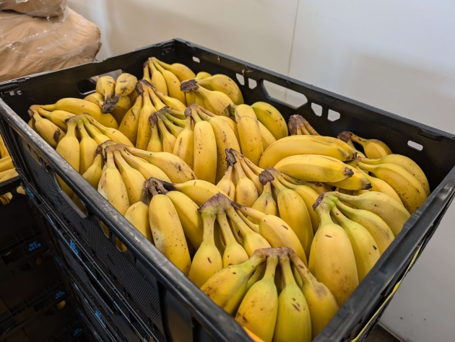
Which of the following value-addition processes is most suitable for ripe bananas? A) Selling them fresh to hawkers B) Turning them into banana crisps or flour C) Storing them in a warm place D) Feeding them to livestock

- The residents of a dry region are advised to harvest rainwater from their rooftops during the rainy season to supplement their water supply for domestic use and small-scale farming. Which of the following structures is most suitable for storing harvested rooftop water on a farm?
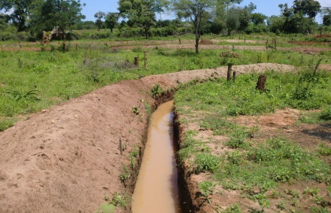
A

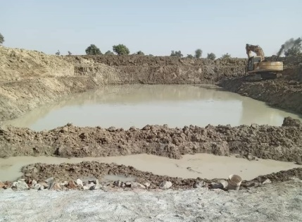

B

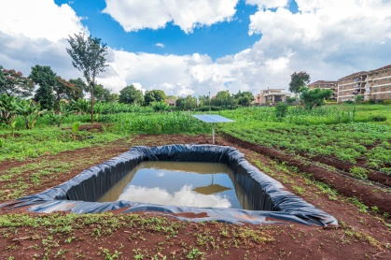

C

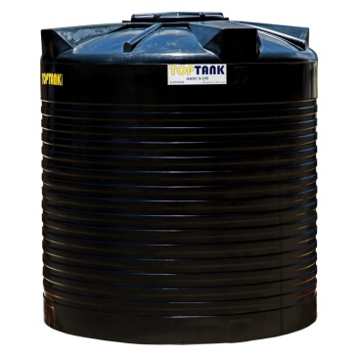

D

- A farmer observes his maize plants exhibiting yellowing leaves, especially the older ones, and stunted growth. He also notes a general weak appearance. These are common signs of a deficiency in which essential plant nutrient? A) Phosphorus B) Potassium C) Nitrogen D) Calcium
- Jane is preparing a meal for her family. She wants to cook beef while preserving its protein content and making it tender.
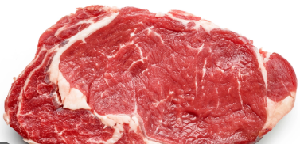
Which cooking method uses moist heat to tenderize tough cuts of meat and largely preserves nutrients? A) Frying B) Roasting C) Steaming D) Grilling
- A farmer observed stunted plant growth and discoloration in his crops, which were planted near a discarded battery recycling site. He suspects the soil is contaminated with heavy metals. What is the most likely cause of soil pollution in this situation? A) Organic fertilizer application B) Agricultural run-off C) Improper disposal of hazardous waste D) Excessive watering
- To improve soil fertility sustainably, a farmer is advised to use decomposed plant and animal residues from his farm.
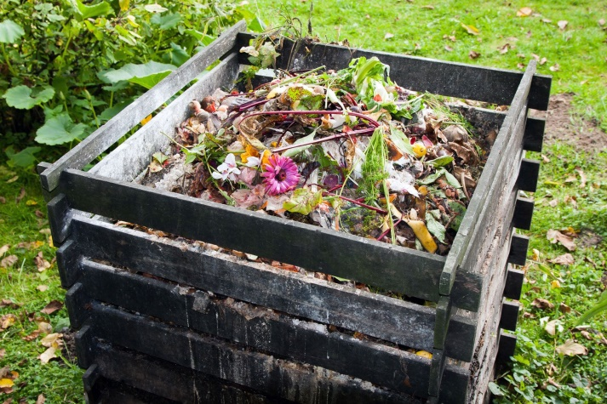
What is this rich organic matter, produced through controlled decomposition, called? A) Chemical fertilizer B) Green manure C) Compost D) Inorganic pesticide

- Emily is making a small fabric pouch. She wants a simple, durable seam that is easy to iron flat. Which seam is best suited for this purpose, providing a flat finish suitable for general construction? A) French seam B) Flat felled seam C) Plain seam D) Bound seam
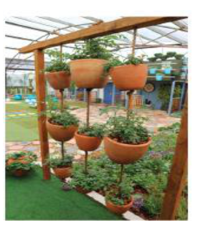
- A household in an urban area with limited ground space wants to grow vegetables. They are considering a method that involves growing plants in containers hung vertically as shown.

What is this method of gardening known as? A) Raised beds B) Container gardening C) Suspended gardens D) Hydroponics
- A nutritionist is educating a community on healthy eating. She emphasizes the importance of a diet that provides adequate amounts of energy, growth materials, and protective substances. What is this type of diet commonly referred to? A) Energy-giving diet B) Body-building diet C) Balanced diet D) Protective diet
- Before storing his beans in a granary, a farmer cleans and repairs the granary thoroughly. He also seals any cracks. Why is it important to ensure a storage structure is well-sealed and free of cracks before storing crops? A) To keep the crops warm B) To prevent entry of pests and rodents C) To allow air circulation D) To enhance crop ripening
- Mwende cooked too much rice for dinner. To avoid waste, she plans to use the leftover rice to make a different dish the next day. Which method of conserving leftover food is Mwende practicing? A) Freezing B) Drying C) Preparing another recipe D) Salting
- After preparing a meal, Mama Chebet ensures all kitchen utensils and surfaces are thoroughly cleaned and disinfected.

What is the primary reason for disinfecting kitchen equipment and surfaces? A) To make them shiny B) To remove food residues C) To kill harmful bacteria and viruses D) To prevent rusting
- During a prolonged dry season, Farmer Akinyi uses conserved forage to feed her dairy cows. She specifically feeds them large, tightly packed bundles of dried grass.
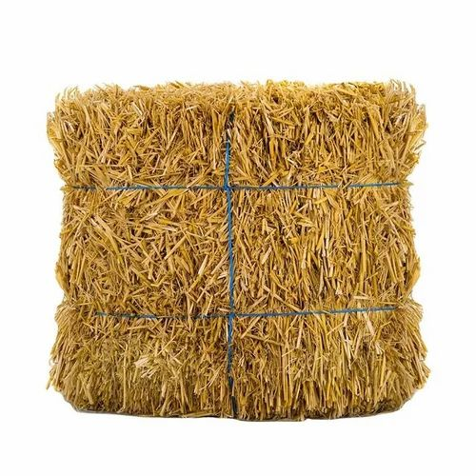
What form of conserved forage is Farmer Akinyi using? A) Silage B) Standing forage C) Baled hay D) Fodder crops

- To control weeds in his maize farm, a farmer uses a jembes to physically remove them.
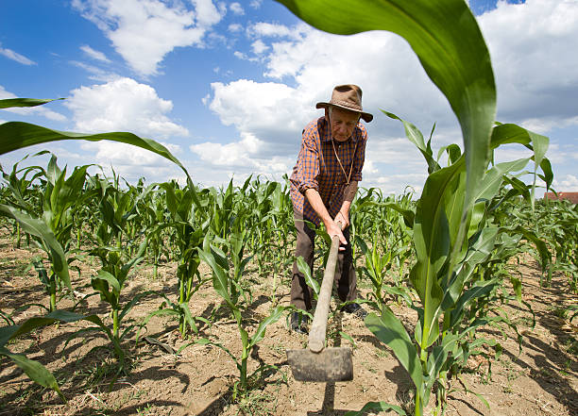
What type of weed control method is the farmer employing? A) Chemical weed control B) Biological weed control C) Mechanical weed control D) Cultural weed control
- Sarah was preparing chapatti.
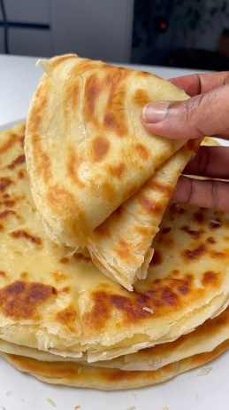
When preparing chapati, Sarah needs to mix flour with water and oil to form a dough. Which piece of equipment is primarily used for mixing flour mixtures into dough? A) Rolling pin B) Mixing bowl C) Sieve D) Frying pan
- A farmer practicing organic gardening wants to provide rapid nutrient uptake for his leafy vegetables. He decides to spray a liquid feed directly onto the leaves. What type of organic feed is he most likely using? A) Farmyard manure B) Compost tea C) Green manure D) Bone meal
- A group of women in Kakamega is starting a small income-generating project by making homemade soaps. Which essential ingredient is a strong alkaline substance used in the saponification process to make soap? A) Glycerine B) sodium hydroxide C) Coconut oil D) Water

- During a field visit to study methods of soil conservation, Grade 8 learners took the following picture.

Identify the practice.
- Cover cropping.
- Relay cropping.
- Mono cropping.
- Strip cropping.
- Before roasting a whole chicken, a cook needs to prepare the carcass. After defeathering and eviscerating, what is the final step in preparing the carcass for cooking? A) Beheading B) Cleaning the internal and external parts thoroughly C) Cutting into pieces D) Salting
- A farmer wants to propagate a high-yielding avocado variety onto a hardy rootstock that is resistant to soil-borne diseases. Which plant propagation technique involves joining parts of two plants so they grow as one? A) Budding B) Layering C) Grafting D) Cutting

- After handwashing some delicate, colourful clothes, you notice the water has become discoloured. What is the most appropriate action to take before rinsing these clothes with other items? A) Add more detergent B) Rinse them separately until the water runs clear C) Soak them longer D) Rinse them with hot water
- A farmer discovers that his stored maize grains are being damaged by small, hard-bodied insects that bore into the kernels. Which of the following is a common storage pest of maize? A) Aphids B) Armyworms C) Weevils D) Tsetse flies
- During a formal dinner, the host offers to serve each guest individually from platters brought to the table. What serving style is being used in this scenario? A) Family service B) Blue plate service C) Buffet service D) Russian service
- Mama Sara has limited space but wants to grow a variety of vegetables for daily family consumption right outside her kitchen door. What term best describes this type of small-scale, accessible garden? A) Commercial garden B) Kitchen backyard garden C) Orchard D) Nursery bed

- A local community group decides to build a low-cost device to dry fruits and vegetables using only sunlight, to prevent post-harvest losses. Which simple device would be most effective for this purpose? A) Electric dehydrator B) Open-air drying rack C) Homemade sundryer D) Microwave oven
- To manage weeds in his farm, Farmer Juma introduces beneficial insects that feed on the specific weed species. What type of weed control method is Farmer Juma employing? A) Chemical control B) Mechanical control C) Biological control D) Cultural control
- Grade 7 learners wanted to establish a crop using the following planting material.

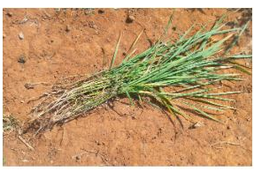

Identify the planting material.
  - Tubers.
  - Splits.
  - Seeds.
  - Vines.

SECTION B: STRUCTURED QUESTIONS (50 Marks)
Answer all questions in the spaces provided.
PART 1: AGRICULTURE (25 Marks)
- Mr. Kiprop, a farmer in Bomet County, is concerned about the severe soil pollution occurring on his farm.He understands that this is leading to significant reduced productivity.
a) Identify two causes of soil pollution that Mr. Kiprop might observe on his farm. (2 marks)
i. ………………………………………………………………………………………………………………..
ii. …………………………………………………………………………………………………………….…
b) Explain two methods of soil conservation that Mr. Kiprop can implement in his farm to reduce soil pollution. (4 marks)
i. ………………………………………………………………………………………………………………..
ii. …………………………………………………………………………………………………………….…
c) Mr. Kiprop also wants to harvest and store water during the rainy season for use during dry spells. State two ways he can harvest and store water on his farm. (4 marks)
i. ………………………………………………………………………………………………………………..
ii. …………………………………………………………………………………………………………….…
- Mary has decided to establish a small-scale poultry project to earn some income and provide food for her family. She plans to rear improved kienyeji chickens.
a) Outline two essential parts of a poultry fold that Mary needs to consider for the welfare of her chickens. (2 marks)
i. ………………………………………………………………………………………………………………..
ii. …………………………………………………………………………………………………………….…
b) Marys chickens are starting to lay eggs. Describe the process of preparing eggs for consumption or sale. (3 marks)
i. ………………………………………………………………………………………………………………..
ii. …………………………………………………………………………………………………………….…
iii. ……………………………………………………………………………………………………………..
c) Later, Mary observes some of her chickens showing signs of disease, including respiratory distress and watery droppings.
i. State one common poultry disease that exhibits such signs. (1 mark)
………………………………………………………………………………………………………………….
ii. Describe two general disease control measures Mary can implement in her poultry farm. (3 marks)
i. ………………………………………………………………………………………………………………..
ii. …………………………………………………………………………………………………………….…
- Farmer Wambua has successfully grown a variety of crops, including maize and beans. He is now looking for ways to reduce post-harvest losses and add value to his produce.
a) Before storing his maize and beans, Farmer Wambua needs to prepare the storage structures. Describe two key steps in preparing storage structures for crop produce. (4 marks)
i. ………………………………………………………………………………………………………………..
ii. …………………………………………………………………………………………………………….…
b) After harvesting, Farmer Wambua has a surplus of maize. Suggest two ways he can add value to his maize produce to fetch better prices or extend its shelf life. (2 marks)
i. ………………………………………………………………………………………………………………..
ii. …………………………………………………………………………………………………………….…
c) Farmer Wambua also practices organic gardening in a section of his farm. Briefly explain the meaning of organic gardening. (2 marks)
i. ………………………………………………………………………………………………………………..
ii. …………………………………………………………………………………………………………….…
PART 2: NUTRITION (25 Marks)
- The Njoki family is committed to maintaining good hygiene in their kitchen and ensuring that the meals they prepare are balanced and nutritious.
a) Explain the importance of routine cleaning of kitchen equipment. (2 marks)
i. ………………………………………………………………………………………………………………..
ii. …………………………………………………………………………………………………………….…
b) The family is preparing a meal for guests. They decide to serve food using the Blue Plate method. Describe how meals are served using the Blue Plate method. (3 marks)
i. ………………………………………………………………………………………………………………..
ii. …………………………………………………………………………………………………………….…
iii. ……………………………………………………………………………………………………………..
ii. …………………………………………………………………………………………………………….…
c) The Njoki family ensures their meals are balanced. Name three food groups that are essential components of a balanced diet. (3 marks)
i. ………………………………………………………………………………………………………………..
ii. …………………………………………………………………………………………………………….…
iii. ……………………………………………………………………………………………………………..
d) After dinner, some food is left over. State two reasons why it is important to conserve leftover foods. (2 marks)
i. ………………………………………………………………………………………………………………..
ii. …………………………………………………………………………………………………………….…
- Sarah is learning about food processing and preservation. She specifically wants to understand how to handle fish and milk to maintain their quality for longer periods.
a) Outline the steps involved in processing fish for consumption after catching. (3 marks)
i. ………………………………………………………………………………………………………………..
ii. …………………………………………………………………………………………………………….…
iii. ……………………………………………………………………………………………………………..
b) Sarah wants to preserve some milk for a few days without refrigeration. Explain two methods she can use to achieve this. (4 marks)
i. ………………………………………………………………………………………………………………..
ii. …………………………………………………………………………………………………………….…
c) She also learns about cooking methods. Differentiate between roasting and steaming as cooking methods, giving one advantage for each. (4 marks)
………………………………………………………………………………………………………………..
………………………………………………………………………………………………………………..
…………………………………………………………………………………………………………….…
………………………………………………………………………………………………………………..
…………………………………………………………………………………………………………….…
…………………………………………………………………………………………………………….…

- Mr. Jumas family is embracing practical skills, including tailoring and simple home repairs. They also value environmental conservation.
a) Mr. Juma wants to make a work bag using his sewing skills. Name two common types of seams he could use in constructing this bag. (2 marks)
i. ………………………………………………………………………………………………………………..
ii. …………………………………………………………………………………………………………….…
b) The family is concerned about proper waste disposal. Outline two methods for cleaning waste disposal facilities in the home. (2 marks)
i. ………………………………………………………………………………………………………………..
ii. …………………………………………………………………………………………………………….…
c) The family wants to create an innovative animal waterer to ensure their chickens have access to clean water while conserving water. Suggest one simple design concept for an innovative animal waterer. (2 marks)
i. ………………………………………………………………………………………………………………..
ii. …………………………………………………………………………………………………………….…

THIS IS THE LAST PRINTED PAGE.

