Grade Four
Islamic Religious Education Activities Schemes Of Work
 |  |  | Term | Three Year School
Wee  k | Lsn | Strand/Theme | Sub strand | Specific learning outcomes | Key inquiry  Questions | Learning experiences | Learning  Resources | Assessmen t methods | Refl
1 | 1 |  |  | 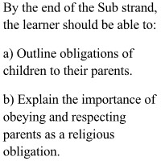 | 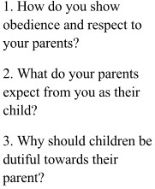 | 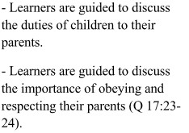 | Qur’an, Course books, Digital  devices, Charts,  praying mats | Portfolio, Oral assessment checklist, Observatio n schedule.
 | 2 |  |  | 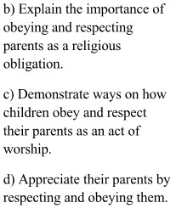 |  | 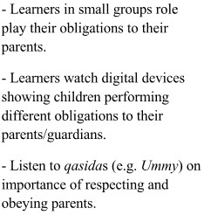 | Qur’an, Course books, Digital  devices, Charts,  praying mats | Portfolio, Oral assessment checklist, Observatio n schedule.

 | 3 |  |  |  |  |  | Qur’an, Course books, Digital  devices, Charts,  praying mats | Portfolio, Oral assessment checklist, Observatio n schedule.
2 | 1 |  | Children’s obligation to  other family members | 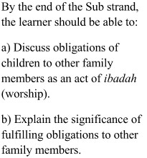 | 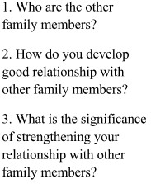 | 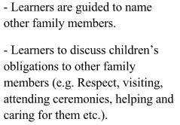 | Qur’an, Course books, Digital  devices, Charts,  praying mats | Portfolio, Oral assessment checklist, Observatio n schedule.

 | 2 |  | Children’s obligation to  other family members | 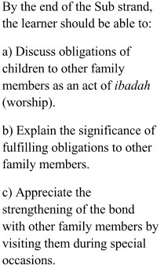 |  | 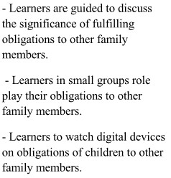 | Qur’an, Course books, Digital  devices, Charts, praying mats | Portfolio, Oral assessment checklist, Observatio n schedule.
 | 3 |  | Children’s obligation to  other family members |  |  |  | Qur’an, Course books, Digital  devices, Charts, praying mats | Portfolio, Oral assessment checklist, Observatio n schedule.

3 | 1 | History Of  Islam | 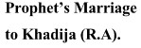 | 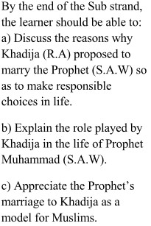 | 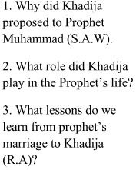 | 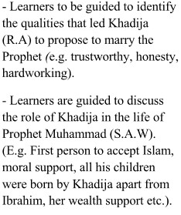 | Qur’an, Course books, Digital  devices, Charts,  praying mats | Portfolio, Oral assessment checklist, Observatio n schedule.
 | 2 |  |  |  |  |  | Qur’an, Course books, Digital  devices, Charts, praying mats | Portfolio, Oral assessment checklist, Observatio n schedule.

 | 3 |  |  |  |  | 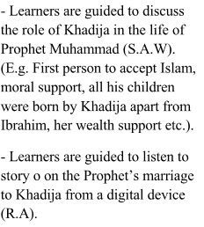 | Qur’an, Course books, Digital  devices, Charts, praying mats | Portfolio, Oral assessment checklist, Observatio n schedule.
4 | 1 |  |  |  |  |  | Qur’an, Course books, Digital  devices, Charts, praying mats | Portfolio, Oral assessment checklist, Observatio n schedule.
 | 2 |  | Call to  Prophethood | 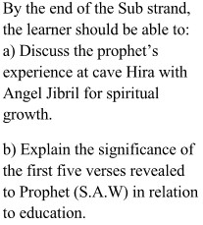 | 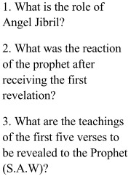 | 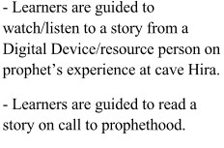 | Qur’an, Course books, Digital  devices, Charts,  praying mats | Portfolio, Oral assessment checklist, Observatio n schedule.

 | 3 |  | Call to  Prophethood |  |  |  | Qur’an, Course books, Digital  devices, Charts,  praying mats | Portfolio, Oral assessment checklist, Observatio n schedule.
5 | 1 |  | Call to  Prophethood | 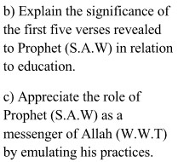 |  | 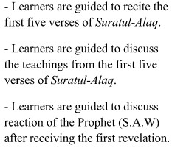 | Qur’an, Course books, Digital  devices, Charts,  praying mats | Portfolio, Oral assessment checklist, Observatio n schedule.

 | 2 |  | Call to  Prophethood |  |  |  | Qur’an, Course books, Digital  devices, Charts, praying mats | Portfolio, Oral assessment checklist, Observatio n schedule.
 | 3 |  |  |  | 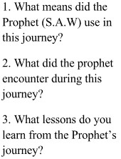 | 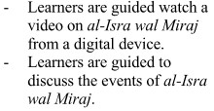 | Qur’an, Course books, Digital  devices, Charts,  praying mats | Portfolio, Oral assessment checklist, Observatio n schedule.

6 | 1 |  |  | 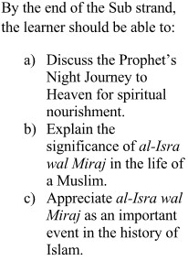 |  |  | Qur’an, Course books, Digital  devices, Charts, praying mats | Portfolio, Oral assessment checklist, Observatio n schedule.
 | 2 |  |  |  |  | 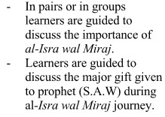 | Qur’an, Course books, Digital  devices, Charts,  praying mats | Portfolio, Oral assessment checklist, Observatio n schedule.
 | 3 |  |  |  |  |  | Qur’an, Course books, Digital  devices, Charts,  praying mats | Portfolio, Oral assessment checklist, Observatio n schedule.
7-9 |  |  |  | REVISION AND ASSESSMENT

