GRADE 4 INDIGENOUS LANGUAGE
SCHEMES OF WORK TERM 3

1 | 1 |  | Extensive reading | 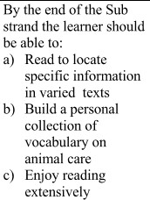 | 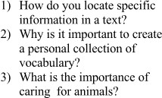 |  | 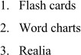 | Observatio n, QA,  Digital assessment
 | 2 |  | Reading to form personal judgment and opinion | 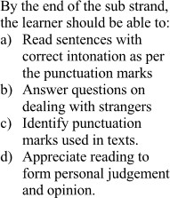 | 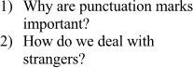 |  |  | Observatio n, QA,  Digital assessment
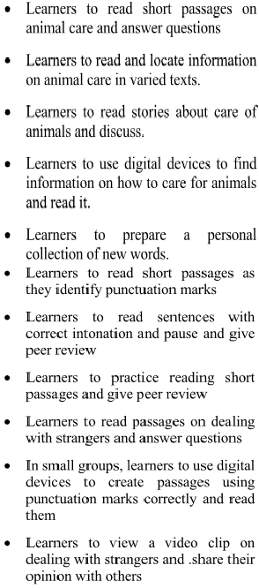
2 | 1 |  | Reading sentences in a variety of structures | 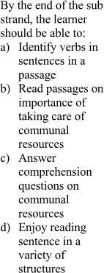 | 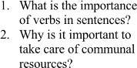 | 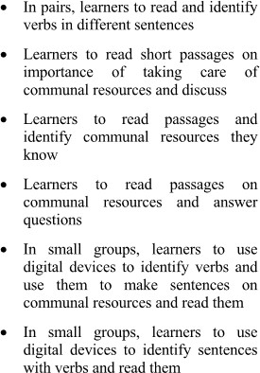 | 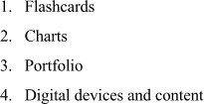 | Observatio n, QA,  Digital assessment
 | 2 | Writing | Writing words and sentences using different structures | 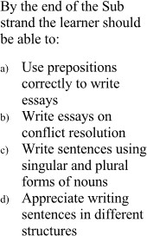 | 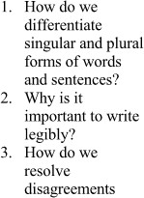 | 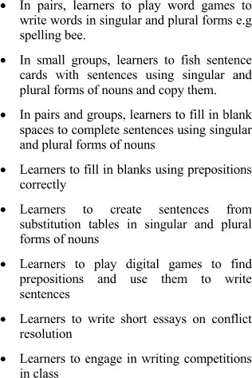 | 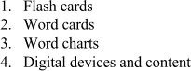 | Observatio n, QA,  Digital assessment

3 | 1 |  | Using punctuation marks appropriately in writing varied texts | 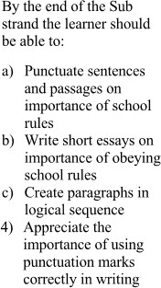 | 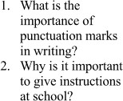 | 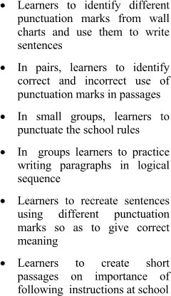 |  | Observatio n, QA,  Digital assessment
 | 2 |  | Using punctuation marks appropriately in writing varied texts |  |  |  |  | Observatio n, QA,  Digital assessment

4 | 1 |  | Writing a variety of texts using sentences in different structures | 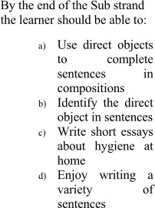 | 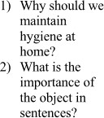 | 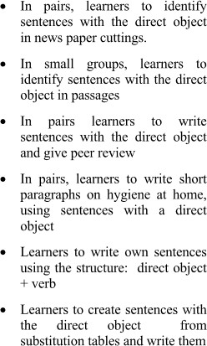 | 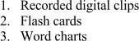 | Observatio n, QA,  Digital assessment
 | 2 |  | Writing a variety of texts using specific sentence structure | 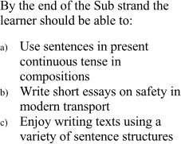 | 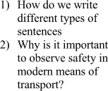 | 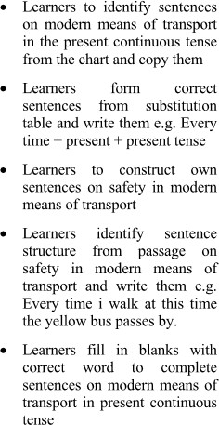 |  | Observatio n, QA,  Digital assessment

5 | 1 |  | Using acquired vocabulary to write in varied contexts | 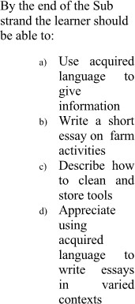 | 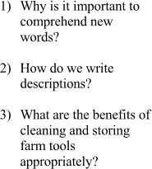 | 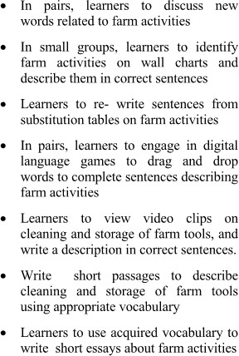 | 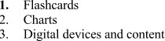 | Observatio n, QA,  Digital assessment
 | 2 |  | Writing using varied sentence structures | 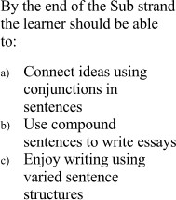 | 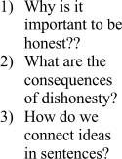 | 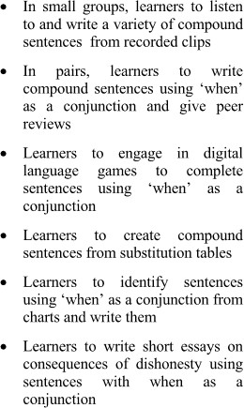 |  | Observatio n, QA,  Digital assessment

6 | 1 |  | Writing various types of texts | 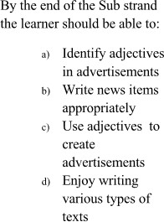 | 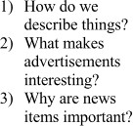 | 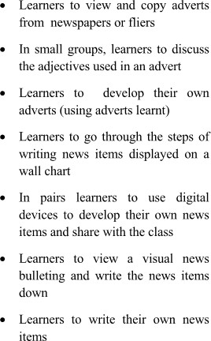 | 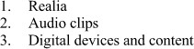 | Observatio n, QA,  Digital assessment
 | 2 |  | Using artistic expressions in writing short stories and imaginative experiences | 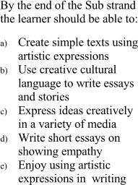 | 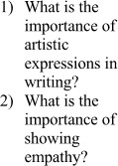 | 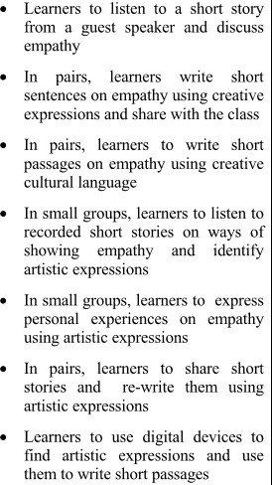 | 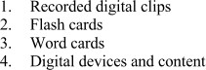 | Observatio n, QA,  Digital assessment

7 | 1 |  | Writing to express imaginative experiences using literary short forms | 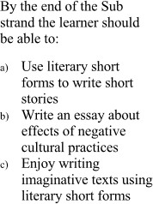 | 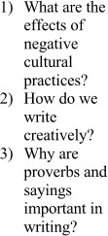 | 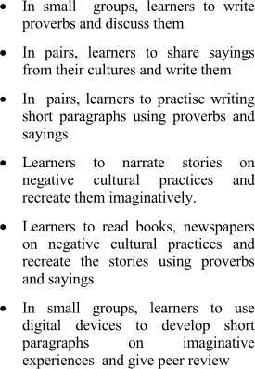 |  | Observatio n, QA,  Digital assessment
 | 2 |  | Writing texts in different contexts | 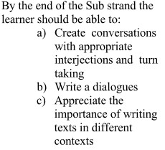 | 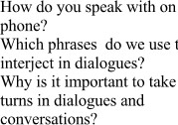 | 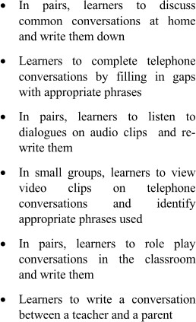 |  | Observatio n, QA,  Digital assessment

8 | 1 |  | Writing to give information | 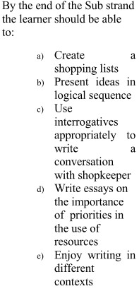 | 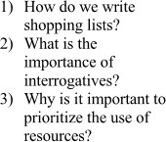 | 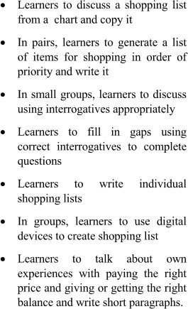 | 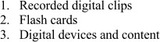 | Observatio n, QA,  Digital assessment

 | 2 |  | Using a variety of vocabulary and sentence structure in writing | 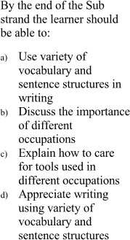 | 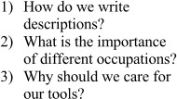 | 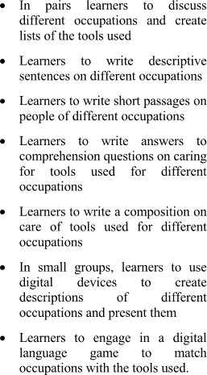 |  | Observatio n, QA,  Digital assessment
9 |  |  |  | Assessment and clossing

End Year

