GRADE 4 HINDUS RELIGIOUS EDUCATION SCHEMES OF WORK TERM 3
Wee k | Ls n | Strand/Them e | Sub strand | Specific learning outcomes | Key inquiry Questions | Learning experiences | Learning Resources | Assessme nt methods | Refl
1 |  | Opening Of The Term/Preparation
2 | 1 | Yoga (Holistic Wellness) |  | 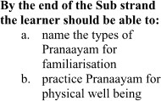 | 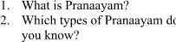 | 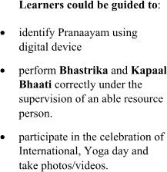 | Scriptures,  Magazines, | Observati  on, QA,
 |  |  |  |  |  |  | Digital | Essay
 |  |  | Pranayaam |  |  |  | devices, | writing,
 |  |  | (Breathing |  |  |  | Newspapers, | Role
 |  |  | exercises) |  |  |  | animated | modelling,
 |  |  | 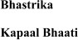 |  |  |  | movies,  Realia | projects
 | 2 |  |  | 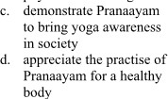 |  |  | Scriptures, | Observati
 |  |  |  |  |  |  | Magazines, | on, QA,
 |  |  |  |  |  |  | Digital | Essay
 |  |  | Pranayaam |  |  |  | devices, | writing,
 |  |  | (Breathing |  |  |  | Newspapers, | Role
 |  |  | exercises) |  |  |  | animated | modelling,
 |  |  |  |  |  |  | movies,  Realia | projects

 | 3 |  |  |  |  |  | Scriptures, | Observati
 |  |  |  |  |  |  | Magazines, | on, QA,
 |  |  | Pranayaam (Breathing exercises) |  |  |  | Digital  devices, Newspapers, animated movies, Realia | Essay  writing, Role modelling, projects
3 | 1 |  |  | 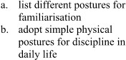 | 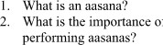 | 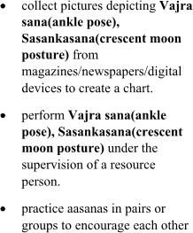 | Scriptures, Magazines, Digital devices, Newspapers, animated movies, Realia | Observati on, QA, Essay writing, Role modelling, projects
 |  |  | Aasanas
 |  |  | (physical
 |  |  | postures)
 |  |  | Vajra sana
 |  |  | (ankle pose)
 | 2 |  |  |  |  |  | Scriptures, | Observati
 |  |  |  |  |  |  | Magazines, | on, QA,
 |  |  |  |  |  |  | Digital | Essay
 |  |  | Aasanas (physical postures) Vajra sana  (ankle pose) |  |  |  | devices,  Newspapers, animated movies, Realia | writing,  Role modelling, projects
 |  |  | 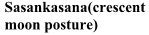
 | 3 |  |  | 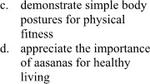 |  |  | Scriptures,  Magazines, Digital devices, Newspapers, animated movies, Realia | Observati  on, QA, Essay writing, Role modelling, projects
 |  |  | Aasanas
 |  |  | (physical
 |  |  | postures)
 |  |  | Vajra sana
 |  |  | (ankle pose)
4 | 1 |  |  |  |  |  | Scriptures, | Observati
 |  |  |  |  |  |  | Magazines, | on, QA,
 |  |  |  |  |  |  | Digital | Essay
 |  |  | Aasanas |  |  |  | devices, | writing,
 |  |  | (physical |  |  |  | Newspapers, | Role
 |  |  | postures) |  |  |  | animated | modelling,
 |  |  | Vajra sana  (ankle pose) |  |  |  | movies, Realia | projects
 | 2 | Sadachaar  (Moral |  | 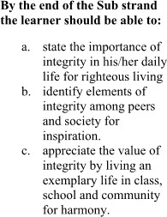 | 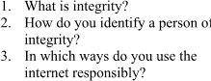 | 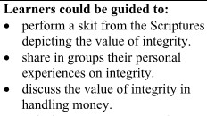 |  | Observati on, QA, Essay writing, Role modelling, projects
 |  | Values) |  |  |  |  | Scriptures, | Observati on, QA, Essay writing, Role modelling, projects
 |  |  |  |  |  |  | Magazines, | Observati on, QA, Essay writing, Role modelling, projects
 |  |  |  |  |  |  | Digital | Observati on, QA, Essay writing, Role modelling, projects
 |  |  | Aspects of |  |  |  | devices, | Observati on, QA, Essay writing, Role modelling, projects
 |  |  | integrity |  |  |  | Newspapers, | Observati on, QA, Essay writing, Role modelling, projects
 |  |  |  |  |  |  | animated | Observati on, QA, Essay writing, Role modelling, projects
 |  |  |  |  |  |  | movies, | Observati on, QA, Essay writing, Role modelling, projects
 |  |  |  |  |  |  | Realia | Observati on, QA, Essay writing, Role modelling, projects
 | 3 |  |  |  |  |  |  | Observati
 |  |  |  |  |  |  |  | on, QA,
 |  |  | Aspects of integrity |  |  |  | Scriptures, Magazines, Digital  devices, Newspapers, | Essay  writing, Role modelling, projects
 |  |  |  |  |  |  | animated
 |  |  |  |  |  |  | movies,
 |  |  |  |  |  |  | Realia
5 | 1 |  |  |  |  |  |  | Observati
 |  |  |  |  |  |  |  | on, QA,
 |  |  | Aspects of integrity |  |  |  | Scriptures, Magazines, Digital devices, Newspapers, | Essay  writing, Role modelling, projects
 |  |  |  |  |  |  | animated
 |  |  |  |  |  |  | movies,
 |  |  |  |  |  |  | Realia
 | 2 |  |  |  |  | 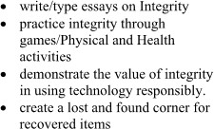 | Scriptures, | Observati
 |  |  |  |  |  |  | Magazines, | on, QA,
 |  |  |  |  |  |  | Digital | Essay
 |  |  | Aspects of |  |  |  | devices, | writing,
 |  |  | integrity |  |  |  | Newspapers, | Role
 |  |  |  |  |  |  | animated | modelling,
 |  |  |  |  |  |  | movies, | projects
 |  |  |  |  |  |  | Realia
 | 3 |  |  |  |  |  | Scriptures, | Observati
 |  |  |  |  |  |  | Magazines, | on, QA,
 |  |  |  |  |  |  | Digital | Essay
 |  |  | Aspects of |  |  |  | devices, | writing,
 |  |  | integrity |  |  |  | Newspapers, | Role
 |  |  |  |  |  |  | animated | modelling,
 |  |  |  |  |  |  | movies, | projects
 |  |  |  |  |  |  | Realia

6 | 1 |  | Aspects of integrity |  |  |  | Scriptures,  Magazines, Digital devices, Newspapers, animated movies, Realia | Observati  on, QA, Essay writing, Role modelling, projects
 | 2
 | 3
7-9 |  | End Year Assesment

