GRADE 4 CHINESE LANGUAGE SCHEMES OF WORK TERM 3

Wee k | Ls n | Strand/Theme | Sub strand | Specific learning outcomes | Key inquiry Questions | Learning experiences | Learning Resources | Assessment methods | Refl
1 | OPENING OF THE TERM/PREPARATION
2 | 1 | Writing |  | 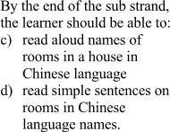 |  | 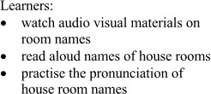 | Cartoons, | Rhythm,
 |  |  |  |  |  |  | books and | Intensity,
 |  |  |  |  |  |  | booklets, | Phoneme,
 |  |  |  |  |  |  | charts, Realia, | Tone
 |  |  | My home |  |  |  | ICT DVDs,
 |  |  |  |  |  |  | newspaper,
 |  |  |  |  |  |  | realia, journal
 | 2 |  |  |  |  |  | Cartoons, | Rhythm,
 |  |  |  |  |  |  | books and | Intensity,
 |  |  |  |  |  |  | booklets, | Phoneme,
 |  |  |  |  |  |  | charts, Realia, | Tone
 |  |  | My home |  |  |  | ICT DVDs,
 |  |  |  |  |  |  | newspaper,
 |  |  |  |  |  |  | realia, journal
3 | 1 |  | My home | 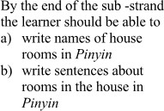 | 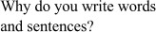 | 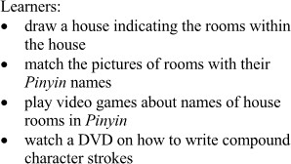 | Cartoons, books and booklets, charts, Realia, | Rhythm, Intensity, Phoneme, Tone
 |  |  |  |  |  |  | ICT DVDs,
 |  |  |  |  |  |  | newspaper,
 |  |  |  |  |  |  | realia, journal

 | 2 |  |  |  |  |  |  | Rhythm,
 |  |  |  |  |  |  | Cartoons, books and  booklets, | Intensity, Phoneme, Tone
 |  |  | My home |  |  |  | charts, Realia,
 |  |  |  |  |  |  | ICT DVDs,
 |  |  |  |  |  |  | newspaper,
 |  |  |  |  |  |  | realia, journal
4 | 1 |  | School life | 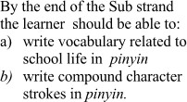 | 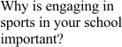 |  | Cartoons, books and  booklets, charts, Realia, | Rhythm, Intensity, Phoneme, Tone
 |  |  |  |  |  |  | ICT DVDs,
 |  |  |  |  |  |  | newspaper,
 |  |  |  |  |  |  | realia, journal
 | 2 |  |  |  |  |  | Cartoons, | Rhythm,  Intensity,
 |  |  |  |  |  |  | books and | Phoneme,
 |  |  |  |  |  |  | booklets, | Tone
 |  |  | School life |  |  |  | charts, Realia,
 |  |  |  |  |  |  | ICT DVDs,
 |  |  |  |  |  |  | newspaper,
 |  |  |  |  |  |  | realia, journal
5 | 1 |  |  | 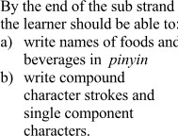 | 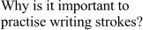 | 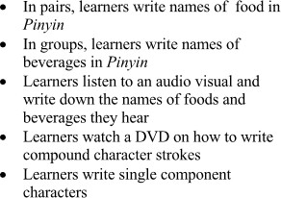 |  | Rhythm,
 |  |  |  |  |  |  |  | Intensity,
 |  |  |  |  |  |  | Cartoons, | Phoneme,
 |  |  | Foods and beverages |  |  |  | books and  booklets, charts, Realia, ICT DVDs, | Tone
 |  |  |  |  |  |  | newspaper,
 |  |  |  |  |  |  | realia, journal
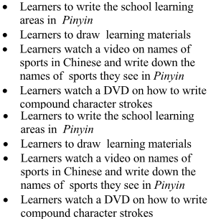
 | 2 |  |  |  |  |  |  | Rhythm,
 |  |  |  |  |  |  |  | Intensity,
 |  |  |  |  |  |  | Cartoons, | Phoneme,
 |  |  | Foods and beverages |  |  |  | books and  booklets, charts, Realia, ICT DVDs, | Tone
 |  |  |  |  |  |  | newspaper,
 |  |  |  |  |  |  | realia, journal
6 | 1 |  |  | 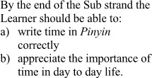 |  | 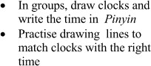 | Cartoons, | Rhythm,
 |  |  |  |  |  |  | books and | Intensity,
 |  |  |  |  |  |  | booklets, | Phoneme,
 |  |  | Time |  |  |  | charts, Realia,  ICT DVDs, | Tone
 |  |  |  |  |  |  | newspaper,
 |  |  |  |  |  |  | realia, journal
 | 2 |  |  |  |  |  | Cartoons, | Rhythm,
 |  |  |  |  |  |  | books and | Intensity,
 |  |  |  |  |  |  | booklets, | Phoneme,
 |  |  | Time |  |  |  | charts, Realia,  ICT DVDs, | Tone
 |  |  |  |  |  |  | newspaper,
 |  |  |  |  |  |  | realia, journal
7 | 1 |  |  | 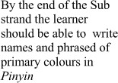 |  | 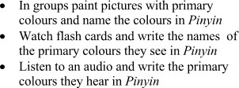 | Cartoons, | Rhythm,
 |  |  |  |  |  |  | books and | Intensity,
 |  |  |  |  |  |  | booklets, | Phoneme,
 |  |  | Colours |  |  |  | charts, Realia,  ICT DVDs, | Tone
 |  |  |  |  |  |  | newspaper,
 |  |  |  |  |  |  | realia, journal

 | 2 |  | Colours |  |  |  | Cartoons, books and booklets, charts, Realia, ICT DVDs,  newspaper, realia, journal | Rhythm, Intensity, Phoneme, Tone
8-9 |  | End Year/Term

