GRADE FOUR ARABIC LANGUAGE SCHEMES OF WORK TERM 3
Term Three Year School
Wee k | Ls n | Strand/Theme | Sub strand | Specific learning outcomes | Key inquiry Questions | Learning experiences | Learning Resources | Assessment methods | Refl
1 | 1 | Writing | 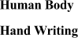 | 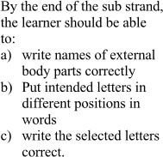 | 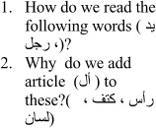 | 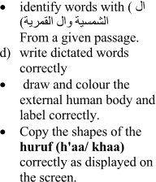 | Course books, newspapers, journals, charts, short stories, pictures, songs, Audio recordings | Teacher made tests, essays, portfolio, peer assessment, writing competition
 | 2 |  | 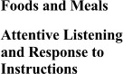 | 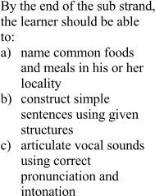 | 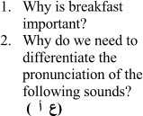 | 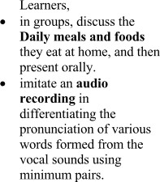 | Course books, newspapers, journals, charts, short stories, pictures, songs, Audio recordings | Teacher made tests, essays, portfolio, peer assessment, writing competition

2 | 1 |  |  |  |  |  | Course books, newspapers, journals, charts, short stories, pictures, songs, Audio recordings | Teacher made tests, essays, portfolio, peer assessment, writing competition
 | 2 |  | 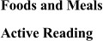 | 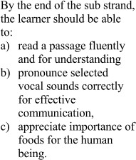 | 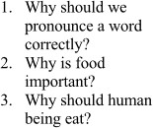 |  | Course books, newspapers, journals, charts, short stories, pictures, songs, Audio recordings | Teacher made tests, essays, portfolio, peer assessment, writing competition
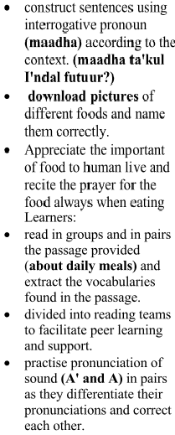
3 | 1 |  |  |  |  | 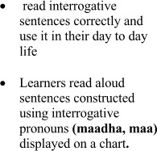 | Course books, newspapers, journals, charts, short stories, pictures, songs, Audio recordings | Teacher made tests, essays, portfolio, peer assessment, writing competition
 | 2 |  | 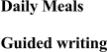 | 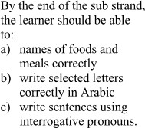 | 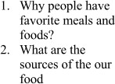 |  | Course books, newspapers, journals, charts, short stories, pictures, songs, Audio recordings | Teacher made tests, essays, portfolio, peer assessment, writing competition
4 | 1 |  |  |  |  |  | Course books, newspapers, journals, charts, short stories, pictures, songs, Audio recordings | Teacher made tests, essays, portfolio, peer assessment, writing competition
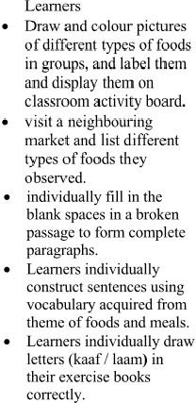
 | 2 |  | 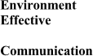 | 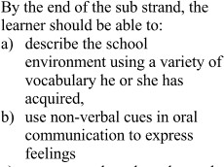 | 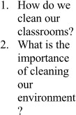 |  | Course books, newspapers, journals, charts, short stories, pictures, songs, Audio recordings | Teacher made tests, essays, portfolio, peer assessment, writing competition
5 | 1 |  |  | 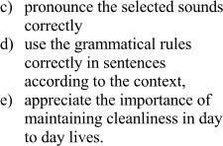 |  |  | Course books, newspapers, journals, charts, short stories, pictures, songs, Audio recordings | Teacher made tests, essays, portfolio, peer assessment, writing competition
 | 2 |  | 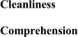 | 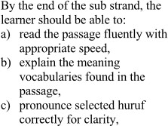 | 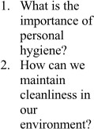 | 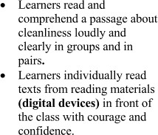 | Course books, newspapers, journals, charts, short stories, pictures, songs, Audio recordings | Teacher made tests, essays, portfolio, peer assessment, writing competition
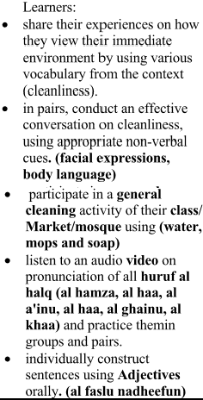
6 | 1 |  |  |  |  | 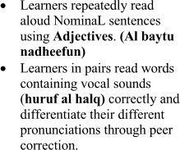 | Course books, newspapers, journals, charts, short stories, pictures, songs, Audio recordings | Teacher made tests, essays, portfolio, peer assessment, writing competition
 | 2 |  | 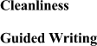 |  | 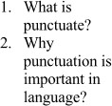 | 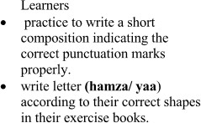 | Course books, newspapers, journals, charts, short stories, pictures, songs, Audio recordings | Teacher made tests, essays, portfolio, peer assessment, writing competition
7 | 1 |  |  |  |  | 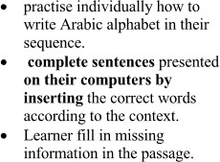 | Course books, newspapers, journals, charts, short stories, pictures, songs, Audio recordings | Teacher made tests, essays, portfolio, peer assessment, writing competition
 | 2
9 |  | End Year/Exams/Closing
