GRADE 4 FRENCH
SCHEMES OF WORK TERM 3
Wee k | Ls n | Strand/Theme | Sub strand | Specific learning outcomes | Key inquiry Questions | Learning experiences | Learning Resources | Assessment methods | Refl
1 | 1 | Listening And Speaking  Reading Writing | Expressing what one wants | 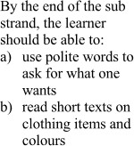 | 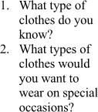 | 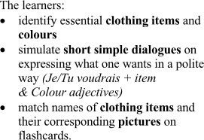 | Charts, Video clips, Maps, Short stories, Real objects, pictures, Journal, Songs, Audio recordings | Word searches/puz zle, Filling missing words, reading aloud, spelling: oral and written,  rearranging
 | 2 |  | Expressing what one wants |  |  |  | Charts, Video clips, Maps, Short stories, Real objects, pictures, Journal, Songs, Audio recordings | Word searches/puz zle, Filling missing words, reading aloud, spelling: oral and written,  rearranging
2 | 1 |  | Expressing what one wants |  |  | 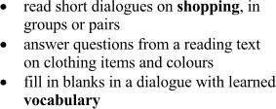 | Charts, Video clips, Maps, Short stories, Real objects, pictures, Journal, Songs, Audio recordings | Word searches/puz zle, Filling missing words, reading aloud, spelling: oral and written,  rearranging
 | 2 |  | Expressing what one wants | 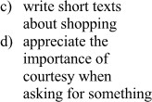 |  |  | Charts, Video clips, Maps, Short stories, Real objects, pictures, Journal, Songs, Audio recordings | Word searches/puz zle, Filling missing words, reading aloud, spelling: oral and written,  rearranging
3 | 1 |  | Expressing what one wants |  |  | 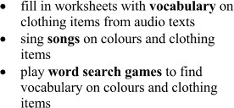 | Charts, Video clips, Maps, Short stories, Real objects, pictures, Journal, Songs, Audio recordings | Word searches/puz zle, Filling missing words, reading aloud, spelling: 2oral and  written, rearranging

4 | 1 |  | Locating objects in our surrounding | 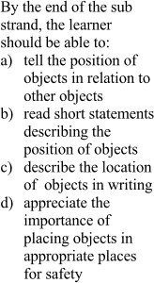 | 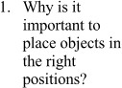 | 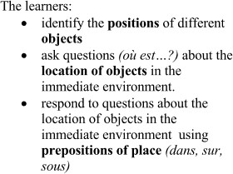 | Charts, Video clips, Maps, Short stories, Real objects, pictures, Journal, Songs, Audio recordings | Word searches/puz zle, Filling missing words, reading aloud, spelling: oral and written,  rearranging
 | 2 |  | Locating objects in our surrounding |  |  | 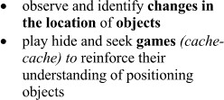 | Charts, Video clips, Maps, Short stories, Real objects, pictures, Journal, Songs, Audio recordings | Word searches/puz zle, Filling missing words, reading aloud, spelling: oral and written,  rearranging
5 | 1 |  | Locating objects in our surrounding |  |  |  | Charts, Video clips, Maps, Short stories, Real objects, pictures, Journal, Songs, Audio recordings | Word searches/puz zle, Filling missing words, reading aloud, spelling: oral and  written, rearranging

 | 2 |  | Locating objects in our surrounding |  |  | 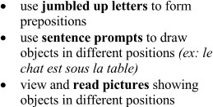 | Charts, Video clips, Maps, Short stories, Real objects, pictures, Journal, Songs, Audio recordings | Word searches/puz zle, Filling missing words, reading aloud, spelling: oral and written, rearranging
6 | 1 |  | Expressing how one feels | 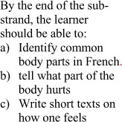 | 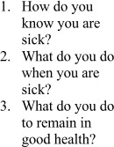 | 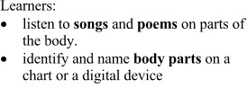 | Charts, Video clips, Maps, Short stories, Real objects, pictures, Journal, Songs, Audio recordings | Word searches/puz zle, Filling missing words, reading aloud, spelling: oral and  written, rearranging
 | 2 |  | Expressing how one feels |  |  |  | Charts, Video clips, Maps, Short stories, Real objects, pictures, Journal, Songs, Audio recordings | Word searches/puz zle, Filling missing words, reading aloud, spelling: oral and written,  rearranging

7 | 1 |  | Expressing how one feels |  |  | 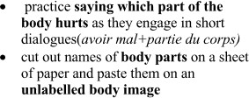 | Charts, Video clips, Maps, Short stories, Real objects, pictures, Journal, Songs, Audio recordings | Word searches/puz zle, Filling missing words, reading aloud, spelling: oral and written,  rearranging
 | 2 |  | Expressing how one feels | 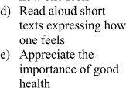 |  |  | Charts, Video clips, Maps, Short stories, Real objects, pictures, Journal, Songs, Audio recordings | Word searches/puz zle, Filling missing words, reading aloud, spelling: oral and written,  rearranging
8 | 1 |  | Expressing how one feels |  |  | 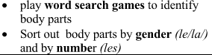 | Charts, Video clips, Maps, Short stories, Real objects, pictures, Journal, Songs, Audio recordings | Word searches/puz zle, Filling missing words, reading aloud, spelling: oral and  written, rearranging

 | 2 |  | Expressing how one feels |  |  |  | Charts, Video clips, Maps, Short stories, Real objects, pictures, Journal, Songs, Audio recordings | Word searches/puz zle, Filling missing words, reading aloud, spelling: oral and written,  rearranging
9 | REVISION AND ASSESSMENT

