NAME: …………………………………………. INDEX NO: ……………………………….

DATE : …………………………………..CANDIDATE’S SIGNATURE:…………………
MANGU HIGH SCHOOL TRIAL 4 MOCK 2025

232/3
PHYSICS
(PRACTICAL)
FORM 4
TIME 2 ½ Hours
INSTRUCTIONS TO CANDIDATES
- Write your name and Admission number in the spaces provided above.
- write the date of examination in the spaces provided above.
- Answer ALL the questions in the spaces provided in the question paper.
- You are supposed to spend the first 15 minutes of the 2½ hours allowed for this paper reading the whole paper carefully before commencing your work.
- Marks are given for a clear record of the observations actually made, their suitability, accuracy and the use made of them.
- Candidates are advised to record their observations as soon as they are made.
- Non-programmable silent electronic calculators may be used.
- This paper consists of 7 printed pages.
- Candidates should check the question paper to ascertain that all the pages are printed as indicated and that no questions are missing.
- Candidates should answer the questions in English.
FOR EXAMINER’S USE ONLY
QUESTION | MAXIMUM SCORE | CANDIDATE’S SCORE
1 | 20
2 | 20
TOTAL | 40

QUESTION ONE
PART A
You are provided with the following
- Metre rule
- Knife edge
- 10 microscope slides
- A 50g mass
- A piece of cellotape
- A pair of vernier calipers
Proceed as follows
(a) Using the vernier calipers provided measure the length L and the width, W of the microscope slide
L=_______________________________ (1mk)
W=_______________________________ (1mk)
(b) Stack ten (10) slides together using a cello tape as shown below fig 1.

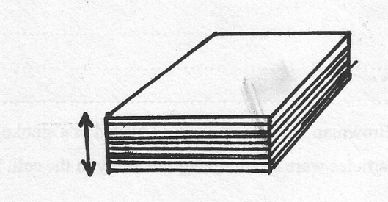
Figure 1
T
(i) Measure the thickness T of the stack of microscope slides. (1mk)
T=_______________________
(ii) Determine the volume v of the stack (2mk)
V=(LWT)
=____________________
(c) Balance the metre rule at its centre of gravity and maintain the position of the fulcrum on the centre of gravity throughout the experiment
Place the 50g mass and the stack of slides as shown in figure 4 below

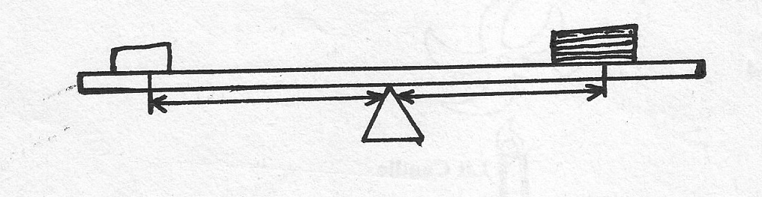
y
x
50g
Adjust the position of both the50g mass and stacked slides until the rule is again balanced making the distances x and y as large as possible
(i) x=_______________ (1mk)
y=_______________ (1mk)

(ii) Calculate the mass ‘m’ in grams of the stacked slides given that (2mk)

(iii) Determine the density of glass given that (2mk)

PART B
You are provided with the following apparatus:
- Resistance wire fitted on a millimeter scale labeled MN
- Switch
- Voltmeter
- Ammeter
- Two dry cells in a cell holder
- Six connecting wires
- Micrometer screw gauge
Proceed as follows;
i. Set –up the apparatus as shown in the Figure 3 below;
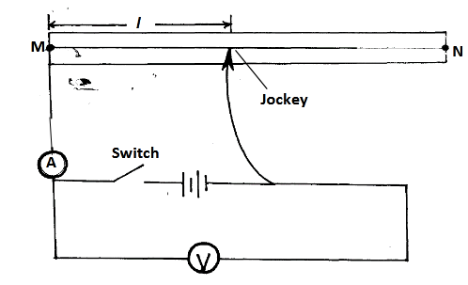
ii. Remove the crocodile clip from the resistance wire MN and close the switch. Record the
voltmeter reading V0.
V0 = ........................................ (1mark)
iii. Attach the Jockey to the resistance wire such that l = 50cm
iv. Record the voltmeter and ammeter readings as V1 and Z respectively
V1 =.............................................. (1mark)
Z =............................................. (1mark)
v. Determine the value of X given that (1mark)
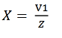

vi. Use the equation below to determine the value of k , where m = 2.549Ω (2marks)
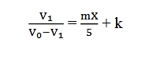
vii. Measure the diameter d of the of the wire on the millimeter scale using the micrometer
screw gauge
d = ..............................mm =.....................................m (1mark)
viii. Determine the resistivity ꝭ of the wire used in this experiment given that (2marks)
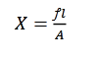
Question two
You are provided with the following;
- A retort stand, boss and clamp.
- Test tube
- Piece of duplicating paper
- A thermometer
- A large beaker containing some water
- A tripod stand and wire gauze
- A cardboard with a hole in the middle
- A burner
- A rubber band
- A stop band
- A stop watch
Proceed as follows;
- Set up the apparatus as shown in figure 4 below.
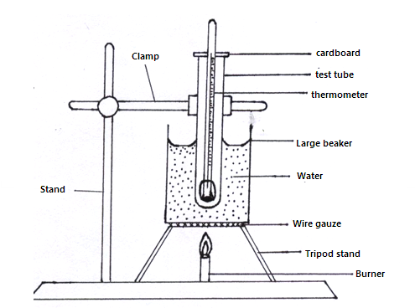
- Heat the water in the beaker provided and leave it to boil
- Wrap the given piece of duplicating paper round the bulb of the thermometer. Use rubber band to hold the paper in place.
- Place the thermometer inside in the dry test tube.
- Place the test tube in the water as shown in the diagram above. Make sure that the water does not enter the test tube. Leave the test tube in the boiling water until the thermometer indicates a steady temperature.
- Remove the thermometer and immediately start the stop watch.
While holding the thermometer in air record the readings of the thermometer T₁ at intervals of 30seconds for 10 minutes. (10mrks)

Time in minutes | 0 | 0.5 | 1.0 | 2.0 | 2.5 | 3.0 | 3.5 | 4.0 | 4.5 | 5.0 | 5.5
T₁ (⁰c)
T₂(⁰c)

Time in Minutes | 6.0 | 6.5 | 7.0 | 8.0 | 8.5 | 9.0 | 9.5 | 10.0
T₁ (ºC)
T₂ (ºC)

- Place the wrapped thermometer directly into boiling water. Leave the thermometer in the boiling water until it indicates a steady temperature.
- Repeat procedure (f) and (g) and record the reading T₂ of the thermometer in the table at half minute intervals for 5minutes.
- Using the same axes on the grid provided, plot a graph of temperature (y-axis) against time for result obtained in (g) and (i) (label the graph T₁ and T₂) (8mrks)
(graph paper provided)
- From the graphs determine;
- For each graph the time for temperature to fall from 60⁰C to 40⁰C. (1mrk)
.........................................................................................................................................
.........................................................................................................................................
- Find the ratio of the two times in k (i) above (1mrk)
.........................................................................................................................................
.........................................................................................................................................

