MANGU HIGH SCHOOL TRIAL 4 MOCK 2025
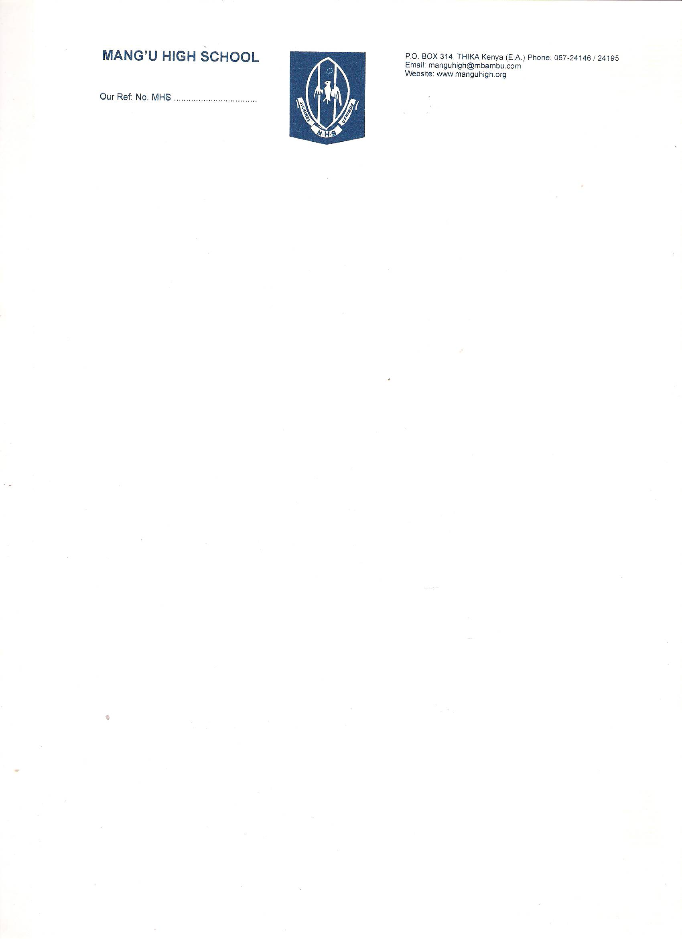
232/3 PHYSICS
PAPER 3
PRACTICALS
CONFIDENTIAL INSTRUCTIONS TO SCHOOLS
The information contained in this paper is to enable the head of school and teacher in charge of physics to make adequate preparations for this year’s physics practical examination. NO ONE ELSE should have access to this paper or acquire knowledge of its contents. Great care must be taken to ensure that the information herein does not reach the candidates either directly or indirectly.
-The physics teacher is NOT expected to perform the experiments
- The apparatus required by each candidate for the physics practical examination are set out on the next page. It is expected that the ordinary apparatus of a physics laboratory will be available.
- The physics teacher should note that it is his/her responsibility to ensure that each apparatus acquired, for this examination agrees with specifications below.
Question 1
- Metre rule
- Knife edge
- 10 microscope slides
- A 50g mass
- A piece of cello tape
- A Vernier caliper (can be shared)
- Resistance wire fitted on a millimeter scale labeled MN,( Nichrome wire G=32mm)
- Switch
- Voltmeter (0-5V)
- Ammeter (0-2.5A)
- Two dry cells in a cell holder
- 8 connecting wires ,atleast 4 with crocodile clips
- Micrometer screw gauge (To be shared)
Question 2
- A retort stand, boss and clamp.
- Test tube
- Piece of duplicating paper
- A thermometer (-10⁰-110⁰)
- A (200ml) beaker containing some water
- A tripod stand and wire gauze
- A cardboard/ carton with a hole in the middle with the size of the thermometer.
- A burner
- A rubber band
- A stop watch

