Name ………………………………………………………………………………….….. Index No. ………………. Class …….


STAREHE GIRLS’ CENTRE MOCK EXAMINATION 2025
PHYSICS -Paper 2
(THEORY)
TIME – 2 hours
232/2 -

Instructions to candidates
(a) Write your name, index number in the spaces provided above.
(b) Sign and write the date of the examination in the spaces provided
(c) This paper consists of TWO Sections: A and B.
(d) Answer ALL the questions in section A and B in the spaces provided.
(e) All working MUST be clearly shown.
(f) KNEC mathematical tables and silent non-programmable electronic calculators may be used.
(g) This paper consists of 13 printed pages
(h) Candidates should check the question paper to ascertain that all the pages are printed as indicated and that no questions are missing
(i) Candidates should answer the questions in English

For examiners use only

Section | Question | Maximum score | Candidates score
A | 1-13 | 25
B | 14 | 11
B | 15 | 11
B | 16 | 13
B | 17 | 10
B | 18 | 10
B | TOTAL SCORE | 80

SECTION A: 25marks
1. The chart below shows an arrangement of different parts of the electromagnetic spectrum.
Radio wave | A | Infrared rays | B | Ultra-violet | χ-Rays
Name the radiation represented by
A …………………………………………………………. (1mark)
State one use of radiation represented by B (1mark)
…………………………………………………………………………………………………………………………………………………………………………………………………………………….……
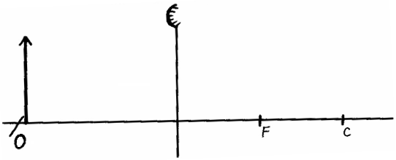
2. An object O is placed in front of convex mirror as shown in the diagram below. Complete the diagram to locate the position of the image, 1. (3 marks)

3. The figure below shows a wire carrying current whose direction is out of the paper. The wire is placed in a magnetic field.
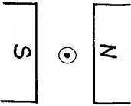

(a)Indicate on the figure the direction of the force F, acting on the wire. (1 mark)
(b)State what would be observed on the wire if the direction of the current is reversed. (1 mark)
…………………………………………………………………………………………………………………………………………………………………………………………………………………………

4. The figure below shows part of the lighting circuit of a house.

i) Give a reason why a fuse is included in the circuit. (1 mark)
…………………………………………………………………………………………………………………………………………………………………………………………………………………………
ii) If each lamp has a power of 60W at voltage of 240V. Calculate the current through one lamp when it is switched on. (2 marks)
........................................................................................................................................................................................................................................................................................................................................................................................................................................................................................................
5. Figure 5 below shows a simple transformer connected to a 12v a.c source and an a.c voltmeter.
Determine the reading on the voltmeter. (2 marks)
..........................................................................................................................................................................................................................................................................................................................................

6. The diagram shows a patient having her eyes tested. A chart with letters on it is placed behind her and she sees the chart reflected in a plane mirror.
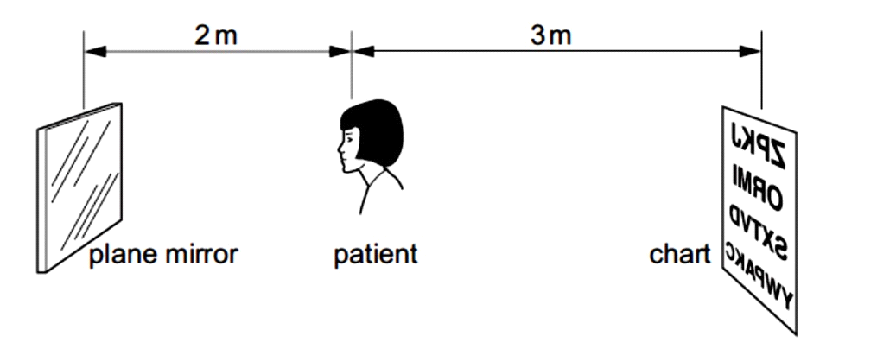
Determine how far away from the patient, the image of the chart is seen. (2 marks)
..........................................................................................................................................................................................................................................................................................................................................
7. State Snell’s law. (1 mark)
.............................................................................................................................................................................................................................................................................................................................................................................................................................................................................................................................................................................................................................................................................
8. The figure below shows an electric circuit.
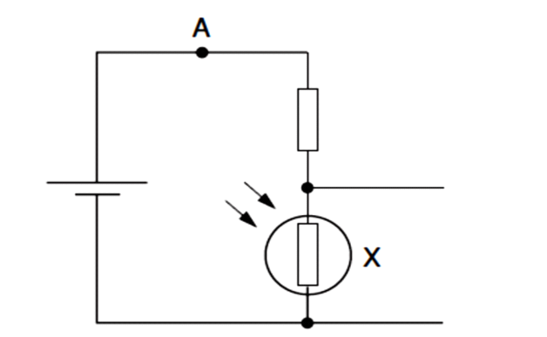

State and explain how the potential difference across X varies as the light shining on it becomes brighter. (2marks) ........................................................................................................................................................................................................................................................................................................................................................................................................................................................................................................

9. Waves pass from deep water to shallow water and refraction occurs.
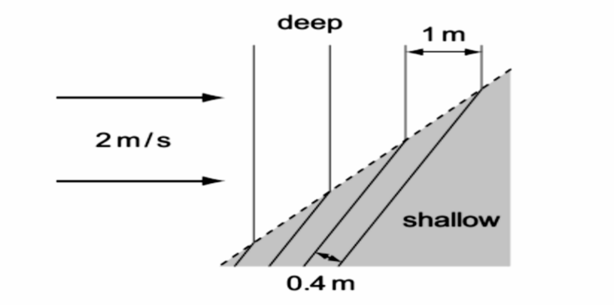
Calculate the speed of the waves in the shallow water (2 marks)
........................................................................................................................................................................................................................................................................................................................................................................................................................................................................................................

10. The diagram below shows a ray of light striking the plane at 35º as shown below.
State the angle of reflection. (1 mark)

11. The figure below shows an iron bar being magnetized by stroking it with a magnet.

Indicate on the iron bar the polarity of resulting magnet. (1 mark)

12. An echo sounder of a ship transmits sound waves to the depth of the sea and receives the echo after 2.4 seconds. If the speed of sound in water is 1600ms⁻¹, determine the depth of the sea. (3 marks)
………………………………………………………………………………………………………………………………………………………………………………………………………………………………………………………………………………………………………………………………………
13. It is observed that when a charged body is brought near the cup of a positively charged electroscope, the divergence of the leaf increases. State the type of charge on the body. (1mark) …………………………………………………………………………………………………………………………………………………………………………………………………………………………
SECTION B (55 marks)
14. (a) The figure below shows a diagram of a Geiger Muller tube connected to a power supply and a pulse counter.

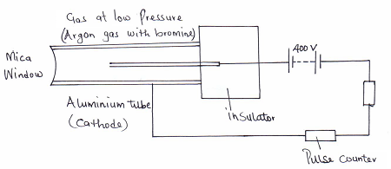

(i)Why should the argon gas be at low pressure? (1mark)
…………………………………………………………………………………………………………………………………………………………………………………………………………………………
(ii)State the purpose of the bromine gas in the tube. (1mark)
…………………………………………………………………………………………………………………………………………………………………………………………………………………………

(iii)Suggest one way of increasing the sensitivity of the tube (1mark)
…………………………………………………………………………………………………………………………………………………………………………………………………………………………
(iv) Find the value of a and b in the following equation. (2marks)

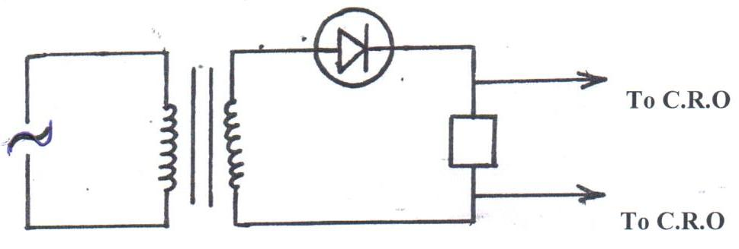
b) The figure below shows a PN junction diode used in a rectifier.

i) ) What is an extrinsic semi conductor? (1mark)
……………………………………………………………………………………………………………
ii) What type of rectification is shown? (1mark)
…………………………………………………………………………………………………………………………………………………………………………………………………………………………
iii)Describe how the rectification is achieved (2marks)
……………………………………………………………………………………………………………………………………………………………………………………………………………………………………………………………………………………………………………………………………………………………………………………………………………………………………………………

iv) In the space provided below, sketch the output signal displayed on the CRO during the rectification process. (2marks)

Voltage
Time in (s)

15. The figure below shows a cathode ray tube
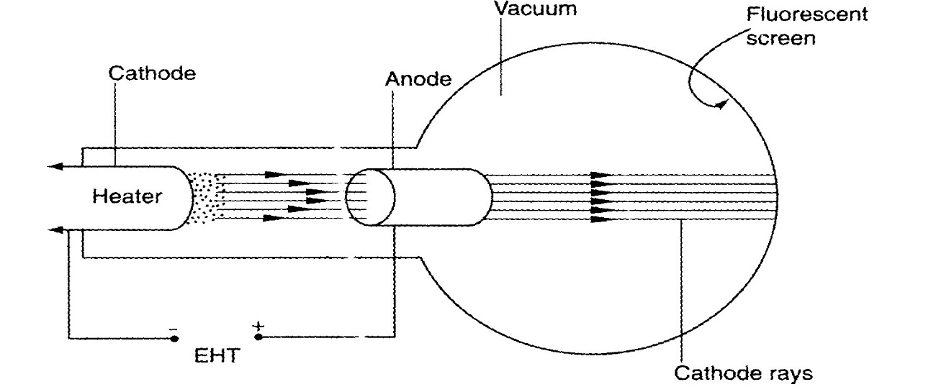

a) State the function of the
i) Heater (1mark)
..................................................................................................................................................................................................................................................................................................
ii) Extra High Tension (E.H.T.) (1 mark) ..................................................................................................................................................................................................................................................................................................
b) State how the intensity of the fluorescence on the screen can be increased. (1 mark)
.................................................................................................................................................................................................................................................................................................. .................................................................................................................................................
c) State the effect of having air in the tube instead of a vacuum (1 mark)
..................................................................................................................................................................................................................................................................................................

d) State one properties of cathode rays (1 mark)
..................................................................................................................................................................................................................................................................................................
e) Distinguish cathode rays and X-rays (1 mark)
...............................................................................................................................................................................................................................................................................................................................................................................................................................................................................................................................................................................................
f) Give one advantages of using a C.R.O instead of a voltmeter in measuring voltages
(1 mark)
..................................................................................................................................................................................................................................................................................................
g) The figure below shows an a.c. voltage. If the Y-gain control reads 10V/cm and the time base reads 5 milliseconds/cm
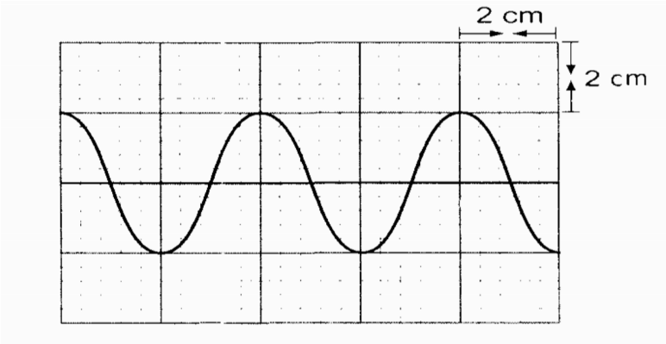
Calculate:
i) The frequency of the alternating voltage (2 marks)
..............................................................................................................................................................................................................................................................................................
ii) Peak to peak voltage of the alternating voltage (2 marks)
...............................................................................................................................................................................................................................................................................................
16 (a)(i) It is observed that when ultra- violet radiation is directed onto a clean zinc plate connected to the cap of a negatively charged leaf electroscope, the leaf falls .Explain this observation ( 2 marks)
...................................................................................................................................................................................................................................................................................................................................................................................................................................................................................................................................................................................................
(ii) State why this observation does not occur if the electroscope is positively charged (1 mark)
………………………………………………………………………………………………………………………………………………………………………………………………………………………………………………………………………………………………
(iii) ,Explain why the leaf of the electroscope does not fall when infra- red radiation is directed onto the zinc plate ( 1 mark)
...................................................................................................................................................................................................................................................................................................................................................................................................................................................
b)State the effect on the electrons emitted by the photoelectric effect when:
(i) The intensity of incident radiation is increased (1 mark)
…………………………………….………………………………………………………………………………………………………………………………………………………….
(ii) The frequency of the incident radiation is increased (1 mark)
……………….………………………………………………………………………………………………………………………………………………………………………………

c) Light of wavelength 4.3 x 10⁻⁷m is incident on two different metal surfaces, nickel and potassium. (Take speed of light as 3.0 x 10⁸ ms⁻¹ and planks constant h as
6.63 x l0⁻³⁴Js).
(i) Determine the energy of the incident radiation. (3 marks)
...................................................................................................................................................................................................................................................................................................................................................................................................................................................
(ii) If the work function of nickel is 8.0 x 10⁻¹⁹J and that of potassium is 3.68 x 10⁻¹⁹J, state with a reason from which of the two metals the given light will eject electrons. (2 marks)
................................................................................................................................................................................................................................................................................................................................................................................................................................................... (iii) Determine the velocity of the emitted electrons from the metal surface in b(ii).
(Take the mass of an electron as 9.1 x 10⁻³¹ kg). (2 marks)
…………………………………………………………………….………………………………………………………………………………………………….……………………………………………………………………………………………………………………
17(a) The figure below shows three resistors as shown.
V
6Ω
3Ω
8Ω

If the voltmeter reads 4V, find the
(i) Effective resistance (3marks) ……………………………………………………………………………………………………………………………………………………………………………………………………………………………………………………………………………………………….
(ii) Current through the 3Ω resistor (2 marks) ………………………………………………………………………………………………………………………………………………………………………………………………
(iii) Potential difference across the 8Ω resistor if the voltage total voltage in the circuit is 10V (1 mark)
………………………………………………………………………………………………………………………………………………………………………………………………
(c) (i) What is meant by the term “terminal voltage” as used in current elecricity?
(1 mark) ………………………………………….………………………………………………………………………….…………………………………………………………………………(ii) A cell supplies a current of 2.0A when connected to a 0.6Ω resistor and 1.5A when the same cell is connected to a 0.9Ω resistor.Find the e.m.f and the internal resistance of the cell. (3marks)
……………………………………………………………………………………………………………………………………………………………………………………………….
18((a) Give a reason why a candle flame is blown when a highly charged conductor is brought close to it as shown below. (1mark)

Highly charged conductor
Candle
Flame
+ + + + + + + + + + + +

………………………………………………………………………………………………………………………………………………………………………………………………………………………………………………………………………………………………
b) State two factors that affect capacitance of a capacitor (2 marks)
………………………………………………………………………………………………………………………………………………………………………………………………………………………………………………………………………………………………
c)The figure below shows 1μF, 2μF, 4μF and 5μF capacitors connected to a battery.
1μF
5μF
2μF
4μF
8.0 V

Determine:
i) The total capacitance. (3marks) ………………………………………………………………………………………………………………………………………………………………………………………………………………………………………………………………………………………………
ii)The total energy stored by the capacitors. (2marks)
………………………………………………………………………………………………………………………………………………………………………………………………………………………………………………………………………………………………
iii) Voltage across the 4μF capacitor. (2marks)
………………………………………………………………………………………………………………………………………………………………………………………………………………………………………………………………………………………………

THIS IS THE LAST PRINTED PAGE

