

STAREHE GIRLS’ CENTRE MOCK EXAMINATION 2025
PHYSICS
PAPER 1

MARKING SCHEME

1.
. 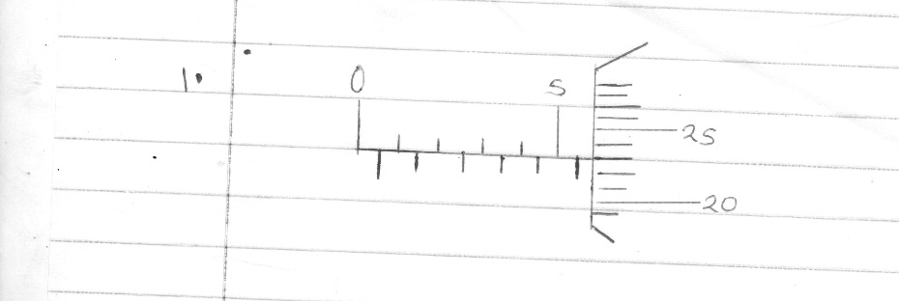
2. diffusion
3. stability increases,position of cog lowers
4. incsrease in the speed of the plane increase the speed of air in the opposite direction,lowering the pressure above the plane.
5. 1/2mv²=mgh
1/2x15x0.2=0.5x10xh
h=0.3m
6 . F₁d₁+F₂d₂=F₃d₃
6d=3(35-d)+4(55-d)
d=25cm
7. death of aquatic life.
8. because of unequal expansion of glass,the outside expands before the inside.
9. Y records higher reading than X,
10. Dull surfaces are better emitters of heat than shinny.
11. 140-96=44
ρ=m/v
=268/44
=6.091
=6091kg/m³

12. Heating increases the length, increasing the turning effect, tilt anticlockwise
13. F=ke
90/300=0.3
0.3/2+0.3/3
0.25m
14. a) when a body is partially or totally immersed in a fluid, it experiences an up thrust
equal to the weight of the fluid displaced.
b) i) W=mg+vρg
=1.3x10+2x0.1x10
=15N
ii) U=weight of the fluid displaced/vvρg
=2x1.3x10=26N
iii) T=U-W
=26-15=9N
c) i) R.D=weight of solid/up thrust
=50/6
=8.3333
ii) Density =R.Dx density of water
=8.3333x1000
=8333.3kg/m³
15. a) i) OA-Body moving at constant velocity
ii) AB-Body at rest
iii) BC-body moving at velocity increasing non uniformly
b) A body remains in a state of rest or in uniform motion in a straight line/uniform velocity unless acted upon by an external force.

c) i)
object

ii) inertia
iii) h=ut+1/2gt² u=0
3.2=1/2x10xt² ,t=0.8sec
iv) S=ut
20x0.8=16m
16. a) temperature at which the volume of a body is assumed to be zero.
b) Record the initial temperature and pressure.
Record the temperature and the corresponding pressure at regular intervals of time
Tabulate the results for pressure and absolute temperature in a table,
draw a graph of pressure versus absolute temperature

c) P₁V₁=P₂V₂
(10⁵+hρg) 4.5=10⁵x18
h=40m

17. a) radius of the bend
Angular velocity

b) i) T=mv²/r - mg
9.2=0.4v²-4
v =3.6056 m/s

ii) T=F_{c} + mg ,F _{c} = (0.4X3.6056²) + 4 = 9.2014N

iii) merry go round
speed governors
centrifuge
18. a) W=FxD
=300X10=3000J
b) W=FxD
=100X10/sin 15=3864J

c) ŋ = work output/work inputx100%
=3000/3864x100%=77.64%

d) M.A . =L/E
=300/100
=3
19. a ) build-up of pressure in the cooker, rising the boiling point. use less energy to
cook.

b) (i) Q = Cθ
= 40 x (34 – 25) = 360J
(ii) Q = MCθ
= 100 x 10ˉ³ x 4.2 x 10³ x (34 – 25)
= 3780J

- Heat lost = 360 + 3780
= 4140J
MCθ = 4140

C = 418.18Jkgˉ¹kˉ¹

