Name: ………………………………………………………………… Index No: ……………………..…………
PRACTICAL MARKING SCHEME
School: ……………………………………………………………….. Candidate’s Signature: …………………
Date: ……………….…………..…Class………………………….. Adm. No:…………………………………

232/3
PHYSICS
Paper 3(PRACTICAL)

Kenya Certificate of Secondary Education (K.C.S.E)
PHYSICS
FORM FOUR

- MARKING SCHEME

QUESTION | PART | MAXIMUM SCORE | CANDIDATE’S SCORE
1 | A | 05
1 | B | 15
2 | A | 10
2 | B | 10
 |  | 40

QUESTION 1
You are provided with the following apparatus;
- A carbon resistor labelled X .
- A carbon resistor labelled Z
- A voltmeter (0 – 5V)
- An ammeter (0 – 1A)
- 5 10Ω carbon resistors.
- Centre zero galvanometer.
- 2 new dry cells and cell holder.
- 8 connecting wires at least 4 with crocodile clips at one end.
- Jockey
- A resistance wire labelled AB mounted on mm scale.
- A switch.
PART A
- Set up the circuit below.

V
A

X

- Record the voltmeter reading E when the switch is open.

E = …………3.0±0.2…………………….V (1mk)

- Close the switch and record the voltmeter and Ammeter readings V and I respectively.

V = ……………2.7±0.2…………………………….V (1mk)

I = ………………0.26±0.02…………………………..A (1mk)

- Account for the difference between E and V. (1mk)
……………lost voltage…………………………………………………………………………………
- Calculate the resistance R for resistor X. (1mk)
$R=\frac{V}{I}=\frac{2.7}{0.26}$ = 10.38Ω (student’s work……answer with correct units correct to 4 s.f. or exact)
PART B
- Set up the circuit as shown in the figure below.
Z
10Ω

G

B
A
a
P

- Close the switch. Tap the jockey at various points on the wire AB and locate point P at which the galvanometer shows zero deflection. Measure and record in the table below the length a where a = AP.
- Repeat procedure b) using two 10Ω resistors in series, then three resistors in series, then four resistors in series and five resistors in series.
- Record your readings in the table below and complete the table where X is the effective resistance for the series combination. (5mks)

Number of 10Ω carbon resistors | One | Two | Three | Four | Five
X (Ω) | 10 | 20 | 30 | 40 | 50  4 s.f. or exact  1mk  ±2.0cm @¹/₂ max 2mks  1mk  1mk
a (cm) | 9.1 | 16.5 | 23.0 | 24.1 | 29.5
¹/_{X} (Ω⁻¹) | 0.1 | 0.05 | 0.03333 | 0.025 | 0.02
¹/_{a} (cm⁻¹) | 0.1099 | 0.06061 | 0.04348 | 0.04149 | 0.03390

- Plot a graph of ¹/_{a} (cm⁻¹) against ¹/_{X} (Ω⁻¹) (5mks)
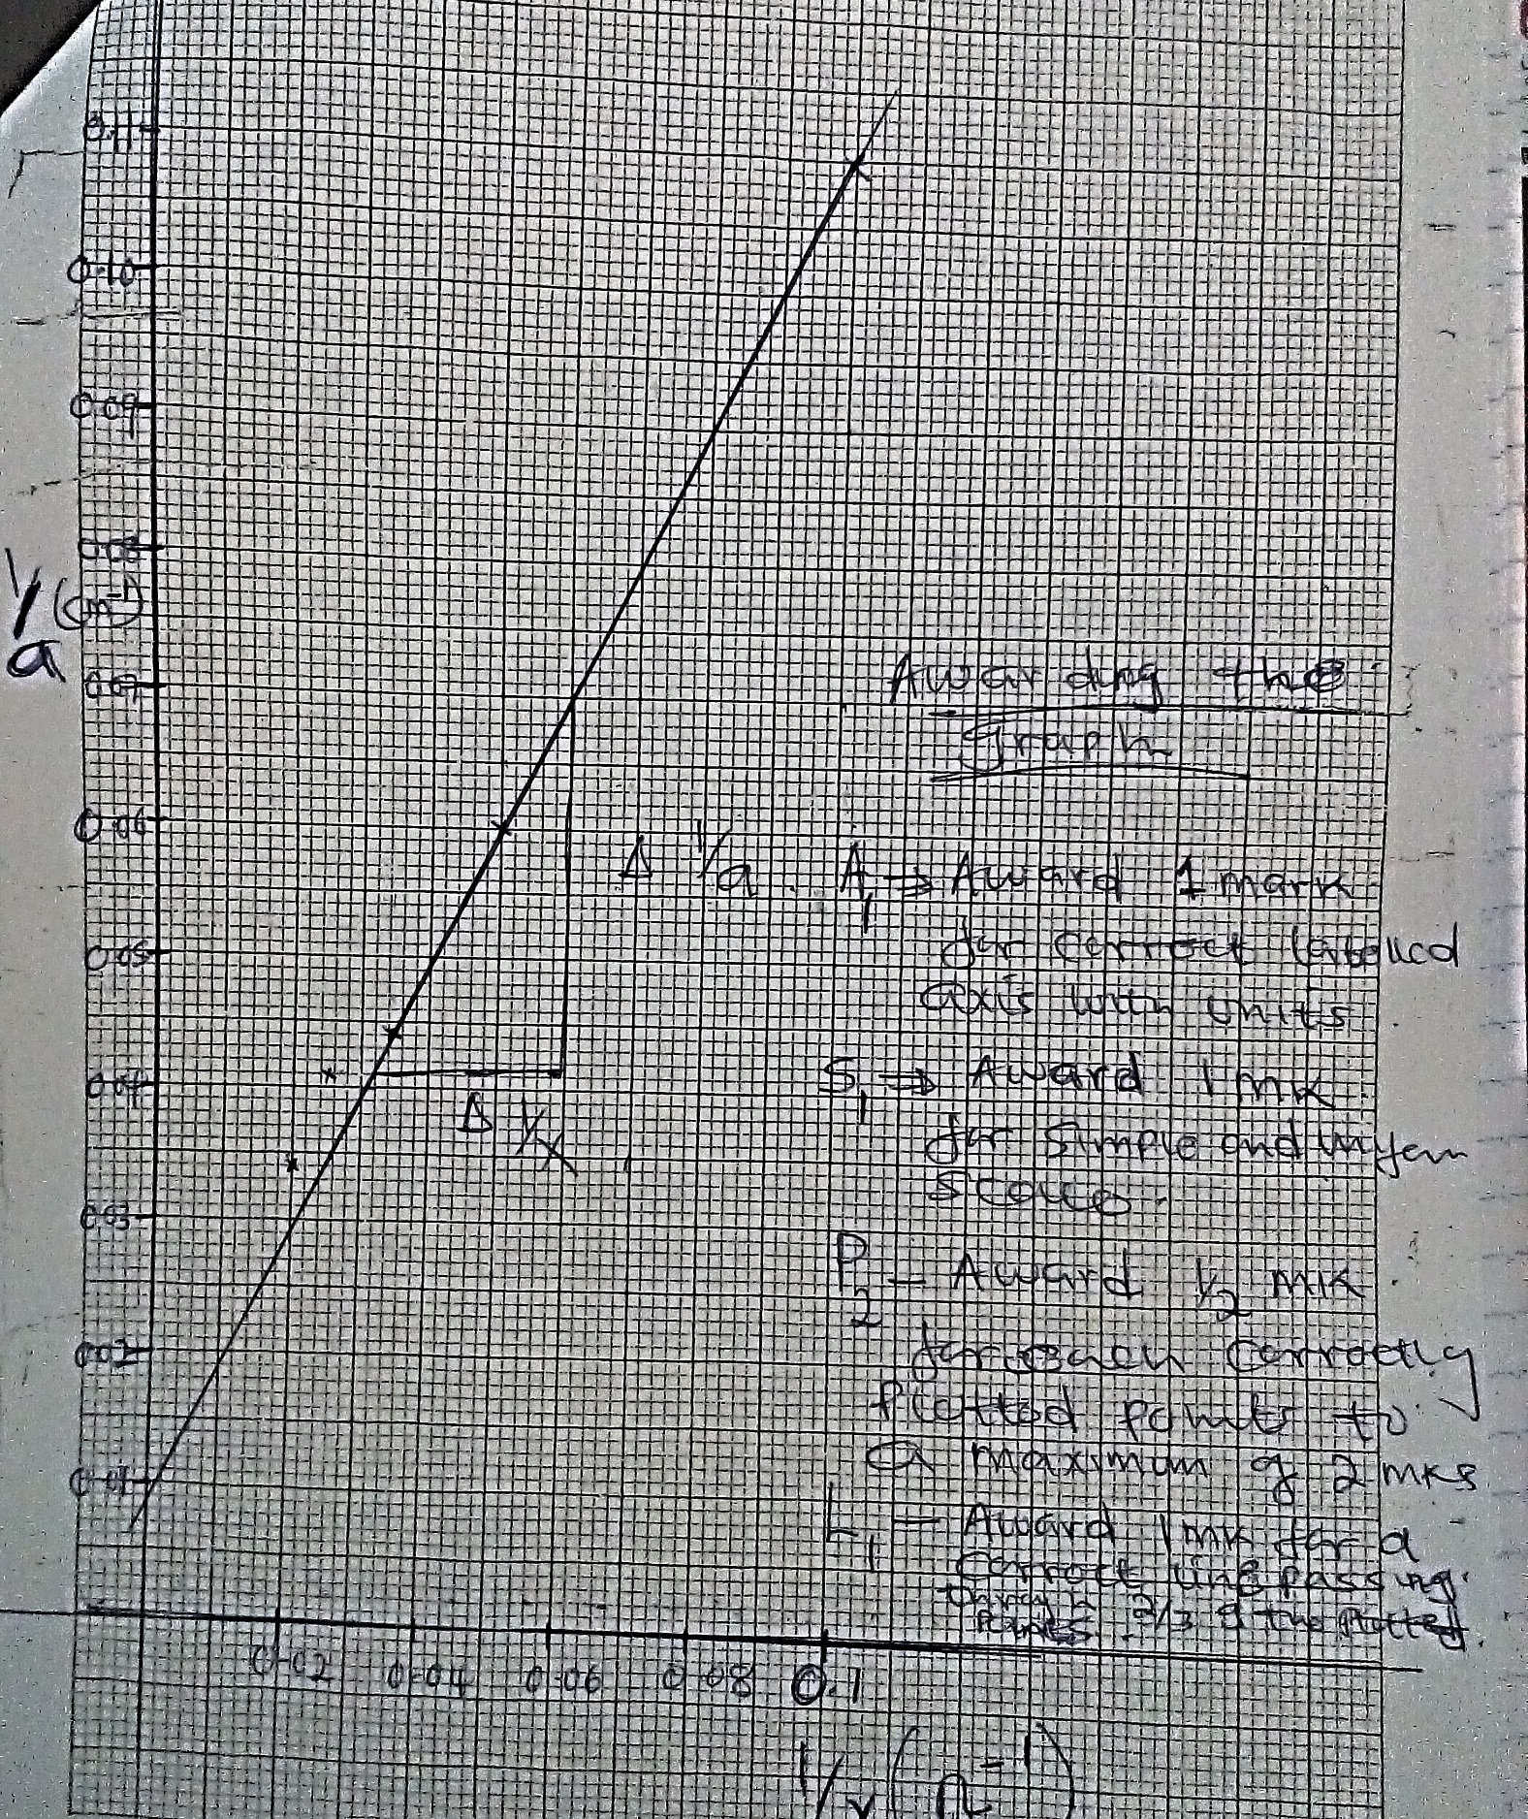
Marking graph

A1 – for correctly labelled axis with correct units

S1 – for simple and uniform scale on both axis.

P2 – for 4 -5 correctly plotted points
P1 – for 3 correctly plotted points
P0 – for less than three correctly plotted points

L1 – for a straight line passing through at least 3 correctly plotted points
- Determine the slope m of the graph. (3mks)
Follow student’s work.
Deny if L mark is 0
Answer correct to 4 s. f. or exact with units.
Deny ½ mk if no units
$$slope= \frac{0.07-0.041√}{0.06-0.031√}$$
$$=\frac{0.029}{0.029}=1Ω/cm√$$

- Given that $\frac{1}{a}=\frac{R}{K} .\frac{1}{X}+\frac{1}{K}$ where K = 100cm, use the graph to determine R. (2mks)
$$\frac{R}{K}=slope$$
$$\frac{R}{100}=1$$

R = 100Ω/cm
Follow student’s work.

Answer correct to 4 s. f. or exact with units.
Deny ½ mk if no units

QUESTION B

PART A
You are provided with the following;

- Metre rule.
- Screen
- Glass beaker (250ml)
- Water plasticine.
- A candle.

Proceed as follows;
- Add a volume V= 200ml of water into the beaker.
- Measure the value of h, the height of water in the beaker.
h = …………7.0±0.5……………cm (1mk)
- Calculate the value of internal radius R of the beaker using the formula $R=\sqrt{\frac{V}{πh}}$ where π=²²/₇
Follow student’s work.

Answer correct to 4 s. f. or exact with units.
Deny ½ mk if no units
$$R=\sqrt{\frac{200}{\frac{22}{7}×7.0}}$$
$$R=\sqrt{9.095}$$
R = 3.016cm
(2mks)

- Fill the beaker with water and set the apparatus as shown below.
h
x
y
Candle
Plasticine
Water
Screen

- Position the candle which acts as an object above the metre rule and 10R from the centre of the water ‘lens’.
- Measure the object distance x. (1mk)
x = ………………30.2±0.2……………….cm
- Move the screen towards or away from the water lens to obtain a sharp and focused bright image (line) on the screen.
- Measure the value of image distance y. (1mk)
y = ……………………6.0 ±0.2………………..cm
- Repeat the experiment for the other values of x in the table below and note and record the corresponding values of y. Complete the table.
Beaker position | 10R | 9R | 8R
x | 30.2 | 27.1 | 24.0  ± 0.2cm ½ mk @ in columns 2 n 3
y | 6.0 | 8.8 | 9.8
$$S=\frac{xy}{x+y}$$ | 5.005 | 6.643 | 6.959  1mk correct to 4 s.f. or exact all values

- Determine the average value of S. (2mks)
Follow student’s work.

Answer correct to 4 s. f. or exact with units.
Deny ½ mk if no units
$$S_{average}=\frac{5.005+6.643+6.959}{3}=6.202$$

- What does S represent. (1mk)
Focal length of the water lens

PART B
You are provided with the following;
- Vernier calipers. (can be shared)
- Micrometer screw gauge (can be shared)
- Boiling tube.
- Test tube.
- Some water in a beaker
- Half metre rule.
- 2 ball bearings.
- Some sand.
- Spatula
- Complete retort stand.
- Measure and record the diameter of one ball bearing using the micrometer screw gauge.
d = …………5.78±0.02…………mm (¹/₂mk)

- Determine the volume V of the ball bearing. (1mk)
Follow student’s work.

Answer correct to 4 s. f. or exact with units.
Deny ½ mk if no units
$$V=\frac{4}{3}×3.142×{\left(\frac{0.578}{2}\right)}^{3}$$

V = ……………0.1011……………..cm³

- Measure and record the outer diameter D of the test tube using the vernier calipers.
D = ……………1.85±0.02 ……………..cm (¹/₂mk)
- Calculate the cross-sectional area A of the tube. (1mk)
Follow student’s work.

Answer correct to 4 s. f. or exact with units.
Deny ½ mk if no units
$$A=3.142×{\left(\frac{1.85}{2}\right)}^{2}$$

A ……………2.688………………….cm²

- Mount the boiling tube on the clamp as shown below and put some water to a height of about 8.5cm from bottom.
Boiling tube
8.5cm
Water

- Gently lower the test tube into the water in the boiling tube.
- Add some sand into the test tube bit by bit until the test tube floats upright in the water.
- Note and record height ho of the water in the boiling tube from the bottom.

ho = ……………13.0±0.5……………cm (1mk)
- Gently lower one ball bearing into the test tube and note and record the new level h in the table below.
- Add the other ball bearing and note and record the corresponding height h.
- Compute the values of h- ho and complete the table. (2mks)
No. of ball bearings (N) | Height h (cm) | h – ho (cm)
1 | 13.5 ± 0.2 (½ mk) | 0.5  1mk for correct evaluation of both values of (h – ho)
2 | 14.0 ± 0.2 (½ mk) | 1.0

- Calculate S the average value of X where $X=\frac{h - ho }{N}$ (1mk)
Follow student’s work.

Answer correct to 4 s. f. or exact with units.
Deny ½ mk if no units
$$S_{average}=\frac{0.5+0.5}{2}=0.5cm$$

- Given that $S=\frac{Vls}{Ale}$

where ℓs is the density of steel and ℓe the density of water, determine the ratio of

$\frac{ls}{le}$ (2mks)

Follow student’s work.

Answer correct to 4 s. f. or exact with units.
Deny answer mark if wrong units are used
$$0.5=\frac{V}{A}×\frac{ls}{le}$$

$$\frac{ls}{le}=13.29$$

- What is the significance of the ratio $\frac{ls}{le}$ (1mk)

Relative density of steel

