GEOGRAPHY (312/1)
PAPER 1
FORM FOUR (4)
Time: 2 ¾ Hours
MARKING SCHEME

- (a) | Name two heavenly bodies that form part of solar system.  - asteroids  - comets  - meteors  - meteorites  - natural satellites/moons | 2×1=2 marks
(b) | State three characteristics of planets.  - planets revolve around the sun  - some planets have satellites/moons revolving around them  - planets are kept in their orbits by strong gravitational pull from the sun  - each planet has its own gravitational force  - planets reflect light from the sun | 3×1=3 marks
- (a) | The diagram below shows six’s thermometer. Use it to answer question (a).  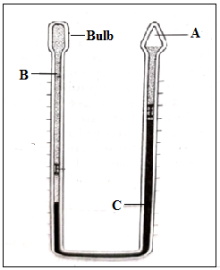  Identify the parts labeled A, B and C  - A – vacuum  - B – alcohol  - C – mercury | 3×1=3 marks
(b) | State two ways through which latitude influence the temperature of a place.  - at the equator sun rays strike the surface at right angles leading to high temperature due to small surface area  - at higher latitudes sun rays strike the surface at acute angles leading to low temperatures due to large surface area  - sun rays cover short distance to reach the surface around equator leading to high temperature  - sun rays cover a longer distance in high latitudes to reach the surface causing low temperature | 2×1=2 marks
- (a) | Give two types of magma.  - acid magma  - intermediate magma  - basic magma | 2×1=2 marks
(b) | Name three lava plateaus found in Kenya.  - Yatta  - Laikipia  - Athi-Kapiti  - Uasin Gishu | 3×1=3 marks
- (a) | Identify two lakes formed through erosion process.  - cirque/corrie/tarn lakes  - ribbon/finger lakes  - oasis/wind-eroded lakes | 2×1=2 marks
(b) | Give three reasons why some lakes are salty.  - some lakes lack outlets to drain away salts  - lakes in hot and dry areas experience high evaporation rates  - some lakes lack fresh water inlets  - some lakes are fed with underground water with a lot of salts  - the rocks over which lake water is in contact with may contain soluble salts  - inlets may dissolve a lot salts which are deposited in the lake | 3×1=3 marks
- (a) | What is weathering?  - mechanical breakdown or chemical decay of rocks at or near the earth’s surface without movement/in situ | 1×2=2 marks
(b) | State three ways through which living organisms cause weathering.  - organic acids released from decaying plants and animals aid in chemical reactions  - plant roots penetrate into the rocks causing them to widen and disintegrates  - plants absorb minerals from the rocks weakening them  - hoofed animals trample on rocks breaking them  - animals release uric acid on rocks which chemical reactions  - human activities such as quarrying break up rocks | 3×1=3 marks
- (a) | Study the map of Kisumu East (1:50,000), sheet 116/2 provided and answer the following questions.  (i) Convert the ratio scale of the map to into a statement scale.  - convert 50,000 cm to km → = 0.5 km  - 1 cm rep 0.5 km | 2×1=2 marks
 | (ii) Give six figure grid reference of the trigonometrical station 1154 SKP 21 in the southern part of the area covered by the map.  - 039832 | 1×2=2 marks
 | (iii) What is the bearing of Rabuor market from Air photo Principal point in GR 0986?  - 249±1⁰ | 1×2=2 marks
 | (iv) What is the length in kilometres of the section of railway line west of the easting 00 to Kisumu station?  - 6.6±0.1 km | 1×2=2 marks
 | (v) Give three drainage features in the area covered by the map.  - lake  - rivers  - seasonal swamps  - papyrus swamps  - waterhole | 3×1=3 marks
(b) | Describe the relief of the area covered by the map.  - there are steep slopes in the north western part  - there is Kano plain in the eastern part  - in the north eastern part there is Nyando escarpment  - northern part has dissected landscape due to numerous rivers  - there are many river valleys  - the highest point is 1872 metres in the Nyando escarpment and lowest point is 1140 metres in the southern part | 4×1=4 marks
(c) | Citing evidence from the map, give two factors that influence cultivation of sugarcane in the area covered by the map  - presence of Agricultural Sugar Research Station/Government experimental farm which extension services to farmers  - few settlement in the plantation area making large tracts of land for cultivation  - network of road (C 543/1) facilitating transportation of sugarcane | 2×2=4 marks
(d) | Identify three social activities carried out within Kisumu municipality. Give evidence.  - medical care – hospital  - education – school  - administration – DO  - security – police line/police station  - sports – stadium  - religion – church | 3×2=6 marks
- (a) | (i) Define the term folding.  - the process by which crustal rocks bend upwards or downwards due to compressional forces | 1×2=2 marks
 | (ii) A part from fold mountains, give three other features formed through folding.  - escarpments  - valley and ridge landscape  - intermontane plateau  - intermontane basin  - cuesta  - rolling plains | 3×1=3 marks
(b) | The map below shows the distribution of fold mountains in the world.  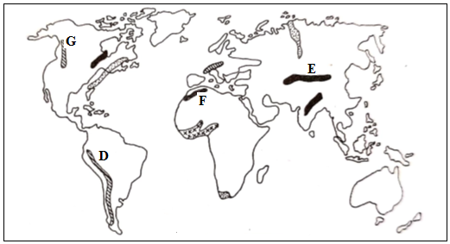  (i) Name the mountains marked D and E.  - D – Andes  - E - Himalayas | 2×1=2 marks
 | (ii) Identify the orogenies the mountains marked F and G were formed.  - F – alpine orogeny  - G – charnian orogeny | 2×1=2 marks
(c) | With the aid of well labeled diagrams, describe the formation of the following types of folds.  (i) Asymmetrical folds.  - crustal rocks are subjected to unequal compressional forces  - one limb is steep while the other is gentle  - limbs dip in opposite direction  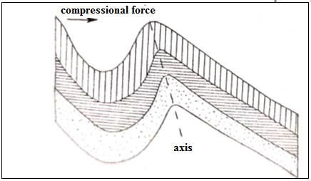  Text – 3 marks  Diagram – 1 mark
(ii) Overfolds.
- one side of crustal rocks experience greater compressional force than the other
- the limb experiencing greater force is pushed over the other limb
- the limbs dip in the same direction
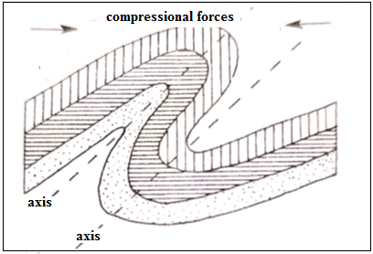
Text – 3 marks
Diagram – 1mark
(d) | Explain four positive influence of folding to human activities.  - folding brings minerals like copper close to the earth’s surface making their extraction easier  - fold mountains receive heavy rainfall on their windward sides which encourage agriculture and settlement, growth of dense forest providing timber,  - fold mountains receive heavy rainfall on their windward sides giving rise to rivers used to generate hydroelectric power, provide water for industrial/agricultural/domestic use  - features due to folding such as fold mountains attract tourists who bring foreign exchange. | 4×2=8 marks
- (a) | What is derived vegetation?  - plant cover that is growing/recovering after human or animal destruction | 1×2=2 marks
(b) | Explain how the following factors influence the distribution of vegetation  (i) Winds  - strong winds may destroy plants or retard their growth  - winds helps in seed dispersal and pollination process | 2×2=4 marks
 | (ii) Rainfall  - areas receiving high rainfall have thick forests  - areas receiving low rainfall have scattered trees and grasslands | 2×2=4 marks
(c) | (i) A part from forests, give two other major vegetation types of the world.  - grasslands  - desert vegetation  - mountain/montane vegetation | 2×1=2 marks
 | (ii) Describe the characteristics of tropical rainforests.  - trees grow in mixed stands/species  - trees are mainly hardwoods  - trees form three distinct canopies  - the trees are evergreen  - trees have buttress roots for support  - trees have broad leaves  - there is little undergrowth | 6×1=6 marks
(d) | Your class is planning to carry out a field study on vegetation around the school.  (i) Give three sources of information you are likely to use before the study.  - textbooks  - journals/magazines/newspapers  - internet  - photographs/video tapes  - forest officers | 3×1=3 marks
 | (ii) Identify four challenges you are likely to encounter during the study.  - attack by wild animals  - heavy rainfall stopping/delaying the study  - thick vegetation hindering movement  - fatigue due to walking long distance  - inadequate data  - uncooperative respondents  - accidents leading to injuries | 4×1=4 marks
- (a) | Differentiate between a river confluence and interfluve.  - confluence is a point where tributaries join the main river while interfluve is a high area between tributaries | 1×2=2 marks
(b) | Explain three types of river erosion.  - headward erosion – the river cuts back at its source upstream increasing the length of its valley  - lateral erosion – wearing away of the river banks widening the channel  - vertical erosion – down cutting of the river bed deepening the channel | 3×2=6 marks
(c) | (i) A part from waterfalls, give three other features of river erosion.  - V – shaped valleys  - gorges  - interlocking spurs  - rapids  - potholes | 3×1=3 marks
 | (ii) State four ways through which waterfalls may be formed.  - When a resistant rock lies horizontally/vertically upstream  - Where a river descends over a sharp edge of a plateau  - Where a river descends over a fault scarp  - Where a river enters the sea through a cliff  - Where a river descends a hanging valley into a glacial trough  - At a point where river rejuvenation takes place | 4×1=4 marks
(d) | Describe how the following features are formed.  (i) Flood plain  - meandering river widens its valley due to lateral erosion  - erosion removes interlocking spurs to form low cliffs/bluffs  - deposits forming slip-off slopes merge to form continuous alluvial deposits  - during floods a lot of alluvium is spread in the river valley to form a plain covered by alluvium known as flood plain | 5×1=5 marks
 | (ii) Arcuate delta  - a river drains its waters into a sea/lake  - low gradient or stagnant sea reduces the speed of the river forcing it to deposit its load  - large and heavy materials are deposited first, light and fine materials are carried further into the sea water  - accumulation of materials build up making the water shallow  - the deposits are divided by numerous distributaries, the seaward edge is surrounded and smooth.  - a triangular or fan-shaped feature is formed | 5×1=5 marks
- (a) | Give four components of the soil.  - inorganic components  - organic matter/humus  - soil water/moisture  - soil air  - living organisms | 4×1=4 marks
(b) | Explain how the following factors influence soil formation.  (i) Living organisms  - microorganisms such as fungi and bacteria assist in the decay of organic matter  - worms/termites aerate and mix the soils  - human activities such as cultivation/construction/mining causes weathering | 2×2=4 marks
 | (ii) Relief  - Steep slopes are eroded resulting into thin soils  - Gentle slopes have mature and well drained soils  - Soils on top of hills are heavily leached  - Flat areas have soils which are poorly drained and immature due to slow rate of mass wasting | 2×2=4 marks
(c) | Explain four causes of soil erosion.  - deforestation exposes the soil to agents of erosion making it possible for the soil to be easily carried away  - overgrazing/overstocking removes vegetation cover and loosening it hence easily carried away  - poor farming methods/cultivation along steep slopes/monoculture loosen the soil encouraging soil erosion  - steep slopes encourages surface run-off which a lot of soil to lowlands  - mining/quarrying loosen the ground hence the soil is easily carried downslope | 4×2=8 marks
(d) | State five significance of soils.  - soils are sources of valuable minerals such as alluvial gold  - clay is a source of raw materials for making pots/ceramics/bricks  - sand is used in building and construction  - loam soil used for agriculture  - soils give physical support for the rooting system of plants  - soils are habitat for micro-organisms such as bacteria | 5×1=5 marks

