Candidate’s Name |  | Assessment Number
School Name |  | School Code
Candidate’s Signature |  | Date

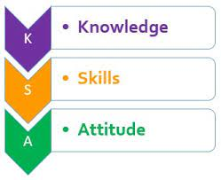

MONITORING JUNIOR SCHOOL LEARNER PROGRESS
GRADE 8: 807
SOCIAL-STUDIES.
CODE: 008 YEAR: 2025
TIME: 1 hour 40 minutes
INSTRUCTIONS TO CANDIDATES
- Write your name and class in the spaces provided above.
- This paper consists of two sections: A and B.
- Answer ALL questions in Section A.
- Answer ALL questions in Section B.
- All answers must be written in the spaces provided.
- Marks for each question are indicated in brackets.
For official use only

SECTION A: MULTIPLE CHOICE QUESTIONS (20 Marks)
Question No. | 1 | 2 |  | 3 | 4 |  | 5 | 6 | 7 |  | 8 | 9 | 10
Max Score | 1 | 1 |  | 1 | 1 |  | 1 | 1 | 1 |  | 1 | 1 | 1
Candidate’s Score
Question No. | 11 |  | 12 |  |  | 13 |  | 14 |  | 15 |  | 16 | 17 | 18 | 19 | 20 | TOTAL
Max Score | 1 |  | 1 |  |  | 1 |  | 1 |  | 1 |  | 1 | 1 | 1 | 1 | 1 | 20
Candidate’s Score

SECTION B: STRUCTURED QUESTIONS. (60 Marks)
Task | Qn Nos. | Max Marks | Candidate's Score
TASK 1: MAPWORK | Q1 a–c | 5
TASK 2: CITIZENSHIP | Q1 a–c | 5
TASK 3: HISTORY | Q1–12 | 30
TASK 4: GEOGRAPHY | Q1–8 | 30
TASK 5: LIFE SKILLS | Q1–3 | 10
TOTAL SCORE (Standardized to 60 Marks) | — | 60
This paper consists of 12 printed pages. Candidates should check the question paper to ascertain that all the pages are printed as indicated and that no questions are missing.

© 2025 The Kenya Junior School Examination and Assessment Series. Turn over

SECTION A: (20 MARKS)
Answer all questions

- While watching a documentary on early societies, Leah noticed that people used cowrie shells to buy goods.
This is an example of:
A) Taxation
B) Origin of money
C) Modern banking
D) Industrial revolution
- A class visit to Fort Jesus exposed learners to Swahili and Portuguese culture.
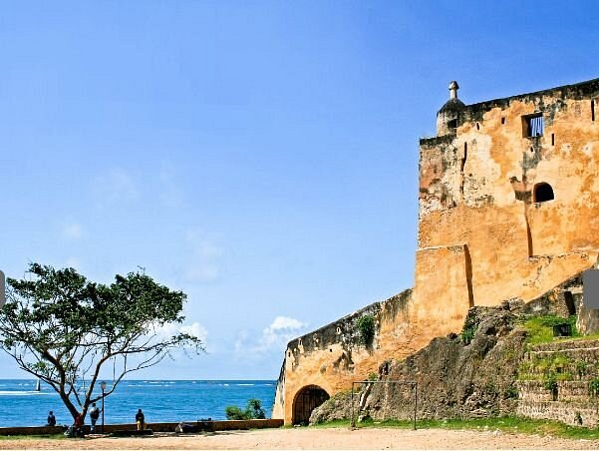
This visit helps them understand:
A) Modern architecture
B) Political campaigns
C) Historical monuments
D) School discipline
- A group of Grade 8 learners formed a peace club after witnessing bullying.
This action promotes:
A) Human evolution
B) War preparation
C) Conflict resolution
D) Tax collection
- Wangari uses her savings from poultry farming to start a small shop. This shows:
A) Peer pressure
B) Entrepreneurship
C) Population growth
D) Exploration

- Salim read about a child forced into labor in another country.
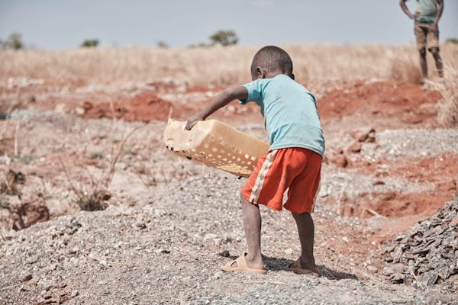
This is an example of:
A) Human rights violation
B) Population growth
C) Entrepreneurship
D) Self-esteem
- The Constitution of Kenya has a section that protects individuals from unfair arrest. This section is about:
A) Human rights
B) Freedom of religion
C) Rule of law
D) Migration
- The picture below shows a type of vegetation found in Africa.
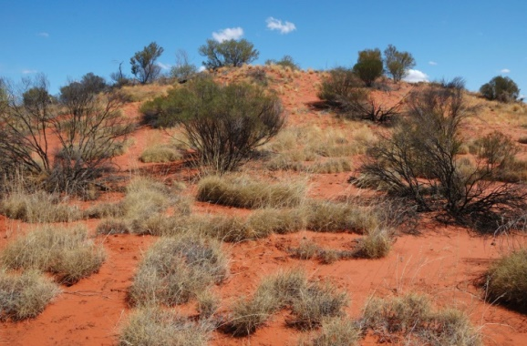
This vegetation is commonly found in:
A) Equatorial region
B) Mediterranean region
C) Semi-desert region
D) Tropical rainforest

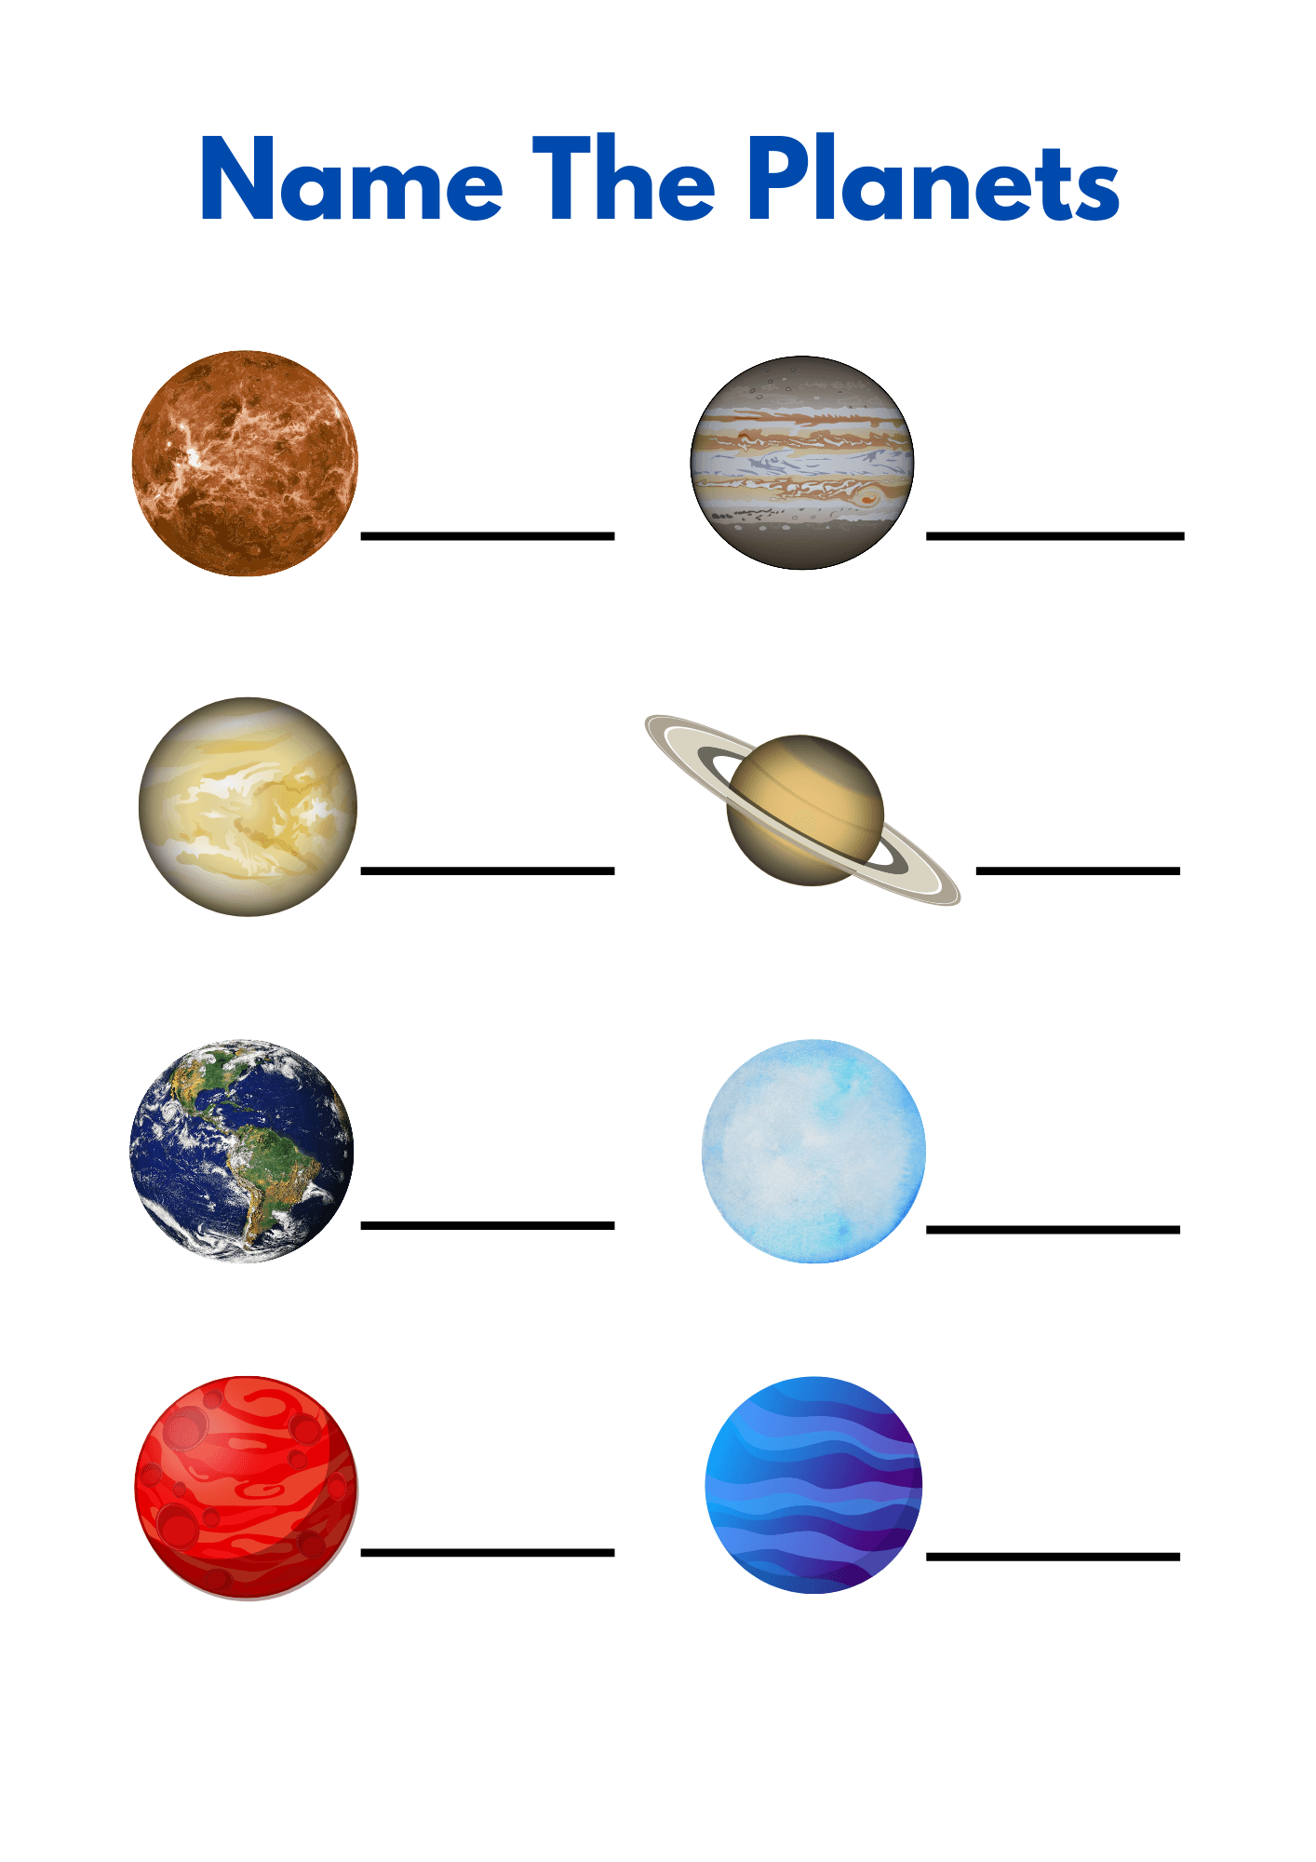
- Mr Oscar displayed photographs of different planets in class. Which planet supports life?
A
B
C
D
- A boy learns that his ancestors lived in caves and used tools made of stone. This period is referred to as:
A) Bronze Age B) Iron Age
C) Stone Age D) Industrial Age
- Which of the following is a component of Social Studies?
A) Engineering B) Chemistry
C) Citizenship D) Algebra
- Musa is part of a school group that helps clean the market every Saturday. This is an example of:
A) Community service learning
B) Political campaign
C) Religious service
D) Domestic work
- A Grade 8 learner says she is proud to be Kenyan and respects national values. She is demonstrating:
A) Self-interest
B) Good citizenship
C) Shyness
D) Bravery

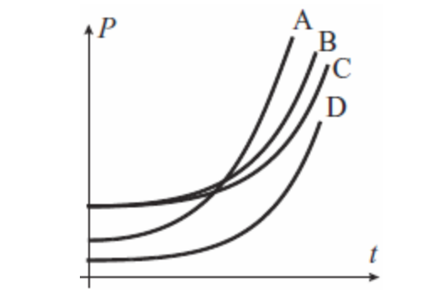
- The table below shows population data for three counties A,B,C and D in Kenya.

Which county has the highest population growth?
A) A B) B C) C D) D
- One of the major causes of the Trans-Saharan slave trade was:
A) Increase in rainfall
B) Need for labor
C) End of war
D) Exploration
- Which of these was a major Swahili civilization city along the East African coast?
A) Timbuktu
B) Meroe
C) Kilwa
D) Addis Ababa
- In a family, members disagree on the use of money. To solve the issue peacefully, they should:
A) Fight it out
B) Separate immediately
C) Use non-violent communication
D) Ignore each other
- Why is it important to protect historical monuments like Great Zimbabwe?
A) For farming purposes
B) To allow mining
C) For learning and tourism
D) To keep wild animals

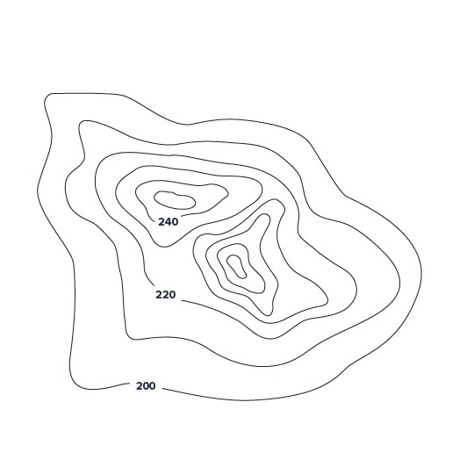
- The Zulu community had strong leadership under:
A) Pharaohs
B) Shaka
C) Mansa Musa
D) Askia
- A student is drawing a sketch map of their school.

The symbol above shows a?
A) Trigonometric station
B) Layer tinting
C) Spot height
D) Contours
- The image below shows people migrating from one region to another due to floods.
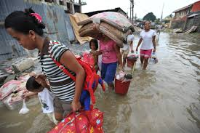
This type of migration is:
A) Political
B) Internal
C) Seasonal
D) Forced

SECTION B: (80 MARKS)

Answer all questions in the spaces provided

TASK 1: MAPWORK (5 MARKS)
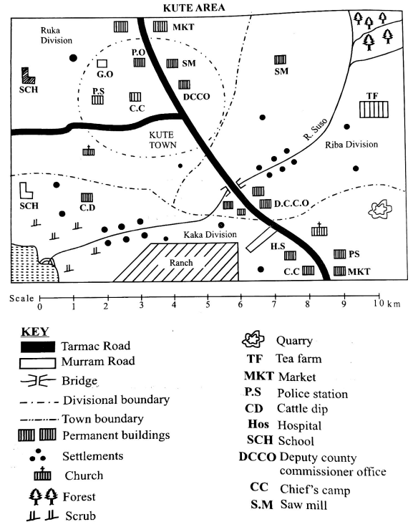
- You are given the map below. Use it to answer question 21 only.

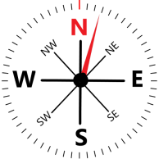

a) Name the type of scale used in the map(1 mark)
__________________________________________________________________________________________.
b) Calculate the actual area of the ranch in KUTE area. (2 marks)

c) Give one marginal information used in the map. (1 mark)
_____________________________________________________________________________________________.
d) Identify the type of settlement in Kute area. (1 mark)
______________________________________________________________________________________________

TASK 2: CITIZENSHIP (5 MARKS)
- In your community, children are taught their rights and responsibilities.
a) List two rights of children in Kenya. (2 marks)
i. _________________________________________________________________________________________
ii. ________________________________________________________________________________________
b) Suggest one way in which children’s rights are protected in Kenya. (1 mark)
i. _____________________________________________________________________________________
c) Name one Nobel Peace Prize winner who advocated for human rights. (1 mark)
i. _________________________________________________________________________________________
d) Give one way of showing good citizenship in school. (1 mark)
i. _________________________________________________________________________________________

TASK 3: HISTORY (30 MARKS)
- Your class is preparing a drama based on the Trans-Saharan slave trade.
a) State two reasons for the development of the Trans-Saharan slave trade. (2 marks)
i. _________________________________________________________________________________________
ii. ________________________________________________________________________________________
b) Identify one slave route used. (1 mark)
i. _________________________________________________________________________________________
c) Explain two effects of the trade on African communities. (4 marks)
i. _________________________________________________________________________________________
ii. ________________________________________________________________________________________
- You visited a museum and saw tools from the Stone Age.
a) State one way the early humans adapted to their environment. (1 mark)
i. _________________________________________________________________________________________
b) Name the scientific theory that explains human origin. (1 mark)
i. _________________________________________________________________________________________
c) List two changes that took place in humans as they evolved. (2 marks)
i. _________________________________________________________________________________________
ii. ________________________________________________________________________________________
- Your group is researching on early African civilizations.
a) Name two early civilizations in Africa. (2 marks)
i. _________________________________________________________________________________________
ii. ________________________________________________________________________________________
b) Explain how the civilization at Kilwa contributed to trade. (2 marks)
i. _________________________________________________________________________________________
ii. ________________________________________________________________________________________
c) Give one best practice from ancient Egypt that has benefited the modern world. (1 mark)
i. _________________________________________________________________________________________
- The Constitution of Kenya provides guidelines on leadership and integrity.
a) Name two components of the Constitution. (2 marks)
i. _________________________________________________________________________________________
ii. ________________________________________________________________________________________
b) State one role of the judiciary. (1 mark)
i. _________________________________________________________________________________________
c) Give two guiding principles of leadership. (2 marks)
i. _________________________________________________________________________________________
ii. ________________________________________________________________________________________
- Look at the picture below of a certain African historical ruins.
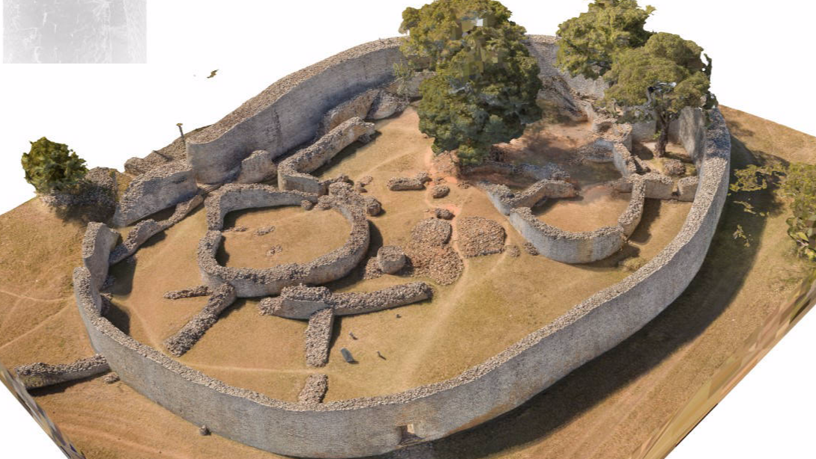

a) Identify the structure. (1 mark)
i. _________________________________________________________________________________________
b) Explain its historical importance. (2 marks)
i. _________________________________________________________________________________________
ii. ________________________________________________________________________________________
c) State one way of conserving such monuments. (1 mark)
i. _________________________________________________________________________________________

TASK 4: GEOGRAPHY (30 MARKS)
- The climate of a place is influenced by many factors.
a) Name two factors influencing climate. (2 marks)
i. _________________________________________________________________________________________
ii. ________________________________________________________________________________________
b) List three characteristics of equatorial climate. (3 marks)
i. _________________________________________________________________________________________
ii. ________________________________________________________________________________________
iii. ________________________________________________________________________________________
- A teacher presented a chart in class with the drawing of the mountain vegetation as shown below.
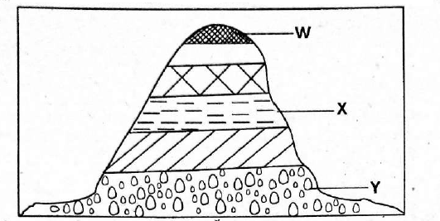
a) Identify the vegetation zones labelled W, X, and Y, respectively. (3mks)
i. _________________________________________________________________________________________
ii. ________________________________________________________________________________________
b) Describe one way in which vegetation influences human activity. (1mark)
i. _________________________________________________________________________________________
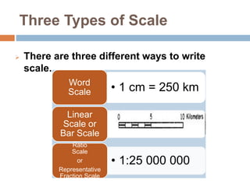
- Refer to the image showing different types of scale.
a) Match each scale with its name. (3 marks)
  - Linear scale

  - Ratio scale

  - Statement scale

b) Convert 1:100,000 to statement scale. (1 mark)

- You are doing a project on drainage systems in Africa.
a) Define the term solar system. (1 mark)
_________________________________________________________________________________________
________________________________________________________________________________________
_______________________________________________________________________________________
b) Name two galaxies in space.(2 marks)
i. _________________________________________________________________________________________
ii. ________________________________________________________________________________________
iii. _______________________________________________________________________________________
c) Describe the origin of the earth with regards to the passing star theory . (2 marks)
__________________________________________________________________________________________
__________________________________________________________________________________________
__________________________________________________________________________________________
__________________________________________________________________________________________

- Lupita Junior school learners visited a certain weather station to learn more about weather and climate.
a) Name two elements of weather. (2 marks)
- ______________________________________________________________________
- ______________________________________________________________________
b) State one factor that affects rainfall. (1 mark)
________________________________________________________________________________
c) Identify the weather instrument shown below. (1 mark)


_____________________________________________________________________________.
c) Give one characteristics of desert climate. (1 mark)
______________________________________________________________________________________
______________________________________________________________________________________

TASK 5: LIFE SKILLS AND PERSONAL DEVELOPMENT (10 MARKS)
- You have a friend who is always sad and feels like nobody cares about him.
a) Suggest two ways to help him build self-esteem. (2 marks)
- ___________________________________________________________________________________
- ___________________________________________________________________________________
b) What is empathy? (1 mark)
________________________________________________________________________________________
________________________________________________________________________________________
c) Give one impact of negative emotions on others. (1 mark)
_____________________________________________________________________________________
_____________________________________________________________________________________
- During group work, Mary refused to work with others. Later, she explained she was facing pressure at home.
a) Define peer pressure. (1 mark)
________________________________________________________________________________________
_______________________________________________________________________________________
b) List two effects of peer pressure. (2 marks)
- ___________________________________________________________________________________
- ___________________________________________________________________________________
c) Suggest one way Mary can manage her emotions. (1 mark)
______________________________________________________________________________________
______________________________________________________________________________________ d) How can the group support her? (1 mark)
____________________________________________________________________________________________

_____________________________________________________________________________________________________________________________

THIS IS THE LAST PRINTED PAGE.

