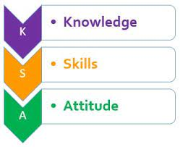

KENYA JUNIOR SCHOOL EDUCATION ASSESSMENT
GRADE 8: 801/1: ENGLISH
CODE: 008 YEAR: 2025
MARKING SCHEME

Question No. | Answer
1 | C
2 | C
3 | C
4 | C
5 | B
6 | C
7 | B
8 | D
9 | C
10 | B
11 | C
12 | B
13 | C
14 | C
15 | C
16 | C
17 | D
18 | C
19 | B
20 | B
21 | B
22 | B
23 | B
24 | B
25 | B
26 | B
27 | B
28 | C
29 | B
30 | C
31 | B
32 | C
33 | B
34 | C
35 | C
36 | D
37 | C
38 | C
39 | C
40 | A
41 | C
42 | B
43 | B
44 | C
45 | C
46 | C
47 | A
48 | A
49 | B
50 | C

THIS IS THE LAST PRINTED PAGE.

