Candidate’s Name |  | Assessment Number
School Name |  | School Code
Candidate’s Signature |  | Date
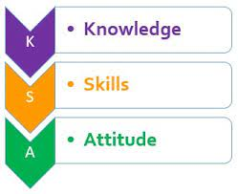


MONITORING JUNIOR SCHOOL LEARNER PROGRESS
GRADE 8: 806/1: AGRICULTURE AND NUTRITION
PAPER 1 (Theory)
CODE: 008 YEAR: 2025
TIME: 2 HOURS
INSTRUCTIONS TO CANDIDATES:
Instructions to Candidates:
- Write your name and assessment number in the spaces provided.
- Answer ALL questions in Section A and Section B.
- All answers must be written in the spaces provided in this question booklet.
- This paper consists of 12 printed pages. Candidates should check the question paper to ascertain that all pages are printed as indicated and that no questions are missing.
- Candidates should answer the questions in English.

For Official Use Only

SECTION A: MULTIPLE CHOICE QUESTIONS (30 Marks)
Question Number | 1 | 2 |  | 3 | 4 |  | 5 | 6 | 7 |  | 8 | 9 | 10 | 11 | 12 | 13 | 14 | 15
Maximum Score | 1 | 1 |  | 1 | 1 |  | 1 | 1 | 1 |  | 1 | 1 | 1 | 1 | 1 | 1 | 1 | 1
Candidate’s Score
Question Number | 16 |  | 17 |  |  | 18 |  | 19 |  | 20 |  | 21 | 22 | 23 | 24 | 25 | 26 | 27 | 28 | 29 | 30 | Total score
Maximum Score | 1 |  | 1 |  |  | 1 |  | 1 |  | 1 |  | 1 | 1 | 1 | 1 | 1 | 1 | 1 | 1 | 1 | 1 | 30
Candidate’s Score

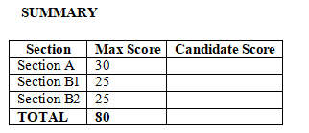
SECTION B: STRUCTURED QUESTIONS (50 Marks)

Part 1: AGRICULTURE (25 Marks)
Qn No. | 31 | 32 | 33 | 34 | 35 | 36 | 37 | Total Agriculture
Max Score | 3 | 3 | 5 | 4 | 4 | 4 | 2 | 24
Cand score

Part 2: NUTRITION (25 Marks)
Qn No. | 38 | 39 | 40 | 41 | 42 | 43 | 44 | Total Nutrition
Max Score | 3 | 3 | 3 | 4 | 4 | 4 | 4 | 25
Cand score

This paper consists of 7 printed pages. Candidates should check the question paper to ascertain that all the pages are printed as indicated and that no questions are missing.
© 2025 The Kenya Junior School Examination and Assessment Series. Turn over

SECTION A: (30 MARKS)
Choose the most appropriate answer for each question.
- Juma notices that rainwater is washing away the topsoil in his family’s farm. Which method would best help him prevent further soil erosion?
A. Mulching B. Grafting
C. Broadcasting D. Thinning
- Your school farm recently constructed a shallow pan to collect and store rainwater.
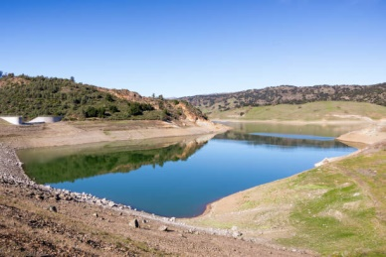
This structure is mainly used for:
A. Compost making B. Raising seedlings
C. Water harvesting D. Washing tools
- Which of the following shows a form of soil pollution?
A. Growing cover crops
B. Dumping plastic waste on the farm
C. Rotating crops
D. Applying organic manure
- Scenario: A farmer adds dry grass and banana leaves on the farm surface to reduce water loss and erosion. This practice is known as:
A. Weeding B. Mulching
C. Thinning D. Manuring
- One of the importance of growing trees in the farm is to:
A. Increase pest infestation
B. Use up farm nutrients
C. Improve soil fertility
D. Block sunlight
- Which of the following is NOT a crop management practice?
A. Pruning B. Weeding
C. Sorting D. Thinning
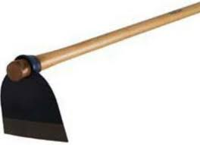
- The image shows a tool used for preparing planting sites. What is the tool called?

A. Slasher B. Hoe C. Rake D. Spade
- Water retention ditches are built across a slope to:
A. Carry water downhill
B. Increase soil erosion
C. Help water soak into the soil
D. Store seeds
- Which method is used in preserving milk for longer use at home?
A. Washing B. Boiling
C. Slicing D. Stirring
- At home, Amina is helping her mother roast maize on a charcoal stove. This cooking method is known as:
A. Steaming B. Boiling
C. Roasting D. Frying
- Mokeira observed that her chicken suffered from a poultry disease as shown.
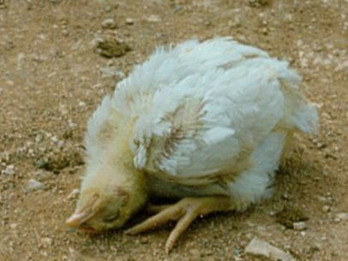
The disease the chicken was suffering from was?
A. Newcastle B. Anthrax
C. Foot and Mouth D. Ringworm
- The correct way to care for coloured clothes during laundry is:
A. Use hot water and bleach
B. Dry in direct sunlight
C. Wash separately using mild soap
D. Mix with white clothes
- Which tilth is most suitable for planting maize seeds?
A. Very fine B. Coarse
C. Moderate D. Lumpy
- Which structure is used in constructing suspended kitchen gardens?
A. Water pan B. Sack C. Shamba D. Chicken coop

- One major benefit of kitchen gardening at home is:
A. Uses expensive tools
B. Requires large land
C. Provides fresh vegetables
D. Increases soil pollution
- Scenario: A learner is making a plain seam using a needle and thread. Which activity is she likely doing?
A. Knitting B. Cooking
C. Sewing D. Drawing
- A home innovation that helps poultry drink water easily is called:
A. Chicken trap B. Egg incubator
C. Poultry shelter D. Animal waterer
- Which item is suitable for storing honey in the kitchen?
A. Plastic cup
B. Open basket
C. Clean glass jar with lid
D. Paper bag
- The component of a balanced diet that helps with growth is:
A. Fats B. Carbohydrates
C. Vitamins D. Proteins
- A school nutritionist serves food to pupils one by one from the same bowl. This serving method is called:
A. Tray method
B. Blue plate service
C. Family service
D. Dish sharing
- Which practice promotes hygiene in poultry rearing?
A. Using dirty water
B. Overcrowding the coop
C. Cleaning the poultry house regularly
D. Allowing pests inside
- Wanjiku noticed yellow patches on sukuma wiki leaves and stunted growth. The most likely cause is:
A. Poor watering
B. Pest infestation
C. Weed competition
D. Good management
- Which of the following is a knitted household item?
A. Cupboard B. Spoon
C. Table mat D. Apron
- A food nutrient that protects the body from diseases is called:
A. Protein B. Vitamin C. Fat D. Carbohydrate
- Scenario: Musa is drying fish under the sun after cleaning and salting it. What is the purpose of this method?
A. To make it hard
B. To improve taste only
C. To preserve it for longer
D. To sell it faster
- Signs of sick crops may include all the following EXCEPT:
A. Wilting
B. Discoloration
C. Shiny green leaves
D. Drying leaves
- A tool used for measuring cooking ingredients accurately is:
A. Knife
B. Sieve
C. Measuring cup
D. Spoon
- The image shows vegetables grown in sacks near a kitchen. What type of garden is this?
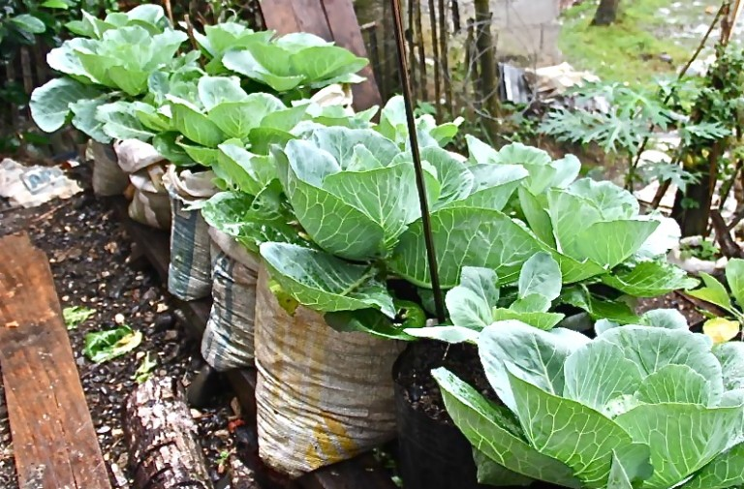
A. Tray garden
B. Fence garden
C. Sack garden
D. Water garden
- Which cooking method uses steam to cook food?
A. Roasting
B. Frying
C. Steaming
D. Baking
- Which type of seam is suitable for making a pillow case?
A. French seam
B. Open seam
C. Back stitch
D. Buttonhole

SECTION B: (50 MARKS)

Part 1: Agriculture (25 Marks)
- Explain two causes of soil pollution and one way of controlling it. (3marks)
- _______________________________________________________________________________.
- _______________________________________________________________________________.
- Describe how a water pond and a shallow pan help in water harvesting on a farm. (3marks)
- _______________________________________________________________________________.
- _______________________________________________________________________________.
- _______________________________________________________________________________.
- _______________________________________________________________________________.
- Use a drawing to illustrate a retention ditch and explain how it prevents soil erosion. (5marks)

- Mention three crop management practices and state their importance. (4marks)
- _______________________________________________________________________________.
- _______________________________________________________________________________.
- _______________________________________________________________________________.
- Your school has introduced a kitchen garden project.
a) State two types of kitchen gardens used in Kenya. (2marks)
- _______________________________________________________________________________.
- _______________________________________________________________________________.
b) Mention two benefits of kitchen gardening. (2marks)
- _______________________________________________________________________________.
- _______________________________________________________________________________.
- Describe the process of dressing a poultry carcass. (4marks)
- _______________________________________________________________________________.
- _______________________________________________________________________________.
- _______________________________________________________________________________.
- _______________________________________________________________________________.
- List any two poultry diseases and describe how they can be prevented. (2marks)
- _______________________________________________________________________________.
- _______________________________________________________________________________.

Part 2: Nutrition (25 Marks)
- Define a balanced diet and list its three main components. (3marks)

_______________________________________________________________________________.
_______________________________________________________________________________.
_______________________________________________________________________________.
- Mention two advantages of using the steaming method when cooking vegetables. (3marks)
- _______________________________________________________________________________.
- _______________________________________________________________________________.

- A learner is asked to demonstrate table dining manners during a meal. Mention any three good practices she should show. (3marks)
- _______________________________________________________________________________.
- _______________________________________________________________________________.
- Your group is planning a meal presentation activity.
a) Describe family serving style. (2marks)
_______________________________________________________________________________.
_______________________________________________________________________________.
b) Mention two hygiene practices to observe when serving. (2marks)
- _______________________________________________________________________________.
- _______________________________________________________________________________.
- Your class is learning about home soap making.
a) State two materials used in making home soap. 2marks)
- _______________________________________________________________________________.
- _______________________________________________________________________________.
b) Give two reasons why homemade soap is important. 2marks)
- _______________________________________________________________________________.
- _______________________________________________________________________________.
- (a) Name two types of seams used when making simple household articles like lap bags. (2marks)
- _______________________________________________________________________________.
- _______________________________________________________________________________.

(b) Draw one of the seams. (2marks)

- Explain two safety and hygiene practices you must follow when preparing honey and eggs at home. (4marks)
- _______________________________________________________________________________.
- _______________________________________________________________________________.

THIS IS THE LAST PRINTED PAGE.

