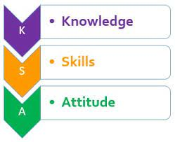

KENYA JUNIOR SCHOOL EDUCATION ASSESSMENT
GRADE 8: 806/1: AGRICULTURE AND NUTRITION
CODE: 008 YEAR: 2025
MARKING SCHEME

SECTION A:
Question No. | Answer
1. | A
2. | C
3. | B
4. | B
5. | C
6. | C
7. | B
8. | C
9. | B
10. | C
11. | A
12. | C
13. | C
14. | B
15. | C
16. | C
17. | D
18. | C
19. | D
20. | D
21. | C
22. | C
23. | C
24. | B
25. | C
26. | C
27. | C
28. | C
29. | C
30. | A

SECTION B: STRUCTURED QUESTIONS (50 Marks)

Part 1: AGRICULTURE (25 Marks)
31. Explain two causes of soil pollution and one way of controlling it. (3 marks)
i. Causes of Soil Pollution:
  - Improper disposal of non-biodegradable waste (e.g., plastics, glass, metals): These materials do not decompose naturally and accumulate in the soil, preventing air and water circulation, hindering plant growth, and releasing harmful chemicals as they break down into micro-plastics. They also physically disrupt the soil structure.
  - Excessive and incorrect use of chemical fertilizers and pesticides: Over-application of synthetic fertilizers (like nitrates and phosphates) can lead to chemical build-up, altering soil pH, harming beneficial microorganisms, and leaching into groundwater. Pesticides and herbicides contain toxic chemicals that persist in the soil, poisoning soil organisms, contaminating crops, and affecting the food chain.
  - Industrial waste and effluents: Untreated waste products, heavy metals, and toxic chemicals from factories and industries, when discharged onto land or into water bodies that eventually contaminate soil, can render the soil infertile and unsafe for cultivation or human contact.
  - Leakage from underground storage tanks and landfills: Hazardous substances from leaking fuel tanks or improperly managed landfills can seep into the soil, contaminating vast areas with persistent organic pollutants and heavy metals, making it unsuitable for any use.
  - Deforestation and poor land management practices: While not direct pollution, these can lead to accelerated soil erosion, exposing lower, less fertile layers and carrying away topsoil, often depositing it in water bodies, which can then deposit contaminated sediments in new areas. This also reduces the soil's capacity to filter pollutants.
ii. Way of Controlling Soil Pollution:
  - Proper waste management and recycling: Implementing effective systems for collecting, sorting, and recycling non-biodegradable materials. This prevents them from being dumped on agricultural land or in landfills where they can leach into the soil. Promoting segregation of waste at source (e.g., organic vs. inorganic).
  - Promotion of organic farming practices: Encouraging the use of organic fertilizers (compost, farmyard manure), biological pest control methods, and crop rotation. This reduces reliance on synthetic chemicals, improving soil health, biodiversity, and reducing chemical residues.
  - Bioremediation: Using microorganisms (bacteria, fungi) or plants to break down or absorb pollutants from contaminated soil. This is a natural and environmentally friendly way to clean up polluted sites.
  - Legislation and strict enforcement: Governments can implement and enforce strict laws regarding industrial waste disposal, chemical use in agriculture, and proper handling of hazardous materials to prevent soil contamination. Penalties for non-compliance should be applied.
  - Public awareness and education: Educating farmers and the general public about the causes and dangers of soil pollution and promoting responsible practices in waste disposal and chemical use.
32. Describe how a water pond and a shallow pan help in water harvesting on a farm. (3 marks)
i. Water Pond: A water pond is a larger, often deeper, excavated depression in the ground designed to collect and store significant volumes of surface runoff water, especially during rainy seasons.
How it helps: As rainwater flows over the farm or surrounding catchment area, it naturally drains into this excavated pond, where it is held. The large capacity of a pond allows for the storage of substantial amounts of water, which can then be used for various farm activities during dry periods, such as irrigating crops, watering livestock, or even for aquaculture (fish farming). The stored water can also recharge groundwater.
ii. Shallow Pan: A shallow pan (also known as a micro-dam or a sunken bed in some contexts) is a smaller, typically shallower, depression or basin constructed within the farm field.
How it helps: Shallow pans are designed to capture and retain rainwater at the immediate point of collection, preventing it from flowing away as runoff. They allow the collected water to slowly infiltrate into the soil, increasing soil moisture content directly around the plants. This is particularly effective for enhancing germination and growth of individual crops or small clusters of plants by concentrating water where it is most needed, reducing localized erosion, and improving water use efficiency. They are usually placed strategically in rows or around individual plants.
33. Use a drawing to illustrate a retention ditch and explain how it prevents soil erosion. (5 marks)
- Drawing (3 marks):
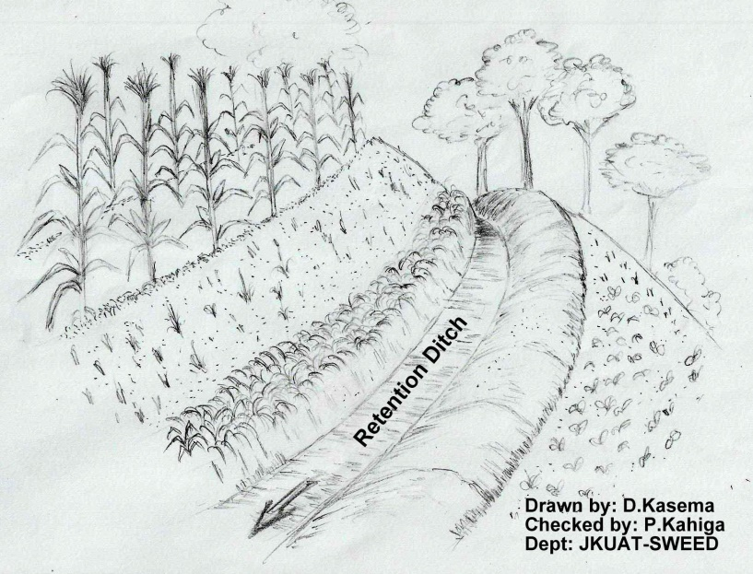
Diagram should show:
    - A clear slope.
    - A ditch dug horizontally (along the contour) across the slope.
    - A bank/ridge of soil on the lower side of the ditch (downhill side).
    - Arrow(s) indicating water flow downhill towards the ditch.
    - Arrow(s) indicating water infiltrating into the soil from the ditch.
    - Label: "Slope," "Retention Ditch," "Soil Bank/Bund."
- Explanation (2 marks):
How it prevents soil erosion: A retention ditch (also known as a contour ditch or bund) is a narrow channel dug along the contour lines of a sloping piece of land, with a raised bank or bund on its downhill side.
Mechanism 1: Trapping Runoff Water: When it rains, surface runoff water flowing down the slope is intercepted and collected by the ditch. Instead of rapidly flowing downslope and carrying away valuable topsoil, the water is held within the ditch.
Mechanism 2: Promoting Infiltration: By holding the water, the retention ditch allows it more time to slowly soak (infiltrate) into the soil. This replenishes soil moisture, makes more water available for plants, and reduces the erosive energy of fast-moving surface water. The ditch effectively breaks the continuous flow of water down the slope, minimizing the force that causes sheet and rill erosion.
Mechanism 3: Trapping Eroded Soil: Any soil particles that are detached by the initial force of rainfall or carried by the slow-moving water are trapped within the ditch before they can be washed further downslope. This helps to conserve topsoil and maintain soil fertility.
34. Mention three crop management practices and state their importance. (4 marks)
i. Practice: Weeding
Importance: Weeding is the removal of unwanted plants (weeds) from the cultivated area. It is crucial because weeds compete with crops for essential resources like sunlight, water, nutrients, and space. By removing weeds, farmers ensure that crops get adequate resources, leading to healthy growth, higher yields, and better quality produce. Weeds can also harbor pests and diseases.
ii. Practice: Thinning
Importance: Thinning involves removing excess seedlings or plants from a row or patch to create optimal spacing between the remaining plants. This is important to reduce competition among crops for nutrients, water, and sunlight, similar to weeding. Proper spacing allows individual plants to develop strong root systems, grow to their full potential, and produce larger, higher-quality fruits or grains, thereby improving overall yield.
iii. Practice: Pruning
Importance: Pruning is the selective removal of specific parts of a plant, such as branches, buds, or roots. Its importance lies in:
    - Improving yield and quality: By removing unproductive or diseased branches, energy is redirected to fruit-bearing parts, increasing fruit size and quantity.
    - Controlling plant shape and size: Pruning helps maintain a manageable plant size, facilitating harvesting and other farm operations.
    - Improving air circulation and light penetration: Removing dense foliage allows better airflow, which reduces humidity and the incidence of fungal diseases. It also ensures sunlight reaches all parts of the plant, promoting uniform ripening.
    - Removing diseased or dead parts: This prevents the spread of diseases within the plant and to other healthy plants.
Other possible crop management practices and their importance:
  - Fertilizer Application/Manuring: Important for replenishing soil nutrients removed by crops, ensuring plants have enough food for vigorous growth and high yields.
  - Pest and Disease Control: Essential for protecting crops from damage caused by insects, fungi, bacteria, and viruses, which can drastically reduce yield and quality.
  - Irrigation: Providing water to crops during dry periods is crucial for their survival and optimal growth, especially in arid or semi-arid regions or during dry spells.
  - Crop Rotation: Helps to maintain soil fertility, manage pests and diseases by breaking their life cycles, and improve soil structure.
  - Tillage/Soil Preparation: Prepares a suitable seedbed, improves soil aeration, and incorporates organic matter, essential for healthy root development and nutrient uptake.
35. Your school has introduced a kitchen garden project.
a) State two types of kitchen gardens used in Kenya. (2 marks)
i) Answer: Sack gardens (Vertical gardens).
Elaboration: These involve growing vegetables in tall sacks filled with soil and manure, with planting holes cut into the sides and top. They are ideal for small spaces, urban areas, and water-scarce regions as they utilize vertical space efficiently and can be managed with minimal water.
ii) Answer: Tire gardens.
Elaboration: Old tires are stacked on top of each other and filled with soil to create raised planting beds. They are an excellent way to repurpose waste materials and are suitable for growing various vegetables in limited spaces. Other types:
Raised bed gardens: Constructed by building a frame (wood, stone, brick) and filling it with enriched soil, offering better drainage and easier access.
Container gardens: Growing plants in pots, buckets, or other containers, suitable for balconies or small paved areas.
Keyhole gardens: Circular raised beds with a central compost basket, designed for efficient water and nutrient distribution, often found in dry areas.
Conventional/Open-field gardens: Traditional gardens directly on the ground, requiring more space but allowing for a wider variety of crops.
b) Mention two benefits of kitchen gardening. (2 marks)
i) Answer: Provides fresh, nutritious, and readily available vegetables/food for the household.
Elaboration: Kitchen gardens offer a continuous supply of healthy produce, reducing the need to buy vegetables from the market. This ensures a family has access to fresh, organic ingredients, which can improve dietary health and food security.
ii) Answer: Reduces household food expenditure.
Elaboration: By growing their own vegetables, families can significantly cut down on grocery bills, saving money that can be used for other essential needs. This promotes economic self-sufficiency.
Other benefits:
Promotes healthy eating habits: Encourages consumption of more vegetables and fruits, particularly among children, who are often more willing to eat what they've helped grow.
Offers a source of income: Surplus produce can be sold to neighbors or local markets, generating extra income for the family.
Educational opportunity: Provides practical learning experience for students and family members about agriculture, plant growth, and environmental sustainability.
Environmentally friendly: Reduces food miles (carbon footprint), promotes organic practices, and can help manage household organic waste through composting.
Therapeutic and recreational activity: Gardening can be a relaxing and enjoyable hobby, providing physical activity and stress relief.
36. Describe the process of dressing a poultry carcass. (4 marks)
i. Bleeding (Slaughter):
The first step after stunning the bird (to minimize stress) is to cut the jugular vein in the neck to allow complete bleeding. Proper bleeding is crucial for good meat quality and shelf life. The bird is usually hung upside down during this process to facilitate drainage of blood.
ii. Scalding:
After bleeding, the bird is immersed in hot water (typically around 60-65°C or 140-150°F) for a short period (30-60 seconds). This process loosens the feathers, making them easier to remove. The water should be hot enough to loosen feathers but not so hot as to cook the skin.
iii. Plucking/Feather Removal:
Immediately after scalding, the feathers are removed. This can be done manually by hand (pulling feathers in the direction of growth) or using a mechanical plucker. All feathers, including down feathers, should be removed thoroughly.
iv. Evisceration (Removal of Internal Organs):
After plucking, an incision is made in the abdominal cavity. The internal organs (guts, liver, heart, gizzard, lungs, etc.) are carefully removed without rupturing them to avoid contamination. The edible organs (giblets) like liver, heart, and gizzard are usually saved, cleaned, and kept separately.
Other steps typically involved:
Singeing: Briefly passing the carcass over a flame to remove any remaining fine hairs.
Washing: The dressed carcass is thoroughly washed with cold water, inside and out, to remove any remaining blood, dirt, or debris.
Chilling/Cooling: The carcass is then quickly chilled to lower its temperature, which inhibits bacterial growth and helps preserve the meat.
37. List any two poultry diseases and describe how they can be prevented. (2 marks)
i. Disease: Newcastle Disease
Description: A highly contagious and often fatal viral disease affecting chickens and other poultry, causing respiratory, nervous, and digestive signs (e.g., coughing, paralysis, twisted neck, green diarrhea).
Prevention: Primarily prevented through vaccination. Chicks are vaccinated at specific ages (e.g., day-old, then booster shots). Good biosecurity measures, such as strict hygiene, limiting visitors, isolating new birds, and preventing contact with wild birds, are also crucial.
ii. Disease: Fowl Pox
Description: A viral disease causing characteristic wart-like lesions on unfeathered parts of the bird (head, comb, wattles) and sometimes in the mouth and throat. It generally has a lower mortality rate than Newcastle but can cause economic losses due to reduced egg production and growth.
Prevention: Prevented through vaccination (wing web method for live vaccine). Also, controlling mosquitoes (which can transmit the wet form of the disease) and maintaining good hygiene in the poultry house helps.
Other possible diseases and their prevention:
Gumboro Disease (Infectious Bursal Disease - IBD):
Prevention: Vaccination is the most effective method, along with strict biosecurity to prevent introduction to the flock.
Coccidiosis:
Prevention: Good litter management (keeping litter dry), use of coccidiostats in feed (medicated feed), and vaccination. Proper hygiene to reduce oocyst build-up.
Marek's Disease:
Prevention: Vaccination of chicks at one day old is highly effective. Good hygiene.
Fowl Cholera:
Prevention: Vaccination, strict biosecurity, sanitation, and prompt isolation of sick birds. Rodent control is also important as they can carry the bacteria.

Part 2: NUTRITION (25 Marks)
38. Define a balanced diet and list its three main components. (3 marks)
Definition: A balanced diet is a diet that provides an adequate amount of all the essential nutrients (carbohydrates, proteins, fats, vitamins, minerals, and water) in the correct proportions needed to maintain good health, proper growth, and normal body function. It ensures that the body receives sufficient energy and all the building blocks for repair, maintenance, and defense against diseases.
Three Main Components:
i. Carbohydrates: Primarily provide energy for daily activities and bodily functions.
ii. Proteins: Essential for growth, repair of body tissues, and production of enzymes and hormones.
iii. Fats/Lipids: Provide concentrated energy, insulate the body, protect organs, and aid in the absorption of fat-soluble vitamins.
While the question asks for three, a comprehensive diet also includes:
Vitamins: Organic compounds needed in small quantities for various metabolic functions and disease prevention.
Minerals: Inorganic elements crucial for bone formation, nerve function, fluid balance, etc.
Water: Vital for hydration, nutrient transport, temperature regulation, and most bodily processes.
39. Mention two advantages of using the steaming method when cooking vegetables. (3 marks)
i. Retains more nutrients (vitamins and minerals).
Elaboration: Steaming cooks food using hot vapor, rather than direct contact with boiling water. This minimizes the leaching of water-soluble vitamins (like Vitamin C and B vitamins) and minerals into the cooking water, ensuring that more of these essential nutrients remain in the vegetables, making them healthier.
ii. Preserves the natural colour, texture, and flavour of vegetables.
Elaboration: Steaming gently cooks vegetables without over-softening or discolouring them. The vegetables retain their vibrant colours, firm yet tender texture, and fresh, natural taste, making them more appealing and palatable. This is often lost in boiling where vegetables can become mushy or dull.
Other advantages:
Does not require added fats/oils: Making it a healthier cooking method as it avoids adding extra calories and unhealthy fats.
Easy to digest: Steamed vegetables are generally easier for the body to digest compared to fried or heavily processed alternatives.
Prevents scorching or burning: Since food is cooked by steam, there is no risk of burning the food, making it a safer and less attention-demanding cooking method.
Versatility: Can cook multiple foods at once (e.g., vegetables and fish) without mixing flavours, using a multi-tiered steamer.
40. A learner is asked to demonstrate table dining manners during a meal. Mention any three good practices she should show. (3 marks)
i. Wash hands before coming to the table.
Elaboration: This is a fundamental hygiene practice that prevents the transfer of germs from hands to food and utensils, ensuring food safety for oneself and others sharing the meal.
ii. Sit upright and do not lean on the table.
Elaboration: Maintaining good posture at the table shows respect for the meal and those sharing it. It also allows for comfortable and proper eating.
iii. Wait for everyone to be served or for the host to start eating before beginning.
Elaboration: This demonstrates patience, respect, and consideration for others at the table. It ensures that everyone can enjoy the meal together and fosters a polite dining atmosphere.
Other good practices:
- Use utensils correctly and quietly: Learn how to hold a knife and fork, and avoid clanking them loudly against the plate.
- Chew food with your mouth closed and avoid talking with a full mouth. This prevents unpleasant sights and sounds and ensures good hygiene.
- Do not reach across the table: Ask politely for items to be passed to you.
- Use a napkin appropriately: Dab your mouth, not wipe it. Keep it on your lap when not in use.
- Eat slowly and avoid rushing. Enjoy your meal and allow for conversation.
- Do not play with food or utensils.
- Excuse yourself when leaving the table during a meal.
- Offer to help serve or clear the table after the meal (if appropriate).
- Express gratitude to the person who prepared/served the meal.
41. Your group is planning a meal presentation activity.
a) Describe family serving style. (2 marks)
Description: Family serving style is a meal service method where all the prepared food is placed in serving dishes (platters, bowls) on the dining table or a side table. Diners then serve themselves from these common dishes, passing them around the table. Each person takes the amount of food they desire from the various dishes presented.
Elaboration: This style promotes a relaxed and communal dining atmosphere, encouraging interaction and conversation as people share the food. It is commonly used in homes and allows individuals to control their portion sizes.
b) Mention two hygiene practices to observe when serving. (2 marks)
i) Answer: Ensure hands are clean (washed with soap and water) or wear clean gloves.
Elaboration: Hands are the primary means of contact with food. Washing hands thoroughly before handling serving utensils or food prevents the transfer of bacteria and contaminants, ensuring the food remains safe and hygienic for consumption.
ii) Answer: Use clean serving utensils (spoons, tongs, ladles) for each dish.
Elaboration: Avoid using hands to serve food or using the same utensil for multiple dishes. Separate, clean serving utensils prevent cross-contamination between different food items and ensure hygienic handling.
Other hygiene practices:
- Cover food dishes to prevent contamination from dust, insects, or airborne particles. This is especially important for food left on the table for some time.
- Avoid sneezing, coughing, or talking directly over food. Turn away or cover your mouth/nose with a tissue if necessary.
- Do not allow sick individuals to handle or serve food.
- Ensure serving dishes and tablecloths are clean.
- Maintain proper food temperatures (hot food hot, cold food cold) to prevent bacterial growth.
42. Your class is learning about home soap making.
a) State two materials used in making home soap. (2 marks)
i) Answer: Fats or oils.
Elaboration: These are the primary ingredients that react with a strong alkali to form soap. Common examples include cooking oils (e.g., coconut oil, palm oil, olive oil, sunflower oil), animal fats (e.g., tallow, lard), or shea butter. They determine the soap's lathering, hardness, and moisturizing properties.
ii) Answer: Lye (Sodium Hydroxide/Caustic Soda) or Potassium Hydroxide.
Elaboration: Lye (NaOH) is a strong alkali used for solid bar soap, while potassium hydroxide (KOH) is used for liquid soap. It is a critical component that undergoes a chemical reaction called saponification with the fats/oils to transform them into soap. It must be handled with extreme care due to its corrosive nature.
Other materials:
Water: Used to dissolve the lye before mixing it with the oils.
Additives: Such as essential oils (for fragrance), colorants (e.g., natural pigments), exfoliants (e.g., oatmeal, coffee grounds), and superfatting agents (extra oils to make the soap more moisturizing).
b) Give two reasons why homemade soap is important. (2 marks)
i) Answer: It can be made using readily available and often cheaper local materials.
Elaboration: Home soap making often utilizes accessible fats, oils, and lye, reducing reliance on expensive commercial soaps. This makes it a cost-effective alternative for households, especially in rural areas, and can even be a source of income.
ii) Answer: Allows control over ingredients, making it suitable for sensitive skin or specific needs.
Elaboration: When making soap at home, one can choose natural ingredients, avoid harsh chemicals, artificial fragrances, and dyes that often irritate sensitive skin or cause allergies. This provides a customized, safer, and potentially more beneficial product for personal use.
Other reasons:
Promotes self-sufficiency and entrepreneurial skills: Individuals or groups can learn a valuable skill that can lead to small-scale business opportunities.
Reduces environmental impact: Can utilize recycled cooking oils, reducing waste. The ingredients are often simpler and more biodegradable than complex commercial soap formulations.
Cultural preservation: In some communities, traditional soap making is a valued cultural practice that can be preserved and passed down.
43. (a) Name two types of seams used when making simple household articles like lap bags. (2 marks)
i) Answer: Plain seam.
Elaboration: This is the most basic and common type of seam. It is formed by placing two pieces of fabric right sides together and stitching a straight line along the edge. It's versatile but often requires the raw edges to be finished to prevent fraying.
ii) Answer: French seam.
Elaboration: This seam encloses the raw edges of the fabric within the seam itself, resulting in a neat, durable, and fray-proof finish on both the inside and outside of the garment or article. It involves two lines of stitching and is ideal for sheer or lightweight fabrics, and items like pillowcases or lap bags where a clean finish is desired. Other types suitable for household articles:
Lapped seam: One edge is lapped over the other, then stitched down. Useful for thick fabrics or where a decorative stitch is desired.
Flat fell seam: A very strong, flat seam where raw edges are completely enclosed, often used on jeans and workwear. Could be used for sturdy bags.
Bound seam: Raw edges are enclosed with a binding strip.
- Open seam.
- Plain seam.
- Overlaid seam
- French seam.
- Machine fell seam (double stitched)
- Run and fell seam.
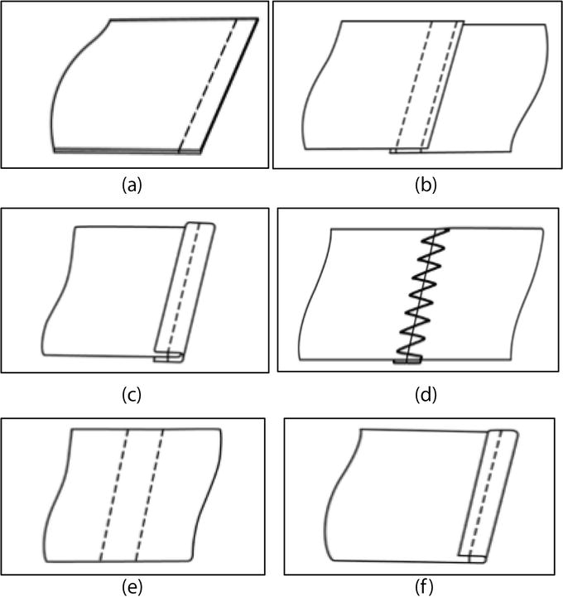
(b) Draw one of the seams. (2 marks)

44. Explain two safety and hygiene practices you must follow when preparing honey and eggs at home. (4 marks)
i. Safety Practice (General for food preparation): Wash hands thoroughly with soap and water before and after handling raw ingredients (honey, eggs) and in between tasks.
Elaboration: Hands can carry bacteria (like Salmonella from eggshells or general dirt). Washing hands prevents cross-contamination, ensuring that pathogens from raw ingredients do not transfer to other foods, utensils, or ready-to-eat surfaces. This is critical for preventing foodborne illnesses.
ii. Hygiene Practice (Specific to Eggs): Store eggs properly in the refrigerator and avoid washing them until just before use.
Elaboration: Eggs should be stored in their original carton in the coldest part of the refrigerator to maintain their freshness and prevent spoilage. Washing eggs prematurely can remove the protective natural coating (bloom) on the shell, making the shell porous and allowing bacteria from the outside to enter the egg, increasing the risk of contamination. Wash just before cracking or cooking.
iii. Safety Practice (Specific to Honey): Handle honey carefully, especially if it's raw or from unknown sources, to avoid contamination and ensure proper storage.
Elaboration: While honey is naturally antibacterial, raw honey can sometimes contain dormant spores of Clostridium botulinum, which can be dangerous for infants under one year old. Therefore, infants should not be given honey. For general use, store honey in a clean, airtight container in a cool, dry place away from direct sunlight to maintain its quality and prevent crystallization or contamination by pests. Use clean utensils when scooping honey to avoid introducing moisture or foreign particles.
iv. Hygiene Practice (General for food preparation): Use clean and separate cutting boards and utensils for raw ingredients (e.g., for breaking eggs if using them in a mix) and ready-to-eat foods.
Elaboration: Cross-contamination is a major risk. If you crack eggs on a surface, bacteria from the shell can transfer. Using separate, clean utensils and boards ensures that any bacteria from raw eggs do not transfer to other ingredients or cooked food, thereby maintaining high hygiene standards and preventing food poisoning.
- Other safety/hygiene practices:
  - Cook eggs thoroughly: Ensure eggs are cooked until the yolk and white are firm to kill any potential Salmonella bacteria.
  - Clean surfaces: Thoroughly clean and sanitize all countertops, cutting boards, and utensils that have come into contact with raw eggs immediately after use.
  - Avoid using cracked or dirty eggs: Cracked shells can allow bacteria to enter. Discard eggs with visibly dirty or cracked shells.

THIS IS THE LAST PRINTED PAGE.

