Candidate’s Name |  | Assessment Number
School Name |  | School Code
Candidate’s Signature |  | Date
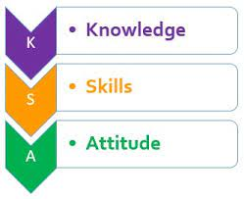


MONITORING JUNIOR SCHOOL LEARNER PROGRESS
GRADE 7: 707: SOCIAL STUDIES.
CODE: 008 YEAR: 2025
TIME: 1 hour 40 minutes
INSTRUCTIONS TO CANDIDATES
- Write your name and class in the spaces provided above.
- This paper consists of two sections: A and B.
- Answer ALL questions in Section A.
- Answer ALL questions in Section B.
- All answers must be written in the spaces provided.
- Marks for each question are indicated in brackets.
For official use only

SECTION A: MULTIPLE CHOICE QUESTIONS (20 Marks)
Question No. | 1 | 2 |  | 3 | 4 |  | 5 | 6 | 7 |  | 8 | 9 | 10
Max Score | 1 | 1 |  | 1 | 1 |  | 1 | 1 | 1 |  | 1 | 1 | 1
Candidate’s Score
Question No. | 11 |  | 12 |  |  | 13 |  | 14 |  | 15 |  | 16 | 17 | 18 | 19 | 20 | TOTAL
Max Score | 1 |  | 1 |  |  | 1 |  | 1 |  | 1 |  | 1 | 1 | 1 | 1 | 1 | 20
Candidate’s Score

SECTION B: STRUCTURED QUESTIONS. (60 Marks)
Task | Qn Nos. | Max Marks | Candidate's Score
TASK 1: MAPWORK | Q1 a–c | 5
TASK 2: CITIZENSHIP | Q1 a–c | 5
TASK 3: HISTORY | Q1–12 | 30
TASK 4: GEOGRAPHY | Q1–8 | 30
TASK 5: LIFE SKILLS | Q1–3 | 10
TOTAL SCORE (Standardized to 60 Marks) | — | 60
This paper consists of 3 printed pages. Candidates should check the question paper to ascertain that all the pages are printed as indicated and that no questions are missing.

© 2025 The Kenya Junior School Examination and Assessment Series. Turn over

SECTION A: (20 Marks)
Answer all questions in this section.

  - During a Social Studies lesson, the teacher asks which subjects make up the curriculum.
Which of the following is NOT a component of Social Studies?
A) History B) Geography C) Mathematics D) Citizenship
  - At the immigration office, a student learns about national identity and belonging.
A person who is legally recognized as a member of a country is called a:
A) Tourist B) Citizen C) Refugee D) Visitor
  - While researching about the pyramids of Egypt, a learner comes across records of past rulers and events.
The study of past events, particularly in human affairs, is known as:
A) Geography B) Citizenship C) History D) Lifeskill
  - On a field trip, the teacher shows learners how to use a tool to determine direction on a sketch map.
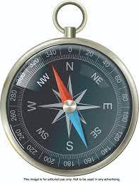

What is the name of the instrument?
A) Ruler B) Compass C) Protractor D) Thermometer
  - A student reflects on how to handle negative thoughts and maintain confidence in school.
Developing positive self-esteem and managing emotions are aspects of:
A) Entrepreneurial opportunities B) Personal development C) Community service D) Conflict resolution
  - During a guidance session, learners complete a worksheet identifying their abilities and preferences.
The process of identifying one's strengths, weaknesses, interests, and values is called:
A) Self-exploration B) Interpersonal relationships C) Political development D) Economic development
  - In Social Studies class, students brainstorm how knowledge of local history can be turned into a business.
Which of the following is an example of an entrepreneurial opportunity in Social Studies?
A) Becoming a doctor B) Starting a historical tour company C) Building a house D) Practicing law
  - While watching a documentary, learners hear that early humans first appeared on a particular continent.
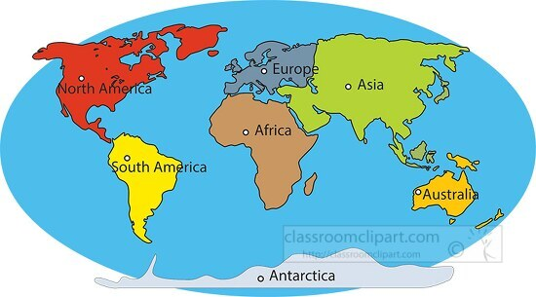

According to scientific theories, where did early humans originate from?
A) Asia B) Europe C) Africa D) America
  - A quiz on early African societies asks learners to identify real civilizations from ancient times.
Which of these is NOT an early civilization in Africa?
A) Egyptian Civilization B) Kush Civilization C) Roman Civilization D) Axumite Civilization
  - Before money was invented, people in early communities still exchanged goods.
What did people primarily use for trade before the invention of money?
A) Credit cards B) Barter system C) Cheques D) Digital currency
  - While studying African history, learners read about people being taken from their homes and forced to work.
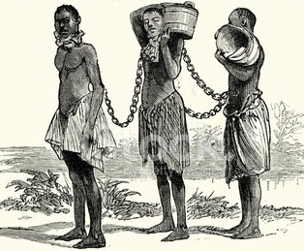
The forced movement of people from their homes to work without pay is known as:
A) Migration B) Trade C) Slavery D) Colonization
  - In a discussion about classroom differences, students list various languages, cultures, and beliefs.
The term that describes the variety of human cultures, beliefs, and practices is:
A) Human uniformity B) Human diversity C) Human isolation D) Human competition
  - Two learners argue over shared resources, and the teacher guides them through problem-solving.
Which of the following is a key step in conflict resolution?
A) Ignoring the problem B) Blaming others C) Open communication D) Fighting
  - On a Saturday, a group of learners helps clean up the local park as part of a school initiative.
Participating in a clean-up drive in your local park is an example of a:
A) Personal hobby B) Community service learning project C) Business venture D) Sports activity
  - A class visits a monument where they learn about events and people from the past.
What is the main purpose of a historical site?
A) To entertain people B) To preserve information about the past C) To sell goods D) To store modern equipment
  - After the domestication of crops and animals, communities began building homes and villages.
The historical development of agriculture led to:
A) Nomadic lifestyle B) Permanent settlements C) Decreased population D) Increased hunting
  - In a geography lesson, learners mark a horizontal line that divides the globe into two halves.
The imaginary line that divides the Earth into the Northern and Southern Hemispheres is the:
A) Prime Meridian B) Tropic of Cancer C) Equator D) International Date Line
  - In Social class, a student describes a dusty red-colored planet with potential for life exploration.
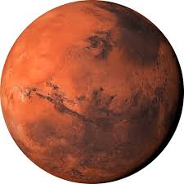

The planet above is?
A) Earth B) Jupiter C) Mars D) Venus
  - Each morning, a teacher reads out the weather forecast, noting if it’s sunny, cloudy, or rainy.
The day-to-day conditions of the atmosphere are referred to as:
A) Climate B) Seasons C) Weather D) Environment
  - A civic education session explains the rights and freedoms of citizens as outlined in the country’s legal framework.
Which of these is a major component of the Constitution of Kenya?
A) Chapters on traditional dances B) Bill of Rights C) Recipes for local dishes D) List of all wild animals

SECTION B: (60 Marks)
Answer all questions in this section in the spaces provided.
TASK 1: MAPWORK (5 Marks)
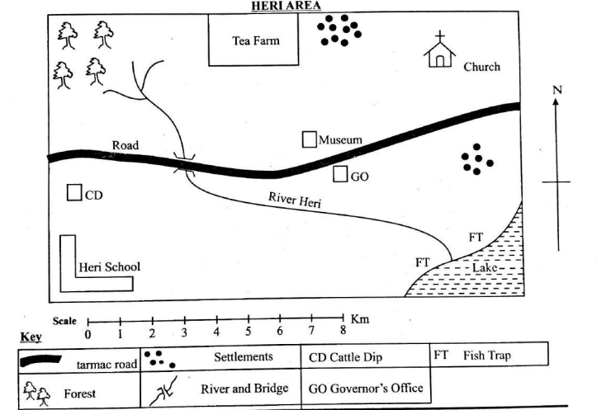
Your school is planning a field trip to a historical site in your county. The teacher has provided a simple sketch map of the area to guide you. Use it to answer question 21.

  - a) Using the compass rose, in which direction is the Museum from the school? (1 Mark)
_______________________________________________________________________________
b) Name two natural features shown on the map. (2 Marks)
i) _______________________________________________________________________________
ii) ______________________________________________________________________________
c) If the scale of the map is 1 cm represents 100 meters, and the distance between the school and the historical monument on the map is 3 cm, what is the actual distance? (2 Marks)
_________________________________________________________________________________
TASK 2: CITIZENSHIP (5 Marks)
  - Sarah is a Grade 7 student who loves her country, Kenya. She often discusses with her friends how they can be good citizens.
a) State two responsibilities of a good citizen in Kenya. (2 Marks)
i) _______________________________________________________________________________
ii) ______________________________________________________________________________
b) Identify two rights of a child as enshrined in the Constitution of Kenya. (2 Marks)
i) _______________________________________________________________________________
ii) ______________________________________________________________________________
c) Why is it important for citizens to participate in community development projects? (1 Mark)
____________________________________________________________________________________
TASK 3: HISTORY (30 Marks)
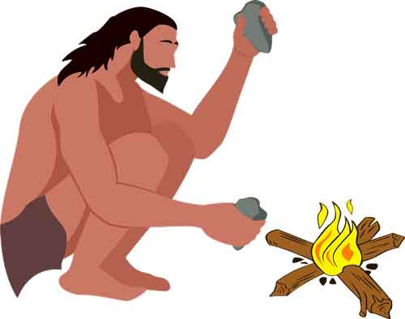
  - Grade 7 learners watched a documentary about the origin of mankind.

a) Name the part of Africa believed to be the cradle of humankind. (1 Mark)
______________________________________________________________________________
b) Give two reasons why the discovery of fire was important to early humans. (2 Marks)
i) _______________________________________________________________________________
ii) ______________________________________________________________________________
  - Identify two contributions of the ancient Egyptian civilization to humanity. (2 Marks)
i) _______________________________________________________________________________
ii) ______________________________________________________________________________
  - Grade 8 learners watched a video clip about the Indian Ocean slave trade.
a) Distinguish between slavery and servitude. (2 Marks)
________________________________________________________________________________________
______________________________________________________________________________________
____________________________________________________________________________________
b) State two negative effects of the Indian Ocean slave trade on African communities. (2 Marks)
i) _______________________________________________________________________________
ii) ______________________________________________________________________________
  - Give one example of an internal form of servitude that existed in some African communities before the coming of Europeans. (1 Mark)
____________________________________________________________________________________
  - An old picture was displayed and learners were asked to debate about it.

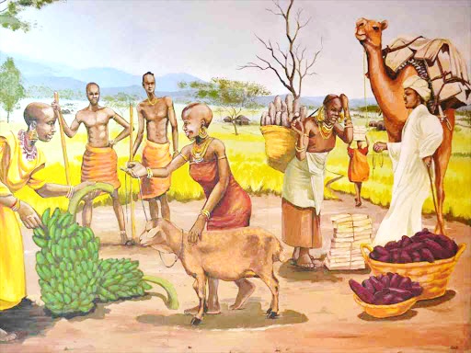

a) Explain the meaning of the barter system of trade. (1 Mark)
___________________________________________________________________________________
___________________________________________________________________________________
b) Give two reasons why the barter system was eventually replaced by money. (2 Marks)
i) _______________________________________________________________________________
ii) ______________________________________________________________________________
  - As a Grade 7 learner, suggest two entrepreneurial opportunities related to the study of history in your local community. (2 Marks)
i) _______________________________________________________________________________
ii) ______________________________________________________________________________

  - Use the map of Africa below to answer question 29.

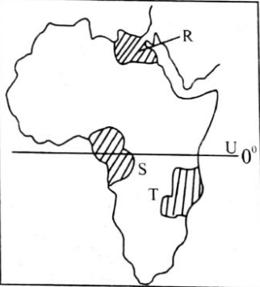

a) What is the name of the major latitude marked U? (1 Mark)
_______________________________________________________________________________________
b) Name the Traditional African Kingdoms labelled R,S and T. (3 Marks)
Kingdom
R
S
T
- Identify two African countries crossed by the Latitude marked U. (2 Marks)
i) _______________________________________________________________________________

ii) ______________________________________________________________________________
  - Terry and Freddy were discussing about the Ogiek, Zulu and the Asante communities during a group discussing time.
a) Describe one economic activity of the Ogiek community. (1 Mark)
________________________________________________________________________________
b) How did the Asante Kingdom accumulate wealth? Give two ways. (2 Marks)
i) _______________________________________________________________________________
ii) ______________________________________________________________________________
c) Mention one key social structure within the Zulu community. (1 Mark)
_________________________________________________________________________________
  - Identify two challenges faced by traditional African communities in preserving their culture in the modern era. (2 Marks)
i) _______________________________________________________________________________
ii) ______________________________________________________________________________
  - Dorothy was reading articles in the constitution of Kenya
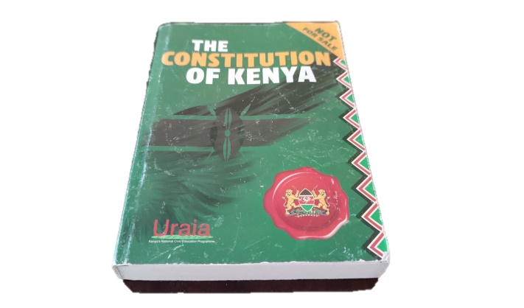
a) Explain the importance of the Constitution of Kenya to its citizens. (2 Marks)
________________________________________________________________________________________
________________________________________________________________________________________
b) Define the term 'African Diaspora'. (1 Mark)
_______________________________________________________________________________________
______________________________________________________________________________________
c) State one way in which the African Diaspora has contributed to the development of Africa. (1 Mark)
_____________________________________________________________________________________
TASK 4: GEOGRAPHY (30 Marks)
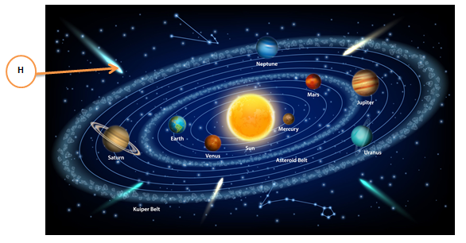
  - Teacher Philemon displayed the following picture in a class wall

a) Identify the planet in our solar system known to support life. (1 Mark)
_________________________________________________________________________________
b) State two conditions on the planet you have mentioned in (a) above that make it suitable for life. (2 Marks)
i) _______________________________________________________________________________
ii) ______________________________________________________________________________
- Name the heavenly body marked H (1 Mark)
_______________________________________________________________________________________
  - Grade 7 learners were discussing about weather and climate during a nature walk.
a) Differentiate between weather and climate. (2 Marks)
________________________________________________________________________________________
________________________________________________________________________________________
b) Name two elements of weather that can be measured using specific instruments. (2 Marks)
i) _______________________________________________________________________________
ii) ______________________________________________________________________________
c) Why is it important for farmers to have knowledge of weather patterns? (1 Mark)
______________________________________________________________________________
  - a) Give two examples of human diversity you might observe in your classroom. (2 Marks)
i) _______________________________________________________________________________
ii) ______________________________________________________________________________
b) Why is it important to respect human diversity? (1 Mark)
________________________________________________________________________________________
________________________________________________________________________________________
c) Suggest two ways to foster positive interpersonal relationships among students in a school setting. (2 Marks)
i) _______________________________________________________________________________
ii) ______________________________________________________________________________

  - a) Identify two safety measures you should observe during a fieldwork activity. (2 Marks)
i) _______________________________________________________________________________
ii) ______________________________________________________________________________
b) Give one reason why fieldwork is important in the study of Social Studies. (1 Mark)
_____________________________________________________________________________________
  - Your class is planning a Community Service Learning (CSL) project to improve the school environment. a) Suggest one CSL project related to improving the school environment. (1 Mark)
_________________________________________________________________________________
b) State two benefits of participating in such a CSL project to the students. (2 Marks)
i) _______________________________________________________________________________
ii) ______________________________________________________________________________
TASK 5: LIFE SKILLS (10 Marks)
  - a) List two qualities of a responsible Grade 7 student. (2 Marks)
i) ___________________________________________________________________________________

ii) ___________________________________________________________________________________
b) Explain how self-exploration can help you in making career choices in the future. (2 Marks)
__________________________________________________________________________________
__________________________________________________________________________________
  - a) Identify two common causes of conflict among learners in school. (2 Marks)
i) _______________________________________________________________________________

ii) ______________________________________________________________________________

b) Describe two non-violent ways of resolving conflicts in school. (2 Marks)
i) _______________________________________________________________________________
ii) ______________________________________________________________________________
c) Why is it important to promote peace in the community? (2 Marks)
___________________________________________________________________________________
__________________________________________________________________________________

THIS IS THE LAT PRINTED PAGE.

