Candidate’s Name |  | Assessment Number
School Name |  | School Code
Candidate’s Signature |  | Date
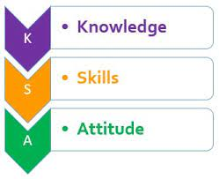


MONITORING JUNIOR SCHOOL LEARNER PROGRESS
GRADE 7: 712/1: PRETECHNICAL STUDIES.
PAPER 1. (Theory)
CODE: 008 YEAR: 2025
TIME: 1 hour 40 minutes
INSTRUCTIONS TO CANDIDATES
- Write your name and assessment number in the spaces provided above.
- Write the name and code of your school in the spaces provided above.
- Sign and write the date of the assessment in the spaces provided above.
- This paper consists of two sections: A and B.
- Section A comprises Multiple Choice Questions.
- Section B comprises Short Structured questions.
- Answer ALL the questions in section A on the separate ANSWER SHEET provided.
- Answer ALL the questions in section B in the spaces provided in this question paper.
- Do not remove any page from this question paper.
- Answer all questions in English.
For official use only

SECTION A: MULTIPLE CHOICE QUESTIONS (30 Marks)
Question Number | 1 | 2 |  | 3 | 4 |  | 5 | 6 | 7 |  | 8 | 9 | 10 | 11 | 12 | 13 | 14 | 15
Maximum Score | 1 | 1 |  | 1 | 1 |  | 1 | 1 | 1 |  | 1 | 1 | 1 | 1 | 1 | 1 | 1 | 1
Candidate’s Score
Question Number | 16 |  | 17 |  |  | 18 |  | 19 |  | 20 |  | 21 | 22 | 23 | 24 | 25 | 26 | 27 | 28 | 29 | 30 | Total score
Maximum Score | 1 |  | 1 |  |  | 1 |  | 1 |  | 1 |  | 1 | 1 | 1 | 1 | 1 | 1 | 1 | 1 | 1 | 1 | 30
Candidate’s Score

SECTION B: STRUCTURED QUESTIONS. (50 Marks)
TASK
Qn No. | 31 | 32 | 33 | 34 | 35 | 36 | 37 | 38 | 39 | 40 | 41 | 42 | 43 | 44 | 45 | 46 | 47 | 48 | 49 | 50 | TOTAL
Max Marks per Qn | 4 | 3 | 4 | 4 | 3 | 3 | 4 | 2 | 3 | 3 | 3 | 3 | 3 | 4 | 3 | 4 | 1 | 1 | 1 | 1 | 50
Candidate’s Score
This paper consists of 11 printed pages. Candidates should check the question paper to ascertain that all the pages are printed as indicated and that no questions are missing.
© 2025 The Kenya Junior School Examination and Assessment Series. Turn over

SECTION A (30 marks)
Answer All questions in this section on the answer sheets provided.
- Which of the following is a core objective of 'Pre-Technical Studies' in Junior School?
A. To train students to become professional engineers immediately.
B. To foster creativity and practical problem-solving skills.
C. To encourage memorization of historical facts.
D. To replace all other academic subjects.

- A student is working in a wood workshop and accidentally leaves a stack of wood planks blocking a fire exit. This creates a risk related to:
A. Online security.
B. Physical threats.
C. Communication breakdown.
D. Financial loss.
- Which characteristic of computers refers to their ability to perform calculations and operations at very high speeds?
A. Accuracy.
B. Diligence.
C. Speed.
D. Versatility.
- When you send a message to a friend using an application like WhatsApp, what fundamental concept of human interaction are you engaging in?
A. Measurement.
B. Communication.
C. Economic production.
D. Technical drawing.
- In a technical drawing, which method of dimensioning is used to indicate the size of an arc or a curved segment?
A. Linear dimensioning.
B. Radial dimensioning.
C. Angular dimensioning.
D. Arc dimensioning.
- Which of the following is a '3D shape'?
A B

C D

- A material known for its excellent electrical conductivity and ductility, often used in wires, is most likely a:
A. Non-metallic material. B. Metallic material.
C. Ceramic material. D. Composite material.
- Which of the following is an example of a 'service'?
A. A newly purchased textbook.

B. A haircut from a barber.

C. A fresh loaf of bread.

D. A new pair of eyeglasses.
- To accurately measure the internal diameter of a pipe, which measuring tool would be most appropriate?
A. Steel rule. B. Tape measure.
C. Inside caliper. D. Outside caliper.
- The natural resources provided by the earth, such as minerals, forests, and water, are classified as which factor of production?
A. Labour. B. Capital.
C. Land. D. Entrepreneurship.
- Which characteristic of money implies that it can be easily broken down into smaller units (e.g., a Ksh 100 note into ten Ksh 10 coins)?
A. Durability.
B. Portability.
C. Divisibility.
D. Uniformity.
- In technical drawing, a line consisting of a series of short dashes is used to represent:
A. The main outline of an object.
B. Hidden details or features.
C. The center of circular objects.
D. The cutting plane.
- An email arrives in your inbox from an unknown sender with the subject "URGENT: Your account will be closed!" and asks you to click a link to update your details. This is an example of:
A. A legitimate notification.
B. Phishing.
C. A software update.
D. Spam marketing.
- A workshop is very dusty due to ongoing sanding activities, and workers are not wearing masks. This creates a risk of:
A. Data corruption.
B. Financial fraud.
C. Respiratory problems (physical threat).
D. Communication barriers.
- Which of the following metals is predominantly used in the construction of large bridges and buildings due to its high strength and rigidity?
A. Copper.
B. Aluminum.
C. Steel.
D. Brass.
- When setting financial goals, why is it important to make them 'specific'?
A. To make them harder to achieve.
B. To allow for more flexibility.
C. To clearly define what needs to be accomplished.
D. To avoid having to plan.

- A company uses misleading advertisements to promote its product, making claims that are not entirely true about its benefits. This is an example of:
A. Ethical practice.
B. Sustainable practice.
C. Transparent practice.
D. Unethical practice.
- Which type of artistic drawing is typically found on public walls or trains, often involving stylized lettering and colourful designs?
A. Portrait.
B. Illustration.
C. Graffiti.
D. Caricature.
- Which classification of computers is designed to be easily carried around and used for personal tasks like Browse and word processing?
A. Mainframe.
B. Supercomputer.
C. Laptop.
D. Server.
- In a team project, clear and open communication is essential because it helps to:
A. Increase competition among members.
B. Facilitate understanding, coordination, and effective problem-solving.
C. Reduce individual accountability.
D. Prolong the project duration.

- Which of the following is a strong characteristic of a successful 'entrepreneur'?
A. Resistance to change.
B. High risk aversion.
C. Proactive and innovative thinking.
D. Tendency to avoid responsibility.
- Which security feature on Kenyan currency notes involves a thread woven into the paper that can be seen when held up to the light?
A. Watermark.
B. See-through feature.
C. Security thread.
D. Raised print.
- When doing 'freehand sketching', the principle of 'proportion' means:
A. Using only straight lines.
B. Representing the relative size and scale of different parts of an object.
C. Adding colour and shading to the drawing.
D. Drawing as fast as possible.
- Which of the following is an example of a 'non-metallic material' commonly used for making electrical insulators?
A. Steel.
B. Aluminum.
C. Plastic.
D. Bronze.

- What is the primary reason for wearing safety glasses in a workshop when using power tools?
A. To keep dust out of the eyes.
B. To prevent eye injury from flying debris.
C. To make the worker look professional.
D. To improve visibility in dim light.
- When dimensioning a component with an angled surface, which method is used to show the degree of the angle?
A. Linear dimensioning.
B. Radial dimensioning.
C. Angular dimensioning.
D. Arc dimensioning.
- The income received by the owner of 'capital' (e.g., machinery, buildings) for its use in production is called:
A. Wages.
B. Rent.
C. Interest.
D. Profit.
- Which of the following is an example of a 'Want'?
A. A warm coat in winter.
B. Basic shelter.
C. A new video game console.
D. Access to clean water.
- In technical drawing, a 'cutting plane line' is used to:
A. Show the overall length of an object.
B. Indicate where an object has been imaginarily cut to reveal internal features.
C. Mark the center of a circle.
D. Point to specific features for a dimension.
- The ability of a computer to perform tasks consistently without getting bored or losing accuracy over long periods is known as:
A. Speed.
B. Versatility.
C. Diligence.
D. Storage.

SECTION B (50 marks)
Answer ALL the questions in this section in the spaces provided.
- Explain two contributions of 'Pre-Technical Studies' to a learner's development of practical skills. (4 marks)
  - _________________________________________________________________________________
  - _________________________________________________________________________________

- In a school's computer lab, a student trips over a loose network cable, causing them to fall and damaging the computer.
a) Identify the 'physical threat' present in this scenario. (1 mark)
______________________________________________________________________________________
b) Suggest two 'safety measures' that could have prevented this incident. (2 marks)
  - _________________________________________________________________________________
  - _________________________________________________________________________________
- Mandeq drew the following 3d SHAPES. Identify them correctly. (4 marks)
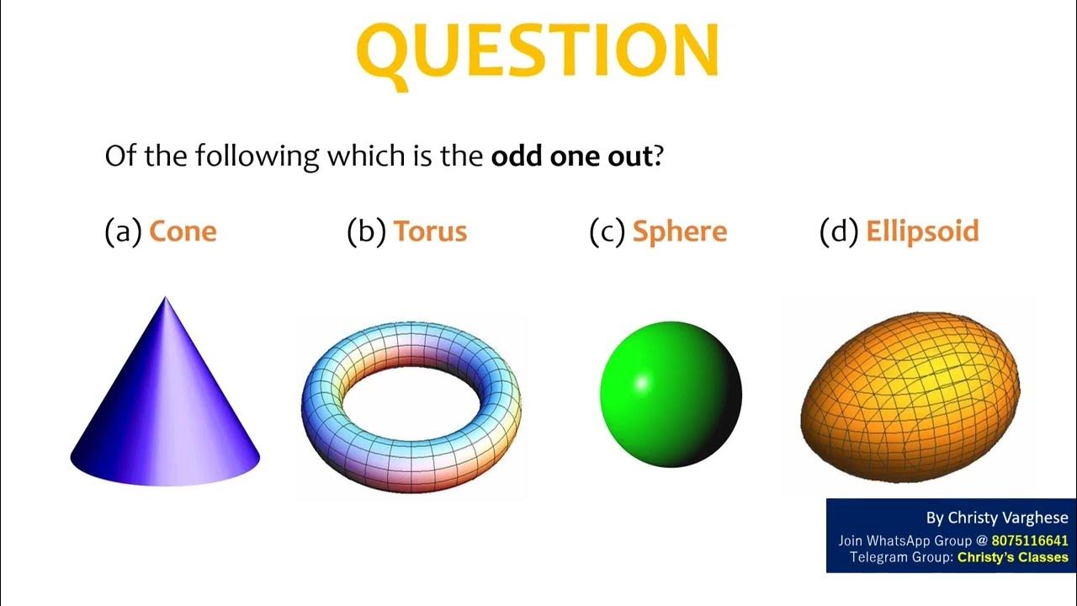
K L M N
K: ______________________________________. L: ______________________________________.
M: ______________________________________. N: ______________________________________.
- A business uses a computer system to manage its customer database, process orders, and send marketing emails.
a) Name two 'characteristics of computers' that make them highly suitable for these business operations. (2 marks)
  - _________________________________________________________________________________
  - ________________________________________________________________________________

b) If the business wants to communicate promotional offers to its customers quickly and efficiently, name two 'ICT tools used in communication' they could use. (2 marks)
  - ________________________________________________________________________________
  - ________________________________________________________________________________
- An individual notices that many people in their neighbourhood struggle to access fresh, organic vegetables. They decide to start a small organic garden business to meet this 'unmet need'.
a) Identify the 'source of business idea' this individual utilized. (1 mark)
____________________________________________________________________________________
b) Name two 'factors that enhance the success of a business' for this new organic garden venture. (2 marks)
  - _________________________________________________________________________________
  - ________________________________________________________________________________
- Jane receives a message on her phone from an unknown number, asking her to click a link to "verify her mobile money account" to avoid suspension.
a) What 'online safety threat' is Jane likely facing? (1 mark)
____________________________________________________________________________________
b) State two best practices Jane should follow to protect herself from such online threats. (2 marks)
  - _________________________________________________________________________________
  - _________________________________________________________________________________
- Differentiate between 'metallic materials' and 'non-metallic materials' based on their general properties, and provide one example for each. (4 marks)
Metallic Materials | Non-metallic Materials
Example: | Example:
- Identify two common 'uses of Steel'. (2 marks)
  - _________________________________________________________________________________
  - ________________________________________________________________________________
- Outline three 'reasons' why 'freehand sketching' is an important skill in technical communication and design. (3 marks)
  - ________________________________________________________________________________
  - ________________________________________________________________________________
  - ________________________________________________________________________________
- A student is drawing a diagram of a machine part that has several holes of different sizes.
a) Which 'method of dimensioning' would be used to indicate the diameter or radius of these holes? (1 mark)
_____________________________________________________________________________________
b) Describe how to properly care for a steel rule after use in a workshop. (2 marks)
____________________________________________________________________________________
___________________________________________________________________________________
- A baker uses flour, sugar, ovens (capital), and his baking skills (labour) to make cakes for sale.
a) Identify two 'characteristics of factors of production' from this scenario. (2 marks)
  - ________________________________________________________________________________
  - ________________________________________________________________________________
b) What is the 'reward' the baker expects for his entrepreneurial efforts and taking the risk of running the business? (1 mark)
___________________________________________________________________________________

- A company manufactures a product that combines a rectangular base with a triangular prism on top. The rectangular base is 10 cm×6 cm. The triangular prism has a base of 6 cm and a height of 4 cm.
a) Calculate the area of the rectangular base. (1 mark)

b) Calculate the area of the triangular cross-section. (2 marks)

- Mary wants to buy a new textbook costing Ksh 2,500 by the end of the term. She plans to save Ksh 250 from her weekly allowance. a) Identify two 'factors to consider when setting financial goals' that Mary has applied in her plan. (2 marks)
  - _________________________________________________________________________________
  - _________________________________________________________________________________
b) State one 'importance of setting financial goals' for Mary in this context. (1 mark)
______________________________________________________________________________________
- Kenyan currency notes feature various images. Describe two 'themes or symbols' found on Kenyan currency, besides the portrait of the first president, and explain their significance. (4 marks)
  - _________________________________________________________________________________
  - _________________________________________________________________________________

- In a group discussion, one student consistently interrupts others and dominates the conversation, leading to frustration and unshared ideas.
a) What is the main 'importance of communication' being neglected by this student? (1 mark)
_____________________________________________________________________________________
b) Suggest two 'fundamentals of communication' that the student should practice to improve the group's effectiveness. (2 marks)
  - _________________________________________________________________________________
  - _________________________________________________________________________________
- A garment factory uses ethically sourced cotton and pays its workers fair wages. They also ensure their production process minimizes water waste.
a) Classify this company's practices as 'ethical' or 'unethical' and justify your answer. (2 marks)
____________________________________________________________________________________
b) Differentiate between 'goods' and 'services' that this factory might produce or require, providing an example for each. (2 marks)
_____________________________________________________________________________________________________________________________________________________________________________________________________________________________________________________________________
- A computer user experiences frequent system crashes and slow performance, suspecting that unwanted programs are running in the background. These points to a problem with the computer's 'software'. Which specific type of 'computer concept' manages the hardware and software resources and allows other programs to run? (1 mark)
_______________________________________________________________________________________
- An artist is hired to paint a realistic image of a person's face, focusing on capturing their features accurately. Which 'type of artistic drawing' is this? (1 mark)
_______________________________________________________________________________________
- A small home user needs a computer mainly for Browse the internet, checking emails, and occasional word processing. Which 'classification of computers' is typically the most affordable and suitable for such basic personal use? (1 mark)
______________________________________________________________________________________
- A team leader is giving clear and concise instructions to her team members about their roles in a new project. What is the fundamental process of exchanging information that is occurring? (1 mark)
______________________________________________________________________________________

THIS IS THE LAST PRINTED PAGE.

