Candidate’s Name |  | Assessment Number
School Name |  | School Code
Candidate’s Signature |  | Date
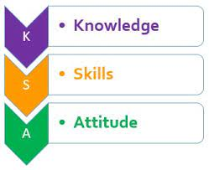


MONITORING JUNIOR SCHOOL LEARNER PROGRESS
GRADE 7: 703: MATHEMATICS
CODE: 008 YEAR: 2025
TIME: 2 HOURS
INSTRUCTIONS TO LEARNERS
- Write your name and Assessment number in the spaces provided above.
- Write the name and code of your school in the spaces provided above.
- Sign and write the date of the assessment in the spaces provided above.
- This question paper consists of TWO sections: A and B.
- Answer ALL the questions in Section A on the separate ANSWER SHEET provided.
- Show all the workings in Section B in the spaces provided.
- Non-programmable calculators may be used, except where stated otherwise.
- Answer ALL the questions in Section B in the spaces provided in this QUESTION PAPER.
- For π, use either the calculator value or 3.142.
- Give non-exact numerical answers, correct to 3 significant figures and one decimal place for angles in degrees, unless a different level of accuracy is specified in the question.
- Do NOT remove any page from this question paper.
- Answer ALL the questions in English.
For Official Use Only

SECTION A: (20 MARKS)
Question No. | 1 | 2 |  | 3 | 4 |  | 5 | 6 | 7 |  | 8 | 9 | 10
Max Score | 1 | 1 |  | 1 | 1 |  | 1 | 1 | 1 |  | 1 | 1 | 1
Candidate’s Score
Question No. | 11 |  | 12 |  |  | 13 |  | 14 |  | 15 |  | 16 | 17 | 18 | 19 | 20 | TOTAL
Max Score | 1 |  | 1 |  |  | 1 |  | 1 |  | 1 |  | 1 | 1 | 1 | 1 | 1 | 20
Candidate’s Score

SECTION B: (30 MARKS)
Question | 21 | 22 | 23 | 24 | 25 | 26 | 27 | 28 | 29 | 30 | TOTAL
Max Score | 3 | 2 | 2 | 4 | 3 | 3 | 3 | 3 | 3 | 4 | 30
Learner's Score
This paper consists of 9 printed pages. Candidates should check the question paper to ascertain that all the pages are printed as indicated and that no questions are missing.
© 2025 The Kenya Junior School Examination and Assessment Series. Turn over

SECTION A: (20 MARKS)
Answer all questions.

- The population of a town was two million, four hundred and five thousand, seven hundred and one. Write this number in figures. A. 2405701 B. 2450701 C. 2045701 D. 24005701
- A company manufactured 25,780 pens in January and 31,125 pens in February. What is the total number of pens manufactured in the two months? A. 56,805 B. 56,905 C. 57,005 D. 57,905
- What is the next number in the sequence:
5, 11, 17, 23, ____?
A. 29 B. 30 C. 31 D. 32
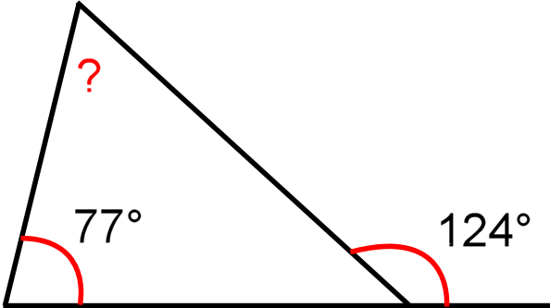
- Which angle is represented by the letter marked P in the diagram below?
P

A. 103° B. 201° C. 90° D. 47°
- What is the sum of the first 20 even numbers? A. 210 B. 400 C. 420 D. 200
- During a school trip, learners drank 41​ of the water, and spilled 81​ of the water. What fraction of the water remained? A. 83​ B. 21​ C. 85​ D. 87​
- A tailor used 3 m 75 cm of fabric for a dress and 2 m 90 cm for a shirt. What is the total length of fabric used? A. 5 m 65 cm B. 6 m 5 cm C. 6 m 65 cm D. 6 m 75 cm
Working space

- A farmer harvested 783,491 kg of maize. He was asked to round off the harvest to the nearest ten thousands. Which of the following is the correct answer? A. 780,000 B. 783,000 C. 790,000 D. 800,000
- What is the largest number that can be formed by the digits 1, 0, 7, 3, 9? A. 97310 B. 10379 C. 97301 D. 97130
- What is the supplementary angle of 75°? A. 15° B. 105° C. 90° D. 285°
- A football match started at quarter past 2 in the afternoon. If the match lasted for 90 minutes. What time in 24 hours clock system did the match end? A. 1415 hrs B. 1545 hrs C. 1515 hrs D. 1600 hrs
- The temperature in a freezer dropped from 5°C to -12°C. What was the drop in temperature? A. 7°C B. 17°C C. -7°C D. -17°C
- A bottle contains 1.5 litres of juice. How many glasses, each holding 0.25 litres, can be filled from the bottle? A. 4 B. 5 C. 6 D. 7
- In a class of 40 learners, 53​ of them prefer Science. How many learners prefer Science? A. 16 B. 20 C. 24 D. 30
- The cost of a pencil is sh. 8. Jane bought p pencils and spent more than sh. 60. Represent this information as an inequality. A. 8p<60 B. 8p>60 C. 8p=60 D. 8p≤60

Working space

- What is the possible value of angle x in the triangle below?
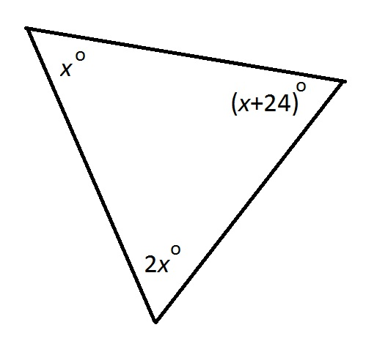

A. 78° B.56° C. 180° D. 39°
- A rectangular field has an area of 225 m². If the length of the field is 25 m, what is its width? A. 9 m B. 15 m C. 20 m D. 25 m
- Which pair of numbers consists of a prime number and a composite number respectively? A. 7, 10 B. 13, 2 C. 1, 5 D. 11, 17
- In a spelling test, a student scored 80%. What fraction represents the test failed by the student? A. 54​ B. 51​ C. 43​ D. 41​
- A baker made 360 cookies. He wants to pack them into bags, with each bag containing 15 cookies. How many bags will he need? A. 20 B. 24 C. 30 D. 15

Working space

SECTION B (30 MARKS)
Answer all questions.
- A circular swimming pool has a radius of 7 meters. A swimmer walked along the edge of the pool for 3 full rounds. What distance did the swimmer cover correct to 2 decimal places? (Use π=3.14) (3 marks)

- What is the least number that can be added to 8975 to make it divisible by 5? (2 marks)

- The teacher asked the students to express the number 144 as a product of its prime factors. Show the correct working. (2 marks)

- A farmer planted maize and beans on his farm. 31​ of the farm was planted with maize, and 52​ of the farm was planted with beans. The remaining part of the farm was left for grazing.
a) What fraction of the farm was left for grazing? (2 marks)

b) If the farm measures 60 acres, how many acres were planted with maize? (2 marks)

- Sarah is twice as old as her brother Tom. If the sum of their ages is 36 years.
a) What is the present age of Tom? (2 marks)

b) What will be Sarah's age in 5 years' time? (1 mark)

- Mary has two sisters. One of her sisters is less than 10 years old, while her other sister is either 12 years old or older than 12 years.
a) Form a compound inequality that represents this information. (2 marks)

b) Represent this information on a number line. (1 mark)

- A Grade 6 student had a gift box in the shape of a cube.

(a) What is the sum of the vertices and faces of the gift box? (1 mark)

(b) Draw a net diagram of the cube. (2 marks)

- The figure drawn below represents a certain figure. What is the area of the figure drawn? (3 marks)
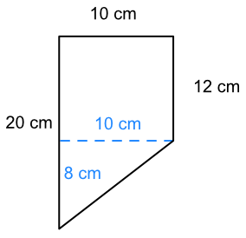

- The diagram below represents a platform.
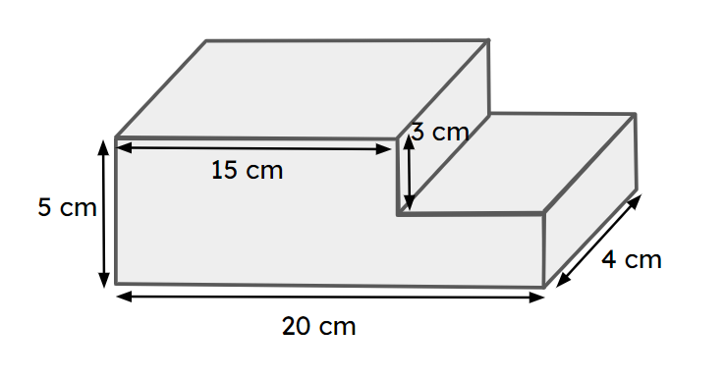
a) What is the volume of the box? (2 marks)

b) Convert the volume above into litres. (1 mark)

- (a) what is the value of x in: 3x + 7 = 22​​ (2 marks)

(b) Evaluate: 1.5×3+8÷2−1 (2 marks)

THIS IS THE LAST PRINTED PAGE.

