Candidate’s Name |  | Assessment Number
School Name |  | School Code
Candidate’s Signature |  | Date

MONITORING JUNIOR SCHOOL LEARNER PROGRESS
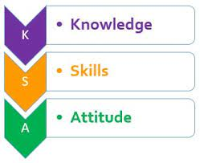

K ENYA JUNIOR SCHOOL EDUCATION ASSESSMENT (KJSEA)
GRADE 7: 705/1: INTEGRATED SCIENCE
PAPER 1 (Theory)
CODE: 008 YEAR: 2025
TIME: 2 HOURS
INSTRUCTIONS TO CANDIDATES:
1. Write your name and assessment number in the spaces provided.
2. Answer ALL questions.
3. Section A: 30 multiple-choice questions (30 marks).
4. Section B: 20 structured questions (40 marks).
5. Use diagrams, images, and symbols to answer questions where necessary.
6. Draw clear, neat, and labeled diagrams where required.

For Official Use Only

SECTION B
Task | Task 1 |  | Task 2 |  |  | Task 3 |  |  | Task 4
Question | 31 | 32 | 33 | 34 | 35 | 36 | 37 | 38 | 39
Score per question
Maximum score | 03 | 03 | 03 | 03 | 01 | 03 | 04 | 05 | 05
Candidate’s score

Task Breakdown for Internal Use (Marking Reference)
Task | Questions Covered | Area covered | Max Marks
Task 1 | Q31–32 | Lab apparatus (ID & uses), Circuit labeling | 6
Task 2 | Q33–35 | Safety in lab, Separation of mixtures, Mood swings | 7
Task 3 | Q36–38 | Symbols, Reproductive system, Adolescence changes | 12
Task 4 | Q39–40 | Litmus test, SI units, Appliances, Mixtures, Kidney, Components of Integrated Science, Conductors, etc. | 15
This paper consists of 8 printed pages. Candidates should check the question paper to ascertain that all the pages are printed as indicated and that no questions are missing.
© 2025 The Kenya Junior School Examination and Assessment Series. Turn over

SECTION A: (30 MARKS)
Answer all questions.

- During a science lesson, the teacher showed a bottle with the symbol below:
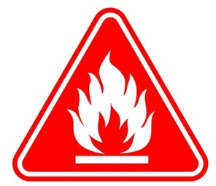
What does the symbol warn about? A. Toxic chemical
B. Radioactive material
C. Flammable substance
D. Corrosive agent
- A student observed that a spoon placed in water appeared bent. Which scientific component best explains this observation? A. Life science
B. Earth science
C. Physical science
D. Social science
- When separating a mixture of water and kerosene, which method is most suitable? A. Decantation
B. Filtration
C. Distillation
D. Magnetism
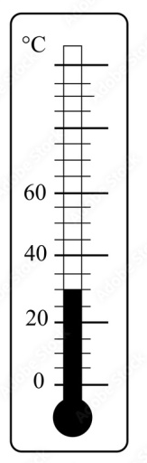
- A laboratory thermometer shows this reading:

What is the temperature shown? A. 20°C B. 25°C
C. 30°C D. 35°C
ENDTERM 2 2025 JUNIOR SCHOOLS ASSESSMENT

KILGORIS CLUSTER JUNIOR SCHOOLS ASSESSMENT

- The diagram below shows a part of the male reproductive system:

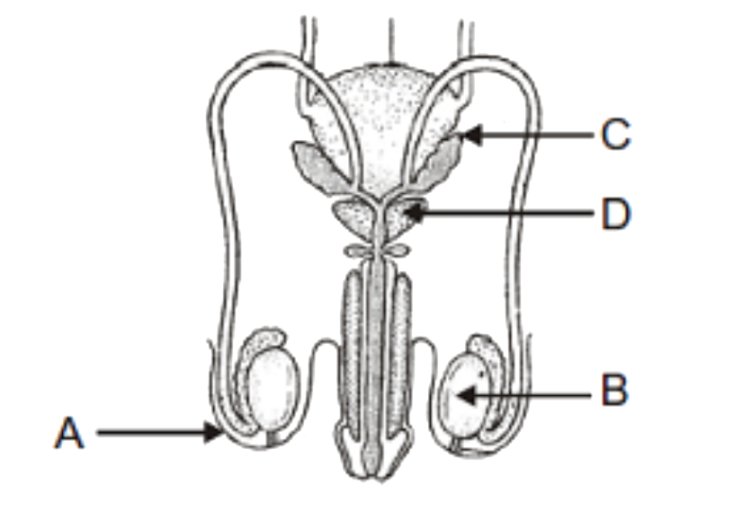
What is the function of the part labeled B? A. Store urine
B. Produce sperm
C. Remove waste
D. Produce urine
- John accidentally spilled acid on his skin during an experiment. What is the immediate first aid action? A. Apply baking soda
B. Rub with oil
C. Wash with cold running water
D. Cover with a cloth
- Mary wanted to know which of the following best describes an indicator. Which one is it? A. Measures temperature
B. Detects light
C. Shows pH of a substance
D. Heats liquids
- A student wants to find the mass of a stone. Which instrument should they use? A. Thermometer B. Beam balance
C. Stop watch D. Bunsen burner
- Peter used a magnet to separate metal pins from wood shavings. This method works because: A. Pins are lighter
B. Pins are magnetic
C. Wood is heavy
D. Pins are shiny
- Mwangangi was studying the parts of a microscope as shown below?
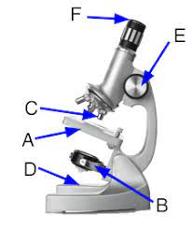
The part labelled C is known as the?
A. Coarse adjustment knob
B. Stage
C. Objective lens
D.Eye piece lens
- A female adolescent may experience emotional changes such as: A. Growth of facial hair
B. Broadening of chest
C. Mood swings
D. Voice breaking
- The diagram below shows a simple electrical circuit prepared by Agnes:
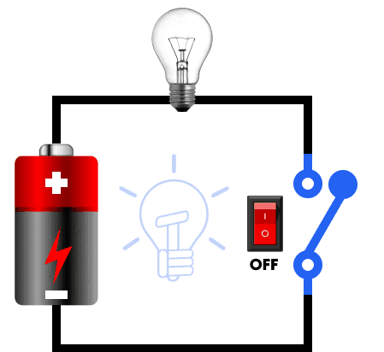
When the switch is open, what happens? A. Bulb lights
B. Circuit is complete
C. Bulb stays off
D. Battery charges
- Among the following units. What SI unit is used to measure length? A. Kilogram
B. Metre
C. Second
D. Celsius
- Which two components of Integrated Science are combined in magnetism? A. Physical and Life
B. Earth and Social
C. Physical and Earth
D. Life and Physical
- Which one is a method of separating mixtures? A. Heating
B. Filtering
C. Weighing
D. Measuring
- Jane was told to identify magnetic materials. Which object is magnetic? A. Plastic ruler
B. Wooden block
C. Iron nail
D. Rubber band
- Which part of the excretory system stores urine before release? A. Kidney
B. Bladder
C. Ureter
D. Liver
- The diagram below shows a mixture:
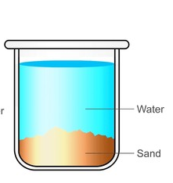
What method would best separate it? A. Decanting
B. Filtering
C. Distilling
D. Evaporating

- The image shows a student handling a beaker while wearing gloves:

Why is the safety gear important? A. For beauty
B. To protect from chemicals
C. For balance
D. To avoid spills
- Lemiso was learning about physical and chemical changes.Which one is a physical change? A. Burning wood
B. Boiling water
C. Rusting iron
D. Digestion
- A simple circuit contains a battery, wires, and a bulb. What must happen for the bulb to light? A. Open circuit
B. Switch off
C. Circuit closed
D. Use longer wires
- Olalashe brought some learning items to school. Which one of them is an acid? A. Soap
B. Vinegar
C. Toothpaste
D. Baking soda
- Tumuka was wondering why some boys and girls change during a certain period in their life. Which is a sign of adolescence in boys? A. Widening of hips
B. Voice deepening
C. Breast development
D. Menstruation
- The table below shows litmus paper results:
Solution | Red Litmus | Blue Litmus
Lemon juice | Stays red | Turns red

What type of solution is lemon juice? A. Base B. Acid C. Neutral D. Water
- During an integrated science lesson, learners handled the following materials. Which one is a non-magnetic material? A. Iron
B. Steel
C. Copper
D. Nickel
- Why is it important to study Integrated Science? A. To play games
B. To understand nature
C. To avoid school
D. To make friends
- Which method best separates salt from seawater? A. Filtering
B. Sieving
C. Evaporation
D. Decanting
- Mwangi was learning about a certain part of a body system.The ureter is part of which body system? A. Circulatory
B. Reproductive
C. Digestive
D. Excretory
- Which one is an indicator used to test acids and bases? A. Oxygen
B. Water
C. Litmus paper
D. Carbon dioxide
- In which household appliance is electrical energy converted into heat energy? A. Television
B. Flat iron
C. Radio
D. Fan

SECTION B: STRUCTURED QUESTIONS (40 MARKS)
Answer all questions clearly and use diagrams where required.
- The image shows various laboratory instruments:

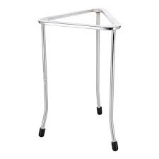
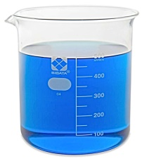
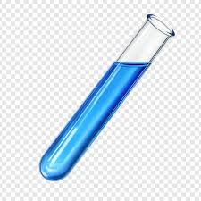

X Y Z

- Identify each item (3 marks)
X: ___________________________________________________.
Y: ___________________________________________________.
Z: ___________________________________________________.
- State one use for each (3 marks)

Item | Use
X
Y
Z

- The diagram below shows a circuit:
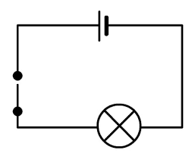
E

F

- Label the parts (2 marks)
E: ___________________________________________________.
F: ___________________________________________________.

- What will happen when the switch is turned off? (1 mark)
____________________________________________________________________________________________________________________________________________________________________
- Explain three ways to ensure safety in a science laboratory. (3 marks)
- ______________________________________________________________________________________
- ______________________________________________________________________________________
- ______________________________________________________________________________________
- John has a mixture of sand and salt. Describe the steps to separate them completely. (3 marks)
__________________________________________________________________________________________________________________________________________________________________________________________________________________________________________________________________________________________________________________________________________________________________________________________________________________________
- Give two reasons why adolescents experience mood swings. (2 marks)
- _____________________________________________________________________________________
- _____________________________________________________________________________________
- The image shows a symbol on a chemical container: ![Image: Skull symbol]
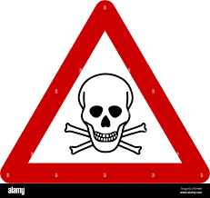

- What does it mean? (1 mark)
____________________________________________________________________________________________________________________________________________________________________
- State one precaution to take when handling the chemical (1 mark)
____________________________________________________________________________________________________________________________________________________________________
- Draw and label the female reproductive system (3 marks)

- Give two physical changes that occur during adolescence (2 marks)
- _______________________________________________________________________________
- _______________________________________________________________________________
- Identify two hormones responsible for menstruation cycle. (2 marks)
- ______________________________________________________________________________.
- ______________________________________________________________________________.
- A student is testing substances with red and blue litmus paper. The results are shown:
Solution | Red Litmus | Blue Litmus
Solution A | Stays red | Turns red
Solution B | Turns blue | Stays blue
- Name substance A and B as acid or base (2 marks)
A: ___________________________________________.
B: ___________________________________________.
- The diagram below shows an SI unit chart: Fill in the correct SI units (3 marks)
Quantity | SI Unit
Time
Mass
Temperature
- Name three common electrical appliances found at home and their uses. (3 marks)
- ________________________________________________________________________________.
- ________________________________________________________________________________.
- ________________________________________________________________________________.
- Define a mixture and name two types of mixtures. (2 marks)
_____________________________________________________________________________________________________________________________________________________________________________________________________________________________________________________
- Draw a labeled diagram of the human kidney. (3 marks)

- List two common kidney disorders and one way of preventing each. (3 marks)
- _______________________________________________________________________________.
- _______________________________________________________________________________.

- What are the three components of Integrated Science? (3 marks)
- _____________________________________________________________________________________.
- _____________________________________________________________________________________.
- _____________________________________________________________________________________.
- Explain the difference between a conductor and an insulator. Give one example of each. (2 marks)
______________________________________________________________________________________________________________________________________________________________________________________________________________________________________________________
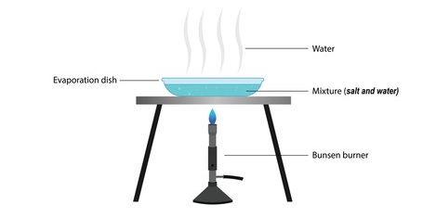
- The diagram shows an experiment involving evaporation:

  - What is happening in the dish? (1 mark)
__________________________________________________________________________________
- What remains after water evaporates? (1 mark)
_________________________________________________________________________________
- Mention two applications of magnets in everyday life. (2 marks)
- _____________________________________________________________________________________.
- _____________________________________________________________________________________.
- Identify two magnetic and two non-magnetic materials (2 marks)
- _____________________________________________________________________________________.
- _____________________________________________________________________________________.
- State two importance of studying Integrated Science (2 marks)
- _____________________________________________________________________________________.
- _____________________________________________________________________________________.
THIS IS THE LAST PRINTED PAGE.

