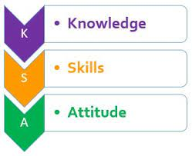

KENYA JUNIOR SCHOOL EDUCATION ASSESSMENT
GRADE 7: 701/1: ENGLISH
CODE: 008 YEAR: 2025
MARKING SCHEME
NO

1 | B
2 | D
3 | B
4 | C
5 | B
6 | C
7 | B
8 | C
9 | B
10 | C
11 | B
12 | C
13 | B
14 | C
15 | B
16 | C
17 | A
18 | C
19 | C
20 | C
21 | B
22 | B
23 | C
24 | C
25 | C
26 | A
27 | A
28 | B
29 | A
30 | C
31 | D
32 | C
33 | C
34 | C
35 | A
36 | B
37 | B
38 | C
39 | A
40 | C
41 | C
42 | D
43 | A
44 | A
45 | A
46 | C
47 | A
48 | A
49 | B
50 | A

THIS IS THE LAST PRINTED PAGE.

