Candidate’s Name |  | Assessment Number
School Name |  | School Code
Candidate’s Signature |  | Date
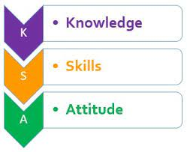
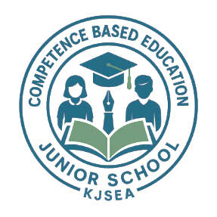

MONITORING JUNIOR SCHOOL LEARNER PROGRESS
GRADE 7: 711/2: CREATIVE ARTS AND SPORTS
PAPER 2 (Theory)
CODE: 008 YEAR: 2025
TIME: 2 HOURS
INSTRUCTIONS TO CANDIDATES:
Instructions to Candidates:
- Write your name and assessment number in the spaces provided.
- Read each question carefully before answering.
- Attempt all questions.
- Do not open this paper until you are told to do so.

For Official Use Only:

SECTION B: (50 Marks)
PART | Task No. | Questions | Max Marks per Question | Total per Task | Candidate’s Score
Part I: Performing Arts | Task 1 | 1(a), 1(b) | 2, 4 | 6
Part I: Performing Arts | Task 2 | 2(a), 2(b) | 2, 2 | 4
Part I: Performing Arts | Task 3 | 3(a), 3(b), 3(c) | 2, 3, 1 | 6
Part I: Performing Arts | Task 4 | 4 | 4 | 4
Part I: Performing Arts | Task 5 | 5(a), 5(b) | 2, 2 | 4
Part I: Performing Arts |  | Part I Subtotal |  | 20
Part II: Sports | Task 6 | 6(a), 6(b) | 3, 1 | 4
Part II: Sports | Task 7 | 7(a), 7(b) | 4, 2 | 6
Part II: Sports | Task 8 | 8(a), 8(b) | 3, 2 | 5
Part II: Sports | Task 9 | 9(a), 9(b), 9(c) | 2, 2, 1 | 5
Part II: Sports |  | Part II Subtotal |  | 20
Part III: Visual Arts | Task 10 | 10(a), 10(b) | 2, 3 | 5
Part III: Visual Arts | Task 11 | 11(a), 11(b) | 2, 3 | 5
Part III: Visual Arts | Task 12 | 12(a), 12(b) | 2, 2 | 4
Part III: Visual Arts | Task 13 | 13(a), 13(b) | 3, 2 | 5
Part III: Visual Arts |  | Part III Subtotal |  | 20
Part III: Visual Arts |  | SECTION B TOTAL |  | 60
This paper consists of 10 printed pages. Candidates should check the question paper to ascertain that all the pages are printed as indicated and that no questions are missing.
© 2025 The Kenya Junior School Examination and Assessment Series. Turn over

SECTION A: (40 MARKS)
Answer all questions.

- During a class presentation, students were asked to mention the main components of Creative Arts and Sports. One student included Agriculture.
Which of the following is not a component of Creative Arts and Sports?
A. Visual Arts
B. Performing Arts
C. Agriculture
D. Physical Education
- A music teacher asked her pupils to clap a 2/4 rhythm in class. She then asked how many beats are found in each bar.
In a 2/4 time signature, how many beats are in each bar?
A. 2 B. 4 C. 8 D. 1
- While composing a class song, Mark left a blank space between notes and called it a “rest.” His friend asked why it was important.
What is the purpose of a rest in a musical composition?
A. To speed up the melody
B. To decorate the notes
C. To show silence
D. To indicate tuning
- During music class, the teacher played a melody and asked the learners to describe why it sounded pleasant.
A good melody should have the following quality:
A. Irregular rhythm
B. Repetition only
C. Random notes
D. Clear phrasing
- In a music lesson, learners were shown an image of a wooden string instrument played using a bow.
Identify this Western solo instrument.
A. Recorder
B. Violin
C. Flute
D. Guitar
- During a field demonstration, the sports teacher displayed several tools used in different games. One item was a long metal spear.
Which of these items is used in javelin?
A. Baton
B. Helmet
C. Javelin spear
D. Whistle
- At a school swimming gala, Achieng used a style where both her arms moved in a circular motion above the water.
Which swimming technique involves moving both arms forward in a circular motion?
A. Backstroke
B. Breaststroke
C. Butterfly
D. Sidestroke
- In a drama and storytelling session, the teacher emphasized how stories help communities.
The importance of storytelling in Creative Arts includes:
A. Increasing physical strength
B. Improving running skills
C. Preserving culture
D. Decorating costumes
- During a football match between classes, a student was caught behind the defenders while receiving the ball.
In football, which of these is a rule violation?
A. Goalkeeping
B. Offside
C. Passing
D. Throw-in
- In a music test, the teacher asked learners to listen to a note and say whether it was high or low.
The pitch in music refers to:
A. How loud the music is
B. The location of the music
C. The highness or lowness of a sound
D. The silence in music
- While teaching how to play the descant recorder, the music teacher warned against blowing too hard.
Which of the following techniques is used in playing a descant recorder?
A. Weaving B. Blowing gently
C. Bouncing D. Swinging
- During a folk dance performance, learners wore costumes with beads and bright cloths.
What does adornment in a folk song costume mean?
A. Singing with energy
B. Using bright and meaningful decorations
C. Wearing school uniforms
D. Changing language in songs
- A learner created a simple animation by drawing a flying bird across several pages of her notebook.
A flipbook animation works best by:
A. Drawing randomly
B. Using clay models
C. Drawing images in sequence on pages
D. Using chalk on blackboard
- In handball practice, the coach instructed learners to use a pass that comes from above the head.
Which pass is common in handball?
A. Overhead pass B. Chess pass
C. Shoulder pass D. Pencil pass
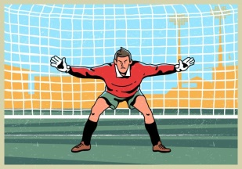
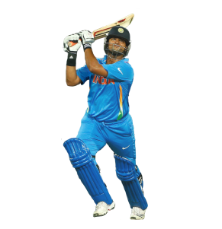
- In a sports picture, a player wearing gloves is shown blocking a ball with both hands.
Which image shows a football goalkeeper?
A B

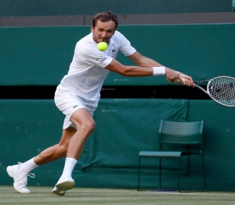
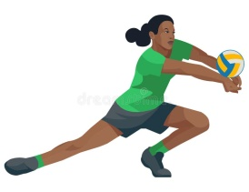
C D

- During music class, the teacher clapped a rhythm pattern that sounded like “long-short.”
A French rhythm pattern commonly used in music is:
A. Long-short
B. Fast-fast
C. Slow-fast
D. Skip-hop
- A music teacher asked the class to play the G major scale on recorders.
G major has which of the following notes?
A. G, A, B, C, D, E, F#
B. A, B, C, D, E, F
C. C, D, E, F, G
D. F, G, A, Bb, C
- In athletics, Amani was able to dodge obstacles and change direction quickly during a relay.
Agility in athletics helps an athlete to:
A. Jump higher
B. Move quickly and change direction
C. Throw farther
D. Endure longer races
- In a PE lesson, the teacher showed illustrations of different sports actions. One image showed a sporting equipment shown below.
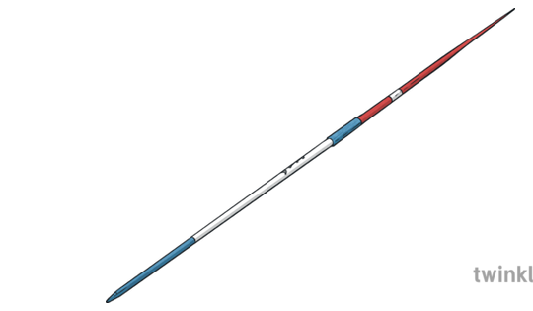
The equipment above is called a?
A. Javelin B. Bat C. Shot put D. Discuss
- A learner submitted an artwork made using colored pencils and crayons.
The component of Visual Arts is:
A. Jogging B. Running
C. Drawing D. Acting
- During a football skills lesson, the coach asked the learners to practice a pass that goes past the defenders.
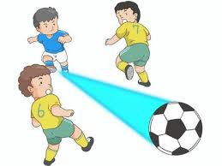
What is the name of the pass used in football?
A. Hook pass
B. Bounce pass
C. Chest pass
D. Through pass
- While listening to a song, the teacher asked students to identify what element helps us know whether a note is high or low.
Which element of music helps in identifying how high or low a note is?
A. Rhythm
B. Harmony
C. Pitch
D. Tempo
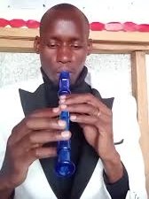
- A learner blew into a straight plastic instrument with finger holes and produced musical notes.

The descant recorder belongs to which family of instruments?
A. String B. Percussion
C. Brass D. Wind
- During PE, the coach gave learners two balls to juggle.
Which of the following techniques improves coordination in sports?
A. Swimming with closed eyes
B. Juggling two balls
C. Sitting for long
D. Skipping storytelling
- In a story-writing competition, learners were told to organize their work well.
A well-structured story must have:
A. Pictures only
B. A beginning, middle, and end
C. Only characters
D. Riddles only
- In art class, learners were given pencils to sketch objects around the school.
Which of the following is a visual art technique?
A. Singing
B. Drawing
C. Sprinting
D. Dribbling
- In a storytelling event, Akinyi acted out her story without speaking, using gestures and expressions.
A storytelling technique that uses facial expressions and body movement is called:
A. Singing
B. Mime
C. Narration
D. Repetition
- During a music quiz, the teacher asked learners to write the G major scale in the correct order.
What is the correct G major scale sequence?
A. G A B C D E F# G
B. C D E F G A B C
C. F G A Bb C D E F
D. A B C# D E F# G A
- While performing a Kenyan folk song, the teacher said it praises community heroes.
In Kenyan folk songs, the song that praises heroes is called:
A. Lullaby B. Praise song
C. Work song D. Love song
- During a swimming lesson, Brian used a style where he floated on his back.
Which swimming style requires the swimmer to float on their back?
A. Freestyle B. Butterfly
C. Backstroke D. Breaststroke
- The music teacher drew the music note below
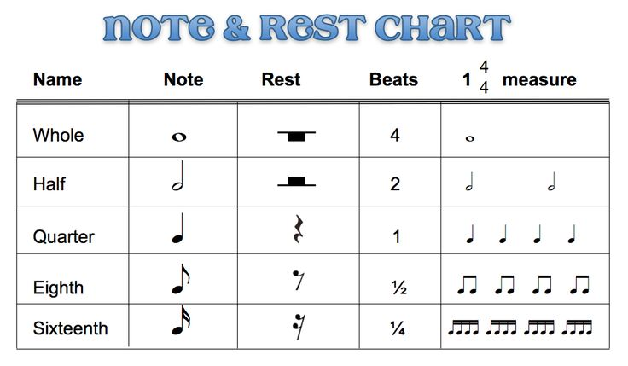
Which one of the following symbol represents the correct rest sign for the note above?
A
B
C
D
- In handball training, learners practiced different types of passes. One option sounded unusual.
Which one is not a pass used in handball?
A. Bounce pass B. Chest pass
C. Lob pass D. Slide pass
- The teacher played a melody that used the same note repeatedly.
A melody with repeated notes is described as:
A. Monotonous B. Complex
C. Rhythmic D. Adorned
- Before starting athletics practice, learners stretched and jogged.
What is the main purpose of warming up before sports activities?
A. To entertain others B. To waste time
C. To prepare the body D. To sing songs
- In an art class, learners used the same design patterns repeatedly across their drawings.
A principle of visual art that involves using the same element repeatedly is:
A. Contrast B. Rhythm C. Proportion D. Emphasis
- During a balance activity, a learner stood on one leg for 30 seconds without falling.
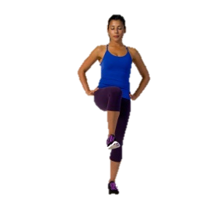
Which of the following shows stability in physical fitness?
A. Balancing on one leg B. Kicking a ball
C. Running fast D. Clapping hands
- A learner created 10 quick sketches of a bird in flight and flipped through them to show movement.
A student draws 10 frames showing a bird flying. This is called:
A. Flipbook animation B. Storyboard
C. Shadow sketching D. Film acting
- In handball, James moved side to side while holding the ball, making it hard for defenders to track him.
In handball, weaving helps in:
A. Improving singing B. Confusing the opponent
C. Wearing a uniform D. Drawing a diagram
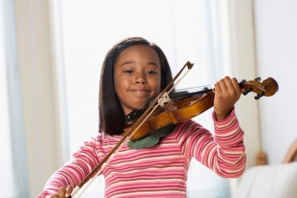
- The learner enjoys playing the instrument below.
Which instrument is shown here?

A. Violin B. Recorder C. Flute D. Drum
- During a swimming safety session, learners were told to hold onto a flat board while learning to kick.
In swimming, which item is used for safety?
A. Stopwatch B. Kickboard
C. Towel D. Swimming cap

SECTION B: (60 MARKS)

Answer all questions.
PART 1: PERFORMING ARTS (20 marks)
41. During music class, your teacher plays a short tune and asks you to describe what you hear.
(a) Define the term melody. (2 marks)
________________________________________________________________________________________________________________________________________________________________________________________
(b) Using your knowledge of music, compose a 4-bar rhythm in a 2/4 time signature using any notes and rests. (2 marks)
_______________________________________________________________________________________________________________________________________________________________________________________________________________________________________________________________________________________________________________________________________________________________________________
42. You are participating in a music competition where your group must compose a short melody in G major.
(a) Write any five notes found in the G major scale. (2 marks)
- _____________________________________.
- _____________________________________.
- _____________________________________.
- _____________________________________.
- _____________________________________.
(b) State two qualities that would make your melody sound good. (2 marks)
- _____________________________________________________________________________________.
- _____________________________________________________________________________________.
43. During a music lesson, you are assigned to explore Western solo instruments.
(a) Name any two Western solo instruments you could use in your presentation. (2 marks)
- _____________________________________________________________________________________.
- _____________________________________________________________________________________.
- (b) Explain how a descant recorder is tuned and played correctly during a performance. (3 marks)
_________________________________________________________________________________________
_________________________________________________________________________________________
_________________________________________________________________________________________
(c) Your music teacher asks why a song has repeated lines. State one reason repetition is used in songs. (1 mark)
____________________________________________________________________________________________
44. Your class is preparing for a cultural music showcase where each group presents a Kenyan folk song.
Identify and briefly describe two classes of Kenyan folk songs that your group could choose from. (4 marks)
- _____________________________________________________________________________________.
- _____________________________________________________________________________________.
- _____________________________________________________________________________________.
- _____________________________________________________________________________________.
45. You are invited to tell a story during a school talent show.
(a) Mention two storytelling techniques you can use to make your performance interesting. (2 marks)
- _____________________________________________________________________________________.
- _____________________________________________________________________________________.
(b) Explain one importance of storytelling in performing arts. (2 marks)
____________________________________________________________________________________________________________________________________________________________________________

c) wafula was beating a drum during an isikuti dance. Name the parts of a drum labelled a and c. ( 2 marks)

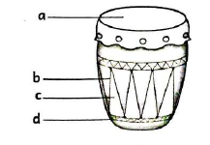
a:_______________________________________.

c: _______________________________________.

PART 2: SPORTS (20 marks)
46. A school handball team is training for an upcoming interschool tournament.
(a) Mention three types of passes the team can use during the game. (3 marks)
- _____________________________________________________________________________________.
- ______________________________________________________________________________________
- ______________________________________________________________________________________
- (b) State one role of the goalkeeper during a handball match. (1 mark)
_____________________________________________________________________________________
47. During a Physical Education lesson, your class is practicing football skills.
(a) Explain two techniques of dribbling that would help you keep control of the ball. (4 marks)
- _____________________________________________________________________________________.
- _____________________________________________________________________________________.
(b) State two rules that all players must observe in a football match. (2 marks)
- _______________________________________________________________________________.
- _______________________________________________________________________________.
48. You have been selected to represent your school in the javelin event during a sports day.
(a) Describe the correct body posture you should use when throwing a javelin. Include a drawing or diagram. (3 marks)
________________________________________________________________________________________
________________________________________________________________________________________
________________________________________________________________________________________
(b) List two important items you will need for the javelin event. (2 marks)
- _____________________________________________________________________________________.
- _____________________________________________________________________________________.
49. During fitness training, your coach asks you to improve your physical skills.
(a) Differentiate between strength and stability in physical fitness. (2 marks)
________________________________________________________________________________________________________________________________________________________________________________________________________________________________________________________________________________________________________________________________________________________________________________
(b) Give two activities that can help you improve your agility in athletics. (2 marks)
- _____________________________________________________________________________________.
- _____________________________________________________________________________________.
(c) What role does coordination play when performing physical exercises like skipping or balancing? (1 mark)
___________________________________________________________________________________________________________________________________________________________________________

PART 3: VISUAL ARTS (20 marks)
50. Your group is assigned to create a simple animation for a school art project.
(a) Explain what is meant by flipbook animation. (2 marks)
________________________________________________________________________________________________________________________________________________________________________________________
(b) Draw three simple frames to show a bouncing ball in motion. (3 marks)

51. You are designing a greeting card to be displayed on your school’s Open Day.
(a) State two elements of visual arts you will use in the card design. (2 marks)
- _____________________________________________________________________________________.
- _____________________________________________________________________________________.
(b) Explain how you will decorate the card to make it attractive. (3 marks)
- _______________________________________________________________________________.
- _______________________________________________________________________________.
- _______________________________________________________________________________.
52. Your class is preparing costumes for a Kenyan folk dance performance.
(a) What is adornment in relation to costumes? (2 marks)
________________________________________________________________________________________________________________________________________________________________________________________
(b) Name two materials you could use to decorate the costumes. (2 marks)
- ______________________________________________________________________________________
- ______________________________________________________________________________________
53. Your school is holding a storytelling competition.
(a) What are three essential elements that make a story complete? (3 marks)
__________________________________________________________________________________________.
__________________________________________________________________________________________.
__________________________________________________________________________________________.
(b) Describe how you would present your story to keep the audience interested. (2 marks)
____________________________________________________________________________________________________________________________________________________________________________________________________________________________________________________________________________________
THIS IS THE LAST PRINTED PAGE.

