Candidate’s Name |  | Assessment Number
School Name |  | School Code
Candidate’s Signature |  | Date
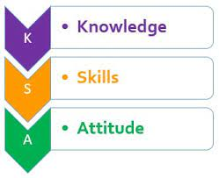
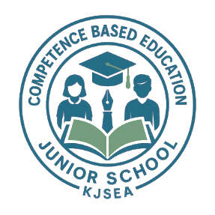

MONITORING JUNIOR SCHOOL LEARNER PROGRESS
GRADE 7: 711/1: CREATIVE ARTS AND SPORTS
PAPER 1 (Project)
CODE: 008 YEAR: 2025
DURATION: 3 weeks

INSTRUCTIONS TO SCHOOLS
- This is a project paper to be done over a 3-weeks period.
- Teachers will assess each task based on the provided scoring rubrics.
- Each milestone should be marked and recorded for every learner as they progress.

This paper consists of 3 printed pages. Candidates should check the question paper to ascertain that all the pages are printed as indicated and that no questions are missing.
© 2025 The Kenya Junior School Examination and Assessment Series. Turn over

1. INTRODUCTION
(i) This is a multidisciplinary project integrating Visual Arts, Performing Arts (Music, Dance, Theatre), and Physical Education (Sports).
(ii) Learners will carry out the entire project and be assessed on individual contributions.
(iii) Each task must follow an assessment rubric. Learners should access the rubric to align their work with expectations.

2. PROJECT DESCRIPTION
The theme of this year’s school project is:
“My Culture, My Strength”
Your school will organize a Cultural Showcase Week, celebrating the heritage, traditions, and creativity of various Kenyan communities. Events will include exhibitions, drama, music, and traditional games.
You are required to complete the following four tasks:

Task 1: Visual Arts – Culture-Inspired Mask Creation
Individually:
a) Design and create a traditional or modern decorative mask inspired by a Kenyan community of your choice. Use recyclable or found materials such as fabric, string, beads, bottle tops, cardboard, or papier-mâché.
b) Document your design process through sketches, notes, and photos.
c) Write a short explanation (half a page) of:
- The community that inspired the design.
- The cultural meaning or purpose of the mask.
- The materials used and why they were chosen.
d) Display your final mask in an art corner set up for the Cultural Showcase Week.

Task 2: Music and Dance – Traditional Instrument and Folk Dance
In groups of 5–8 learners:
a) Improvise and build a simple traditional musical instrument (e.g., shaker, drum, lyre, flute) using locally available materials.
b) Learn and rehearse a folk dance from a Kenyan community to accompany the instrument.
Include:
- Body movement patterns and steps.
- Rhythm and coordination.
- Use of traditional attire or props.
c) Each group will perform the folk dance accompanied by the instrument during the Cultural Showcase.
d) Document your instrument-making process and dance rehearsal through photos, videos, or a poster summary.

Task 3: Theatre – Cultural Monologue or Skit
Individually:
a) Choose a traditional proverb, myth, or folktale and write a short monologue or skit (1–2 minutes).
- Focus on dialogue, character portrayal, and cultural relevance.
- Include clear beginning, middle, and end.
b) Rehearse and present your piece using:
- Effective voice projection
- Gestures and facial expression
- Proper use of space and props (if needed)
c) Write a brief summary explaining:
- The origin or meaning of the proverb or story
- The moral or lesson being communicated
Present your skit/monologue on stage during the Cultural Showcase Week.

Task 4: Sports – Indigenous Kenyan Games and Athletics
In small teams (4–6 learners):
a) Research and play an indigenous or traditional game (e.g., Ajua, Kati, Kula Mti, Blada, Mweso).
b) Demonstrate the game during the Cultural Showcase, explaining:
- The origin and cultural relevance of the game
- The rules of play
- The skills required
c) Improvise materials required for the game if needed.
d) Additionally, participate in short athletics activities (e.g., relays, sprinting, or hurdles) to promote physical fitness.
e) Reflect on what you learned about teamwork, leadership, and fairness in a short journal entry (half a page).

THIS IS THE LAST PRINTED PAGE.

