Candidate’s Name |  | Assessment Number
School Name |  | School Code
Candidate’s Signature |  | Date



MONITORING JUNIOR SCHOOL LEARNER PROGRESS
GRADE 7: 706/1 AGRICULTURE AND NUTRITION
PAPER 1 (Theory)
CODE: 008 YEAR: 2025
TIME: 2 HOURS
INSTRUCTIONS TO CANDIDATES:
Instructions to Candidates:
- Write your name and assessment number in the spaces provided.
- Answer ALL questions in Section A and Section B.
- All answers must be written in the spaces provided in this question booklet.
- This paper consists of 12 printed pages. Candidates should check the question paper to ascertain that all pages are printed as indicated and that no questions are missing.
- Candidates should answer the questions in English.

For Official Use Only

SECTION A: MULTIPLE CHOICE QUESTIONS (30 Marks)
Question Number | 1 | 2 |  | 3 | 4 |  | 5 | 6 | 7 |  | 8 | 9 | 10 | 11 | 12 | 13 | 14 | 15
Maximum Score | 1 | 1 |  | 1 | 1 |  | 1 | 1 | 1 |  | 1 | 1 | 1 | 1 | 1 | 1 | 1 | 1
Candidate’s Score
Question Number | 16 |  | 17 |  |  | 18 |  | 19 |  | 20 |  | 21 | 22 | 23 | 24 | 25 | 26 | 27 | 28 | 29 | 30 | Total score
Maximum Score | 1 |  | 1 |  |  | 1 |  | 1 |  | 1 |  | 1 | 1 | 1 | 1 | 1 | 1 | 1 | 1 | 1 | 1 | 30
Candidate’s Score

SECTION B: STRUCTURED QUESTIONS. (50 Marks)
Task | Task 1: Agriculture |  |  |  | Task 2: Nutrition
Question Number | 31 | 32 | 33 | 34 | 35 | 36 | 37 | 38
Maximum Score | 2 | 4 | 3 | 5 | 9 | 3 | 4 | 3
Candidate’s Score
Maximum task score | 23 |  |  |  | 27
Candidate’s task score
This paper consists of 9 printed pages. Candidates should check the question paper to ascertain that all the pages are printed as indicated and that no questions are missing.
© 2025 The Kenya Junior School Examination and Assessment Series. Turn over

SECTION A: (30 Marks)
Answer all questions.

- Which of the following is NOT a way of conserving soil resources? A. Terracing B. Contour ploughing C. Bush burning D. Afforestation
- What is the primary benefit of constructing water retention structures in a farm? A. To increase soil erosion B. To reduce water availability for crops C. To ensure water availability during dry seasons D. To encourage water run-off
- Which of these is a major cause of soil pollution? A. Organic farming B. Proper waste disposal C. Overuse of chemical fertilizers D. Crop rotation
- Wafula took a photograph of a tree as shown below
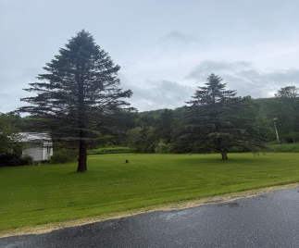
The tree in the picture contributes to soil conservation mainly by: A. Increasing wind erosion B. Loosening the soil structure C. Holding soil particles together with its roots D. Competing with crops for nutrients
- Which cooking method involves placing food in a perforated container above boiling water? A. Roasting B. Frying C. Steaming D. Grilling
- Mama Akinyi wants to preserve the vitamins in her vegetables while cooking. Which method is most recommended? A. Boiling for a long time B. Steaming lightly C. Frying until crispy D. Adding a lot of baking soda

- Which of the following is a product obtained from animals? A. Maize B. Eggs C. Beans D. Wheat
- When establishing crops, what is the importance of preparing an appropriate tilth? A. To make it difficult for seeds to germinate B. To provide good aeration and root penetration C. To encourage weed growth D. To compact the soil
- Which of these is NOT a crop management practice? A. Weeding B. Pest control C. Harvesting D. Selling produce
- You observe a farmer burning crop residues in his farm. This practice is likely to lead to: A. Increased soil fertility B. Soil erosion and loss of organic matter C. Improved water retention D. Reduced pest infestation
- What is the main purpose of adding value to crop produce? A. To make it cheaper B. To increase its shelf life and marketability C. To make it heavier D. To reduce its nutritional value
- Which of the following is a common ingredient used in making homemade soap? A. Sugar B. Salt C. Caustic soda D. Vinegar
- When preparing a planting site, which of these activities comes first? A. Planting B. Weeding C. Digging and breaking up the soil D. Fertilizing
- What is the primary role of a construction frame in a suspended garden? A. To provide shade for the plants B. To hold the containers and support the plants C. To scare away pests D. To store water

- Animals were seen in a condition as shown below.
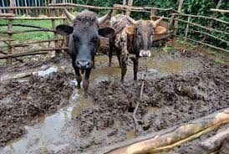
The condition of the animal shed in the picture is likely to lead to: A. Increased animal productivity B. Spread of diseases among animals C. Reduced feed consumption D. Higher quality animal products
- Which type of tilth is best for planting small seeds like carrots? A. Coarse tilth B. Fine tilth C. Lumpy tilth D. Rocky tilth
- What is the correct way to handle loose coloured clothes during laundry? A. Wash them with white clothes B. Wash them separately to prevent colour bleeding C. Use hot water for all washes D. Dry them in direct sunlight for long periods
- What skill involves creating fabric by interlocking loops of yarn using needles? A. Sewing B. Knitting C. Weaving D. Embroidery
- When preparing honey, which of these is NOT a crucial step? A. Harvesting honeycombs B. Extracting honey from the comb C. Adding sugar and water D. Straining the honey
- What is the most hygienic way to store freshly collected eggs? A. On the kitchen counter at room temperature B. In a clean, cool place, preferably refrigerated C. In direct sunlight D. Mixed with other food items
- Which of the following is a benefit of crop rotation as a crop management practice? A. Increases pest population B. Depletes soil nutrients C. Improves soil fertility and controls pests D. Encourages monoculture
- What happens to the nutritional value of food when it is overcooked? A. It increases significantly B. It remains the same C. It often decreases, especially for vitamins D. It turns into harmful substances
- Which practice helps in controlling soil pollution caused by plastic waste? A. Burying plastic waste B. Burning plastic waste C. Recycling and proper disposal of plastics D. Throwing plastic waste into rivers
- A farmer notices that water quickly runs off his farm, leading to soil erosion. Which water retention structure would be most suitable to address this problem? A. A large dam B. A small rock bund C. A simple ditch D. A well
- What is the main aim of mulching in crop management? A. To encourage weed growth B. To increase soil temperature C. To conserve soil moisture and suppress weeds D. To attract pests
- Why is it important to practice good hygiene when rearing animals? A. To make the animals smell better B. To prevent the spread of diseases to humans and other animals C. To increase feed consumption D. To make the animals grow faster
- Which of the following is a way of adding value to bananas? A. Leaving them to rot B. Making banana crisps or flour C. Selling them immediately after harvest D. Throwing them away if they are overripe

- Before establishing crops, what is the significance of removing weeds from the planting site? A. Weeds provide shade for the young crops B. Weeds compete with crops for nutrients, water, and sunlight C. Weeds help in soil aeration D. Weeds improve the appearance of the farm

- What type of tilth is generally preferred for planting maize seeds? A. Very fine tilth B. Medium tilth C. Hard, compacted tilth D. Stony tilth
- Which of these is an example of a good hygienic practice when handling animal products like milk? A. Using dirty containers for storage B. Leaving milk uncovered C. Boiling milk before consumption D. Mixing fresh milk with old milk

SECTION B: (50 Marks)

Answer all questions
PART 1: AGRICULTURE (25 Marks)
- Mercy lives in a rural area where soil erosion is a major problem, especially during the rainy season. She observes that her neighbor, Mr. Kimani, has planted trees along the contours of his farm and constructed small ditches.
a) Identify two ways in which Mr. Kimani's actions are helping to conserve soil resources on his farm. (2 Marks)
i. _________________________________________________________________________________.
ii. _________________________________________________________________________________.
b) Besides what Mr. Kimani is doing, suggest two other methods of conserving soil resources that Mercy can advise her community to adopt. (2 Marks) i. _________________________________________________________________________________.
ii. _________________________________________________________________________________.
- A farmer has been using a lot of chemical fertilizers and pesticides on his farm for several years. Recently, he has noticed that his soil is becoming less productive, and there are fewer earthworms.
a) What is the main cause of soil pollution in this scenario? (1 Mark)
_______________________________________________________________________________________
_______________________________________________________________________________________
b) State two ways in which the farmer can control soil pollution on his farm. (2 Marks)
i. _________________________________________________________________________________.
ii. _________________________________________________________________________________.
c) Explain one importance of growing trees in relation to controlling soil pollution. (1 Mark) i. _________________________________________________________________________________.
- Suleiman took photographs of water retention structures during a school trip.
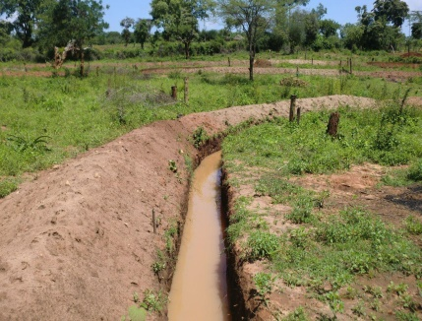
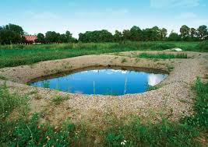
K L
a) Identify any two water retention structures shown in the illustration. (2 Marks)
i. K ____________________________________________________________.
ii. L ___________________________________________________________.
b) Explain how one of the identified structures helps in water retention. (1 Mark)
_______________________________________________________________________________________
______________________________________________________________________________________
- Before planting his cabbage seedlings, John observed that his soil was very lumpy and hard. He knows that the type of soil preparation (tilth) is crucial for good crop establishment.
a) What is the recommended appropriate tilth for planting cabbage seedlings? (1 Mark)
_____________________________________________________________________________________

b) Describe two characteristics of this appropriate tilth. (2 Marks)
i. __________________________________________________________________________________.
ii. __________________________________________________________________________________.
c) Name two common farm tools John can use to achieve the appropriate tilth. (2 Marks)
i. __________________________________________________________________________________.
ii. _________________________________________________________________________________.
- Mary is preparing a new plot for planting maize. She has just cleared the land.
a) List three essential steps Mary needs to undertake in preparing the planting site before actual planting. (3 Marks)
i. __________________________________________________________________________________.
ii. __________________________________________________________________________________.
iii. __________________________________________________________________________________.
b) After establishing her maize crop, Mary needs to manage it effectively. Name three crop management practices she should carry out. (3 Marks)
i. __________________________________________________________________________________.
ii. _________________________________________________________________________________.
iii. _________________________________________________________________________________.
c) Provide one reason for carrying out each of the crop management practices listed in 5(b) above. (3 Marks) i. _________________________________________________________________________________.
ii. ________________________________________________________________________________.
iii. _______________________________________________________________________________.

PART 2: NUTRITION (25 Marks)
- Aisha has harvested fresh spinach from her kitchen garden. She wants to cook it in a way that preserves most of its nutrients.
a) Suggest two cooking methods that Aisha can use to conserve the nutrients in her spinach. (2 Marks)
i. ___________________________________________________________________________________.
ii. ___________________________________________________________________________________.
b) Explain why one of the suggested methods in (a) above helps in nutrient conservation. (1 Mark)
_______________________________________________________________________________________
_______________________________________________________________________________________
- Amina's family keeps chickens for eggs and meat. She is responsible for collecting and preparing the eggs.
a) Describe the hygienic practices Amina should observe when collecting eggs from the chicken coop. (2 Marks)
_______________________________________________________________________________________
_______________________________________________________________________________________
b) Outline the steps Amina would follow to prepare a simple boiled egg for breakfast. (3 Marks)
i. ____________________________________________________________________________________.
ii. ___________________________________________________________________________________.
iii. __________________________________________________________________________________.
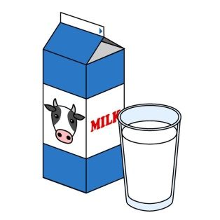
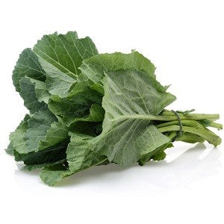
- Museveni was asked to bring the following food items for a class lesson..
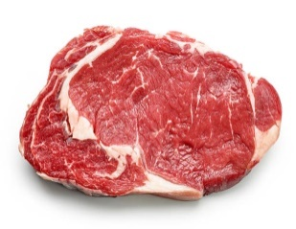
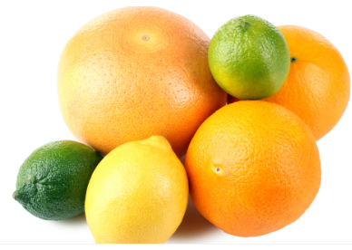

M N O P
a) Identify any two animal products from the illustration that are sources of proteins. (2 Marks)
i. ______________________________ ii. ______________________________.
b) State one nutritional benefit of consuming animal products. (1 Mark)
__________________________________________________________________________________
- Your school is planning to start a suspended garden to grow vegetables for the school's kitchen.
a) What is the main purpose of the construction frame in a suspended garden? (1 Mark)
______________________________________________________________________________________________________________________________________________________________________________
b) Suggest two advantages of a suspended garden compared to a traditional garden plot. (2 Marks)
i. ____________________________________________________________________________________.
ii. ___________________________________________________________________________________.
- John's family has a surplus of tomatoes after a good harvest. His mother is thinking of ways to prevent them from going bad and to earn some extra income.
a) Suggest two ways John's mother can add value to her tomato produce. (2 Marks)
i. __________________________________________________________________________________.
ii. __________________________________________________________________________________.
b) Explain one benefit of adding value to crop produce. (1 Mark)
_______________________________________________________________________________________
_______________________________________________________________________________________
- Mama Pendo wants to start making her own soap at home using simple ingredients.
a) Name two key raw materials required to make homemade soap. (2 Marks)
i. ___________________________________________________________________________________.
ii. ___________________________________________________________________________________.

b) Briefly describe one safety precaution Mama Pendo should take when making homemade soap. (1 Mark)
- Jane is doing her laundry. She has a mix of white clothes and brightly coloured clothes, some of which are new.
a) What is the correct practice Jane should follow when washing the new, loose coloured clothes? (1 Mark)
_______________________________________________________________________________________
_______________________________________________________________________________________
b) Why is this practice important? (1 Mark)
_______________________________________________________________________________________
_______________________________________________________________________________________
- Your grandmother wants to make a scarf using yarn. She uses long needles to create loops.
a) Which fabric craft skill is your grandmother using? (1 Mark)
______________________________________________________________________________________
b) Name one item, other than a scarf, that can be made using this skill. (1 Mark)
______________________________________________________________________________________

THIS IS THE LAST PRINTED PAGE.

