Name: …………………………………………………………… Adm No: …………………………
Class: …………………………………………………………. Candidate’s Sign: ………...............
Date: ………………………………............................................

312/1
GEOGRAPHY
PAPER 1

TIME: 2 ¾ HOURS



KISII SCHOOL
MOCK EXAM 2025
Kenya Certificate of Secondary Education (K.C.S.E)

INSTRUCTIONS TO CANDIDATES:

- This paper consists of two sections: A and B
- Answer all the questions in section A
- Answer question 6 and any two questions from section B
- All answers must be written in the answer booklet provided

SECTION A: 25 MARKS
(Answer all the questions in this section)

- a) Differentiate between latitude and longitude. (2mks)
b) If the local time in New York 74⁰ West is 08:00am, what is the time at Kitale 35⁰ East? (3mks)

- a) Other than fog, name two other forms of precipitation. (2mks)
b) State three conditions necessary for the formation of fog. (3mks)

- a) Name two types of earth movements that occur within the earth`s crust. (2mks)
b) Mention any three causes of earth movements. (3mks)

- The diagram below shows some underground features of a karst scenery. Use it to answer the questions that follow.

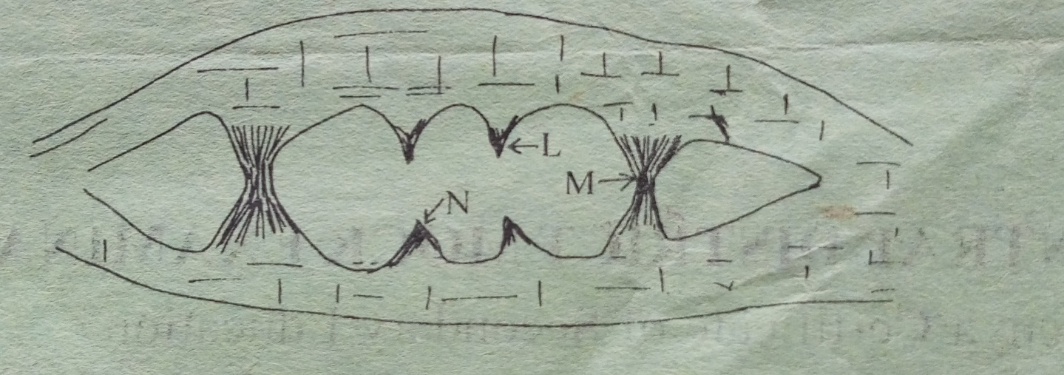
- Name the features marked L, M and N. (3mks)
- State two conditions necessary for the formation of a karst landscape. (2mks)

- a) State three processes of wind erosion in arid areas. (3mks)
(b) The diagram below shows some features produced by water erosion in deserts.

- Name the features marked A and B. (2mks)

SECTION B: 75 MARKS
(Answer question 6 and any other two questions from this section)

- Study the map of Mumias 1:50,000 (Sheet 101/2) provided and answer the following questions.

- i) Identify the two methods used to represent relief on this map. (2mks)
ii) What is the Vertical Interval used on this map? (1mk)

- i) Identify four man-made features found in grid square 6637. (4mks)
(ii) What is the direction of Nyapera market from Buhuyu dam? (2mks)

- i) Giving evidences, identify three social services found in the area covered by the map. (3mks)
ii) Explain two factors influencing settlement in the area covered by the map. (4mks)
iii) Identify three types of natural vegetation in the area covered by the map. (3mks)

- Draw a cross section along Northing 29 from Easting 58 to 64. On the cross section, show the following: (7mks)
- Dry weather road
- River
- Motorable track

- a) (i) Distinguish between magma and lava. (2mks)
(ii) List any three intrusive volcanic features. (3mks)

b) Using a well labelled diagram describe the formation of a caldera by violent explosion. (5mks)
c) Explain four negative effects of volcanicity in Kenya. (8mks)

d) Your class intends to carry out a field study on volcanic rocks.
i) State three ways you would prepare for the study. (3mks)
ii) Give four reasons why it would be necessary to carry rock samples during the field study. (4mks)

- a) (i) State three factors that influence mass wasting. (2mks)
(ii) Describe how the following types of mass wasting take place. (6mks)
- Avalanche
- slumping
iii) List three types of rapid mass wasting. (3mks)

b) Students from your class carried out a field study on mass movement around your school.
- State three evidences of soil creep you are likely to identify during the study. (3mks)
- Name any three methods of data collection you`re likely to employ during the study. (3mks)
- Explain four effects of mass wasting on the environment. (8mks)

- Below is a map of Africa showing climatic regions. Use it to answer the questions that follow.

a) Identify the climatic regions marked A, B and C. (3mks)
b) Outline four characteristics for each of the following climatic regions.
(i) Climatic region marked A (4mks)
(ii) Climate region marked C (4mks)
- Describe four human activities that may contribute to climate change. (8mks)
- (i) Describe a suitable site for locating a weather station. (2mks)
(ii) Give reasons why a Stevenson screen:
- Has louvres (2mks)
- Is painted white (2mks)

- (a) (i) Differentiate between river rejuvenation and river capture. (2mks)
ii. Name three features that form as a result of river erosion. (3mks)
(b) i) Explain four ways through which a river transports its load. (8mks)
ii) Give two ways by which rivers can improve food security in a region. (2mks)
(c) You are planning to carried out a field study on the lower course of river Tana.
(i) Give three reasons why you would require a route map. (3mks)
(ii) State four characteristics of a river at the old stage that you`re likely to observe. (4mks)
(iii) Give three follow-up activities you would undertake in relation to the field study. (3mks)

