

STAREHE GIRLS’ CENTRE MOCK EXAMINATION 2025

312/2
GEOGRAPHY
PAPER 2
FORM FOUR
MARKING SCHEME
SECTION A
1. a) Name two provinces in Canada where wheat is grown in large scale.
- Manitoba
- Alberta
- Saskatchewan
(Any 2 x 1 = 2 mks)

b) List three social factors that influence agriculture.
- Tradition/culture/diet
- Land ownership and inheritance
- Religion
- Gender roles
- Technology
- Foreign influence
(Any 3 x 1 = 3mks)

c) State two factors that favour mechanization of wheat farming in Canada.
- Canada plains are gentle sloping
- Wheat farms are large/expansive/land is scarcely populated
- Farmers have adequate capital to set up large farms
- Availability of technology/skilled labour
(Any 2 x 1 = 2 mks)

2. a) Name two horticultural crops grown in Kenya.
- Vegetables/tomatoes/onion/carrots (allow any correct vegetable)
- Fruits/oranges/pineapples/plums/mangoes (allow any correct fruit)
- Flowers – roses, carnations etc
(Any 2 x 1 = 2 mks)

b) Reasons why horticulture is more developed in Netherlands than in Kenya.
- There is high demand both local and foreign for horticultural crops products in Netherlands than in Kenya
- Farmers in Netherlands have more access to the capital needed for horticultural farming than in Kenya
- There is more advanced appropriate technology in the Netherlands, which has enhanced horticultural farming than in Kenya
- Netherlands unlike Kenya has well-developed means of transport which enables fast movement of horticultural products
- Netherlands unlike Kenya has highly skilled labour for production and handling of horticultural products
- There is more advanced horticultural farming related research in Netherlands than in Kenya
- Netherlands unlike Kenya has a well organized marketing procedure/co-operatives/auction marts

(Any 3 well compared points 3 x 1 = 3mks)

3. a) State three reasons why marine fisheries in Kenya are underdeveloped.
- The continental shelf is narrow
- Poor transport connections to the fisheries
- Coastline is fairly straight/has few indentation
- The water is warm for fish breeding/shallow continental shelf/lack of upwelling water
- Low demand for fish locally
- Fishermen lack modern equipment/presentation/storage facilities
- Inadequate storage facilities – competition from developed countries

(Any 3 x 1 = 3 mks)

4. a) Name two conditions necessary for the formation of petroleum.
- Presence of sedimentary rocks
- Presence of non-porous rocks/cap rock
- Presence of porous rocks
- Presence of organic remains/fossils
- Presence of pressure to compress the organic remains

(Any 2 x 1 = 2mks)

b) List three ways in which open cast mining affects environment.
- Leaves behind ugly open craters/derelict landscape
- It causes air, water, noise pollution
- It leads to soil erosion
- Dumping of rock waste litters the surface/land pollution
- Water collects in the open craters forming breeding grounds for mosquitoes/pests
- Destruction of biodiversity (plants and animals)
(Any 3 x 1 = 3 mks)

5. Apart from desertification, other environmental hazards in Kenya.
- Lightning
- Strong winds
- Hailstorms
- Dust storms
- Pests/diseases
- Floods
(Any 2 x 1 = 2mks)

Question 6
a) i) Sugar = $\frac{99,000}{713,000} ×{360}^{o}=49.99$ $⋍$ 50º

Iron & Steel = $\frac{300,000}{713,000} ×{360}^{o}=151.5$
$⋍$ 152º

Fertilizer = $\frac{84,000}{1713,000} ×{360}^{o}=42.4$
$⋍$ 42º

Wheat =$\frac{125,000}{713,000} ×{360}^{o}=63.1$
$⋍$ 63º

Coal =$\frac{105,000}{713,000} ×{360}^{o}=53.01$
$⋍$ 53º

T = 1 mk
Circle = 1 mk
Key = 1 mk
Divisions = 5 mks
8 mks

A PIE CHART REPRESENTING KENYA IMPORTS IN 1987

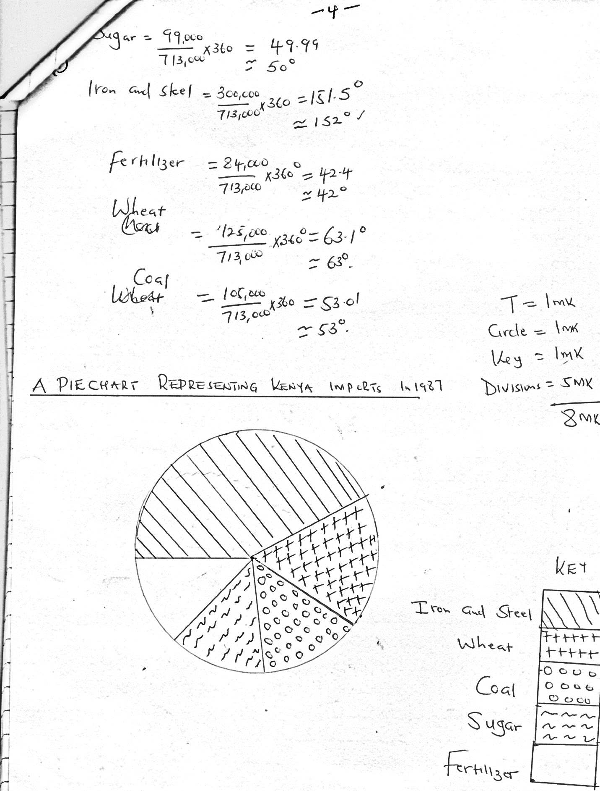

6. a) ii) State three advantages of using pie charts to represent statistical data.
- It is easy to compare the information represented
- They give a good/clear visual impression
- They are easy to construct
- They are easy to read and interpret
(Any 3 x 1 = 3mks)

b) Explain why Kenya imports sugar and wheat yet she is a producer of the same commodities
- Illegal exports/smuggling/hoarding of commodities creates artificial shortage hence need to import
- Pests and diseases reduce the amount of wheat hence need for importation
- Kenya is not self-sufficient due to high population
- Cane sugar produced in Kenya is sold at higher price than beet sugar hence Kenya makes profit in exporting
- Crop failure due to droughts leads to shortages necessitating importation to supplement the locally produced wheat
- Increased cost of farm inputs leads to low production, hence the need to supplement the local supplies through importation
- Mismanagement of industries leads to the collapse and hence need to supplement local supplies (Any 3 x 2 = 6mks)
c) Explain four factors that influence importation and exportation of goods in and out of Kenya.
- Government policy through legislation. The government can encourage or discourage trade
- Demand for goods both locally and outside Kenya encourages importation and exportation of goods
- Availability of means of transport and communication enhances trade inhabit/non-availability
- Level of industrialization/development dictates the types of goods to be imported and those exported
- Distribution of resources/type of goods determine what a country exports and what it imports
(Any 4 x 2 = 8mks)

7. a) Name three types of industries located in the Ruhr region of Germany other than iron and steel.
- Engineering
- Chemical industries/petrol chemical/fertilizer
- Textile industries
- Oil refining
- Electronics
- Food processing
- Cutlery and surgical equipments
- Service industries – banking, insurance, tourism, transport
(Any 3 x 1 = 3 mks)
b) Four factors which led to growth of iron and steel industry in Ruhr region of Germany.
- The region is centrally located in Europe – this offers easy access to all parts of Europe
- Region is served by navigable rivers and canals which provide cheap means of transport for raw materials and finished products
- Availability of raw materials – it is economical to set up iron and steel industry near the source of raw materials because they are bulky. The Ruhr region has coal, iron ore and limestone
- Existence of traditional industries which led to development of necessary skills
- Presence of rich companies/families which are ready to provide capital for development of industries
- Region has abundance source of power such as oil, coal, HEP which is necessary in iron and steel industries
- Dense and affluent population in central and western Europe provides ready market for iron and steel
(Any 4 x 2 = 8mks)

c) Four ways in which Kenya has benefited by assembling motor vehicles locally.
- Foreign exchange/income locally or externally earned through sale locally or exportation of motor vehicles
- Kenya saves foreign exchange by importing parts of motor vehicles instead of complete unit
- Creation of job opportunities for Kenyans reducing the unemployment problem
- Industry has allowed development of skills among Kenyans
- Industry has enabled Kenya to establish trade links with her neighbours
- Has led to stimulation of other related industries e.g. tyres , paints, glass etc
- Has led to investment of capital by rich companies
(Any 4 x 2 = 8 mks)

d) Describe problems experienced in Kenya as a result of industrial development.
- Industries have taken over land. This has led to high/unaffordable land rates
- Production of industries waste has led to the degradation of land/air/water (pollution)
- Erosion of social values which has resulted from mixing up of people of different culture/loss of cultural values/increase in crimes
- Concentration of infrastructure and services in industrial centres has caused an imbalance in economic development
- Emergence of slums due to lack of housing facilities/straining/overstretching social facilities
- Depletion of natural resources to satisfy deman
(Any 3 x 2 = 6 mks)

8. a) Name four sources of electric power other than water.
- Coal
- Oil
- Solar energy/sun
- Geothermal energy
- Bio gas
- Wind
(Any 4 x 1 = 4mks)

b) List five factors that favours the location of hydroelectric power plant.
- Fast flowing water/waterfall to drive turbines/head of water
- Large volume of water
- Constant flow of water/river without great fluctuations
- Availability of space for a reservoir/low populated area
- Hard basement rock for foundation
- Narrow gorge/valley
- Government policy
(Any 5 x 1 = 5mks)

c) Explain five ways in which Kenya has benefited from the development of a seven forks hydroelectric power scheme.
- Government earns some income/revenue from electricity fees
- The scheme generates electricity which is used for industrial/domestic purposes
- Dams have modified the local climate and vegetation
- The projects provides sites that are tourist attraction
- It has led to control of floods in the lower parts of river Tana enabling people to make use of the valley
- The project has created reservoirs which provide fishing grounds
- Some of the dams provide water for irrigation purposes
(Any 5 x 1 = 5mks)

d) Explain three problems that Kenya face as a result of overdependence on petroleum.
- The country relies on importance of oil ignoring other sectors of the economy
- When prices of oil increases sharply Kenya spends large amount of her revenue on importation which affects balance of trade
- Increase in oil prices results in increase in the cost of manufactured goods and services causing inflation in the country
- Oil producing and exporting countries (OPEC) dictates the price without consulting the consumers such as Kenya. This necessitates high taxation to create revenue for importing oil
- Kenya exercises a higher shortage of petroleum product e.g. gas leading to destruction of forests
(Any 3 x 2 = 6mks)

9. a) Three physical conditions necessary for growing of sugarcane.
- It requires deep fertile clay soil/black cotton soils
- It requires high temperatures ranging from 20ºC and 28ºC
- It requires high rainfall of at least (1000mm – 1250mm) annually
- It is grown in gentle sloping/undulating land to enable mechanization
- It requires well-drained soils
(Any 3 x 1 = 3mks)
b) Describe commercial production of sugarcane from:
i) Land preparation to harvesting
- Land is ploughed using machines
- Furrows are made in the field
- Sugarcane cuttings are dipped in insecticides before planting
- Fertilizer is applied in the field severally
- The sugarcane cuttings (setts) are buried/planted in furrows
- Weeding is done severally/spraying of herbicides
- Crop matures at about 18 – 24 months and cane is manually harvested using matchets/pangas
- Cane is piled in heaps and loaded into tractors to factories
(Any 6 x 1 = 6 mks follow sequence)
ii) Processing to marketing of sugar
- At the factory, cane is received and weighed
- It is washed and later crashed to remove juice
- Juice is boiled for water to evaporate
- It is stirred in tank to allow formation of crystals
- Crystals are separated form molasses
- For white sugar, bleach is added
- Sugar is dried/graded/refined
- Sugar is weighed and packed
- Sugar is sold to marketing board
- Marketing board distributes sugar to wholesalers
(Any 8 x 1 = 8mks)
c) i) Methods appropriate used to collect data.
- Interviewing a resource person in the factory
- Filling in a questionnaire
- Observing stages in sugar processing
- Taking photograph
(Any 2 x 1 = 2mks)

ii) Problems facing sugarcane farmers in Kenya identified by students.
- Fire outbreaks in sugarcane areas destroy the cane
- Delayed payment lowers farmers morale. This lowers production
- Low prices of sugarcane discourages the farmers whose effort to earn a living is directed elsewhere
- Inadequate/unreliable transport delays the collection of sugarcane from the farm/lowering the tonnage
- Delay in harvesting the cane lowers quality and tonnage of harvest, thus the farmers earn less/breakdown of machinery in mills and farms
- Mismanagement of sugar companies leading to losses/demoralizing the farmers
- The high cost of farm inputs leads to low income for the farmers and this discourages them
- Pest and diseases destroy the cane/stagnate the growth of cane lowering the produce
- Bad weather denies sugarcane mature time
- Poor seeds hence poor harvest reduce quality
- Stiff competition from imported sugar. Cane factories cannot pay farmers/delayed payments
(Any 3 x 2 = 6mks)
10. a) Distinguish between transport and communication.
- Transport is the activity of movement of people and commodities from one place to another while communication is process of relaying information from one person to another through a certain medium.
(2mks)
10. b) Name three products transported by pipeline.
- Oil
- Gas
- water
(3 x 1 = 3mks)
c) Explain why there are few railway links among African countries.
- African countries were colonized by different colonial governments who constructed rail lines only within the area of jurisdiction
- Many African countries have political differences, which lead to mistrust and hostility. This works against any efforts to construct railway jointly
- African countries have railway of different gauges, which make it difficult for them to be connected
- There is little interstate trade among African countries. This does not warrant construction of railways to transport bulky goods
- African countries lack sufficient capital to establish railways which rely mainly on import raw materials/mountainous landscape/swampy terrain have hindered development of rails to link the countries
(Any 3 x 2 = 6mks)
d) Explain three ways in which Kenya has benefited from her international airports.
- Employment opportunities thus solving problems of unemployment/improving standards of living
- It has promoted tourism by providing direct links with the tourists country of origin
- It has promoted horticultural products by providing efficient means of transport to foreign markets
- Helped to generate revenue through taxation of goods and passengers at the airport/foreign exchange
- It has promoted international understanding by enabling Kenya to interact with people from other parts of the world
- It has promoted international trade by enabling business people to travel to and from Kenya easily
(Any 3 x 2 = 6mks)
e) Describe four problems facing transport and communication in Africa.
- Africa has difficult terrain which makes it difficult to develop transport and communication facilities e.g. great rift valley
- The African continent has extensive regions with harsh environment e.g. deserts like Sahara, thick tropical forest like Congo. These areas have low population hence no significant economic activity to encourage establishment of transport and communication
- Most rivers in Africa are non-navigable because of fluctuation of water levels, numerous rock outcrop, rugged terrain
- Inadequate communication facilities e.g. limited development of telephone network
- Civil wars – leads to destruction
(Any 4 x 2 = 8 mks)

