Name …………………………………………………………………………………………….….. Index No. ………………. Class …….


STAREHE GIRLS’ CENTRE MOCK EXAMINATION 2025

312/1
GEOGRAPHY
PAPER 1

TIME: 2 ¾ HOURS

Geography
Paper 1

INSTRUCTIONS TO CANDIDATES:

- This paper consists of two sections: A and B
- Answer all the questions in section A
- Answer question 6 and any two questions from section B
- All answers must be written in the answer booklet provided

SECTION A
Answer all the questions in this section.
1. The diagram below represents part of the earth’s crust which has been subjected to tension forces.
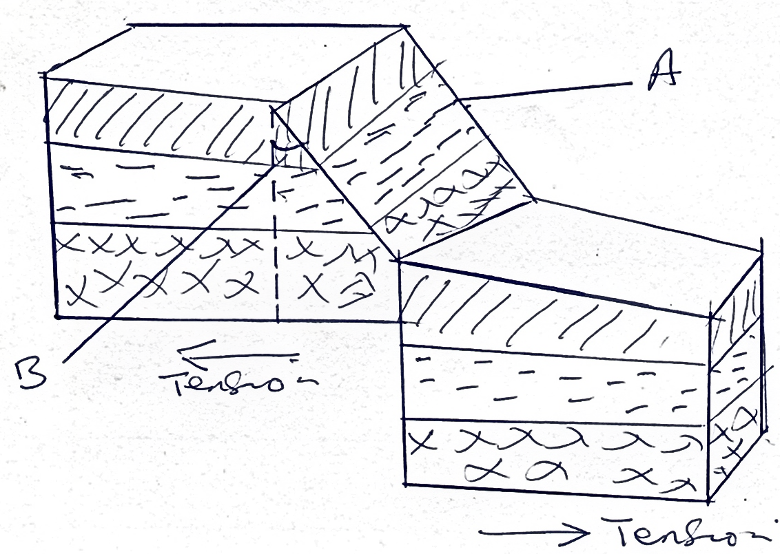
a) i) Name the slope marked A. (1 mk)
ii) Name the angle marked B. (1 mk)
b) State three ways in which faulting can influence drainage systems. (3mks)

2. a) Differentiate between longitudes and latitudes. (2mks)
b) If the local time in Nairobi on longitude 37ºE is 10.00 a.m. What will the time be at Buchanan Liberian on longitude 10ºW? (3 mks)

3. a) List four characteristics of desert soils. (3 mks)
b) Give two factors that contribute to soil leaching. (2 mks)

4. a) Give the two dates of equinoxes. (2 mks)
b) State three effects of the rotation of the earth. (3 mks)

5. a) Name the type of delta found at the mouth of:
i) River Nile (1 mk)
ii) River Omo (1 mk)

b) State three conditions necessary for the formation of a delta. (3 mks)

SECTION B
Answer question 6 and any other two questions from this section.
6. Study the map of Oyugis 1:50,000 (sheet 130/1) provided and answer the following questions.
a) i) State the magnetic declination when this map was drawn. (1 mk)
ii) Give the longitudinal extent of the area converted by the map. (1 mk)

b) i) Name the feature found at the grid reference (786399). (2 mks)
ii) Identify two types of vegetation found in the area covered by the map. (2 mks)

c) Citing evidence from the map, give four economic activities. (4 mks)

d) Students from Tabaka in Oyugis carried out a field study on settlement activities in the area.
i) Identify two settlement patterns they found depicted in the area. (2 mks)
ii) Give two problems they were likely to encounter in their study. (2 mks)

e) Draw a rectangle measuring 8cm by 6cm to represent area East of Eastings 90 and between Northings 36 and 39. On it indicate: (5 mks)
i) District boundary
ii) All weather road bound surface
iii) Seasonal swamp

7. a) Differentiate between vulcanicity and volcanicity. (2 mks)

b) i) Other than lava plateau, list down four features resulting from extrusive volcanic activity. (4 mks)
ii) Describe how lava plateau is formed. (5 mks)

c) Explain four ways in which vulcanicity has influenced human activities in Kenya. (8 mks)

d) You intend to carry out a field study of the landforms around your school.
i) State three objectives of your study. (3 mks) ii) State three methods you would use to record the information you would collect.
(3 mks)

8. a) Differentiate between weather and climate. (2 mks)

b) Describe the climatic conditions experienced in the Kenya highlands. (9 mks)

c) Explain how the following factors influence climate.
i) Latitude (2 mks)
ii) Altitude (2 mks)
iii) Aspect (2 mks)
iv) Winds (2 mks)

d) Explain three ways in which vegetation in the Nyika region of Kenya adapts to the climatic conditions experienced in the area. (6 mks)

9. a) Name three places in East Africa where glaciers are found. (3 mks)

b) Describe how each of the following glacial features are formed.
i) Arete (4 mks)
ii) Pyramidal peak (4mks)
iii) Hanging valleys (4 mks)

c) Explain five benefits of glaciated landscape to man. (10 mks)

10. a) List three processes through which coasts are eroded. (3 mks)

b) State two causes of submergence of coasts. (2 mks)

c) Using well labeled diagrams, explain how each of the following features are formed.
i) Spit (4 mks)
ii) Blow hole (4 mks)

d) Some students carried out field study on the coastal features found along the coast of Kenya.
i) State three preparations they made for their study. (3 mks)
ii) List three features formed as a result of coastal emergence that they are likely to have studied. (3 mks)

e) Explain three ways in which features resulting from coastal emergence are of significance to Kenya. (6 mks)

END

