NAME: …………………………………………. INDEX NO: ……………………………….

DATE : …………………………………..CANDIDATE’S SIGNATURE:…………………

MANGU HIGH SCHOOL TRIAL 4 MOCK 2025
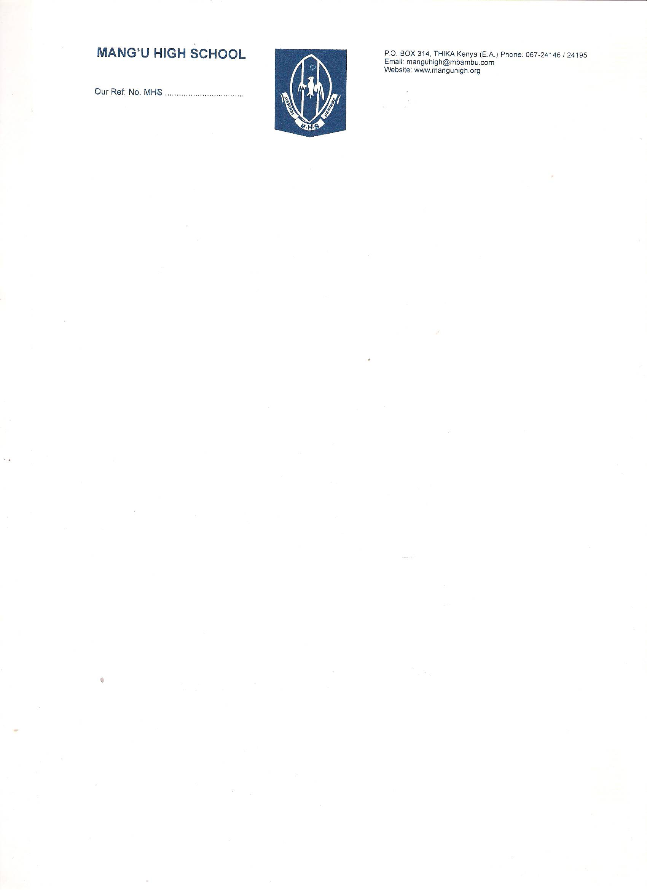
ENGLISH (101)
FORM 4

101/3 ENGLISH Paper 3
(Creative Composition and Essay based on Set Text)
JULY/AUGUST 2025– Time: 2 ½ hours
Instructions to Candidates
- Write your name, Adm number and class in the spaces provided above.
- Write your school, date of examination and sign in the spaces provided above.
- Answer three questions.
- In question 1, choose either (a) or (b)
- This paper consists of 16 printed pages. Candidates should check to ascertain that all pages are printed as indicated and that no question is missing.
For Examiner’s Use Only
QUESTION | MAXIMUM SCORE | CANDIDATE’S SCORE
1 | 20
2 | 20
3 | 20
TOTAL | 60

- Imaginative composition. (20 marks)
Either;
- Write a composition with the following beginning;
As I stepped into the dingy lit room, a sense of unease washed over me …
Or;
- Write an essay discussing how poor parenting has had negative effect on children.

- The Compulsory Set Text; Fathers of Nations by Paul Vitta. (20 marks)
The irresponsible decisions that people make in life have consequences. Drawing illustrations from the novel Fathers of Nations show how valid this assertion is.

- The Short Story − A Silent Song and Other Stories by (20 marks)
The low self-esteem that some children suffer is a result of parents who try to control their lives. Using relevant illustrations from the story Sins of the fathers, show the truth in this statement.
Or
The Play − Parliament of Owls by Adipo Sidang (20 marks)
Ineffective leaders use oppressive means to govern the citizens but it leads to misery. Citing illustrations from Adipo Sidang’s Parliament of Owls, write an essay to show the validity of this statement.

Or

The Novel – Artist of the Floating World by Kazuo Ishiguro (20 marks)
The ambitious nature of artists makes them strive to bring a change in life and even if they fail they still take pride in it. Write a composition using textual evidence from Kazuo Ishiguro’s novel Artist of the Floating World to show the truth of this statement

………………………………………………………………………………………………………………………………………………………………………………………………………………………………………………………………………………………………………………………………………………………………………………………………………………………………………………………………………………………………………………………………………………………………………………………………………………………………………………………………………………………………………………………………………………………………………………………………………………………………………………………………………………………………………………………………………………………………………………………………………………………………………………………………………………………………………………………………………………………………………………………………………………………………………………………………………………………………………………………………………………………………………………………………………………………………………………………………………………………………………………………………………………………………………………………………………………………………………………………………………………………………………………………………………………………………………………………………………………………………………………………………………………………………………………………………………………………………………………………………………………………………………………………………………………………………………………………………………………………………………………………………………………………………………………………………………………………………………………………………………………………………………………………………………………………………………………………………………………………………………………………………………………………………
………………………………………………………………………………………………………………………………………………………………………………………………………………………………………………………………………………………………………………………………………………………………………………………………………………………………………………………………………………………………………………………………………………………………………………………………………………………………………………………………………………………………………………………………………………………………………………………………………………………………………………………………………………………………………………………………………………………………………………………………………………………………………………………………………………………………………………………………………………………………………………………………………………………………………………………………………………………………………………………………………………………………………………………………………………………………………………………………………………………………………………………………………………………………………………………………………………………………………………………………………………………………………………………………………………………………………………………………………………………………………………………………………………………………………………………………………………………………………………………………………………………………………………………………………………………………………………………………………………………………………………………………………………………………………………………………………………………………………………………………………………………………………………………………………………………………………………………………………………………………………………………………………………………………
………………………………………………………………………………………………………………………………………………………………………………………………………………………………………………………………………………………………………………………………………………………………………………………………………………………………………………………………………………………………………………………………………………………………………………………………………………………………………………………………………………………………………………………………………………………………………………………………………………………………………………………………………………………………………………………………………………………………………………………………………………………………………………………………………………………………………………………………………………………………………………………………………………………………………………………………………………………………………………………………………………………………………………………………………………………………………………………………………………………………………………………………………………………………………………………………………………………………………………………………………………………………………………………………………………………………………………………………………………………………………………………………………………………………………………………………………………………………………………………………………………………………………………………………………………………………………………………………………………………………………………………………………………………………………………………………………………………………………………………………………………………………………………………………………………………………………………………………………………………………………………………………………………………………
………………………………………………………………………………………………………………………………………………………………………………………………………………………………………………………………………………………………………………………………………………………………………………………………………………………………………………………………………………………………………………………………………………………………………………………………………………………………………………………………………………………………………………………………………………………………………………………………………………………………………………………………………………………………………………………………………………………………………………………………………………………………………………………………………………………………………………………………………………………………………………………………………………………………………………………………………………………………………………………………………………………………………………………………………………………………………………………………………………………………………………………………………………………………………………………………………………………………………………………………………………………………………………………………………………………………………………………………………………………………………………………………………………………………………………………………………………………………………………………………………………………………………………………………………………………………………………………………………………………………………………………………………………………………………………………………………………………………………………………………………………………………………………………………………………………………………………………………………………………………………………………………………………………………
………………………………………………………………………………………………………………………………………………………………………………………………………………………………………………………………………………………………………………………………………………………………………………………………………………………………………………………………………………………………………………………………………………………………………………………………………………………………………………………………………………………………………………………………………………………………………………………………………………………………………………………………………………………………………………………………………………………………………………………………………………………………………………………………………………………………………………………………………………………………………………………………………………………………………………………………………………………………………………………………………………………………………………………………………………………………………………………………………………………………………………………………………………………………………………………………………………………………………………………………………………………………………………………………………………………………………………………………………………………………………………………………………………………………………………………………………………………………………………………………………………………………………………………………………………………………………………………………………………………………………………………………………………………………………………………………………………………………………………………………………………………………………………………………………………………………………………………………………………………………………………………………………………………………
………………………………………………………………………………………………………………………………………………………………………………………………………………………………………………………………………………………………………………………………………………………………………………………………………………………………………………………………………………………………………………………………………………………………………………………………………………………………………………………………………………………………………………………………………………………………………………………………………………………………………………………………………………………………………………………………………………………………………………………………………………………………………………………………………………………………………………………………………………………………………………………………………………………………………………………………………………………………………………………………………………………………………………………………………………………………………………………………………………………………………………………………………………………………………………………………………………………………………………………………………………………………………………………………………………………………………………………………………………………………………………………………………………………………………………………………………………………………………………………………………………………………………………………………………………………………………………………………………………………………………………………………………………………………………………………………………………………………………………………………………………………………………………………………………………………………………………………………………………………………………………………………………………………………
………………………………………………………………………………………………………………………………………………………………………………………………………………………………………………………………………………………………………………………………………………………………………………………………………………………………………………………………………………………………………………………………………………………………………………………………………………………………………………………………………………………………………………………………………………………………………………………………………………………………………………………………………………………………………………………………………………………………………………………………………………………………………………………………………………………………………………………………………………………………………………………………………………………………………………………………………………………………………………………………………………………………………………………………………………………………………………………………………………………………………………………………………………………………………………………………………………………………………………………………………………………………………………………………………………………………………………………………………………………………………………………………………………………………………………………………………………………………………………………………………………………………………………………………………………………………………………………………………………………………………………………………………………………………………………………………………………………………………………………………………………………………………………………………………………………………………………………………………………………………………………………………………………………………
………………………………………………………………………………………………………………………………………………………………………………………………………………………………………………………………………………………………………………………………………………………………………………………………………………………………………………………………………………………………………………………………………………………………………………………………………………………………………………………………………………………………………………………………………………………………………………………………………………………………………………………………………………………………………………………………………………………………………………………………………………………………………………………………………………………………………………………………………………………………………………………………………………………………………………………………………………………………………………………………………………………………………………………………………………………………………………………………………………………………………………………………………………………………………………………………………………………………………………………………………………………………………………………………………………………………………………………………………………………………………………………………………………………………………………………………………………………………………………………………………………………………………………………………………………………………………………………………………………………………………………………………………………………………………………………………………………………………………………………………………………………………………………………………………………………………………………………………………………………………………………………………………………………………
………………………………………………………………………………………………………………………………………………………………………………………………………………………………………………………………………………………………………………………………………………………………………………………………………………………………………………………………………………………………………………………………………………………………………………………………………………………………………………………………………………………………………………………………………………………………………………………………………………………………………………………………………………………………………………………………………………………………………………………………………………………………………………………………………………………………………………………………………………………………………………………………………………………………………………………………………………………………………………………………………………………………………………………………………………………………………………………………………………………………………………………………………………………………………………………………………………………………………………………………………………………………………………………………………………………………………………………………………………………………………………………………………………………………………………………………………………………………………………………………………………………………………………………………………………………………………………………………………………………………………………………………………………………………………………………………………………………………………………………………………………………………………………………………………………………………………………………………………………………………………………………………………………………………
……………………………………………………………………………………………………………………………………………………………………………………………………………………………………………………………………………………………………………………………………………………………………………………………………………………………………………………………………………………………………………………………………………………………………………………………………………………………………………………………………………………………………………………………………………………………………………………………………………………………………………………………………………………………………………………………………………………………………………………………………………………………………………………………………………………………………………………………………………………………………………………………………………………………………………………………………………………………………………………………………………………………………………………………………………………………………………………………………………………………………………………………………………………………………………………………………………………………………………………………………………………………...………………………………………………………………………………………………………………………………………………………………………………………………………………………………………………………………………………………………………………………………………………………………………………………………………………………………………………………………………………………………………………………………………………………………………………………………………………………………………………………………………………………………………………………………………………………………………………………………………………………………………………………………
………………………………………………………………………………………………………………………………………………………………………………………………………………………………………………………………………………………………………………………………………………………………………………………………………………………………………………………………………………………………………………………………………………………………………………………………………………………………………………………………………………………………………………………………………………………………………………………………………………………………………………………………………………………………………………………………………………………………………………………………………………………………………………………………………………………………………………………………………………………………
………………………………………………………………………………………………………………………………………………………………………………………………………………………………………………………………………………………………………………………………………………………………………………………………………………………………………………………………………………………………………………………………………………………………………………………………………………………………………………………………………………………………………………………………………………………………………………………………………………………………………………………………………………………………………………………………………………………………………………………………………………………………………………………………………………………………………………………………………………………………………………………………………………………………………………………………………………………………………………………………………………………………………………………………
………………………………………………………………………………………………………………………………………………………………………………………………………………………………………………………………………………………………………………………………………………………………………………………………………………………………………………………………………………………………………………………………………………………………………………………………………………………………………………………………………………………………………………………………………………………………………………………………………………………………………………………………………………………………………………………………………………………………………………………………………………………………………………………………………………………………………………………………………………………………………………………………………………………………………………………………………………………………………………………………………………………………………………………………………………………………………………………………………………………………………………………………………………………………………………………………………………………………………………………………………………………………………………………………………………………………………………………………………………………………………………………………………………………………………………………………………………………………………………………………………………………………………………………………………………………………………………………………………………………………………………………………………………………………………………………………………………………………………………………………………………………………………………………………………………………………………………………………………………………………………………………………………………………………
………………………………………………………………………………………………………………………………………………………………………………………………………………………………………………………………………………………………………………………………………………………………………………………………………………………………………………………………………………………………………………………………………………………………………………………………………………………………………………………………………………………………………………………………………………………………………………………………………………………………………………………………………………………………………………………………………………………………………………………………………………………………………………………………………………………………………………………………………………………………………………………………………………………………………………………………………………………………………………………………………………………………………………………………………………………………………………………………………………………………………………………………………………………………………………………………………………………………………………………………………………………………………………………………………………………………………………………………………………………………………………………………………………………………………………………………………………………………………………………………………………………………………………………………………………………………………………………………………………………………………………………………………………………………………………………………………………………………………………………………………………………………………………………………………………………………………………………………………………………………………………………………………………………………
………………………………………………………………………………………………………………………………………………………………………………………………………………………………………………………………………………………………………………………………………………………………………………………………………………………………………………………………………………………………………………………………………………………………………………………………………………………………………………………………………………………………………………………………………………………………………………………………………………………………………………………………………………………………………………………………………………………………………………………………………………………………………………………………………………………………………………………………………………………………
………………………………………………………………………………………………………………………………………………………………………………………………………………………………………………………………………………………………………………………………………………………………………………………………………………………………………………………………………………………………………………………………………………………………………………………………………………………………………………………………………………………………………………………………………………………………………………………………………………………………………………………………………………………………………………………………………………………………………………………………………………………………………………………………………………………………………………………………………………………………………………………………………………………………………………………………………………………………………………………………………………………………………………………………
THIS IS THE LAST PRINTED PAGE.

