Name …………………………………………………………………………………………….….. Index No. ………………. Class …….


STAREHE GIRLS’ CENTRE MOCK EXAMINATION 2025
COMPUTER STUDIES
451/1
Paper 1
TIME: 2 ½ HOURS

Instruction to candidates
- Write your name and index number in the space provided above.
- Sign and write the date of examination in the spaces provided above.
- This paper consists of two sections A and B.
- Answer all the questions in section A.
- Answer question 16 (Compulsory) and any other three questions from section B.
- All answers should be written in the space provided in the question paper.
- Candidates should check the question paper to ascertain that all the pages are printed as indicated and that no questions are missing.

For Examiner’s Use Only
Section | Question Number | Candidate’s Score
A | 1-15
B | 16
B | 17
B | 18
B | 19
B | 20
Total Score
SECTION A (40 MARKS)
Answer ALL the questions in this section
- Define the following terms (4 marks)
- Multiplexing
…………………………………………………………………………………………………………………………………………………………………………………………..………………………………………………………………………………………
- Baseband signal
…………………………………………………………………………………………………………………………………………………………………………………………………………………………………………………………………………………...

- Explain the difference between digital signal and analog signal in data communication.
(2 marks)
………………………………………………………………………………………………………………………………………………………………………………………………………………………………………………………………………………………………………………………………………………………………………………………………………………………………………………………………………………………………………………………………………………………………………...

- List down two types of computer viruses (2 marks)
……………………………………………………………………………………………………………………………………………………………………………………………………………………………………………………………………………………
………………………………………………………………………………………………………………………………………...

- Below is a graphical representation of a section of a Microsoft words application window.
Use it to answer the question that follow.
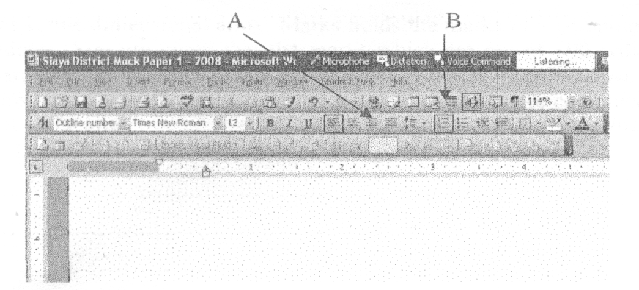

Give the uses of the icons labeled A and B (2 marks)
A …………………………………………………………………………………………………………………………..……………….
B …………………………………………………………………………………………………………………………………………...

- Define the following terms as used in disk management
- Partitioning (2 marks)
…………………………………………………………………………………………………………………………………………………………………………………………………………………………………………………………………………………….………..
- Defragmentation (2 marks)
………………………………………………………………………………………………………………………………………………………………………………………….…………………………………………………………………………………………………..
- State three ways in which your school librarian can use a computer (3 marks)
………………………………………………………………………………………………………………………………………………………………………………………………………………………………………………………………………………………………………………………………………………………………………………………………………………………………………………

- i) Write the acronym UPS in full? (1 mark)
………………………………………………………………………………………………………………………………………………
ii) Explain the uses of UPS? (1 mark)
………………………………………………………………………………………………………………………………………………………………………………………………………………………………………………………………………………………………

- a) Give two possible ways of fitting the document in one page (2 marks)
………………………………………………………………………………………………………………………………………………………………………………………………………………………………………………………………………………………………………………………………………………………………………………………………………………………………………………………………………………………………………………………………………………………………………………………………

b) The shopkeeper one day switched on the computer and experienced a number of problems with windows operating system that he had installed. The problems included failure to load the operating system during the booting. After several trials of switching on the computer booting. It hand so often alongside abnormal restarting. State any two possible causes for the computer’s behavior. (2 marks)
……………………………………………………………………………………………………………………………………………………………………………………………………………………………………………………………………………………………………………………………………………………………………………………………………………………………………………………………………………………………………………………………………………………………………………………………………………………………………………………………………………………………………………………

- Differentiate between real time processing and batch processing giving examples where each could be used. (4 marks)
……………………………………………………………………………………………………………………………………………………………………………………………………………………………………………………………………………………………………………………………………………………………………………………………………………………………………………………………………………………………………………………………………………………………………………………………………………………………………………………………………………………………………………………

- In Kenya Tea Packers Company several people are employed as record clerks, typists and messenger. The company intends to introduce a computerized system in all the departments. Suggest three reasons that would make workers unhappy with the new system. (3 marks)
………………………………………………………………………………………………………………………………………………………………………………………………………………………………………………………………………………………………………………………………………………………………………………………………………………………………
…………………………………………………………………………………………………………………………………………

- Give two advantages of an electronic spreadsheet over traditional analysis ledger sheet.
(2 marks)
…………………………………………………………………………………………………………………………………………………………………………………………………………………………………………………………………………………………………………………………………………………………………………………………………………………………………………………………………………………………………………………………………………………………………………

- Explain the following terms as used in information Technology with reference to software purchase:-
- User friendliness (1 mark)
……………………………………………………………………………………………………………………………………………………………………………………………………………………………………………………………………….…………..

- Authenticity (1 mark)
……………………………………………………………………………………………………………………………………………………………………………………………………………………………………………………………………………….…..

- While purchasing computers for his school the principal Miruriiri high school decided to consult an expert. As a computer student advise him on four hard ware considerations.
(2 marks)
……………………………………………………………………………………………………………………………………………………………………………………………………………………………………………………………………………………………………………………………………………………………………………………………………………………………………………………………………………………………………………………………………………………………………………………………………………………………………………………………………………………………………………………

- Give the names of the following system flowchart symbols (2 marks)

A B C D
A …………………………………………………………………………………………………………………………………
B …………………………………………………………………………………………………………………………………
C ………………………………………………………………………………………………………………………………….
D …………………………………………………………………………………………………………………………………

- State any two features of a user friendly program (2 marks)
………………………………………………………………………………………………………………………………………………………………………………………………………………………………………………………………………………………………………………………………………………………………………………………………………………………………………………………………………………………………………………………………………………………………………..
SECTION B (60 MARKS)
Answer question 16 and any other three questions from this section
- a) State three qualities of a good pseudo code? (3 marks)
………………………………………………………………………………………………………………………………………………………………………………………………………………………………………………………………………………………………………………………………………………………………………………………………………………………………

b) i) State the 3 translators used in programming (3 marks)
………………………………………………………………………………………………………………………………………………………………………………………………………………………………………………………………………………………………………………………………………………………………………………………………………………………………
ii) List two examples of;
- Third generation languages (1 mark)
……………………………………………………………………………………………………………………………………………………………………………………………………………………………………………………………..
- Object oriented languages (1 mark)
………………………………………………………………………………………………………………………………………………………………………………………………………………………………………………………..…….
c) Draw a flowchart that was used to come up with the following pseud code (7 marks)
Start
N=0
X=0
While n < 3
Repeat
X = X + 1
While x < 2
N = N +1
End while
Stop

- a) The diagram below shows four common network topologies A, B, C and D.
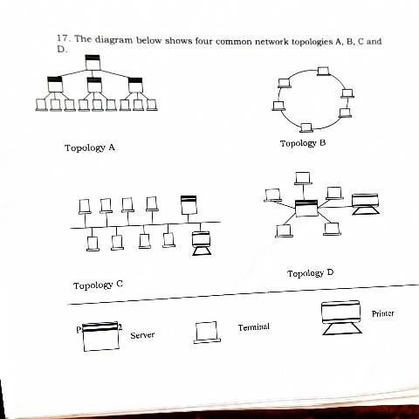

- Name the network topologies A, B, C and D (4 marks)
A ……………………………………………………………………………………………………………………………….……..
B …………………………………………………………………………………………………………………………..…………
C ……………………………………………………………………………………………………………..……………………….
D ……………………………………………………………………………………………………………….……………………..

- Explain what happens if server X topology A fails (1 mark)
……………………………………………………………………………………………………………………………………………………………………………………………………………………………………………………………………………………

- List two problems associated with network topology B (2 marks)
……………………………………………………………………………………………………………………………………………………………………………………………………………………………………………………………………………………

- List two disadvantages associated with network topology D (2 marks)
……………………………………………………………………………………………………………………………………………………………………………………………………………………………………………………………………………………

b) Differentiate between Internet and World Wide Web. (2 marks)
……………………………………………………………………………………………………………………………………………………………………………………………………………………………………………………………………………………………………………………………………………………………………………………………………………………………………………..

c) Convert the following binary number, 11001011.001 into decimal form. (4 marks)
………………………………………………………………………………………………………………………………………………………………………………………………………………………………………………………………………………………………………………………………………………………………………………………………………………………………………………………………………………………………………………………………………………………………………………………………………………………………………………………………………………………………………………………………………………

- a) Human activity systems are said to be soft systems. Give three reasons why they are said to be so. (3 marks)
………………………………………………………………………………………………………………………………………………………………………………………………………………………………………………………………………………………………………………………………………………………………………………………………………………………………
b) What are hard information systems? (2 marks)
………………………………………………………………………………………………………………………………………………………………………………………………………………………………………………………………………………………………………………………………………………………………………………………………………………………………

c) Discuss any five characteristics of a system. (10 marks)
……………………………………………………………………………………………………………………………………………………………………………………………………………………………………………………………………………………………………………………………………………………………………………………………………………………………………………………………………………………………………………………………………………………………………………………………………………………………………………………………………………………………………………………………………………………………………………………………………………………………………………………………………………………………………………………………………………………………………………………………………………………………………………………………………………………………………………………………………………………………………………………………………………………………………………………………………………………………………………………………………………………………………………………………………………………………………………………………………………………………………………………………………………………………………………………
- a) One of the functions of an operating system is job scheduling. Explain what is meant by job scheduling. (2 marks)
………………………………………………………………………………………………………………………………………………………………………………………………………………………………………………………………………………………………………………………………………………………………………………………………………………………………

b) List and explain three types of user interfaces. (6 marks)
………………………………………………………………………………………………………………………………………………………………………………………………………………………………………………………………………………………………………………………………………………………………………………………………………………………………………………………………………………………………………………………………………………………………………………………………………………………………………………………………………………………………………………………………………………………………………………………………………………………………………………………………

c) Describe the following categories of software (4 marks)
- Firmware
………………………………………………………………………………………………………………………………………………………………………………..………………………………………………………………………………………………….

- Proprietary software
……………………………………………………………………………………………………………………………………………………………………………………………………………………………………………………………………………………

d) A new company ABC intends to go into business of desktop publishing. Advice the company on three computer hardware specification features to consider as a measure of enhancing performance. (3 marks)
……………………………………………………………………………………………………………………………………………………………………………………………………………………………………………………………………………………………………………………………………………………………………………………………………………………………………………………………………………………………………………………………………………………………………………………………………………………………………………………………………………………………………………………………………………………………………………………………………………………………………………………………..
- a) Briefly explain the following terms as used in spreadsheet (4 marks)
- Cell
…………………………………..……………………………………………………………………………………………………
- Range
…………………..………………………………………………………………………………………………………..................
- Value
………………………..………………………………………………………………………………………………………………
- Function
…………………………………………………………………………………………………………………………………………

b) List three paragraph formatting features of word processors (3 marks)
………………………………………………………………………………………………………………………………………………………………………………………………………………………………………………………………………………………………………………………………………………………………………………………………………………………………………………
………………………………………………………………………………………………………………………………………………

c) Explain the difference between the printing of multiple pages and multiple copies. (2 marks)
……………………………………………………………………………………………………………………………………………………………………………………………………………………………………………………………………………………………………………………………………………………………………………………………………………………………………………………………………………………………………………………………………………………………………………………………..

d) Distinguish between a worksheet and a work book (2 marks)
………………………………………………………………………………………………………………………………………………………………………………………………………………………………………………………………………………………………………………………………………………………………………………………………………………………………………………

e) The following is an excel worksheet showing the performance of students in Tana class.
A | B  Adam | C  Student name | D Cat 1/50 | E Cat 2/50 | F  Total / 40 | G  Exam / 60 | H  Total
1  2  3  4  5  6  7  8  9 | 4321  4333  4330  4322  4324 | Dolline Mbesa  Selina Mbugua  Winnie Wanjema  MagaretWambari  Fani Njuguna  Maximum  Minimum  Average | 30  20  25  27  28  (c)  (d)  (e) | 28  29  26  24  24 | (a) | 45  55  50  43  42 | (b)

Using the above worksheet write the following formula to calculate the values in cells labeled a, b, c, d, and e (4 marks)
………………………………………………………………………………………………………………………………………………………………………………………………………………………………………………………………………………………………
………………………………………………………………………………………………………………………………………………
………………………………………………………………………………………………………………………………………………
………………………………………………………………………………………………………………………………………………
………………………………………………………………………………………………………………………………………………
………………………………………………………………………………………………………………………………………………
………………………………………………………………………………………………………………………………………………

