233/2
CHEMISTRY
PAPER 2

Form 4 2025

Paper 2

MARKING SCHEME

FORM 4 CHEMISTRY PAPER 2
MARKING SCHEME
- (a)(i) filtration √1
(ii) its insoluble in Liquid L √1
(iii) sand √1 and water √1
Both must be correct
(iv) Decantation√1
(v) Apparatus A- filter funnel √1
Apparatus B – conical flask √1
(vi) used to deliver solution/ liquids carefully to apparatus with narrow necks. √1
Can be used in dissolving highly soluble gases in water to avoid sucking back effects√1
(b)(i) Blue hydrated copper(ii) sulphate turns to white powder
Colourless liquid droplets on the cooler parts of the test tube √1
(ii) water √1
(iii) temporary chemical change √1 because change can be reversed√1

- (a) Zn_{(s)} + CuSO_{4(aq)} ZnSO_{4(aq)} + CU_{(s)}√1
(b) To ensure all the copper(ii) sulphate solution was used up √1
(c) Blue colour of copper(ii) solution fades√1 because copper(ii) ions responsible for the colour are displaced from the solution√1
Brown solid is deposited √1 because copper(ii) ions are reduced to copper metal which is a brown solid. √1
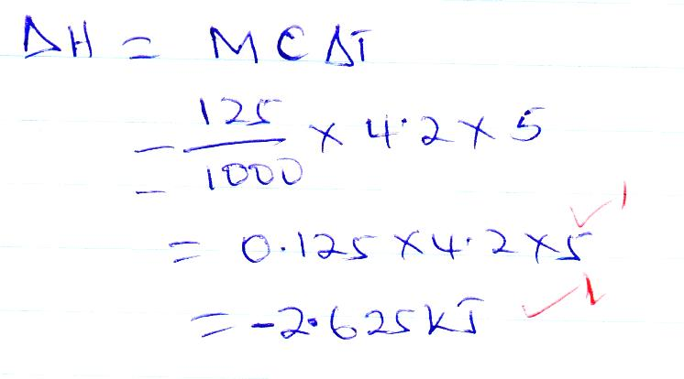
(d)

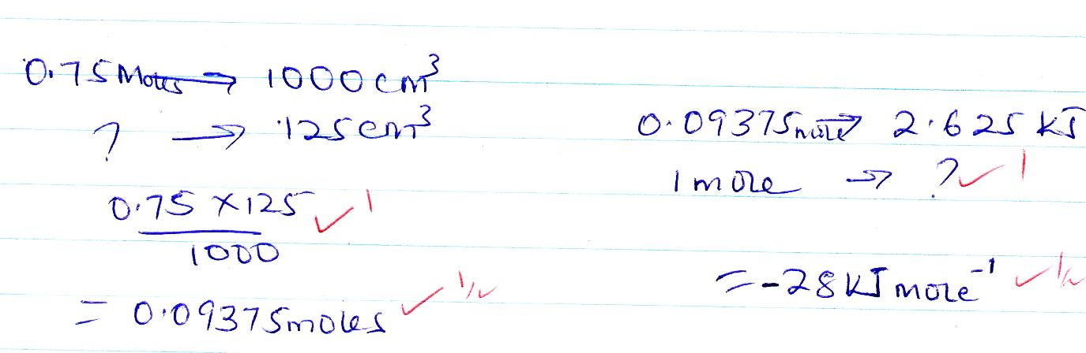
(e)

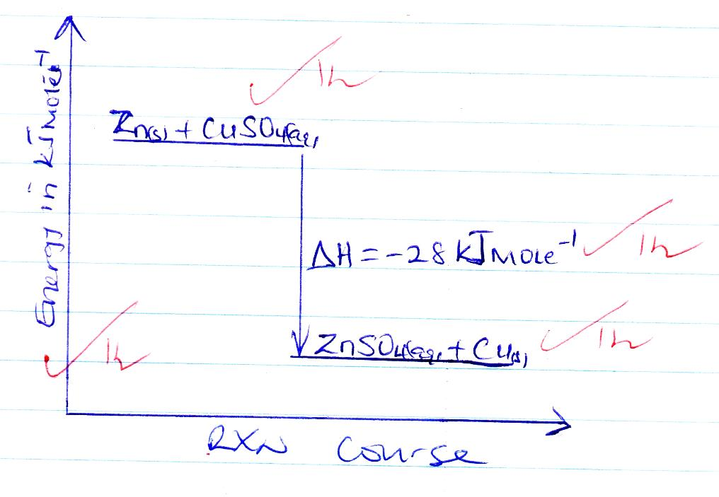
(f)

- (a) (i) substance M- lead (ii) hydroxide/ pb(OH)₂
(ii) solid P- lead(ii) carbonate/ PbCO₃
(iii) gas R- carbon (iv) oxide √1
(iv) Solution L- Nitric (v) acid √1
(b) (i) Pb(OH)_{2(s)} + 2OH⁻ [Pb(OH)₄]²⁻_{(aq)} √1
(ii) Pb²⁺⁽_{aq)} + SO²⁻_{4(aq)} PbSO_{4(s)} √1
(c) forms white ppt √1 insoluble in √1 excess ammonia
(ii) (a) H₃^{O+} √1
(b) H₂O(l)

- (a) hydrogen gas
b) (i) Mg_{(s)} + H₂O_{(l)} MgO_{(s)} +H_{2(g)} √1
(ii) H_{2(g)} + O_{2(g)} H₂O_{(l)} √1
(c) (i) to drive out air that was initially in the glass tube so that it does oxidise the magnesium ribbon. √1
(d) clamp and stand √1
(e) mass of magnesium increases√1 because magnesium react with oxygen ,to form magnesium oxide powder. √1
(f) less dense than air √1
- insoluble in water √1
- colourless and oudourless gas √1
Any two correct
(g) used in haber process to manufacture ammonia gas
- used in hardening of margarine(oil)
Any two correct
(h) to generate steam that would react with magnesium ribbon. √1

- (a) hydrogen gas √1
(b) H_{2(g)} + Cl_{2(g)} 2HCl_{(g)} √1
(c) to increase the surface area over which the gas dissolves in water √1
(d)(i) Electrolysis of brine
Cracking of long chain hydrocarbons
Any one correct
(ii) Electrolysis of fused sodium chloride or brine √1
(e) to prevent explosion when chlorine reacts with hydrogen. √1
(f) removing mist from metal √1
Making of dyes and drugs √1
(g) open a bottle of concentrated ammonia√1and place it near hydrogen chloride gas, dense white fumes of NH₄Cl are observed
- (a)(i) propane √1
(ii) But-2-ene √1
(iii) 5- bromo pent- 2- ene √1
(b)(i) Bromo ethane √1
(ii)
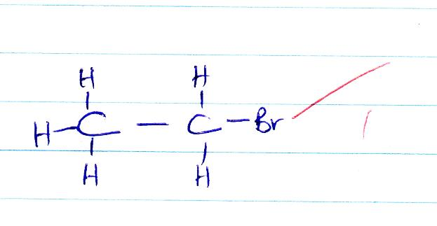

(iii)
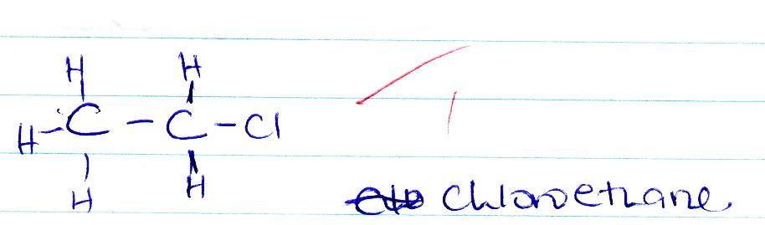

(c) used as a fuel. √1
(d) natural gas√1
Biogas √1
Crude oil √1
Any two correct

- (a)(I) D- its most electronegative √1
(ii) K- its most electropositive √1
(b) Alkaline earth metals √1
(c) (i) F₂G₃ √1
Accept Al₂O₃
(ii) K₂O √1
(d) F is larger than G√1. G has higher nuclear charge hence electrons are pulled inwards more strongly. √1
(e) has giant ionic structure with strong ionic bonds. √1

(f) (i) its used in light bulbs to provide an inert environment to prevent oxidation. √1
Used as an insulator in arch welding √1
Any correct

(ii) used in manufacture of magnesium hydroxide which is used as anti-acid medicine
Its low density alloy with aluminum is used in airplane construction
Any correct

