Name: …………………………………………………………… Adm No: ……..…...................................

Class: ……………………………………………………....…. Candidate’s sign ……………………....

Date: ……………………………………………………………

231/3
BIOLOGY
PAPER 3

TIME: 1 ¾ HOURS



KISII SCHOOL
MOCK EXAM 2025
Kenya Certificate of Secondary Education (K.C.S.E)

Biology
Practical

INSTRUCTIONS TO CANDIDATES:
- Write your name and admission number in the spaces provided.
- Sign and write date of examination in the spaces provided above
- Answer all the questions in section A and B
- You are required to spend the first 15 minutes of the 1 ¾ hours allowed for this paper reading the whole paper carefully.

For Examiner’s Use Only:

QUESTIONS | MAXIMUM SCORE | CANDIDATE’S SCORE
1 | 15
2 | 14
3 | 11
TOTAL | 40

1. You are provided with several specimens N and indicator D, which is Bromothymol blue. Study them and answer the questions that follow:
- (i) Identify the part of plant represented by specimen N. (1mk)
……………………………………………………………………………………………………………

(ii) Give a reason for your answer in a) i) above. (1mk)
……………………………………………………………………………………………………………

- i) Name the physiological process which is taking place in specimen N. (1mk)
……………………………………………………………………………………………………………

ii) Describe the two changes which occurred to specimen N during the process named in b)i) above. (2mks)
…………………………………………………………………………………………………………..
……………………………………………………………………………………………………………………………………………………………………………………………………………………………………………………………………………………………………………………………………………………………………………………………………………………………………………………

- i) State two internal factors which would promote the physiological process exhibited by specimen N, (2mks)
……………………………………………………………………………………………………………
……………………………………………………………………………………………………………

ii) State two external conditions which would inhibit the process demonstrated by specimen N. (2mks)
……………………………………………………………………………………………………………
……………………………………………………………………………………………………………
- Take a small piece of cotton wool and insert into a test tube. Use a wooden splint to push it to the bottom. Add two drops of indicator marked D, and spread it uniformly in the cotton wool by pressing using the wooden splint. Drain the excess indicator and then add 10 pieces of specimen N into the test tube. Close the mouth of the test tube tightly using the remaining cotton wool. Leave the set up to stand on the tube rack for 20 minutes.

- Record your observation after 20 minutes (1mk)
……………………………………………………………………………………………………………
- Account the observation in d) i) above (3mks)
……………………………………………………………………………………………………………
……………………………………………………………………………………………………………
………………………………………………………………………………………………………………………………………………………………………………………………………………………………………………………………………………………………………………………………………
- Suggest a control for his experiment. (1mk)
…………………………………………………………………………………………………………....

2. Below are diagrams of part the urinary system. Examine them and answer the questions below.

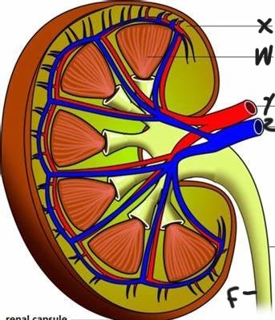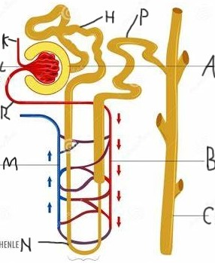

(a) Name the parts labeled K, F, X,A and H (5mks)
K. ..................................................................................................................................
F. ..................................................................................................................................
X. ..................................................................................................................................
A ……………………………………………………………………………………..
H ………………………………………………………………………………………
(b) State two adaptations of part labeled H to its function (2mks)
....................................................................................................................................................................................................................................................................................................................................................................................................................................................................................................................................................................................................................................................................................................................................................................................................................................................

(c) From the name the part where;
(i) Counter current flow occurs (lmk)
....................................................................................................................................................................
(ii) Reabsorption of water occurs (1mk)
....................................................................................................................................................................
(iii) Name the metabolic wastes components in the blood that do not enter the renal tubule (1mks)
………………………………………………………………………………………………………………………………………………………………………………………………………………………………………………………………………………………………………………………………………
(d) Explain what would happen to the process of urine formation in absence of anti-diuretic hormone (3mks)
..................................................................................................................................................................................................................................................................................................................................................................................................................................................................................................................................................................................................................................................................................................................................................................................................................................................................................................................................................................................................................................................................................................................................................................................................................................................................
3. Photographs A, B, C, D, and E below represent organisms that occupy a certain Ecosystem studied on a field visit.

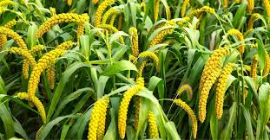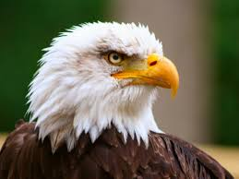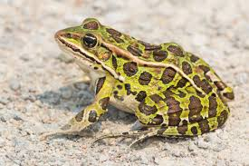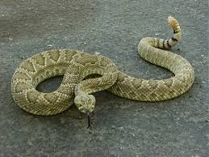
E
C
A
B
D

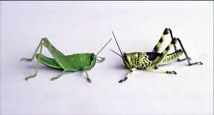
(a)Using the letters assigned to each organism, construct two food chains ending with a Tertiary consumer. (2mks)
…………………………………………………………………………………………………………..
……………………………………………………………………………………………………………………………………………………………………………………………………………………………………………………………………………………………………………………………………………………………………………………………………………………………………………………
(i)Suppose organism B migrated out of this ecosystem, suggest two possible effects on the ecosystem. (2mks)
………………………………………………………………………………………………………………………………………………………………………………………………………………….
(ii)Using observable features only, state the adaptations of organism A to different ways of locomotion. (3mks)
……………………………………………………………………………………………………………………………………………………………………………………………………………………………………………………………………………………………………………………………………………………………………………………………………………………………………………………
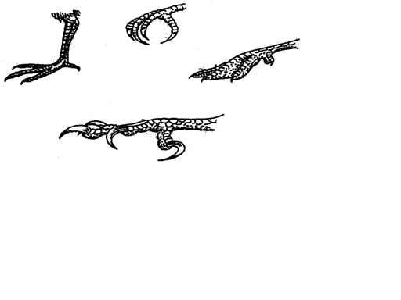
(b) Carefully observe feet from four different birds labeled G, H, J, and K
J
K
G
H

(i) What evolutionary concept is shown by these feet? (1mk)
………………………………………………………………………………………………
(ii)State the functional adaptations shown by the feet labeled G, J, and K (3mks)
G: …………………………………………………………………………………………………….
J: ………………………………………………………………………………………………………
H: ………………………………………………………………………………………………………
(iii)For the feet H and G, state the observable features that suit the birds to that environment. (2mks)
H: ………………………………………………………………………………………………………...
G: ………………………………………………………………………………………………………

