NAME: …………………………………………. INDEX NO: ……………………………….

DATE : …………………………………..CANDIDATE’S SIGNATURE:…………………

MANGU HIGH SCHOOL TRIAL 4 MOCK 2025


231/3
BIOLOGY
PAPER 3
PRACTICAL
1 ¾ HOURS

FORM FOUR
JULY/AUGUST 2025

INSTRUCTIONS TO CANDIDATES
1. Write your name and index number in the spaces provided.
2. Write the date of the examination in the spaces provided above
3. Answer all questions in the spaces provided
4. You are required to spend the first 15 minutes of the 1 ¾ hours allowed for this paper reading the whole paper carefully before commencing your work.,

FOR EXAMINER’S USE ONLY
Questions | Maximum score | Candidates score
1 | 12
2 | 14
3 | 14
Total score | 40

1. You are provided with a specimen labeled K and hydrogen peroxide
(a) (i) What part of plant is specimen K? (1mk)

………………………………………………………………………………………….
………………………………………………………………………………………….
(ii) Give a reason for your answer in a (i) above (1mk)

…………………………………………………………………………………………….
…………………………………………………………………………………………….
(b) Cut three equal cubes whose sides are about 1cm from specimen K. place one of the cubes in a boiling tube labeled A; boil the second cube for about 15 minutes and then place it into a boiling tube labeled B; Cut the third cube into small pieces and place the pieces in a boiling tube labeled C
To each boiling tube add 5ms of hydrogen peroxide
(i) Record your observations in the table below (3mks)
Tube | Observations
A
B
C

(ii) Account for your observations in tubes B and C (2mks)
B……………………………………………………………………………………………………

………………………………………………………………………………………………………

……………………………………………………………………………………………………
C (2mks)
………………………………………………………………………………………………………

………………………………………………………………………………………………………

………………………………………………………………………………………………………

………………………………………………………………………………………………………
(c) (i) Write a chemical equation for the reaction that occurs in test tube A (1mk)
……………………………………………………………………………………………………………………………………………………………………………………………………………………………….
(ii) What is the significance of the reaction to living organisms (1mk)
………………………………………………………………………………………………………………………………………………………………………………………………………………………………
(iii) Name the organ in mammals where the above reaction occurs at the highest rate (1mk)
………………………………………………………………………………………………………………………………………………………………………………………………………………………

- You are provided with photographs A, B and C, use them to answer questions that follow.

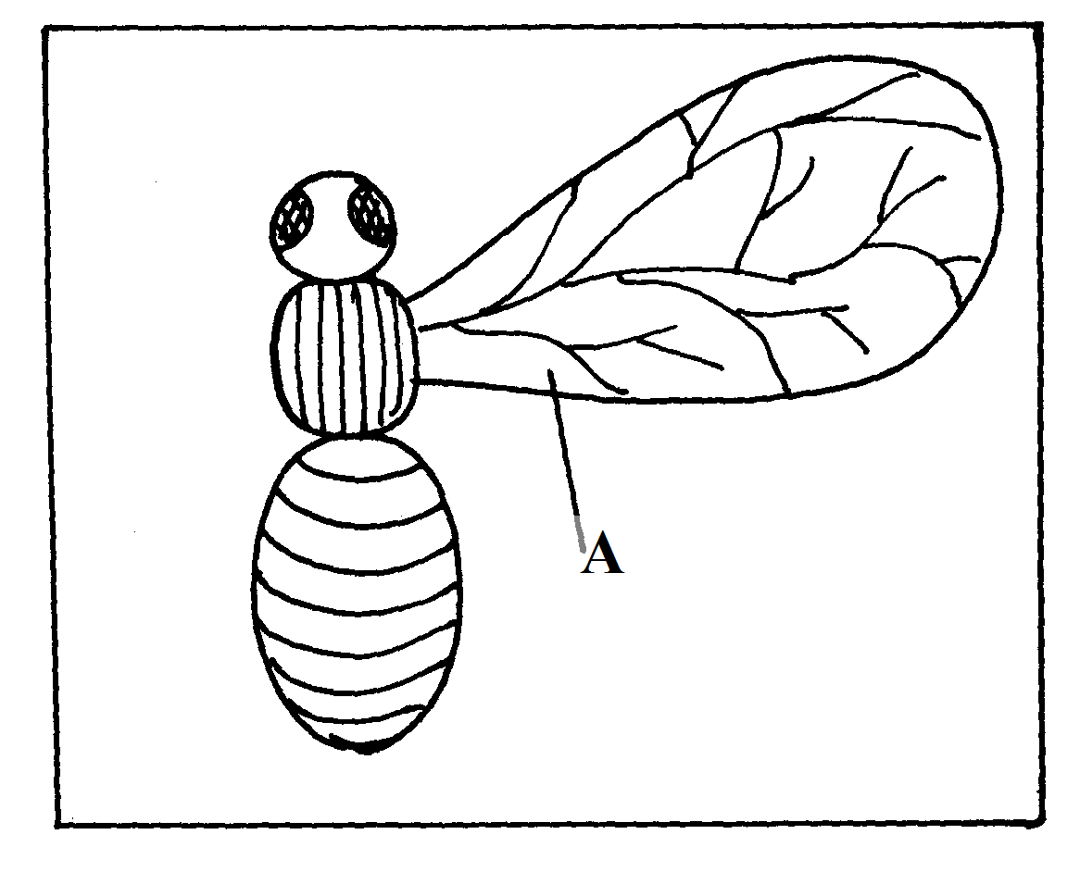

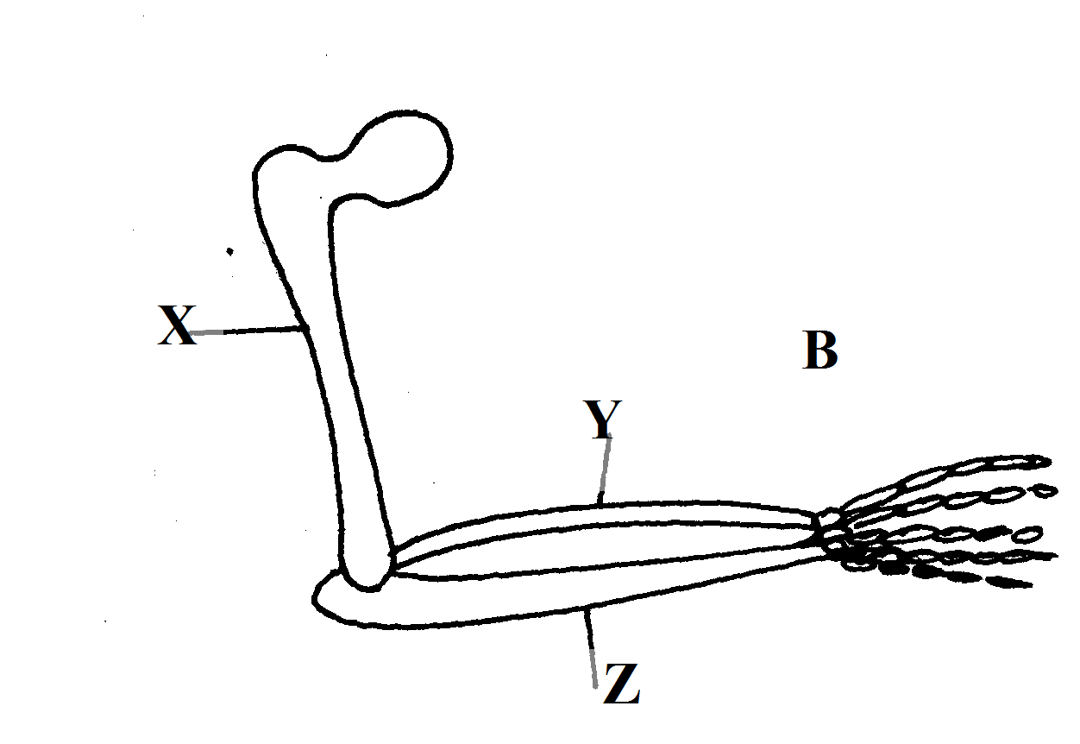

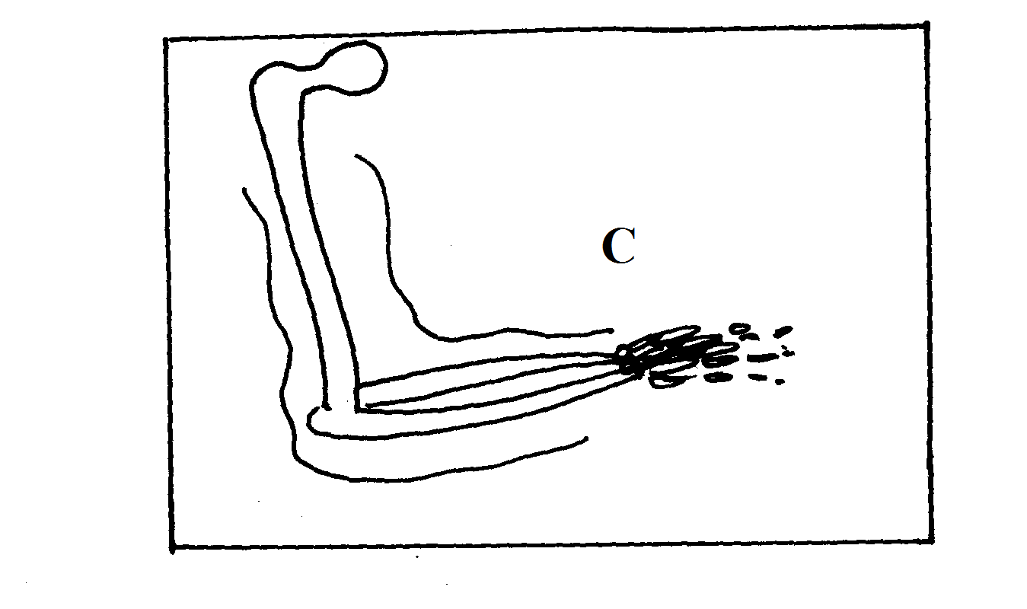
(a)Identify the parts labeled X,Y and Z. (3mks)
X……………………………………………………………………………………
Y…………………………………………………………………………………
Z……………………………………………………………………………………
(b)What common name is given to structure ref?
(i)A and C……………………………………..………………(1mk)

(ii)B and C………………………………………………………. ……(1mk)

(c)Give a reason for your answer in b (i) and (ii) above. (2mks)
(i)……………………………………………………………………………………………………………………………………………………………………………………………………………………………………………………………………………………………………
(ii)…………………………………………………………………………………………………………………………………………………………………………………………………………………………………………………………………………
d) State the type of evolution that leads to emergence of structures named in 2 b (i) and (ii) above. (2mks)
(i) ………………………………………………………………………

(ii)……………………………………………………………………….
e)Identify two differences between structures A and C. (2mks)

A | C

f) (i)What is a vestigial structure? (1mk)
……………………………………………………………………………………………..
……………………………………………………………………………………………..

(ii)Give two examples of vestigial structures in human being (2mks)

…………………………………………………………………….

…………………………………………………………………….

- Study photographs C and D and answer the questions.

PHOTOGRAPH C
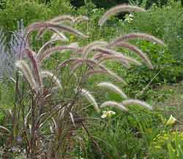

PHOTOGRAPH D

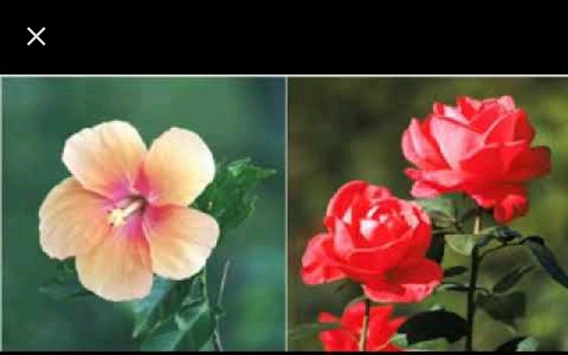
- With a reason state the agent of pollination of each of the flowers. (4mks)

Flower | Agent of pollination | Reason
C
D

- Classify the plants in photograph D using the taxonomic units below and reasons for your answer. (4mks)

Taxonomic unit |  | Reason
Division

Class

- The diagrams below shows a type of cell division occurring in organisms above. Identify each of the stages A to D giving reasons for your answer. (4mks)
A B

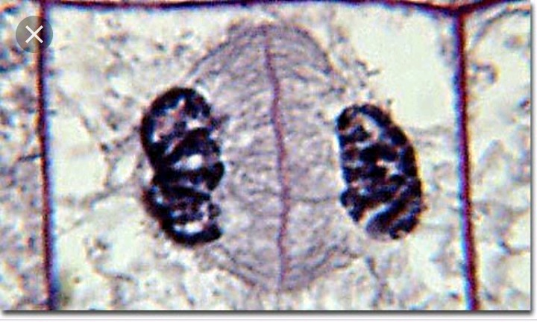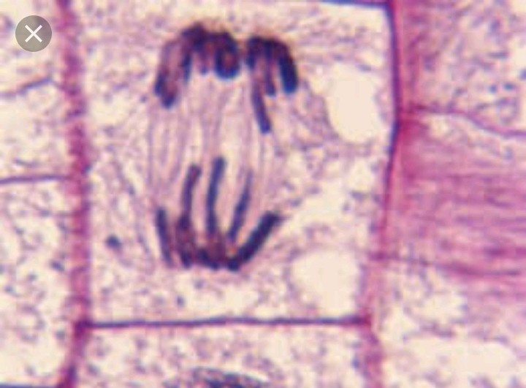

C D
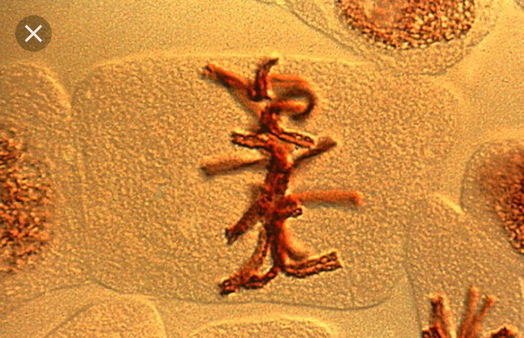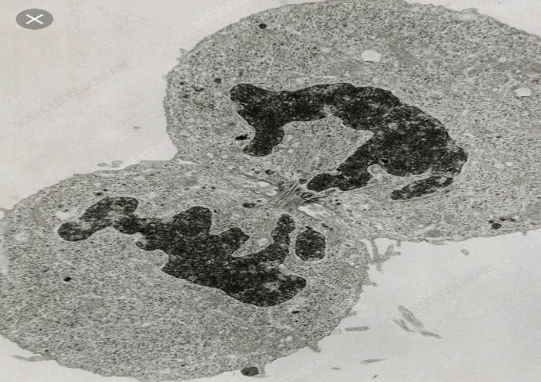

STAGE | REASON
A
B
C
D

(d). Giving reason, identify the kingdom to which the cell in stages A and B belongs. (2mks)

Kingdom…………………………………………………………………………………..

Reason …………………………………………………………………………………….

………………………………………………………………………………………

