Name …………………………………………………………………………………………….….. Index No. ………………. Class …….


STAREHE GIRLS’ CENTRE MOCK EXAMINATION 2025
231/2
BIOLOGY
PAPER 2

TIME: 2 HOURS

Biology
Paper 2

INSTRUCTIONS TO CANDIDATES:
- Write your name and admission number in the spaces provided.
- Sign and write the date of examination.
- This paper consists of two sections A and B.
- Answer all the questions in Section A in the spaces provided.
- In section B answer questions 6 (compulsory) and either question 7 or 8 in the spaces provided.
- Check and ascertain that no questions are missing.

For Examiner’s Use Only:

SECTIONS | QUESTION | MAXIMUM SCORE | CANDIDATES SCORE
A | 1  2  3  4  5 | 8  8  8  8  8
B | 6  7  8 | 20  20  20
TOTAL SCORE |  | 80

SECTION A (40 MARKS)
Answer all questions in this section

1 (a) the table below shows the concentration of sodium and iodine ions in pond water and in the
cell sap.
 | Sodium ion concentration | Iodine concentration
Pond water | 180 | 0.4
Cell sap | 90 | 500
Giving reasons name the process through which each of the ions is taken up by the plants
- Sodium ion (2mks)
…………………………………………………………………………………………………………………………………………………………………………………………………………………………………………………………………………………………………………………………………………………………………………………………………………………………………………………………………………
- Iodine ion (2mks)
…………………………………………………………………………………………………………………………………………………………………………………………………………………………………………………………………………………………………………………………………………………………………………………………………………………………………………………………………………
(b) The lettuce plant was then treated with a chemical substance that inhibits the synthesis of ATP Giving a reason, state which ion was affected by the treatment (2mks)
……………………………………………………………………………………………………………………………………………………………………………………………………………………………………………………………………………………………………………………………………………………………………………………………………………………………………………………………………………………………………………………………………………………………………………………………
(c) Explain why fresh water fish cannot survive is marine habitat (2mks)
……………………………………………………………………………………………………………………………………………………………………………………………………………………………………………………………………………………………………………………………………………………….……………………………………………………………………………………………………………………………………………………………………………………………………………………………………
2. The diagram below represents recycling of nutrients in a certain ecosystem

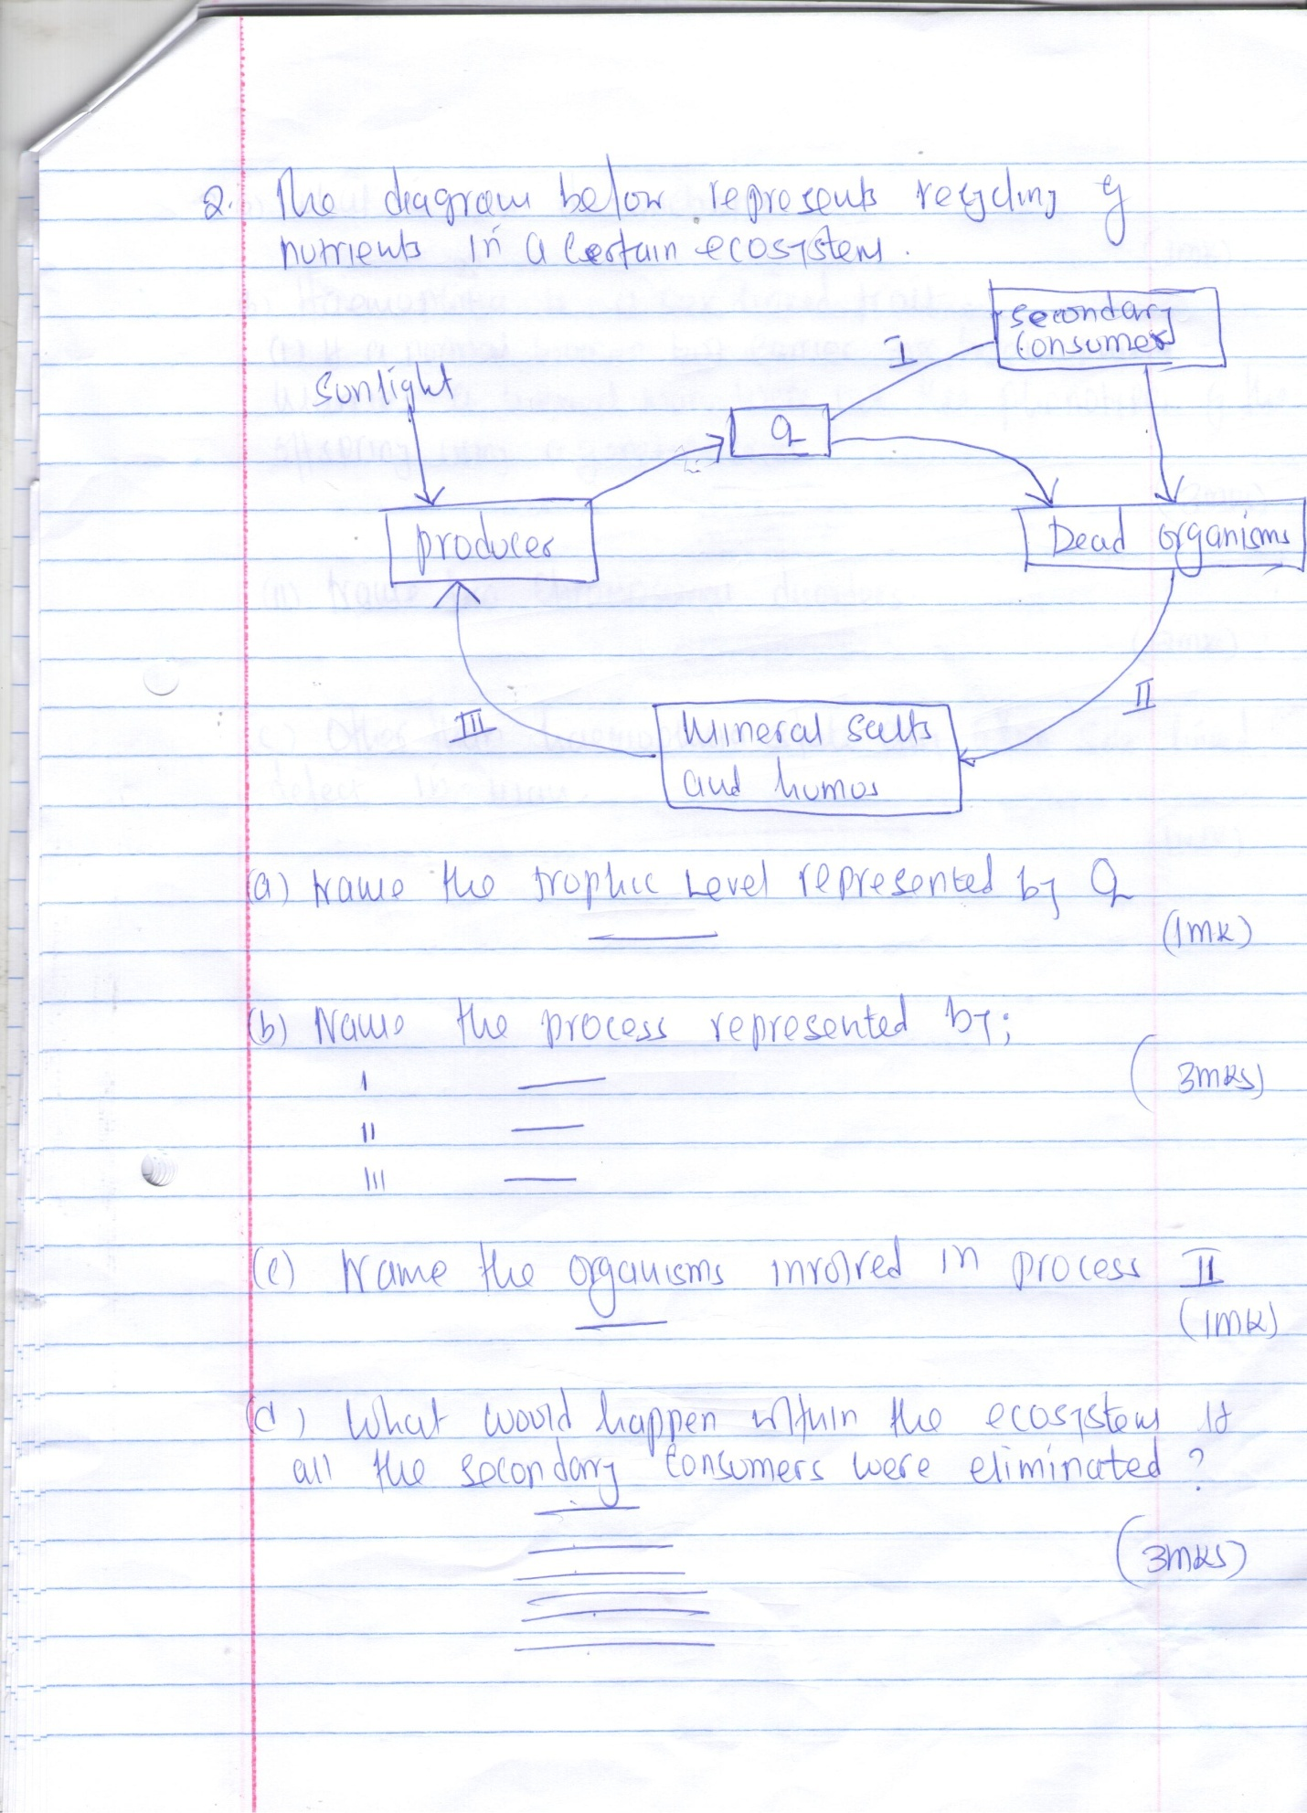
(a) Name the trophic level represented by Q (1mk)
……………………………………………………………………………………………………………………………………………………………………………………………………………………………………
(b) Name the process represented by: (3mks)
I
…………………………………………………………………………………………………………………
II
…………………………………………………………………………………………………………………
III
…………………………………………………………………………………………………………………
(c) Name the organism involved in process II (1mk)
…………………………………………………………………………………………………………………..
(d) What would happen within the ecosystem if all the secondary consumers were eliminated?
(3mks)
……………………………………………………………………………………………………………………………………………………………………………………………………………………………………………………………………………………………………………………………………………………….
3. (a) what is non disjunction (1mk)
…………………………………………………………………………………………………………………

(b) Haemophilia is a sex linked trait
(i) If a normal woman but carrier for haemophilia marries a normal man, work out the phenotype of the offspring using a genetic cross (3mks)
…………………………………………………………………………………………………………………………………………………………………………………………………………………………………………………………………………………………………………………………………………………………………………………………………………………………………………………………………………………………………………………………………………….………………………………………………
(ii) Name two chromosomal disorders (2mks)
……………………………………………………………………………………………………………………………………………………………………………………………………………………………………
(c) Other then haemophilia, state any other two sex - linked defect in man (2mks)
……………………………………………………………………………………………………………………………………………………………………………………………………………………………………
4. An experiment was set to investigate the effect of unilateral light on the growth of oat coleoptiles. The diagram in the table represents the experimental set ups the start and the result at the end of experiment.
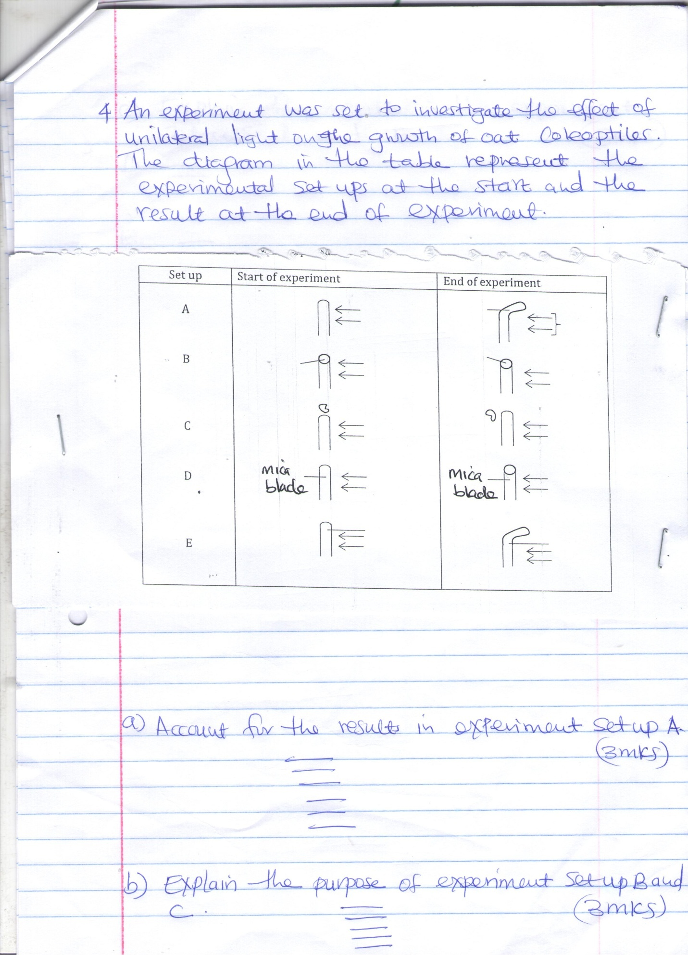
(a) Account for the reaction in experiment set up A (3mks)
…………………………………………………………………………………………………………………………………………………………………………………………………………………………………………………………………………………………………………………………………………………………………………………………………………………………………………………………………………………………………………………………………………….………………………………………………
(b) Explain the purpose of experiment set up B and C (3mks)
…………………………………………………………………………………………………………………………………………………………………………………………………………………………………………………………………………………………………………………………………………………………………………………………………………………………………………………………………………………………………………………………………………….………………………………………………
(c) Explain the results in the experiment set D and E (2mks)
D
……………………………………………………………………………………………………………………………………………………………………………………………………………………………………
E
……………………………………………………………………………………………………………………………………………………………………………………………………………………………………
5. The diagram below represents a transverse section through mammalian skin
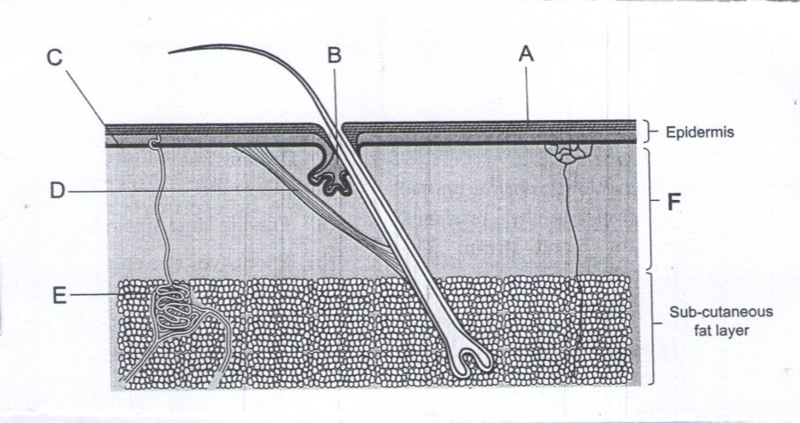
(a) Name the structures A and B (2mks)
A………………………………………………………………………………………………..
B……………………………………………………………………………………………….
(b) (i) Explain how the hair in human beings helps in keeping the body warm (3mks)
……………………………………………………………………………………………………………………………………………………………………………………………………………………………………
…………………………………………………………………………………………………………………
…………………………………………………………………………………………………………………
(ii) Explain other methods by which the skin helps to keep the body warm (3mks)
……………………………………………………………………………………………………………………………………………………………………………………………………………………………………
…………………………………………………………………………………………………………………
…………………………………………………………………………………………………………………
SECTION B: (40MARKS)
Answer question 6 (compulsory) and either question 7 or 8 in the spaces provided.
6. The table below shows how the width of the stomata and the wind speed can affect the rate of transpiration from a leaf of a plant. The width are measured in micrometers (nm)
Width of stomata in (nm) | Rate of transpiration in gm/M²/ hour
 | In still air | In wind
0 | 0.0 | 0.0
5 | 0.9 | 4.0
10 | 16.0 | 7.0
15 | 2.0 | 8.4
20 | 2.2 | 9.0
(a) On the same axes plot a graph of rate of transpiration against width of the stomata (8mks)

(b) Use your graph to predict the rate of transpiration when the stomata have a width of 8nm

…………………………………………………………………………………………………………………..……………………………………………………………………………………………………………………………………………………………………………………………………………………………………
(c) Describe the relationship between the width of stomata and the rate of transpiration in still air
(3mks)
…………………………………………………………………………………………………………………………………………………………………………………………………………………………………………………………………………………………………………………………………………………………………………………………………………………………………………………………………………
(d) Explain why the rate of transpiration in wind differs from rate in still air (3mks)
…………………………………………………………………………………………………………………………………………………………………………………………………………………………………………………………………………………………………………………………………………………………………………………………………………………………………………………………………………
(e) Explain why transpiration is important in plants (4mks)
……………………………………………………………………………………………………………………………………………………………………………………………………………………………………………………………………………………………………………………………………………………….
………………………………………………………………………………………………………………………………………………………………………………………………………………………………………………………………………………………………………………………………………………………
7. Describe the various ways in which seeds and fruits are adapted for dispersal (20mks)

8. (a) State the possible application of the following plants hormones in agriculture (8mks)
- Auxins
- Gibberellins
(b) Explain how each of the following serves as evidence of organic evolution
(i) Fossil records (3mks)
(ii) Comparative antinomy (6mks)
(iii) Geographical distribution (3mks)

…………………………………………………………………………………………………………………………………………………………………………………………………………………………………………………………………………………………………………………………………………………………………………………………………………………………………………………………………………………………………………………………………………………………………………………………………………………………………………………………………………………………………………………………………………………………………………………………………………………………………………………………………………………………………………………………………………………………………………………………………………………………………………………………………………………………………………………………………………………………………………………………
…………………………………………………………………………………………………………………………………………………………………………………………………………………………………………………………………………………………………………………………………………………………………………………………………………………………………………………………………………………………………………………………………………………………………………………………………………………………………………………………………………………………………………………………………………………………………………………………………………………………………………………………………………………………………………………………………………………………………………………………………………………………………………………………………………………………………………………………………………………………………………………………
…………………………………………………………………………………………………………………………………………………………………………………………………………………………………………………………………………………………………………………………………………………………………………………………………………………………………………………………………………………………………………………………………………………………………………………………………………………………………………………………………………………………………………………………………………………………………………………………………………………………………………………………………………………………………………………………………………………………………………………………………………………………………………………………………………………………………………………………………………………………………………………………
…………………………………………………………………………………………………………………………………………………………………………………………………………………………………………………………………………………………………………………………………………………………………………………………………………………………………………………………………………………………………………………………………………………………………………………………………………………………………………………………………………………………………………………………………………………………………………………………………………………………………………………………………………………………………………………………………………………………………………………………………………………………………………………………………………………………………………………………………………………………………………………………
…………………………………………………………………………………………………………………………………………………………………………………………………………………………………………………………………………………………………………………………………………………………………………………………………………………………………………………………………………………………………………………………………………………………………………………………………………………………………………………………………………………………………………………………………………………………………………………………………………………………………………………………………………………………………………………………………………………………………………………………………………………………………………………………………………………………………………………………………………………………………………………………
…………………………………………………………………………………………………………………………………………………………………………………………………………………………………………………………………………………………………………………………………………………………………………………………………………………………………………………………………………………………………………………………………………………………………………………………………………………………………………………………………………………………………………………………………………………………………………………………………………………………………………………………………………………………………………………………………………………………………………………………………………………………………………………………………………………………………………………………………………………………………………………………
………………………………………………………………………………………………………………………………………………………………………………………………………………………………………………………………………………………………………………………………………………………………………………………………………………………………………………………………………………………………………………………………………………………………………………………………………………………………………………………………………………………………………………
……………………………………………………………………………………………………………………………………………………………………………………………………………………………………
……………………………………………………………………………………………………………………………………………………………………………………………………………………………………
…………………………………………………………………………………………………………………

